Chapter five
Fieldwork

5.90998

5.1 Introduction
5.2 Instrumentation
5.3 Methodology of point's selection
5.4 Selection of Points

Introduction
As mentioned in the project timeline, a field work is to be performed in order to get precise GNSS point readings. This work is divided into many stages. First, exploration of points on the specified area is to be done before the observing them, also these points are located on some areas of personal property or it may be doesn’t existing due to the early time of 1932 when the point where installed. Then, existing points are to be chosen according to point's quality and good distribution. Finally, the selected points are going to observed and evaluated.

Instrumentation
Using GNSS based devices is roughly known for any researcher or a student in the field surveying and Geometric hence, the use of GNSS static method that was described before is to be practiced in order to master the task needed to get the necessary data.
The initial stage is practical training for using the GNSS devices. Two types of GNSS apparatus are used in this project they instrument are:
1. Leica 900.
2. Trimble R8.
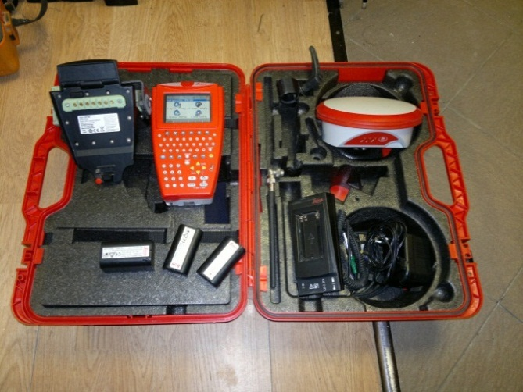
Ultimately, the main structure of the devices is familiar, also using them became familiar and team is ready for the stage of point observations, as shown in figure (5-1) & (5-2).

Figure (5-1): Leica 900 GNSS components
Table (5- 1): Technical Specifications for Leica GPS 900.
Networking Technology | Smart Track + Double frequency
GNSS antenna, ATX 900 GG | Built-in ground plane with Smart Check + and Bluetooth ® wireless technology,
Accuracy | Horizontal accuracy: + 10MM 1 ppm, the kinetic  Vertical accuracy: 20mm + 1 ppm, the kinetic
Refresh rate | Position update rate: 1Hz standard 0.2 Hz - Option 5 Hertz
Range | RTK range: 2500m standard, option 5000m
Temperature | Operation: -30 ° C to +65 ° C  Storage: -30 ° C to +80 ° C

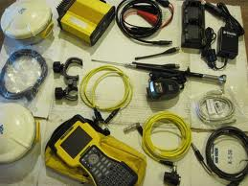
Figure ‎ (5-2): Trimble R8 GNSS components.
Table (5- 2): Technical Specifications for Trimble R8.
Interface | Console TSC2
Communication | Bluetooth. Internal and external Radio. GSM module
Accuracy | Horizontal accuracy: + 5MM 1 ppm, the kinetic  Vertical accuracy: +20MM + 1 ppm, the kinetic
Ports | (RS-232 port),( Limo Port)
Temperature | Process: between -40° to 65 ° C  Storage: between -40 ° to 75 ° C

Methodology of point's selection

List of points and their coordinates are obtained from the Palestinian department of land survey.

Benefiting from a GIS ortho photo of the West Bank, and by conversion of the txt file of trigs into a shapefile in a GIS Software. The location of points can be easily identified.

The availability of points is not guaranteed by a theoretical database, so exploration of the points is the only way to get into points.

By using a hand held GPS, the application of stakeout method is used to explore the points and to reach there position.

Selection of Points
Points that are needed is ones of known and briefly precise 3-dimensional coordinates, these are the geodetic Triangulation points fixed during the British mandate on Palestine.
The actual preparations for setting up a triangulation system commenced only in February 1921, after the Survey Department moved to its new home in Jaffa. The survey began in May 1921.The first step was for the survey teams to layout geodetic points throughout the entire country, measure their values, and provide mathematical bases for the survey networks. The geodetic points required for mapping are classed in three categories:
1) Fixed points, or trigonometric stations, were determined by trigonometric methods and must be in sight of each other for the surveying observations. These imaginary lines form the sides of the triangles of the observation net. The data obtained were the position of the points in planmetric coordinates. The elevation of the points was determined above the datum (reference) level, which is the mean sea level (MSL).
2) Spot heights were determined by precise leveling and not necessarily in relation to the trigonometric network. The topographic heights were measured above the MSL along fixed runs in the field.
3) Gravimetric points, for the determination of the figure of the Earth.
As the points of trigonometric stations were mostly available with their names and position values, the points of project network were chosen from these points suitable coverage of the areas Hebron, Tulkarem and Qlqelya districts is chosen according to the availability of points and ease of accessibility to them. In the next stage of this project more point in the West Bank are going to be observed. Figure (5-3) & (5-4) illustrates the distribution of these points within the area of study.
The Registered points are explained in the tables (5-3) and (5-24).
Table (5.3) also shows the information about points’ names and coordinates also it provides the location of the point according to the nearest town or city (Tulkarem and Qlqelya).

Table (5-3): Selected network points (Registered)
Point(name) | Easting(m) | Northing(m) | Elevation(m) | Location
771R | 152428.755 | 189125.387 | 87.46 | Ertah
765R | 153983.185 | 190067.438 | 141.89 | Tulkarem
103P | 153226.77 | 192522.21 | 568.75 | Shwakeh
805S | 160711.45 | 189707.65 | 319.55 | Kafr Al Labad
717T | 167342.37 | 180965.21 | 480.48 | Jeet
162F | 160688.16 | 178393.60 | 412.10 | Baqa AL-hatab
367X | 155518.06 | 170527.23 | 234.39 | Senerya
728T | 152720.92 | 172117.77 | 203.80 | Bat Ameen
191E | 150347.36 | 173830.56 | 173.20 | Ras Atya
21F | 147550.43 | 176307.09 | 73.55 | Qalqelya
4E | 149095.62 | 177710.29 | 116.49 | Qalqelya
722T | 153639.08 | 176230.31 | 252.33 | Ezbet AL-Tabeeb
870P | 156276.64 | 176536.64 | 276.00 | Azoon
821P | 154797.24 | 177543.27 | 255.53 | Azoon
236B | 156596.20 | 177579.47 | 316.49 | Seer
803R | 153118.58 | 181710.14 | 156.05 | Falamya
816S | 159351.59 | 182755.56 | 389.22 | Jyous
815S | 158978.45 | 183966.59 | 318.61 | Jyous
796S | 159177.69 | 192258.98 | 323.54 | Balaa
493D | 155624.81 | 199032.28 | 103.51 | Zaita
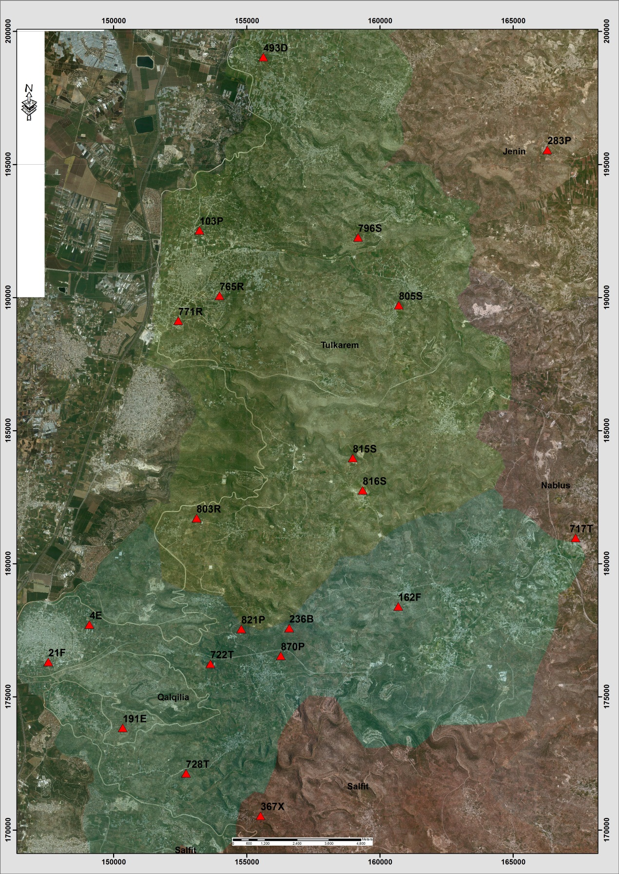
Figure (5-3): distribution of points within study area in Tulkarem and Qlqelya districts
Table (5-4): Details of Trig (771R)
Date:- 3/5/2014 |  | Obs.Team:- Saleh natour, Abedalhafez almuhtaseb, Ala'a rjob, Samer Serhan
Point ID:- 771R |  | Instrument:- Leica 900
File Name:- Saleh VRS |  | Point Number:- 033
Obs.Time:- 14 : 40 : 03 |  | Accuracy:- 0.02 m
Coordinates | E | N | H
Registered | 152430.13 | 189125.78 | 86.20
Observe | 152430.3 | 189125.76 | 86.02
WGS1984 | 35° 01' 25.23243" E | 32° 17' 44.60026" N | 106.57
Description | This trig is located in the village of Ertah on the rock
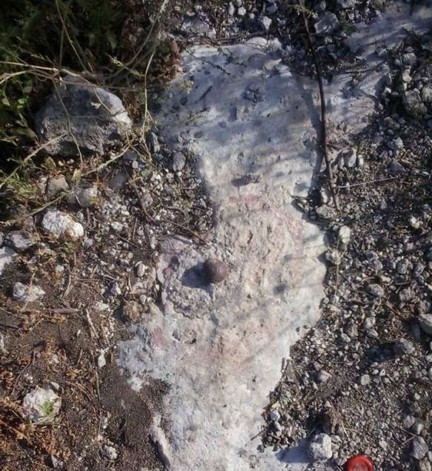
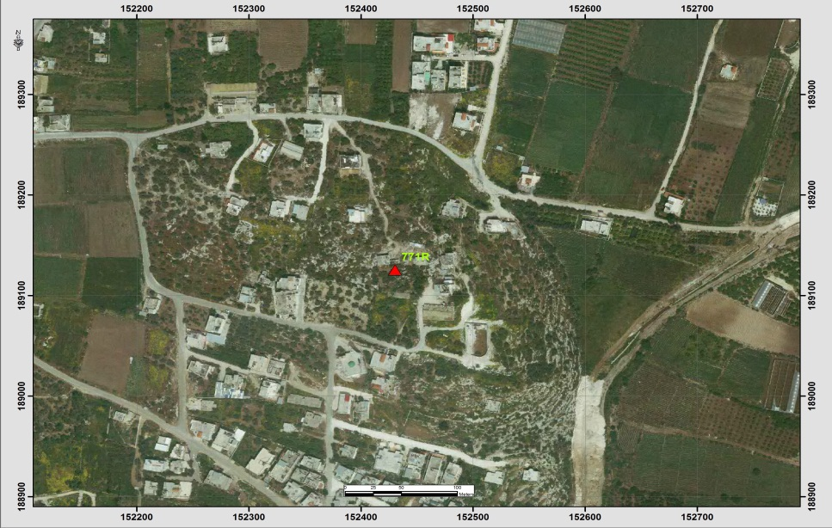
Table (5-5): Details of Trig (765R)
Date:- 3/5/2014 |  | Obs.Team:- Saleh natour, Abedalhafez almuhtaseb, Ala'a rjob, Samer Serhan
Point ID:- 765R |  | Instrument:- Leica 900
File Name:- Saleh VRS |  | Point Number:- 032
Obs.Time:- 14 : 24 : 14 |  | Accuracy:- 0.02 m
Coordinates | E | N | H
Registered | 153983.12 | 190068.37 | 140.30
Observe | 153983.19 | 190067.91 | 140.23
WGS1984 | 35° 02' 24.52971" E | 32° 18' 15.26666" N | 160.77
Description | This trig is located in Tulkarem on the rock
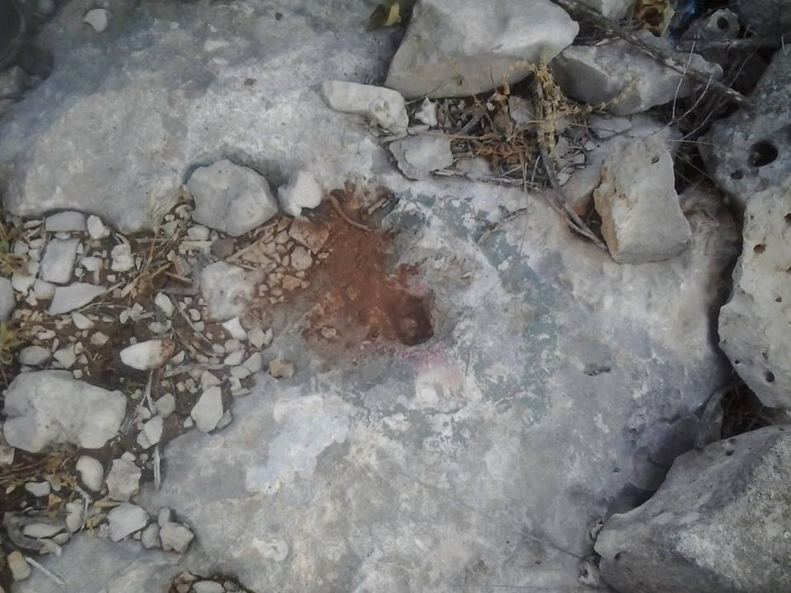
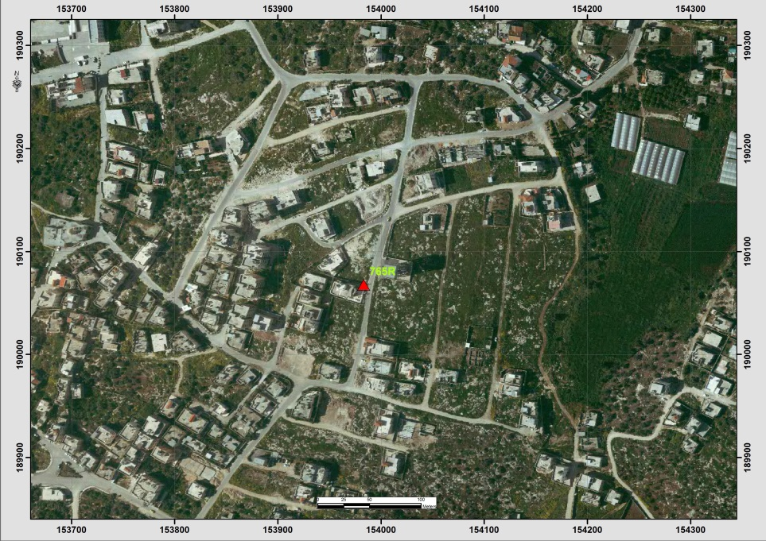

Table (5-6): Details of Trig (103P)
Date:- 3/5/2014 |  | Obs.Team:- Saleh natour, Abedalhafez almuhtaseb, Ala'a rjob, Samer Serhan
Point ID:- 103P |  | Instrument:- Leica 900
File Name:- Saleh VRS |  | Point Number:- 029
Obs.Time:- 14 : 01 : 12 |  | Accuracy:- 0.03 m
Coordinates | E | N | H
Registered | 153226.77 | 192522.21 | 86.35
Observe | 153226.94 | 192521.90 | 86.32
WGS1984 | 35° 01' 55.47163" E | 32° 19' 34.89309" N | 106.87
Description | This trig is located in the village of Shwakeh on the rock
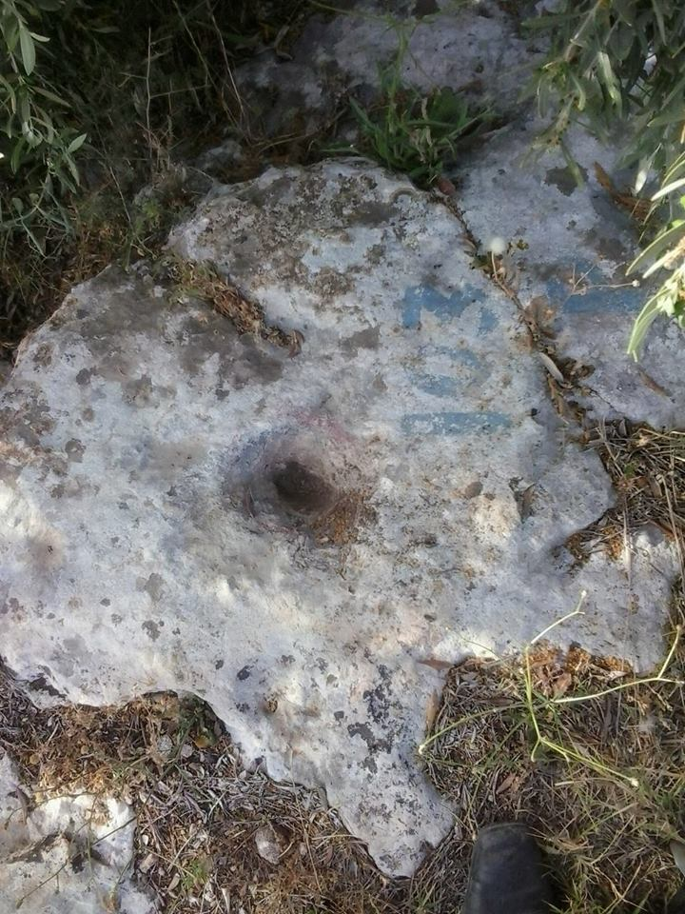

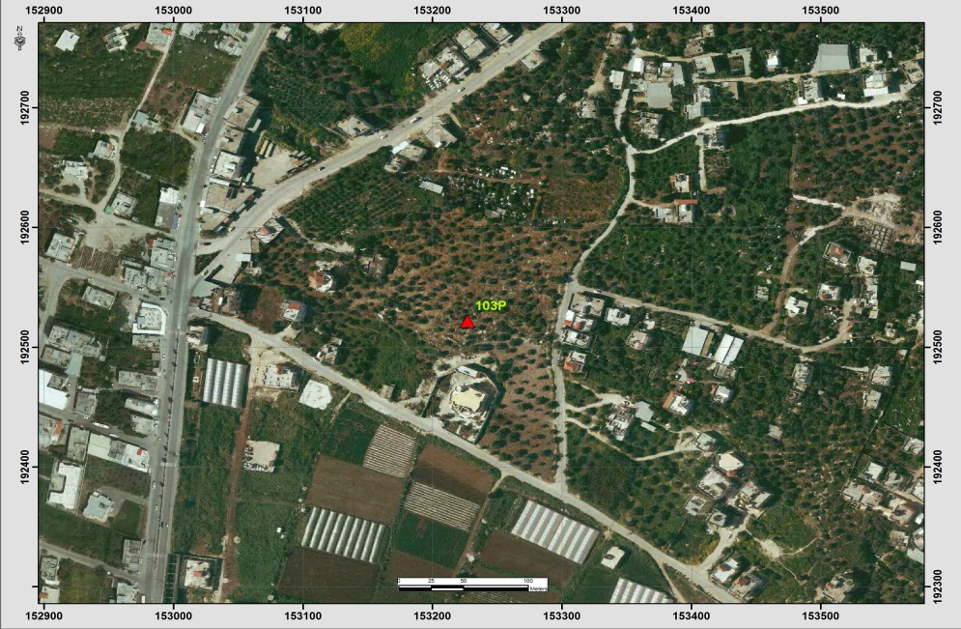

Table (5-7): Details of Trig (805S)
Date:- 21/8/2014 |  | Obs.Team:- Saleh natour, Abedalhafez almuhtaseb, Ala'a rjob, Samer Serhan
Point ID:- 805S |  | Instrument:- Leica Viva GS08
File Name:- Saleh VRS |  | Point Number:- 007
Obs.Time:- 11 : 38 : 00 |  | Accuracy:- 0.011 m
Coordinates | E | N | H
Registered | 160711.45 | 189707.65. | 319.55
Observe | 160711.22 | 189707.39 | 319.40
WGS1984 | 35° 6 ' 41.71596" E | 32° 18' 3.82533" N | 339.91
Description | This trig is located in the village of Kafr Al Labad on the rock
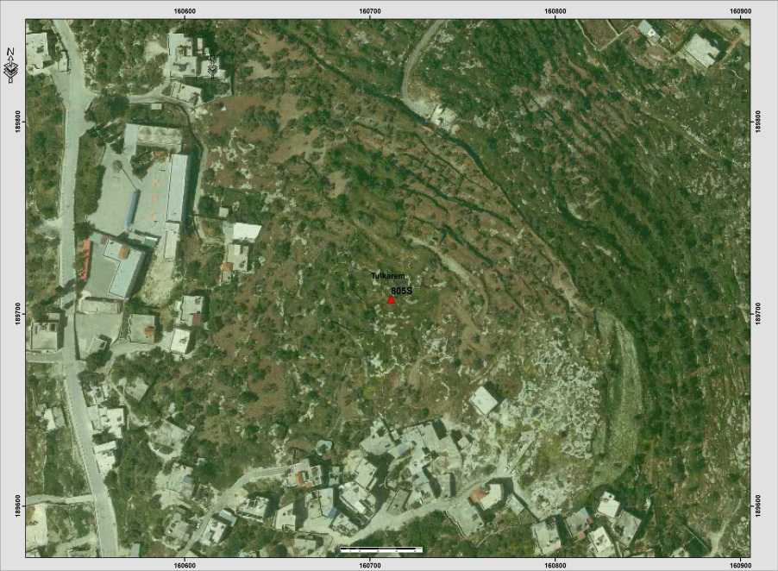

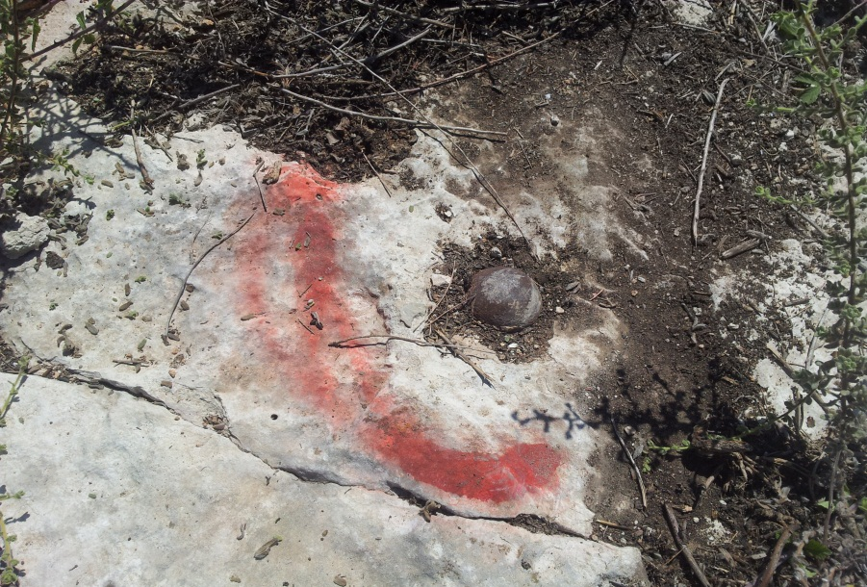
Table (5-8): Details of Trig (717T)
Date:- 2/5/2014 |  | Obs.Team:- Saleh natour, Abedalhafez almuhtaseb, Ala'a rjob, Samer Serhan
Point ID:- 717T |  | Instrument:- Leica 900
File Name:- Saleh VRS |  | Point Number:- 027
Obs.Time:- 16 : 27 : 58 |  | Accuracy:- 0.01 m
Coordinates | E | N | H
Registered | 167342.37 | 180965.21 | 480.48
Observe | 167342.04 | 180964.88 | 480.54
WGS1984 | 35° 10' 55.23534" E | 32° 13' 20.12599" N | 501.01
Description | This trig is located in the village of Jeet on the rock
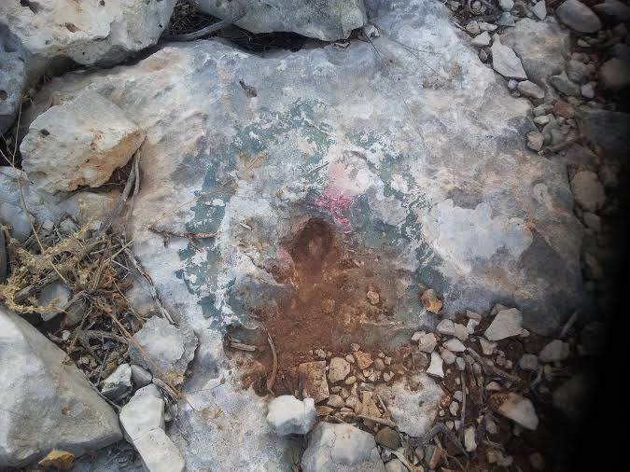
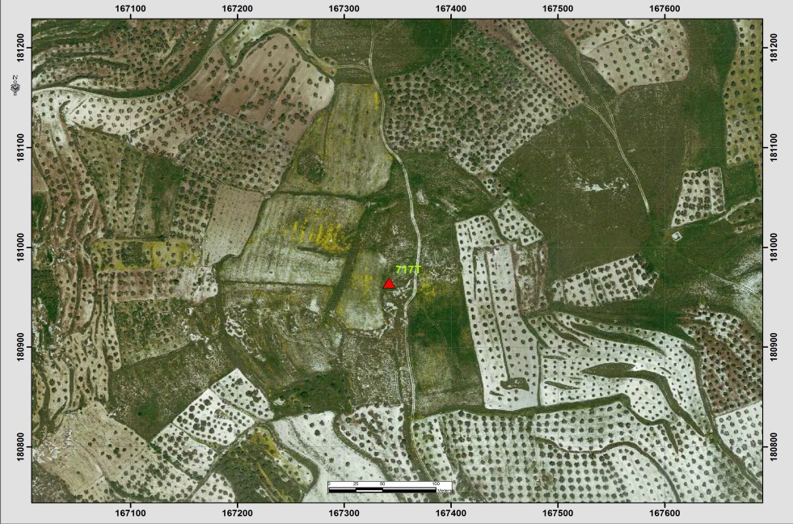
Table (5-9): Details of Trig (162F)
Date:- 2/5/2014 |  | Obs.Team:- Saleh natour, Abedalhafez almuhtaseb, Ala'a rjob, Samer Serhan
Point ID:- 162F |  | Instrument:- Leica 900
File Name:- Saleh VRS |  | Point Number:- 026
Obs.Time:- 16 : 03 : 22 |  | Accuracy:- 0.02 m
Coordinates | E | N | H
Registered | 160688.16 | 178393.60 | 412.10
Observe | 160687.45 | 178392.98 | 412.03
WGS1984 | 35° 06' 41.18190" E | 32° 11' 56.51568" N | 432.51
Description | This trig is located in the village of Baqa AL-hatab on the rock
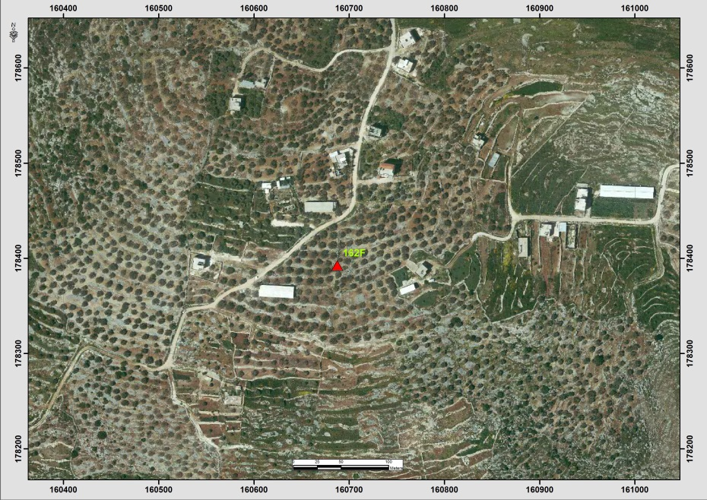

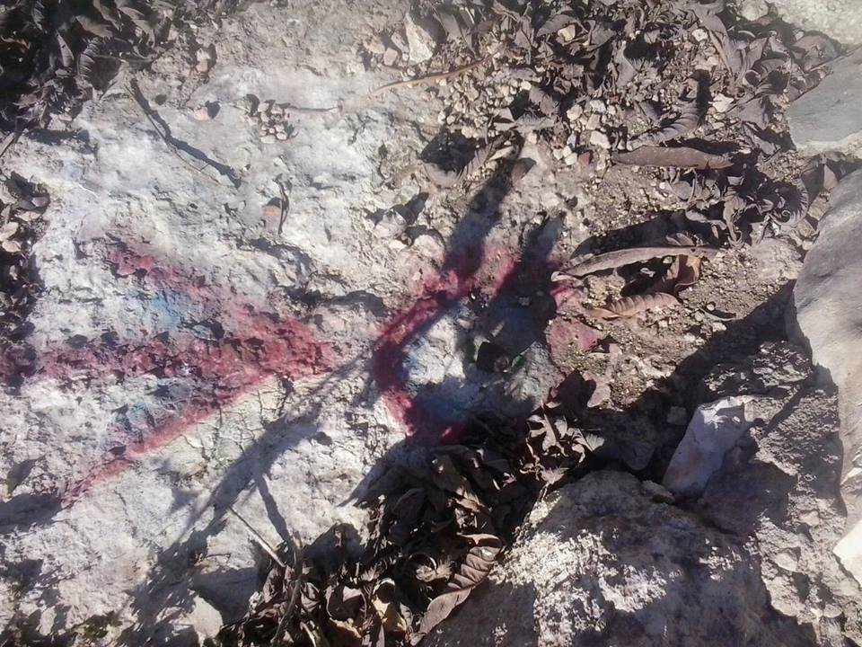
Table (5-10): Details of Trig (367X)
Date:- 2/5/2014 |  | Obs.Team:- Saleh natour, Abedalhafez almuhtaseb, Ala'a rjob, Samer Serhan
Point ID:- 367X |  | Instrument:- Leica 900
File Name:- Saleh VRS |  | Point Number:- 024
Obs.Time:- 15 : 09 : 30 |  | Accuracy:- 0.01 m
Coordinates | E | N | H
Registered | 155518.06 | 170527.23 | 234.39
Observe | 155517.97 | 170527.11 | 234.45
WGS1984 | 35° 03' 24.22248" E | 32° 07' 40.96853" N | 254.95
Description | This trig is located in the village of Senerya on the rock
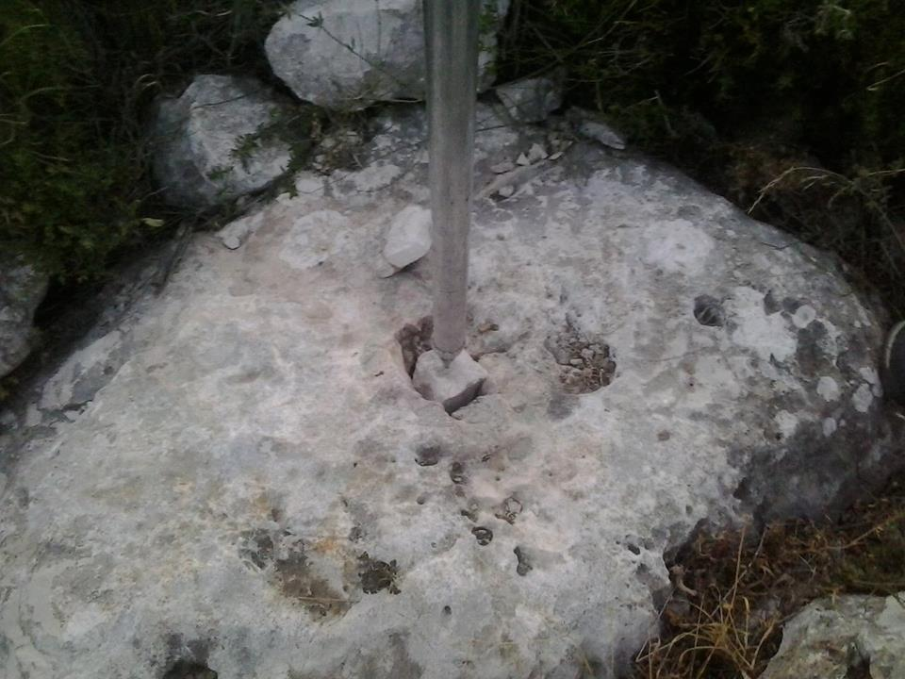
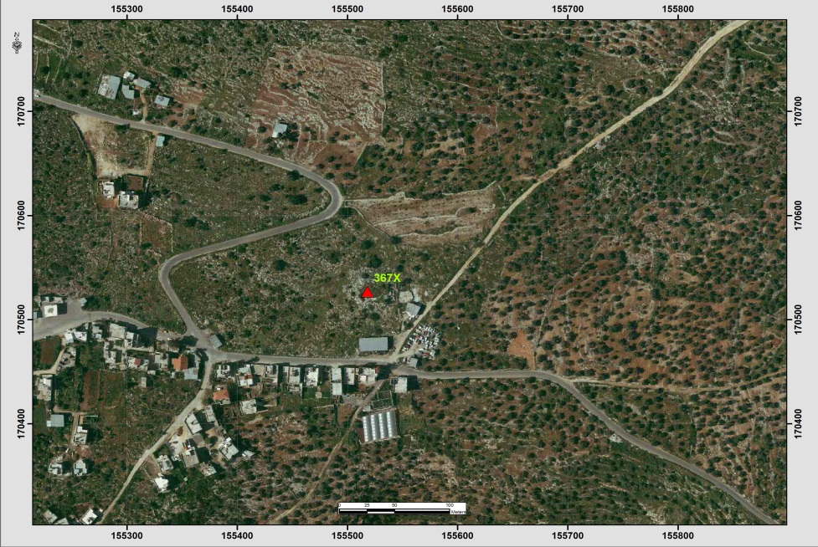
Table (5-11): Details of Trig (728T)
Date:- 2/5/2014 |  | Obs.Team:- Saleh natour, Abedalhafez almuhtaseb, Ala'a rjob, Samer Serhan
Point ID:- 728T |  | Instrument:- Leica 900
File Name:- Saleh VRS |  | Point Number:- 023
Obs.Time:- 14 : 54 : 10 |  | Accuracy:- 0.02 m
Coordinates | E | N | H
Registered | 152720.92 | 172117.77 | 203.80
Observe | 152720.82 | 172117.78 | 203.72
WGS1984 | 35° 01' 37.40965" E | 32° 08' 32.47135" N | 224.22
Description | This trig is located in the village of Bat Ameen on the rock
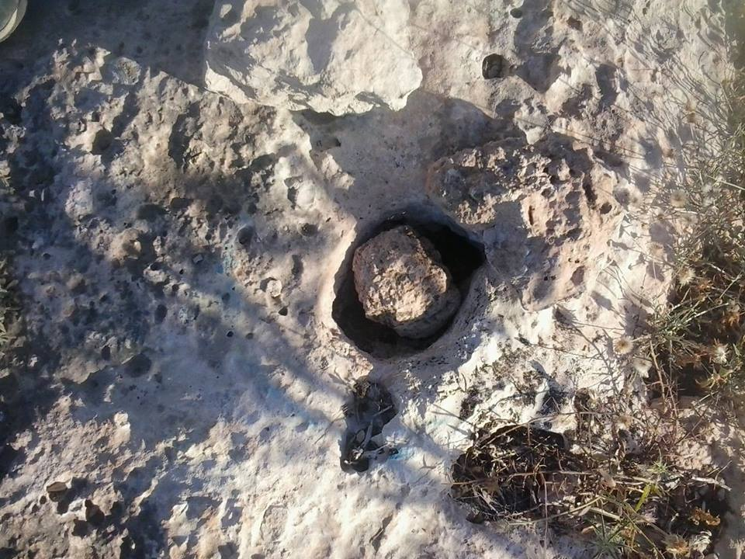
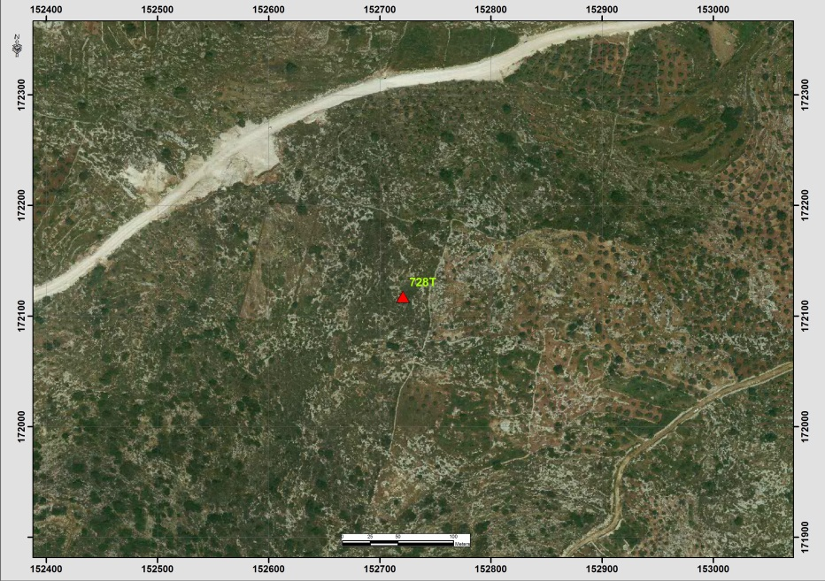
Table (5-12): Details of Trig (191E)
Date:- 2/5/2014 |  | Obs.Team:- Saleh natour, Abedalhafez almuhtaseb, Ala'a rjob, Samer Serhan
Point ID:- 191E |  | Instrument:- Leica 900
File Name:- Saleh VRS |  | Point Number:- 022
Obs.Time:- 14 : 35 : 52 |  | Accuracy:- 0.02 m
Coordinates | E | N | H
Registered | 150347.36 | 173830.56 | 173.20
Observe | 150347.40 | 173830.62 | 173.16
WGS1984 | 35° 00' 06.72506" E | 32° 09' 27.94125" N | 193.68
Description | This trig is located in the village of Ras Atya on the rock
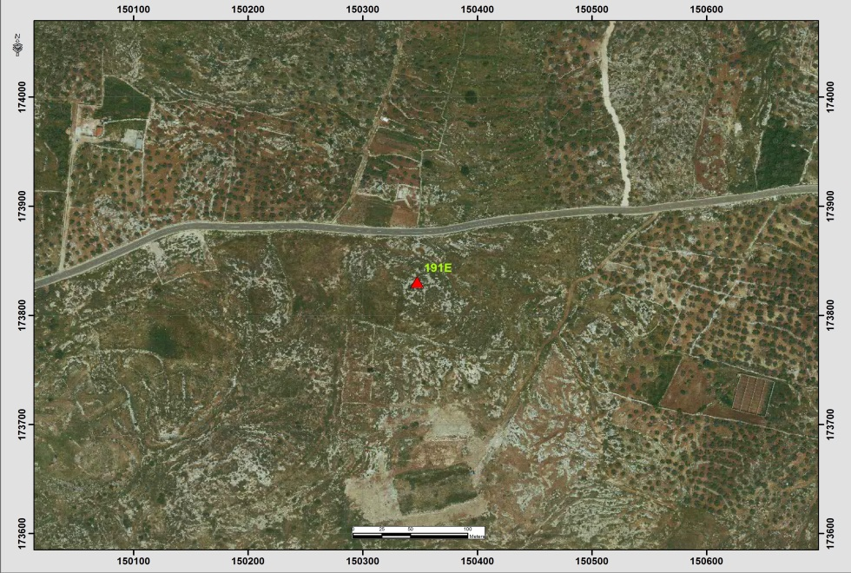
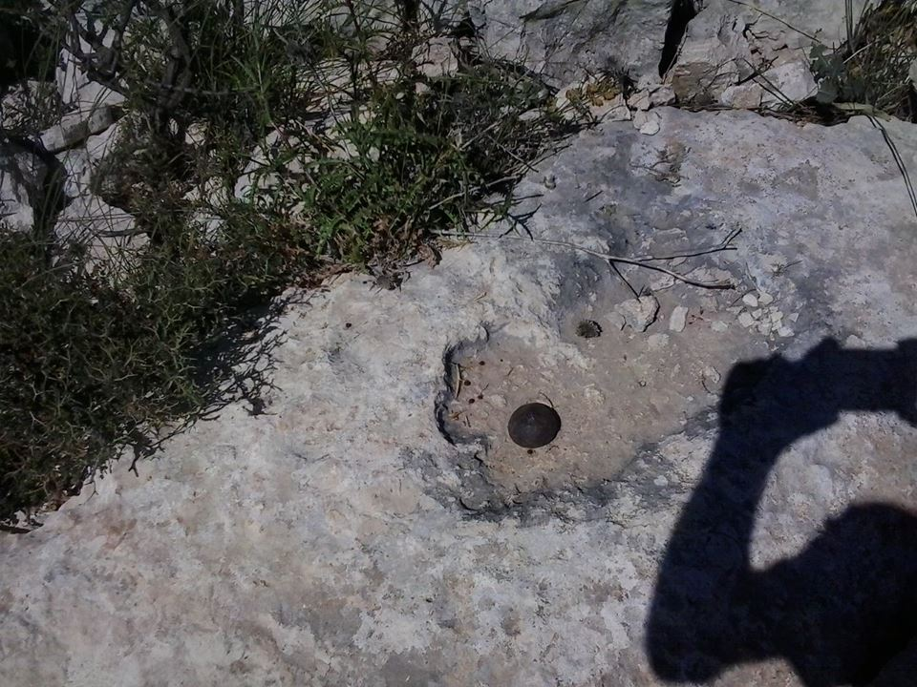
Table (5-13): Details of Trig (21F)
Date:- 2/5/2014 |  | Obs.Team:- Saleh natour, Abedalhafez almuhtaseb, Ala'a rjob, Samer Serhan
Point ID:- 21F |  | Instrument:- Leica 900
File Name:- Saleh VRS |  | Point Number:- 020
Obs.Time:- 14 : 19 : 56 |  | Accuracy:- 0.03 m
Coordinates | E | N | H
Registered | 147550.43 | 176307.09 | 73.55
Observe | 147550.28 | 176307.14 | 73.49
WGS1984 | 34° 58' 19.77452" E | 32° 10' 48.15557" N | 94.03
Description | This trig is located in Qalqelya on the rock
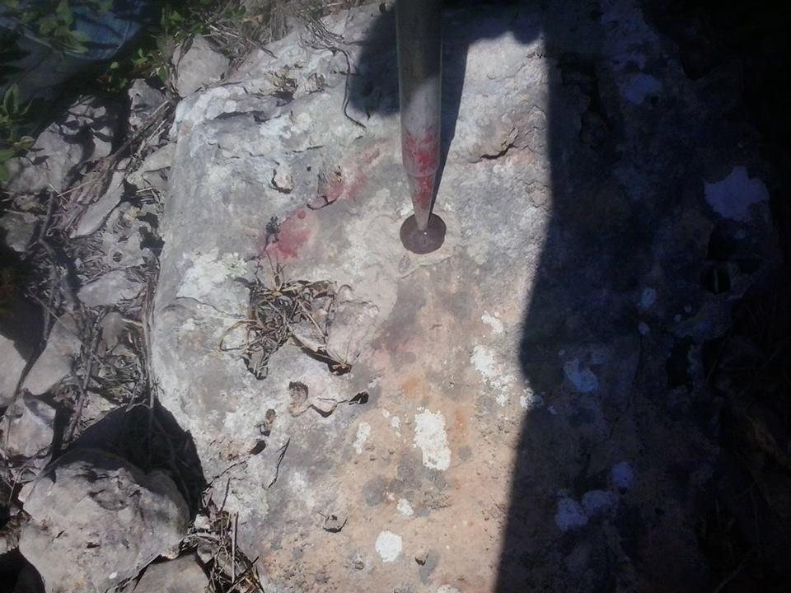
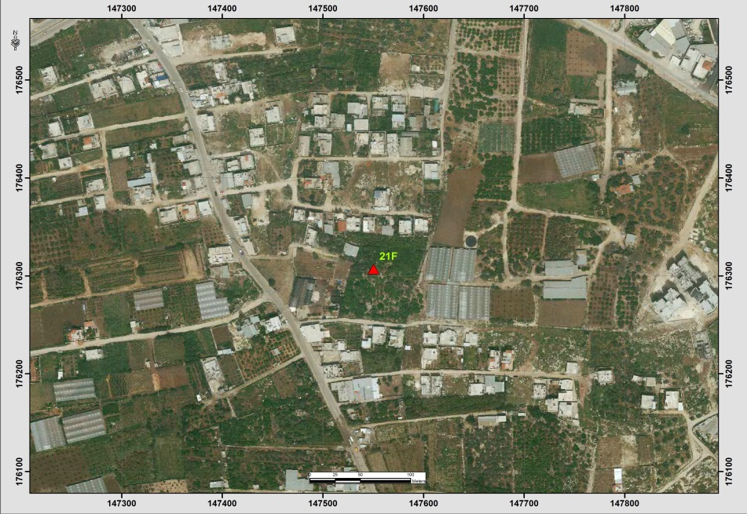
Table (5-14): Details of Trig (4E)
Date:- 2/5/2014 |  | Obs.Team:- Saleh natour, Abedalhafez almuhtaseb, Ala'a rjob, Samer Serhan
Point ID:- 4E |  | Instrument:- Leica 900
File Name:- Saleh VRS |  | Point Number:- 019
Obs.Time:- 14 : 04 : 59 |  | Accuracy:- 0.02 m
Coordinates | E | N | H
Registered | 149095.62 | 177710.29 | 116.49
Observe | 149095.64 | 177710.43 | 116.52
WGS1984 | 34° 59' 18.65699" E | 32° 11' 33.81648" N | 137.05
Description | This trig is located in Qalqelya on the rock
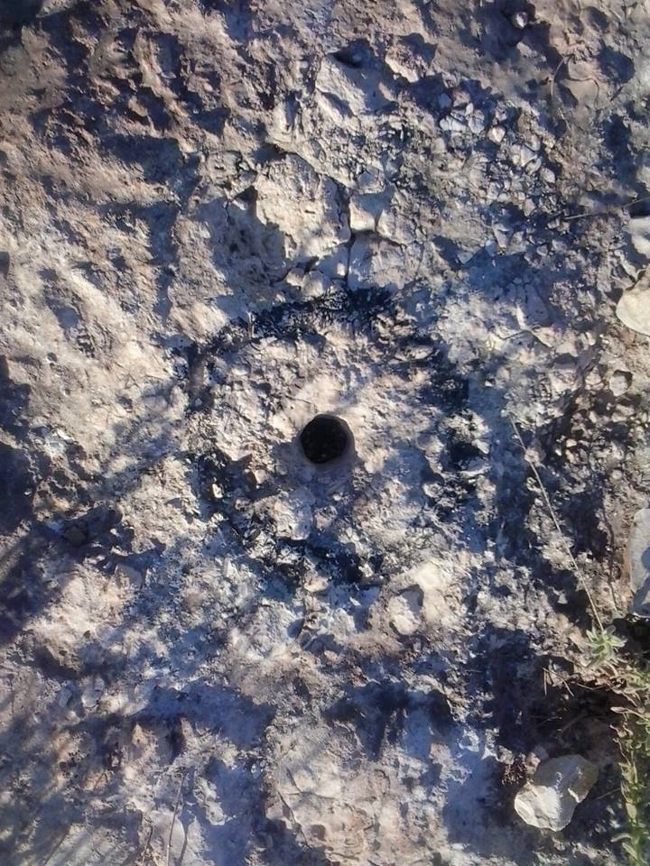
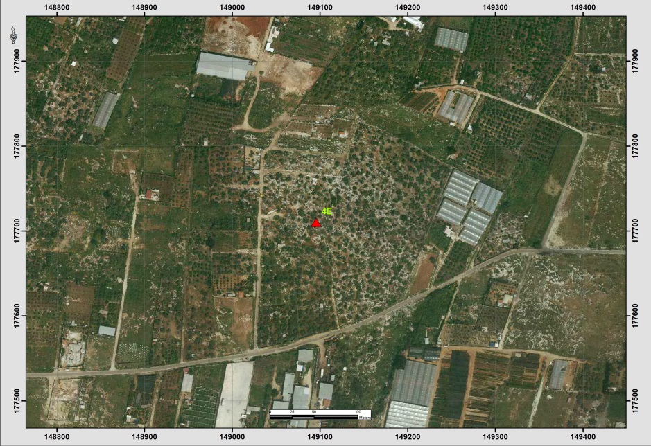

Table (5-15): Details of Trig (722T)
Date:- 2/5/2014 |  | Obs.Team:- Saleh natour, Abedalhafez almuhtaseb, Ala'a rjob, Samer Serhan
Point ID:- 722T |  | Instrument:- Leica 900
File Name:- Saleh VRS |  | Point Number:- 018
Obs.Time:- 13 : 49 : 05 |  | Accuracy:- 0.02 m
Coordinates | E | N | H
Registered | 153639.08 | 176230.31 | 252.33
Observe | 153639.03 | 176230.17 | 252.29
WGS1984 | 35° 02' 12.20067" E | 32° 10' 46.02441" N | 272.8
Description | This trig is located in the village of Ezbet AL-Tabeeb on the rock
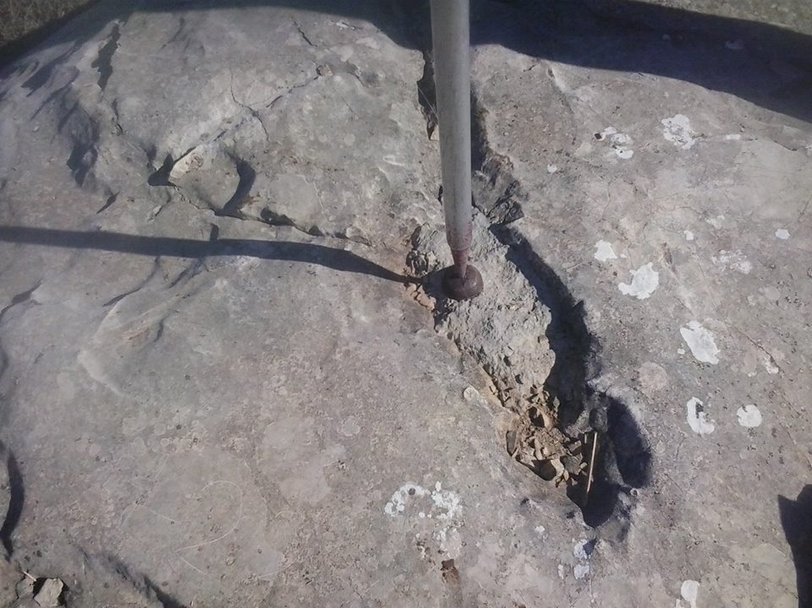
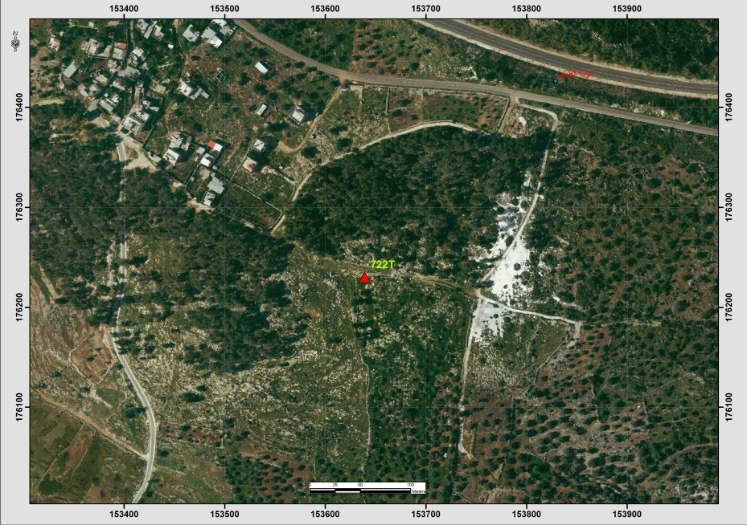
Table (5-16): Details of Trig (870P)
Date:- 2/5/2014 |  | Obs.Team:- Saleh natour, Abedalhafez almuhtaseb, Ala'a rjob, Samer Serhan
Point ID:- 870P |  | Instrument:- Leica 900
File Name:- Saleh VRS |  | Point Number:- 017
Obs.Time:- 13 : 29 : 54 |  | Accuracy:- 0.02 m
Coordinates | E | N | H
Registered | 156276.64 | 176536.64 | 276.00
Observe | 156276.59 | 176536.64 | 275.98
WGS1984 | 35° 03' 52.86639" E | 32° 10' 56.09613" N | 296.49
Description | This trig is located in the village of Azoon on the rock
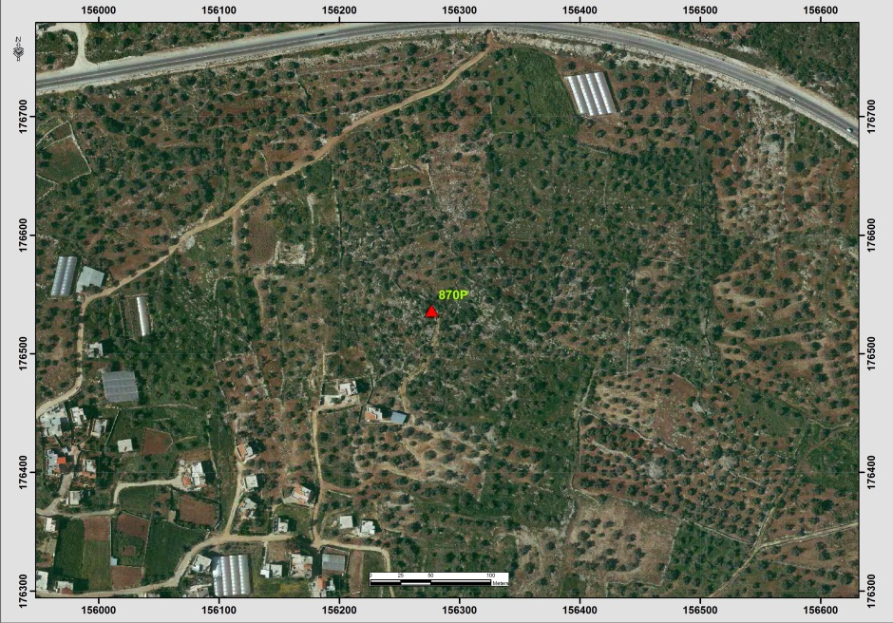
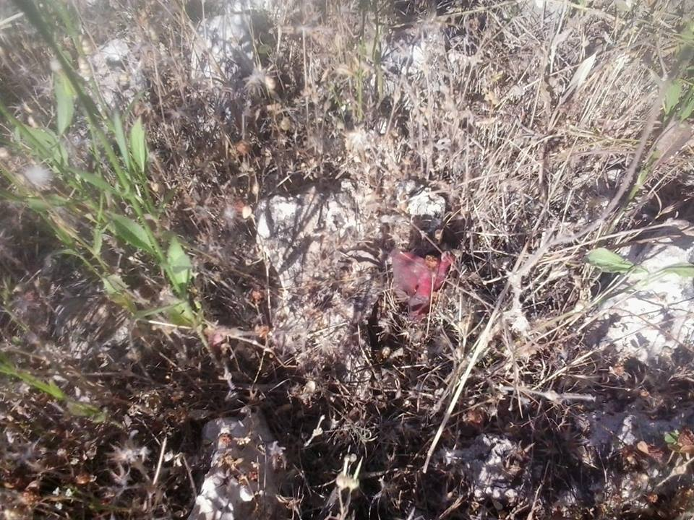

Table (5-17): Details of Trig (821P)
Date:- 2/5/2014 |  | Obs.Team:- Saleh natour, Abedalhafez almuhtaseb, Ala'a rjob, Samer Serhan
Point ID:- 821P |  | Instrument:- Leica 900
File Name:- Saleh VRS |  | Point Number:- 016
Obs.Time:- 13 : 16 : 26 |  | Accuracy:- 0.02 m
Coordinates | E | N | H
Registered | 154797.24 | 177543.27 | 255.53
Observe | 154797.40 | 177543.00 | 255.72
WGS1984 | 35° 02' 56.34554" E | 32° 11' 28.70065" N | 276.23
Description | This trig is located in the village of Azoon on the rock
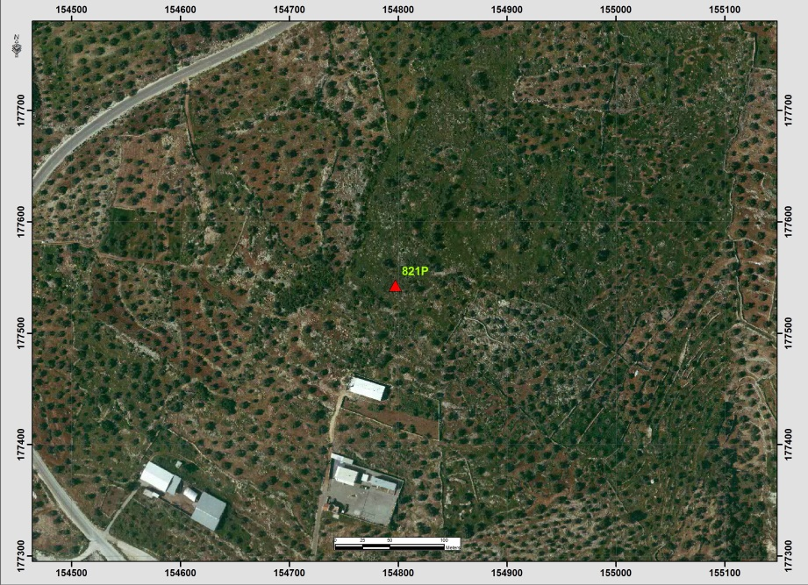

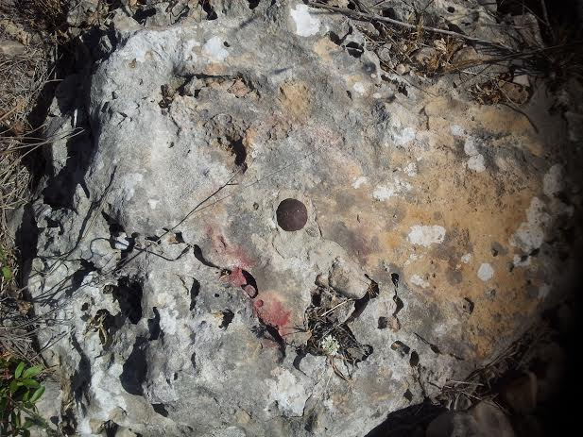
Table (5-18): Details of Trig (236B)
Date:- 2/5/2014 |  | Obs.Team:- Saleh natour, Abedalhafez almuhtaseb, Ala'a rjob, Samer Serhan
Point ID:- 236B |  | Instrument:- Leica 900
File Name:- Saleh VRS |  | Point Number:- 015
Obs.Time:- 12 : 56 : 40 |  | Accuracy:- 0.02 m
Coordinates | E | N | H
Registered | 156596.20 | 177579.47 | 316.49
Observe | 156596.26 | 177579.19 | 316.44
WGS1984 | 35° 04' 05.01872" E | 32° 11' 29.95476" N | 336.95
Description | This trig is located in the village of Seer on the rock
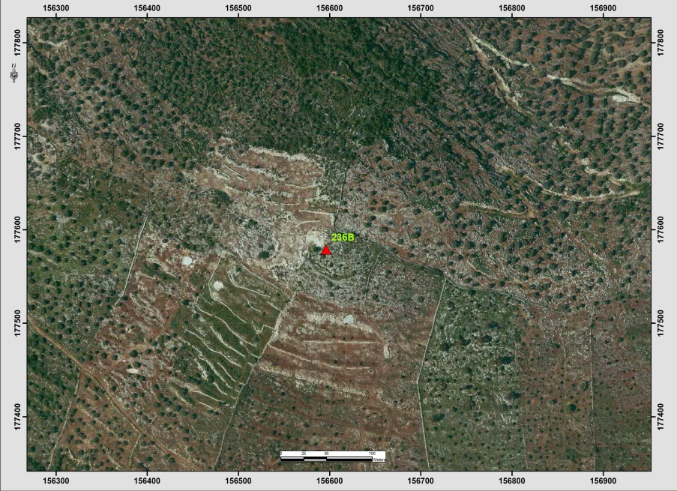
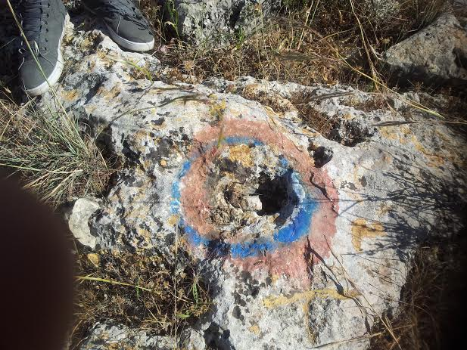
Table (5-19): Details of Trig (803R)
Date:- 2/5/2014 |  | Obs.Team:- Saleh natour, Abedalhafez almuhtaseb, Ala'a rjob, Samer Serhan
Point ID:- 803R |  | Instrument:- Leica 900
File Name:- Saleh VRS |  | Point Number:- 013
Obs.Time:- 12 : 23 : 53 |  | Accuracy:- 0.03 m
Coordinates | E | N | H
Registered | 153118.58 | 181710.14 | 156.05
Observe | 153118.71 | 181709.99 | 156.14
WGS1984 | 35° 01' 52.00159" E | 32° 13' 43.89428" N | 176.67
Description | This trig is located in the village of Falamya on the rock
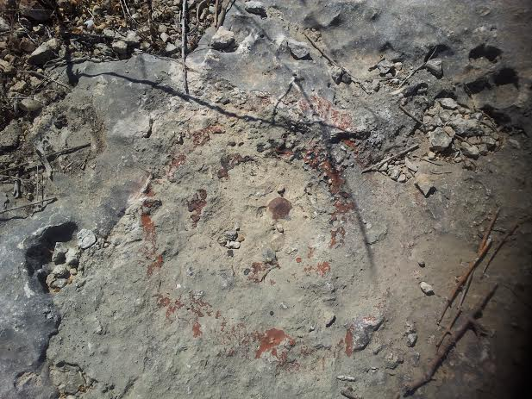
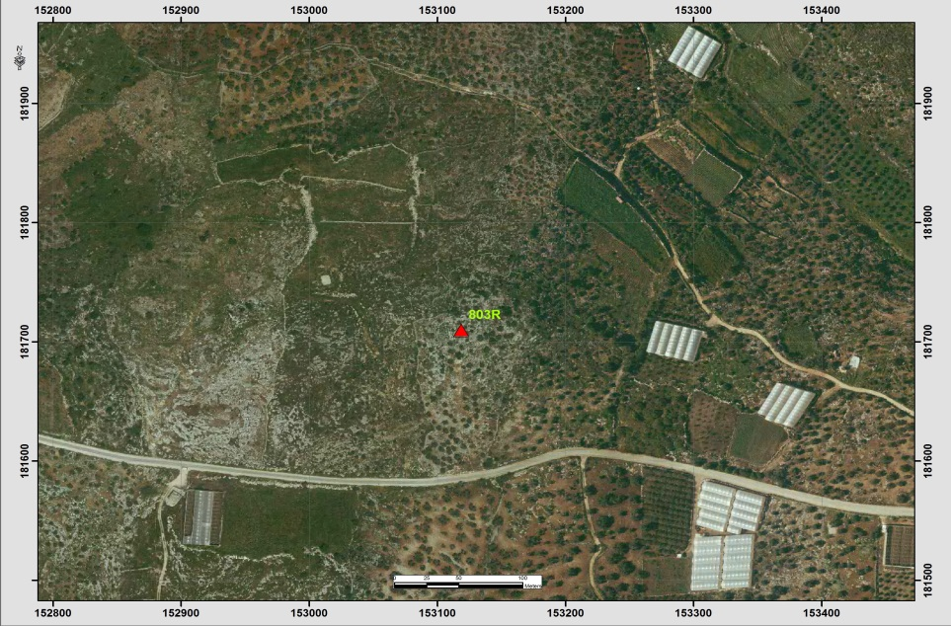

Table (5-20): Details of Trig (816S)
Date:- 2/5/2014 |  | Obs.Team:- Saleh natour, Abedalhafez almuhtaseb, Ala'a rjob, Samer Serhan
Point ID:- 816S |  | Instrument:- Leica 900
File Name:- Saleh VRS |  | Point Number:- 011
Obs.Time:- 12 : 02 : 49 |  | Accuracy:- 0.01 m
Coordinates | E | N | H
Registered | 159351.59 | 182755.56 | 389.22
Observe | 159351.53 | 182755.44 | 389.17
WGS1984 | 35° 05' 50.00996" E | 32° 14' 18.09803" N | 409.68
Description | This trig is located in the village of Jyous on the rock
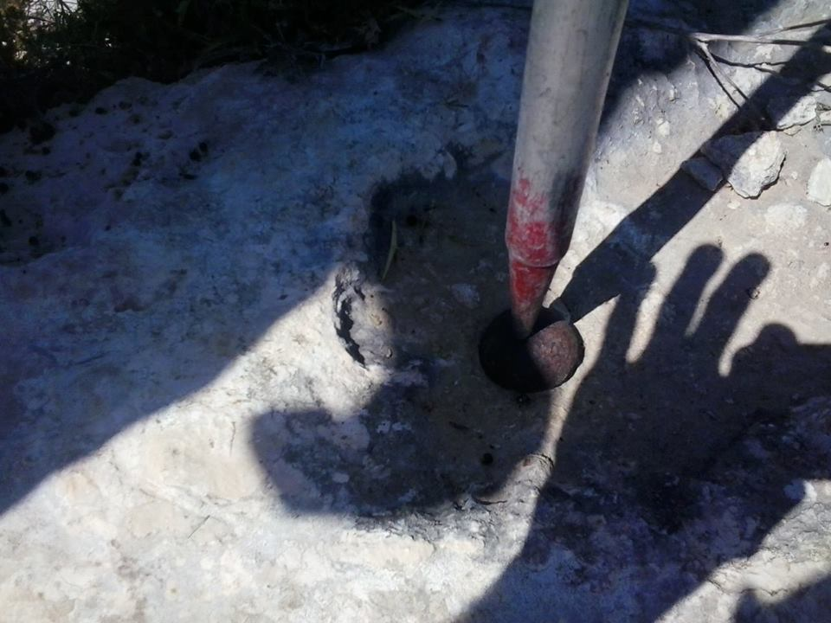
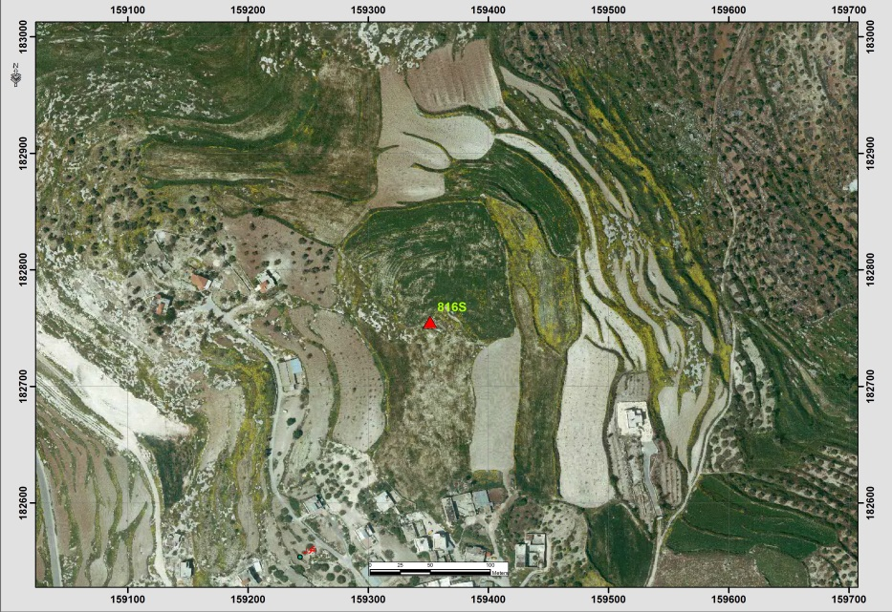

Table (5-21): Details of Trig (815S)
Date:- 2/5/2014 |  | Obs.Team:- Saleh natour, Abedalhafez almuhtaseb, Ala'a rjob, Samer Serhan
Point ID:- 815S |  | Instrument:- Leica 900
File Name:- Saleh VRS |  | Point Number:- 008
Obs.Time:- 11 : 38 : 46 |  | Accuracy:- 0.01 m
Coordinates | E | N | H
Registered | 158978.45 | 183966.59 | 318.61
Observe | 158978.29 | 183966.49 | 318.72
WGS1984 | 35° 05' 35.70547" E | 32° 14' 57.40085" N | 339.23
Description | This trig is located in the village of Jyous on the rock
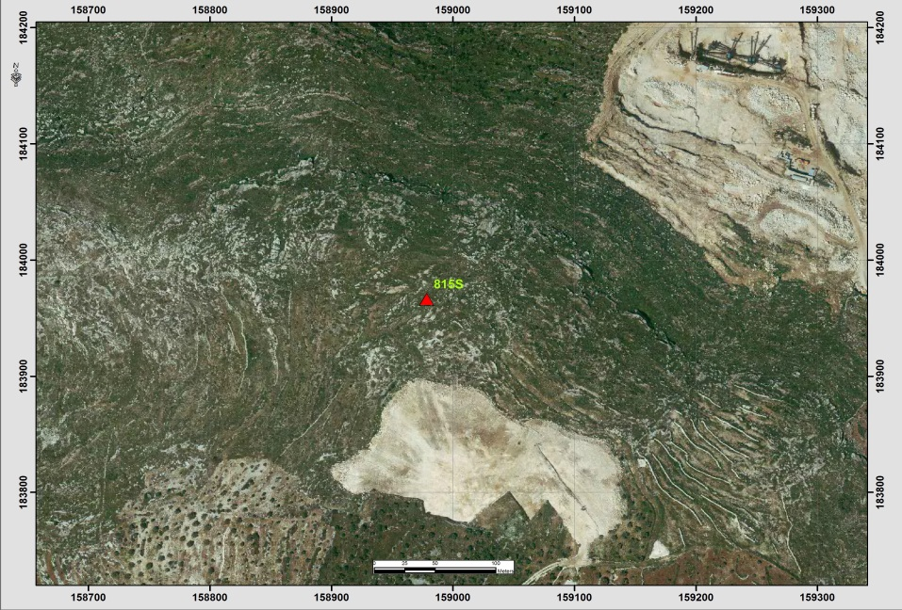

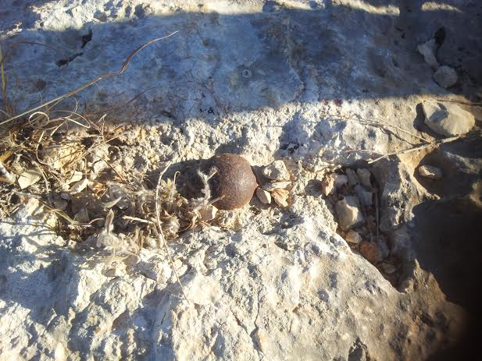
Table (5-22): Details of Trig (796S)
Date:- 1/5/2014 |  | Obs.Team:- Saleh natour, Abedalhafez almuhtaseb, Ala'a rjob, Samer Serhan
Point ID:- 796S |  | Instrument:- Leica 900
File Name:- Saleh VRS |  | Point Number:- 005
Obs.Time:- 16 : 32 : 03 |  | Accuracy:- 0.02 m
Coordinates | E | N | H
Registered | 159177.69 | 192258.98 | 323.54
Observe | 159177.15 | 192259.41 | 323.62
WGS1984 | 35° 05' 42.97984" E | 32° 19' 26.62575" N | 344.15
Description | This trig is located in the village of Balaa on the rock
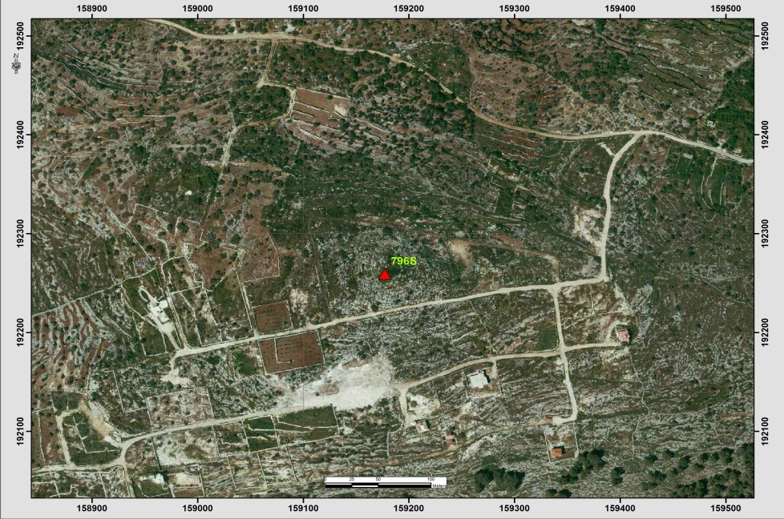
Table (5-23): Details of Trig (493D)
Date:- 1/5/2014 |  | Obs.Team:- Saleh natour, Abedalhafez almuhtaseb, Ala'a rjob, Samer Serhan
Point ID:- 493D |  | Instrument:- Leica 900
File Name:- Saleh VRS |  | Point Number:- 001
Obs.Time:- 12 : 59 : 32 |  | Accuracy:- 0.01 m
Coordinates | E | N | H
Registered | 155624.81 | 199032.28 | 103.51
Observe | 155625.26 | 199034.05 | 101.49
WGS1984 | 35° 03' 26.82601" E | 32° 23' 06.41448" N | 122.05
Description | This trig is located in the village of Zaita on the rock
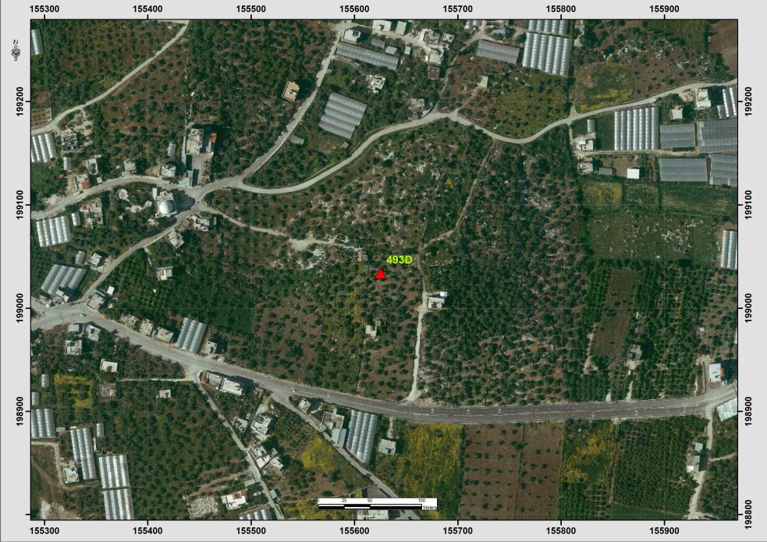
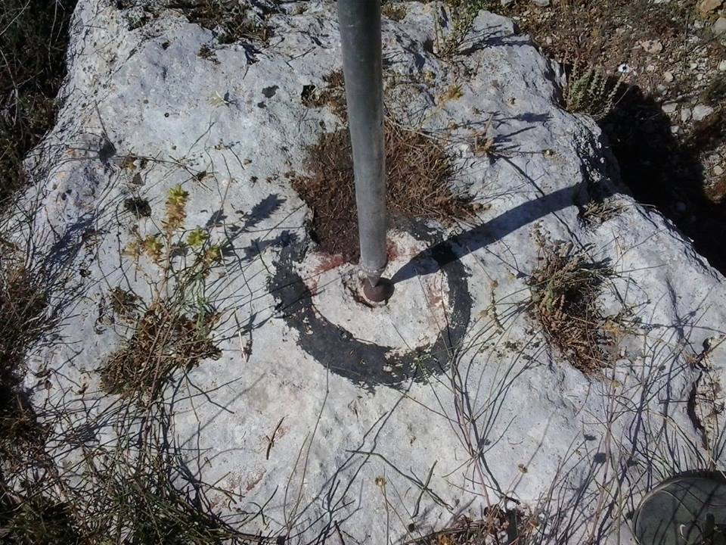
Table (5.24) also shows the information about points’ names and coordinates also it provides the location of the point according to the nearest town or city (Hebron).
Table (5-24): Selected network points (Registered)
Point(name) | Easting(m) | Northing(m) | Elevation(m) | Location
585B | 160773.39 | 91851.11 | 794.29 | Yatta
569B | 157249.15 | 94224.60 | 810.69 | Yatta
565B | 156086.70 | 95234.67 | 774.12 | Yatta
564B | 156716.18 | 95937.00 | 774.24 | Yatta
537T | 166776.27 | 103869.46 | 942.61 | Bani Naeem
394F | 148752.64 | 108279.93 | 805.21 | Ithna
344N | 152271.78 | 108643.28 | 614.98 | Trqwmya
336N | 157079.28 | 117367.82 | 638.89 | Soureef
570T | 156096.76 | 117739.33 | 588.94 | Soureef
552B | 155580.17 | 101424.37 | 913.81 | Dura (Sinjer)
356N | 155722.87 | 107271.25 | 875.47 | Hebron (Looza)
441F | 142397.9 | 91081.11 | 643.29 | Aldahriyeh(Ramadeen)
520T | 157133.47 | 113959.94 | 849.42 | Halhoul (Jala)
351N | 150135.28 | 103756.06 | 730.17 | Dura(Homsa)
597B | 160474.73 | 100867.46 | 902.79 | Hebron(Qilqis mt.)
373N | 155409.64 | 96442.86 | 739.5 | Yatta (beit Emra)
347N | 152144.28 | 110606.8 | 567.75 | Beit Oula
705P | 148918.70 | 92762.38 | 669.29 | Aldahriyeh
402N | 158738.85 | 87520.78 | 796.08 | Alsamoua'
437N | 169288.70 | 107612.62 | 824.20 | ALshyoukh(Wad AL-reem)

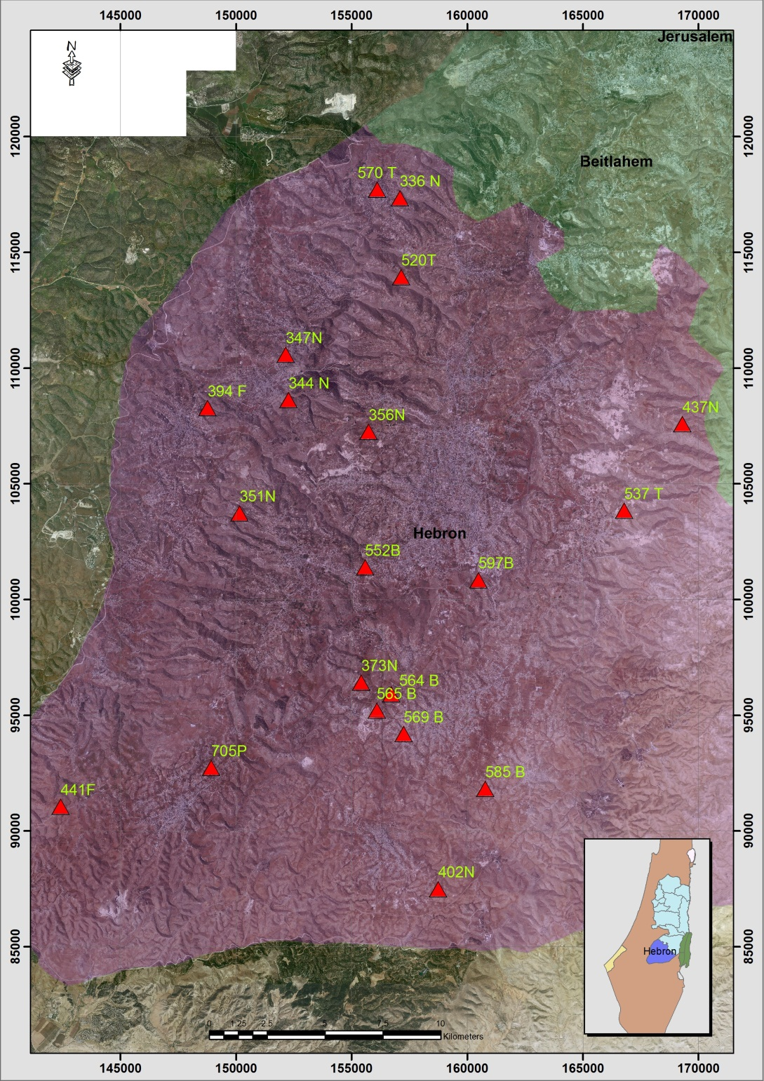
Figure (5-4): distribution of points within study area in Hebron district.
Table (5-25): Details of Trig (585B)
Date:- 12/3/2014 |  | Obs.Team:- Saleh natour, Abedalhafez almuhtaseb, Ala'a rjob, Samer Serhan
Point ID:- 585B |  | Instrument:- Trimble R8
File Name:- Banan |  | Point Number:- 001
Obs.Time:- 12 : 49 : 52 |  | Accuracy:- 0.02 m
Coordinates | E | N | H
Registered | 160773.39 | 91851.11 | 794.29
Observe | 160773.55 | 91851.66 | 794.37
WGS1984 | 35° 06' 47.23873" E | 31° 25' 06.85521" N | 813.313
Description | This trig is located in the village of Yatta on the rock
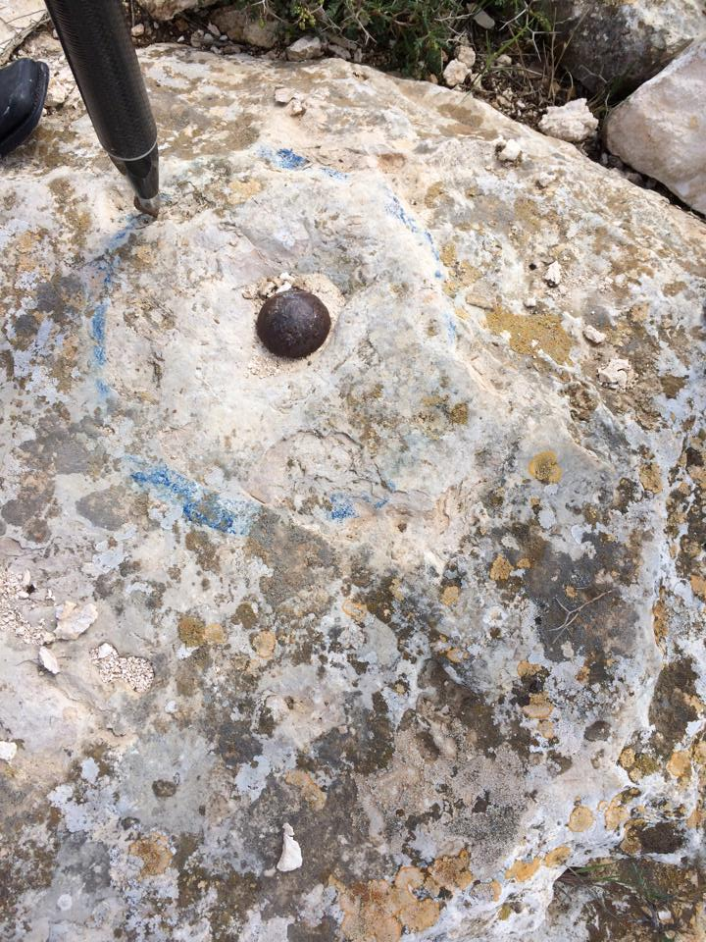

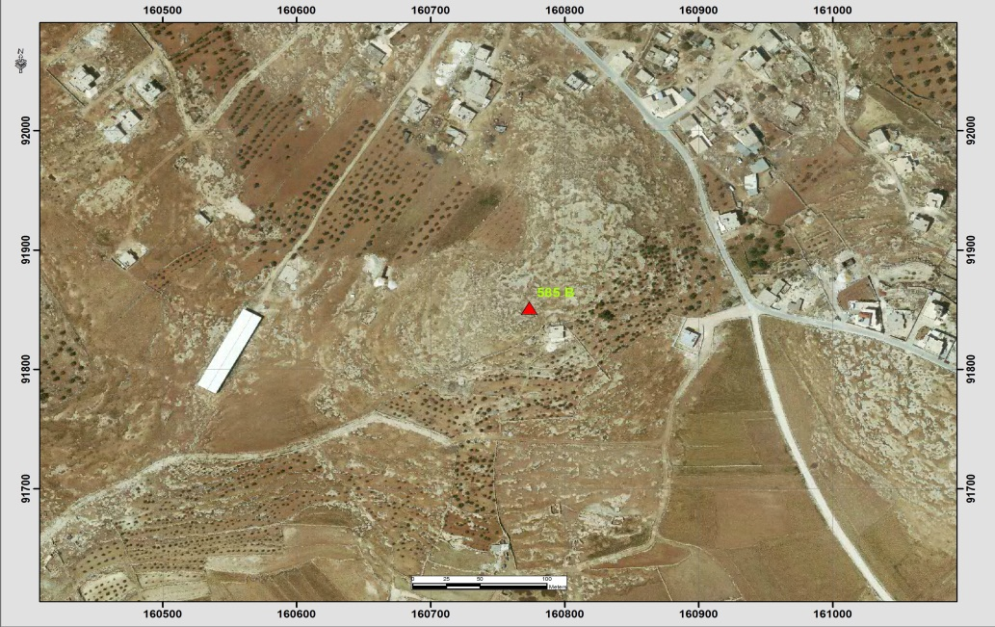
Table (5-26): Details of Trig (569B)
Date:- 12/3/2014 |  | Obs.Team:- Saleh natour, Abedalhafez almuhtaseb, Ala'a rjob, Samer Serhan
Point ID:- 569B |  | Instrument:- Trimble R8
File Name:- Banan |  | Point Number:- 002
Obs.Time:- 13 : 20 : 31 |  | Accuracy:- 0.02 m
Coordinates | E | N | H
Registered | 157249.15 | 94224.60 | 810.69
Observe | 157249.17 | 94224.41 | 810.53
WGS1984 | 35° 04' 33.69938" E | 31° 26' 23.77949" N | 829.664
Description | This trig is located in the village of Yatta on the rock
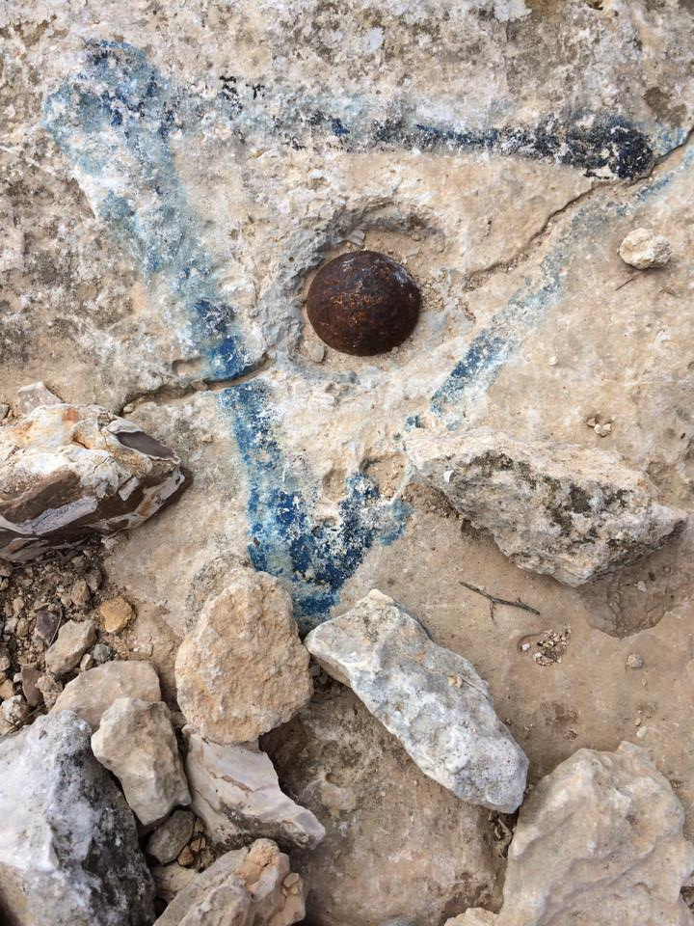

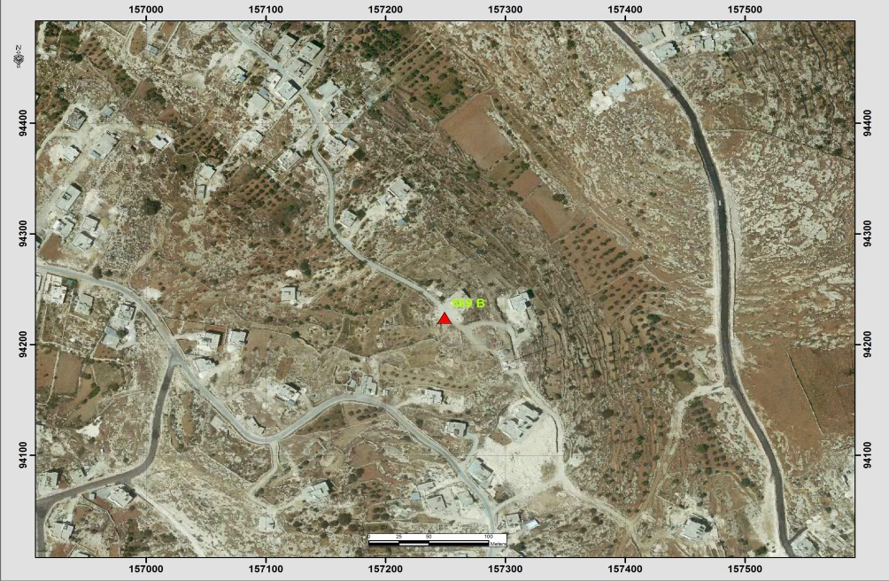
Table (5-27): Details of Trig (565B)
Date:- 12/3/2014 |  | Obs.Team:- Saleh natour, Abedalhafez almuhtaseb, Ala'a rjob, Samer Serhan
Point ID:- 565B |  | Instrument:- Trimble R8
File Name:- Banan |  | Point Number:- 003
Obs.Time:- 13 : 42 : 45 |  | Accuracy:- 0.02 m
Coordinates | E | N | H
Registered | 156086.70 | 95234.67 | 774.12
Observe | 156086.89 | 95235.00 | 773.88
WGS1984 | 35° 03' 49.63568" E | 31° 26' 56.54489" N | 793.07
Description | This trig is located in the village of Yatta on the rock
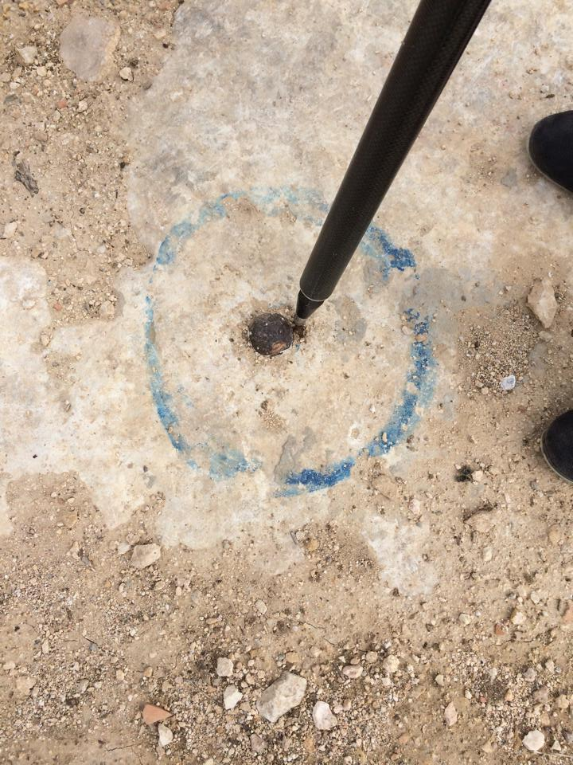
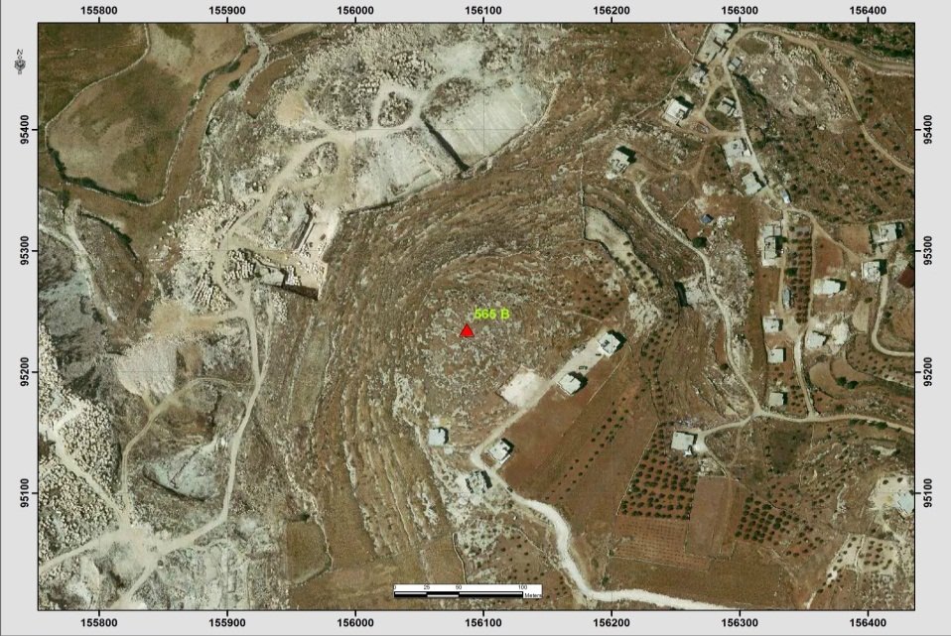
Table (5-28): Details of Trig (564B)
Date:- 12/3/2014 |  | Obs.Team:- Saleh natour, Abedalhafez almuhtaseb, Ala'a rjob, Samer Serhan
Point ID:- 564B |  | Instrument:- Trimble R8
File Name:- Banan |  | Point Number:- 004
Obs.Time:- 13 : 55 : 39 |  | Accuracy:- 0.02 m
Coordinates | E | N | H
Registered | 156716.18 | 95937.00 | 774.24
Observe | 156716.45 | 95937.29 | 773.99
WGS1984 | 35° 04' 13.44649" E | 31° 27' 19.37238" N | 793.202
Description | This trig is located in the village of Yatta on the rock
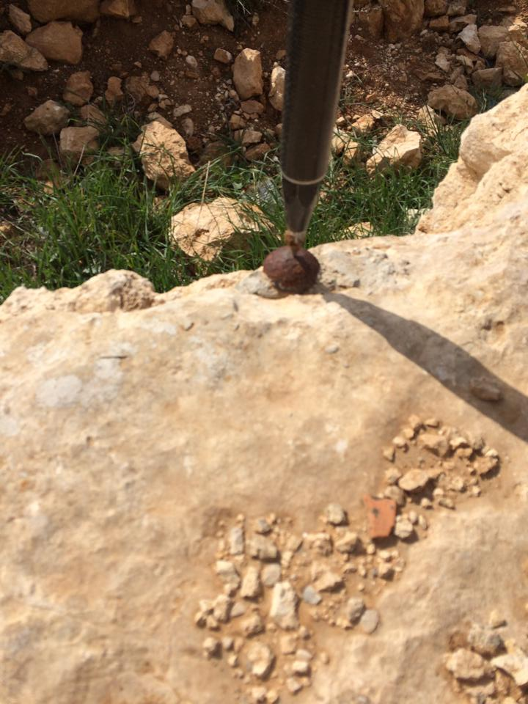
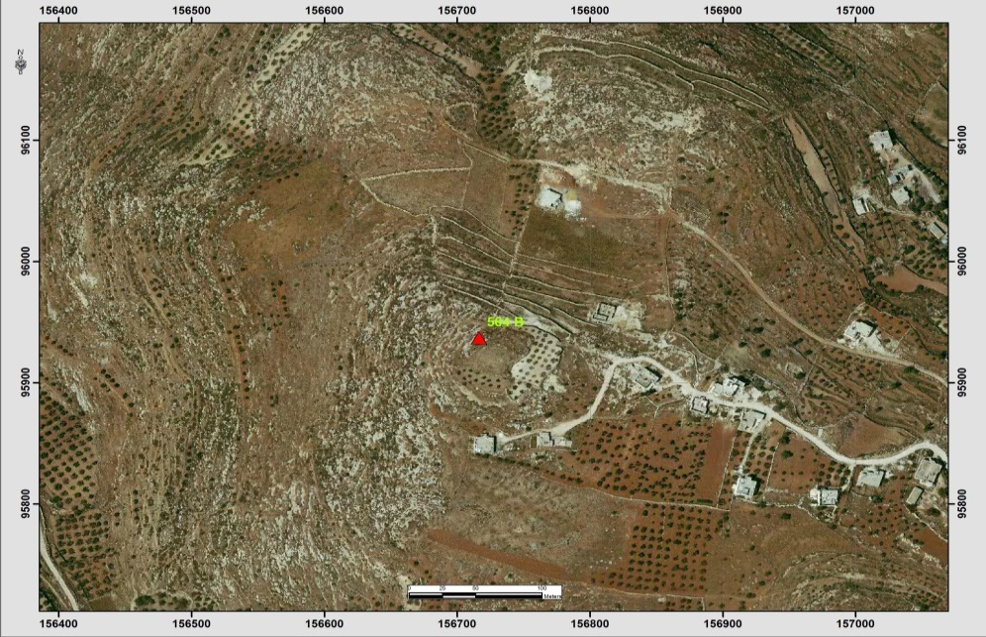
Table (5-29): Details of Trig (537T)
Date:- 30/3/2014 |  | Obs.Team:- Saleh natour, Abedalhafez almuhtaseb, Ala'a rjob, Samer Serhan
Point ID:- 537T |  | Instrument:- Trimble R8
File Name:- Banan |  | Point Number:- 005
Obs.Time:- 14 : 11 : 18 |  | Accuracy:- 0.02 m
Coordinates | E | N | H
Registered | 166776.27 | 103869.46 | 942.61
Observe | 166776.34 | 103869.94 | 942.72
WGS1984 | 35° 10' 34.39121" E | 31° 31' 37.16903" N | 961.906
Description | This trig is located in the village of Bani Naeem on the rock
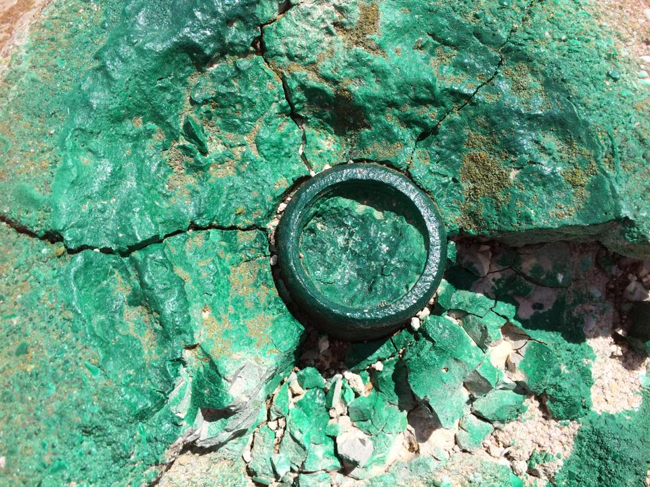
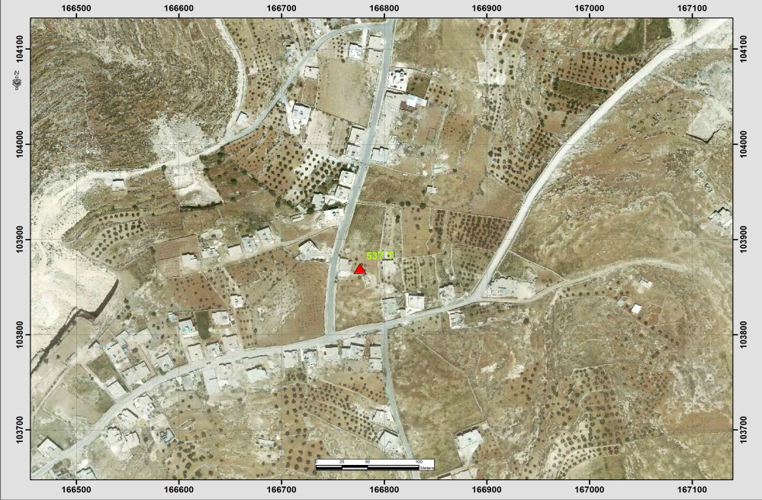
Table (5-30): Details of Trig (394F)
Date:- 30/3/2014 |  | Obs.Team:- Saleh natour, Abedalhafez almuhtaseb, Ala'a rjob, Samer Serhan
Point ID:- 394F |  | Instrument:- Trimble R8
File Name:- Banan |  | Point Number:- 006
Obs.Time:- 14 : 49 : 32 |  | Accuracy:- 0.02 m
Coordinates | E | N | H
Registered | 148752.64 | 108302.93 | 805.21
Observe | 148751.75 | 108302.31 | 506.60
WGS1984 | 34° 59'10.85108" E | 31° 34' 00.41847" N | 525.871
Description | This trig is located in the village of Ithna on the rock
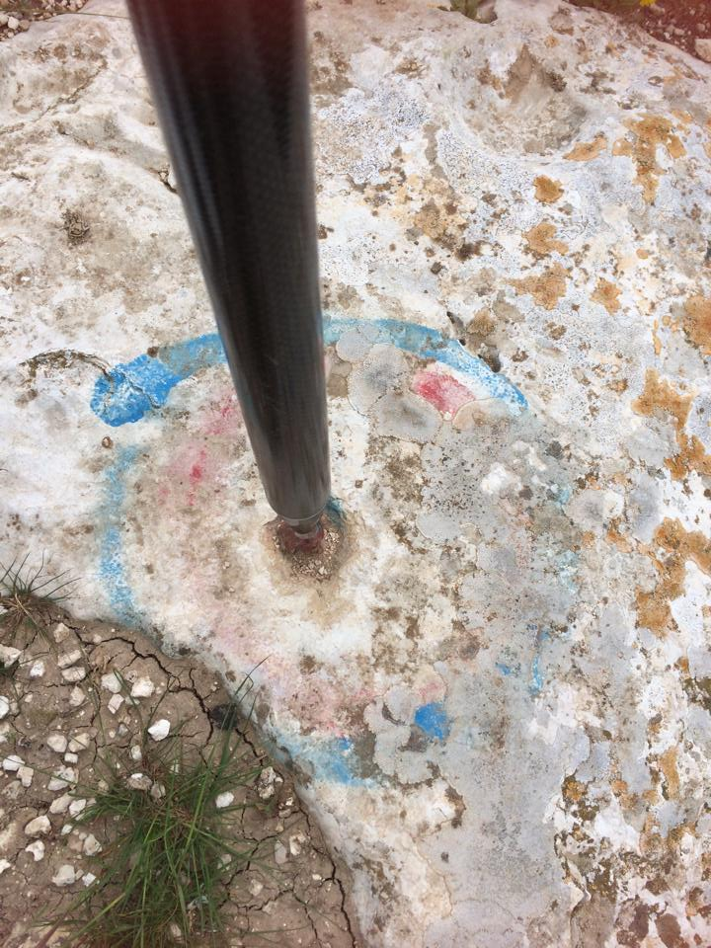
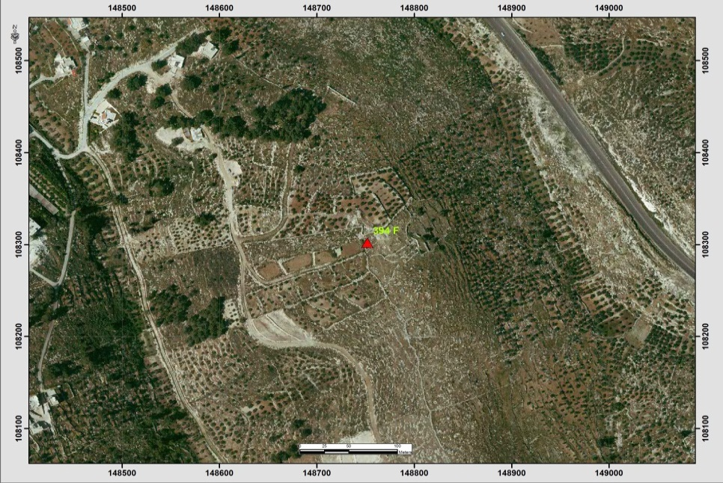
Table (5-31): Details of Trig (344N)
Date:- 30/3/2014 |  | Obs.Team:- Saleh natour, Abedalhafez almuhtaseb, Ala'a rjob, Samer Serhan
Point ID:- 344N |  | Instrument:- Trimble R8
File Name:- Banan |  | Point Number:- 007
Obs.Time:- 15 : 00 : 54 |  | Accuracy:- 0.02 m
Coordinates | E | N | H
Registered | 152271.78 | 108643.28 | 614.98
Observe | 152272.21 | 108643.48 | 614.53
WGS1984 | 35° 01' 24.32650" E | 31° 34' 11.70650" N | 634.002
Description | This trig is located in the village of Trqwmya on the rock
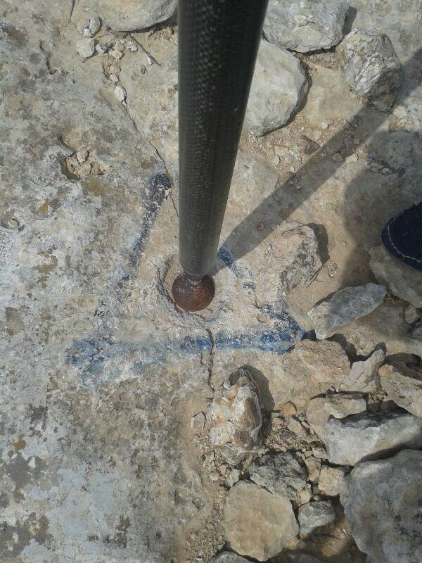
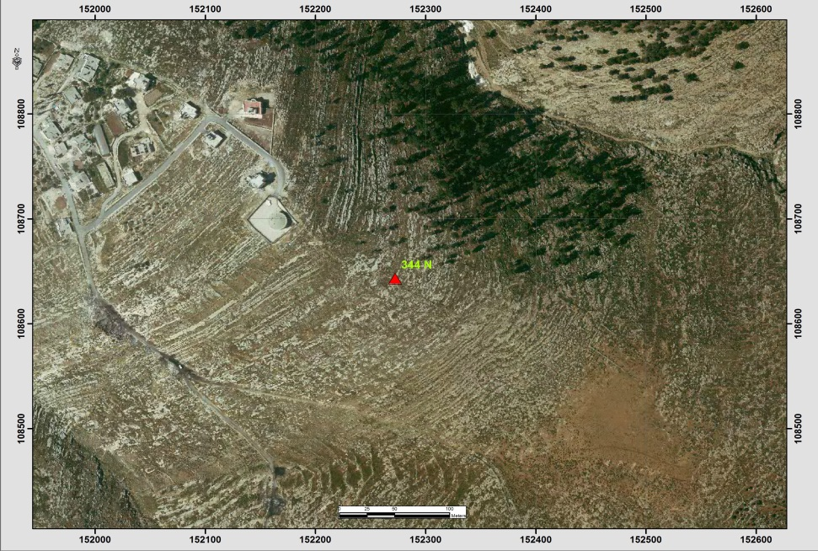
Table (5-32): Details of Trig (336N)
Date:- 30/3/2014 |  | Obs.Team:- Saleh natour, Abedalhafez almuhtaseb, Ala'a rjob, Samer Serhan
Point ID:- 336N |  | Instrument:- Trimble R8
File Name:- Banan |  | Point Number:- 008
Obs.Time:- 15 : 35 : 29 |  | Accuracy:- 0.02 m
Coordinates | E | N | H
Registered | 157079.28 | 117367.82 | 638.89
Observe | 157079.64 | 117371.15 | 638.45
WGS1984 | 35° 04' 26.23579" E | 31° 38' 55.28771" N | 658.207
Description | This trig is located in the village of Soureef on the rock
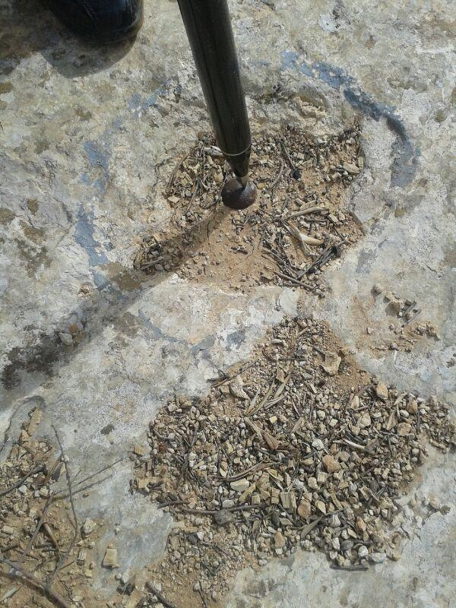
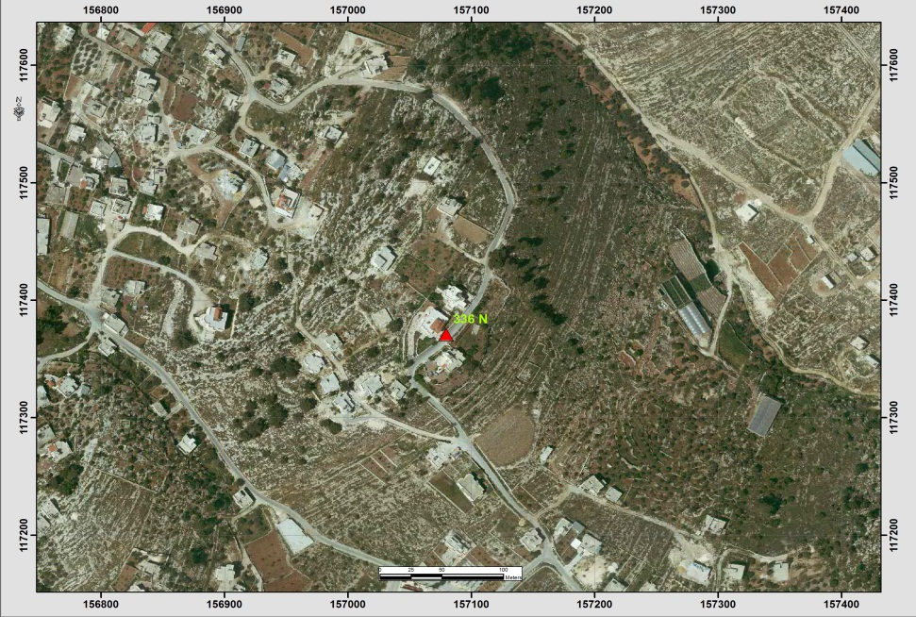
Table (5-33): Details of Trig (570T)
Date:- 30/3/2014 |  | Obs.Team:- Saleh natour, Abedalhafez almuhtaseb, Ala'a rjob, Samer Serhan
Point ID:- 570T |  | Instrument:- Trimble R8
File Name:- Banan |  | Point Number:- 009
Obs.Time:- 15 : 56 : 27 |  | Accuracy:- 0.02 m
Coordinates | E | N | H
Registered | 156096.76 | 117739.33 | 588.94
Observe | 156097.26 | 117739.77 | 589.90
WGS1984 | 35° 03' 48.93300" E | 31° 39' 07.21559" N | 609.623
Description | This trig is located in the village of Soureef on the rock
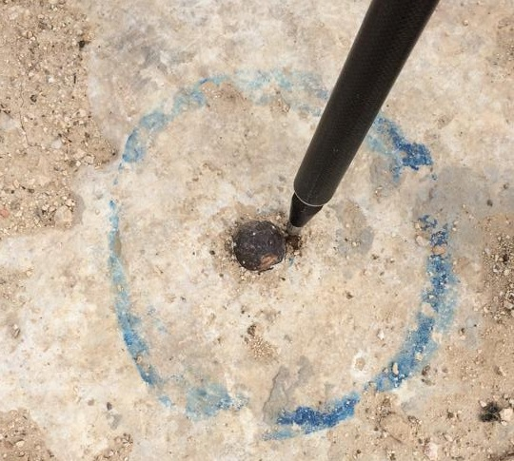
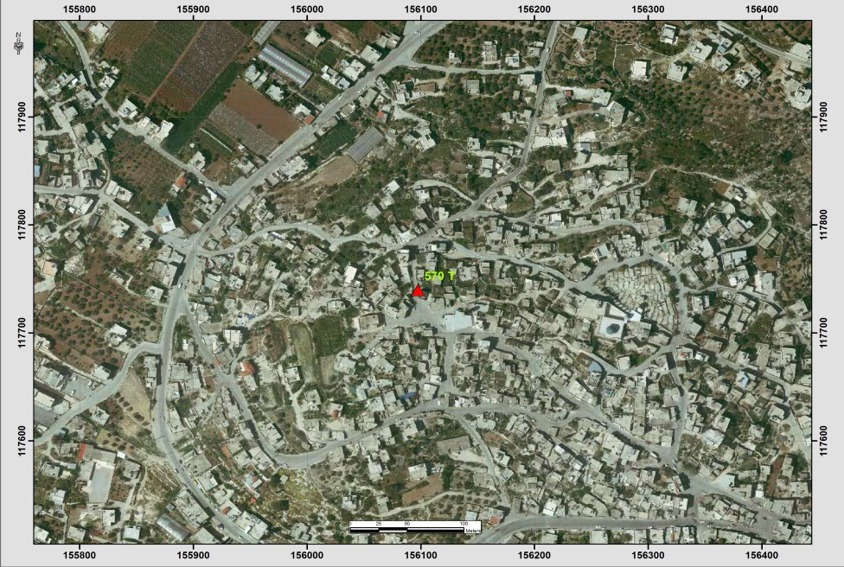
Table (5-34): Details of Trig (552B)
Date:- 11/5/2014 |  | Obs.Team:- Saleh natour, Abedalhafez almuhtaseb, Ala'a rjob, Samer Serhan
Point ID:- 552B |  | Instrument:- Leica 900
File Name:- Hebron VRS |  | Point Number:- 34
Obs.Time:- 08 : 15 : 01 |  | Accuracy:- 0.02 m
Coordinates | E | N | H
Registered | 155580.17 | 101424.37 | 913.81
Observe | 155580.41 | 101424.55 | 913.19
WGS1984 | 35° 03' 30.14658" E | 31° 30' 17.48970" N | 933.5
Description | This trig is located in the village of Dura (Sinjer)  on the rock
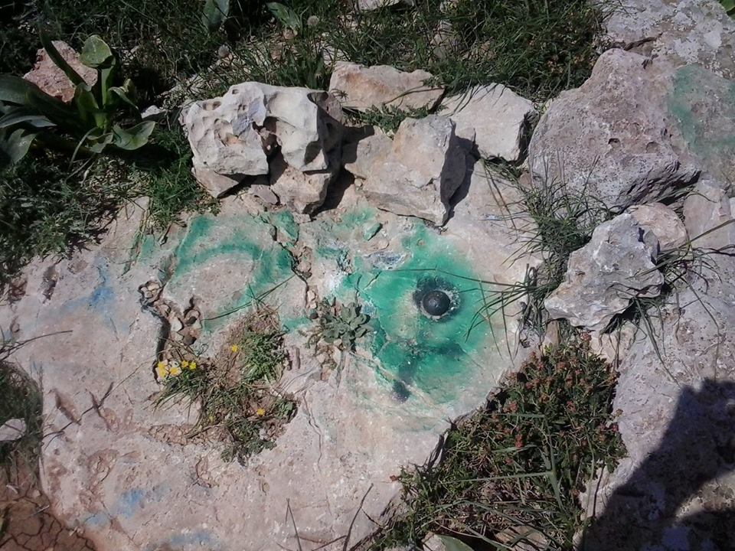
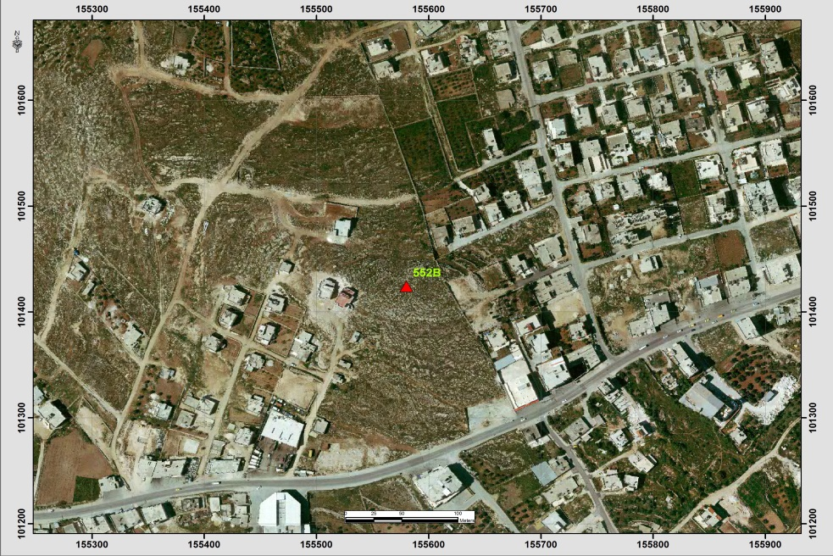
Table (5-35): Details of Trig (356N)
Date:- 11/5/2014 |  | Obs.Team:- Saleh natour, Abedalhafez almuhtaseb, Ala'a rjob, Samer Serhan
Point ID:- 356N |  | Instrument:- Leica 900
File Name:- Hebron VRS |  | Point Number:- 33
Obs.Time:- 04 : 25 : 15 |  | Accuracy:- 0.02 m
Coordinates | E | N | H
Registered | 155722.87 | 107271.25 | 875.47
Observe | 155723.17 | 107271.38 | 874.83
WGS1984 | 35° 03' 35.26416" E | 31° 33' 27.32726" N | 895.15
Description | This trig is located in the village of Hebron (Looza)  on the rock
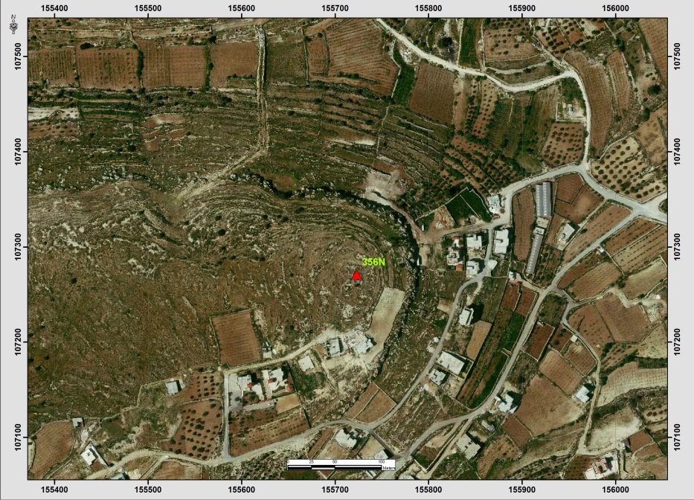

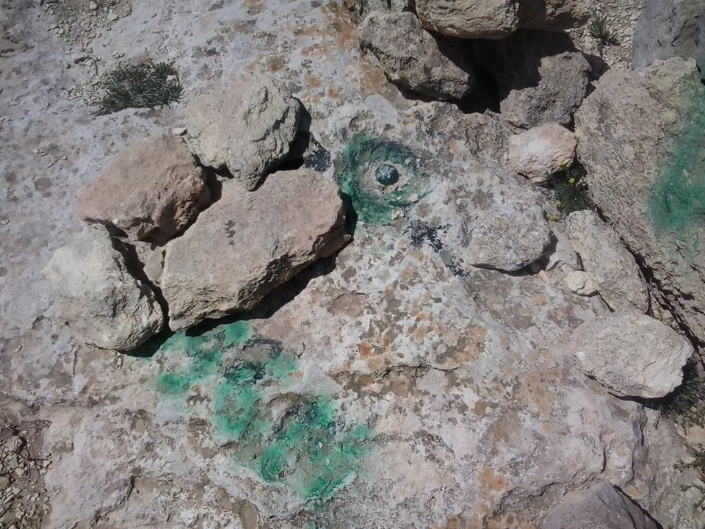
Table (5-36): Details of Trig (441F)
Date:- 10/5/2014 |  | Obs.Team:- Saleh natour, Abedalhafez almuhtaseb, Ala'a rjob, Samer Serhan
Point ID:- 441F |  | Instrument:- Leica 900
File Name:- Hebron VRS |  | Point Number:- 23
Obs.Time:- 06 : 45 : 57 |  | Accuracy:- 0.01 m
Coordinates | E | N | H
Registered | 142397.90 | 91081.11 | 643.29
Observe | 142398.23 | 91081.13 | 641.04
WGS1984 | 34° 55' 11.62075" E | 31° 24' 40.82418" N | 661.38
Description | This trig is located in the village of Aldahriyeh(Ramadeen)  on the rock
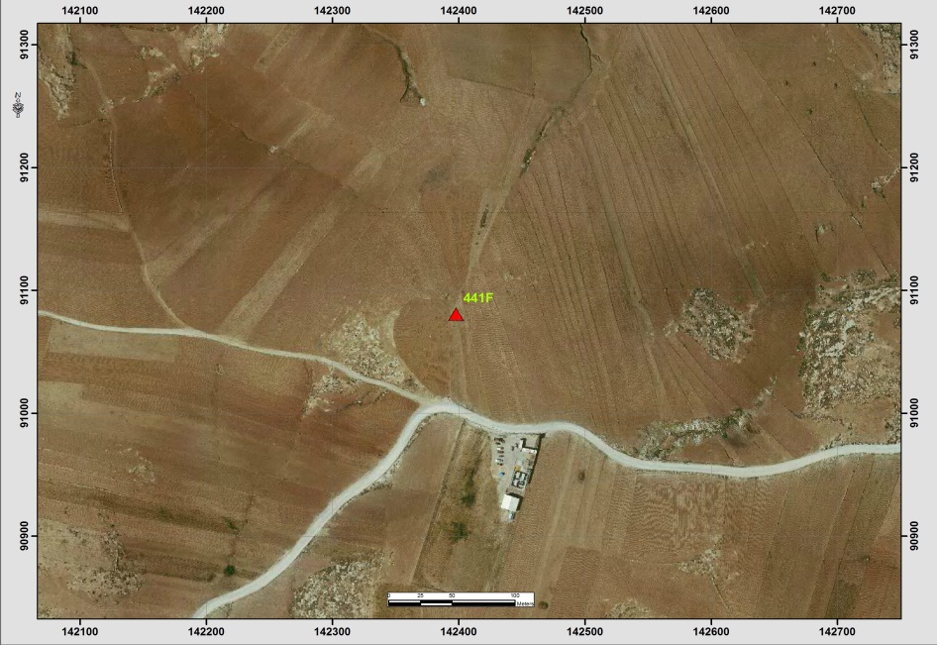
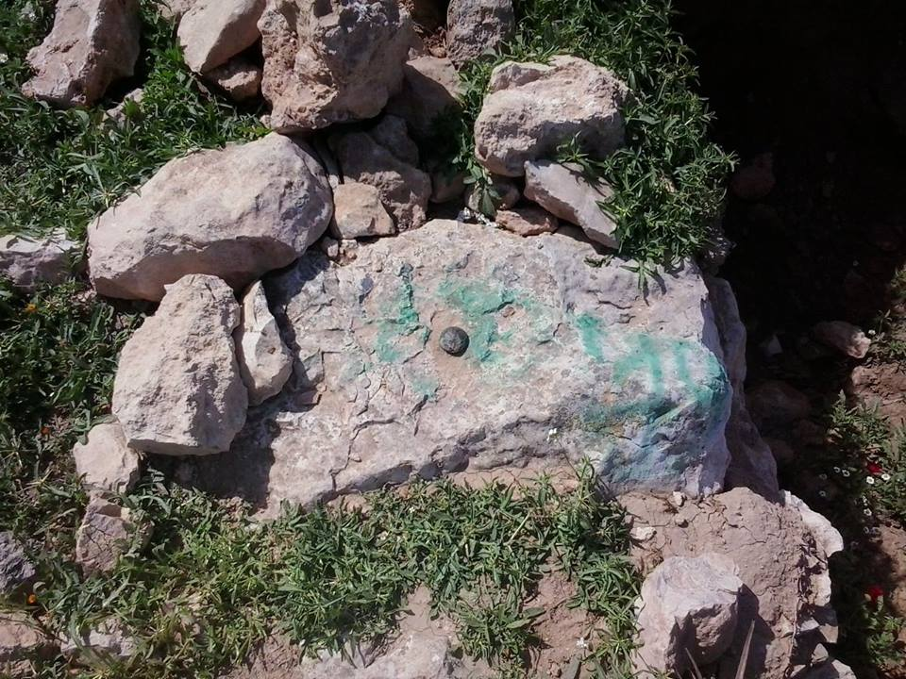
Table (5-37): Details of Trig (520T)
Date:- 10/5/2014 |  | Obs.Team:- Saleh natour, Abedalhafez almuhtaseb, Ala'a rjob, Samer Serhan
Point ID:- 520T |  | Instrument:- Leica 900
File Name:- Hebron VRS |  | Point Number:- 31
Obs. Time:- 02 : 21 : 25 |  | Accuracy:- 0.01 m
Coordinates | E | N | H
Registered | 157133.47 | 113959.94 | 849.42
Observe | 157133.43 | 113960.30 | 848.41
WGS1984 | 35° 04' 28.43555" E | 31° 37' 04.55495" N | 868.75
Description | This trig is located in the village of Halhoul (Jala)  on the rock
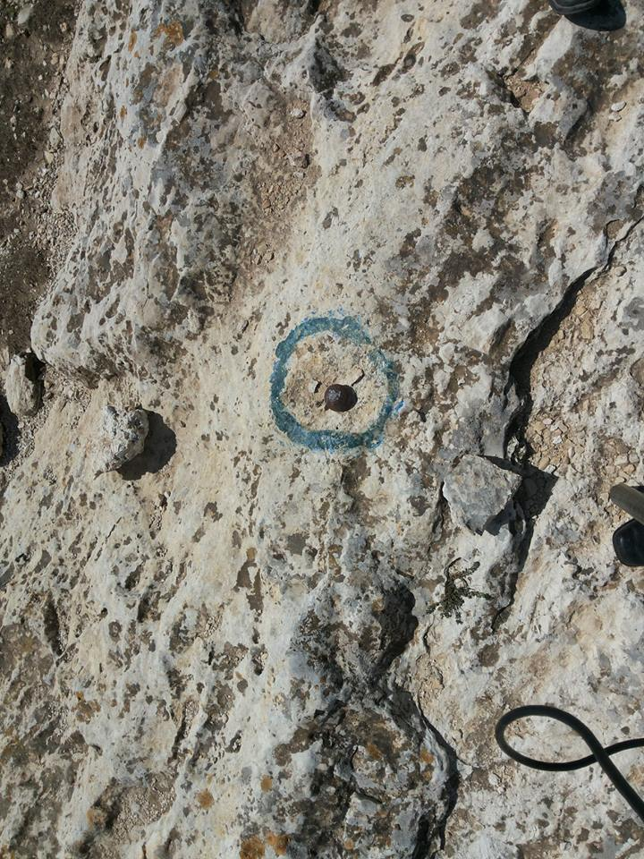
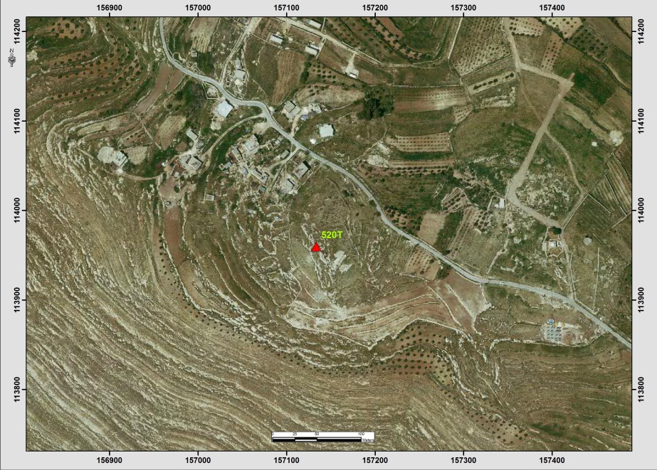

Table (5-38): Details of Trig (351N)
Date:- 10/5/2014 |  | Obs.Team:- Saleh natour, Abedalhafez almuhtaseb, Ala'a rjob, Samer Serhan
Point ID:- 351N |  | Instrument:- Leica 900
File Name:- Hebron VRS |  | Point Number:- 35
Obs. Time:- 08 : 42 : 41 |  | Accuracy:- 0.03 m
Coordinates | E | N | H
Registered | 150135.28 | 103756.06 | 730.17
Observe | 150135.31 | 103756.04 | 728.56
WGS1984 | 35° 00' 03.63926" E | 31° 31' 32.90565" N | 748.90
Description | This trig is located in the village of Dura (Homsa)  on the rock
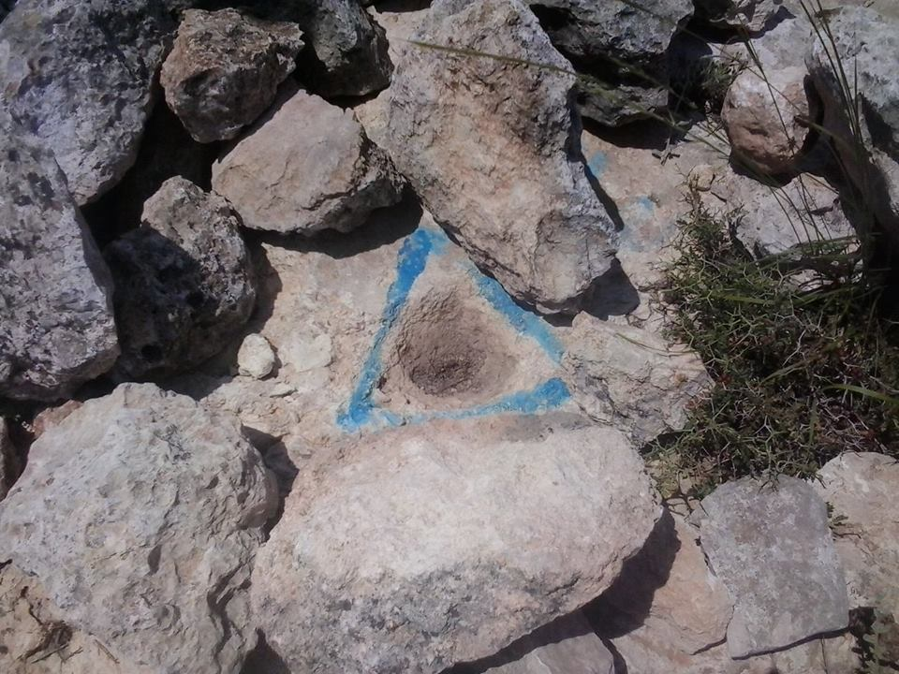
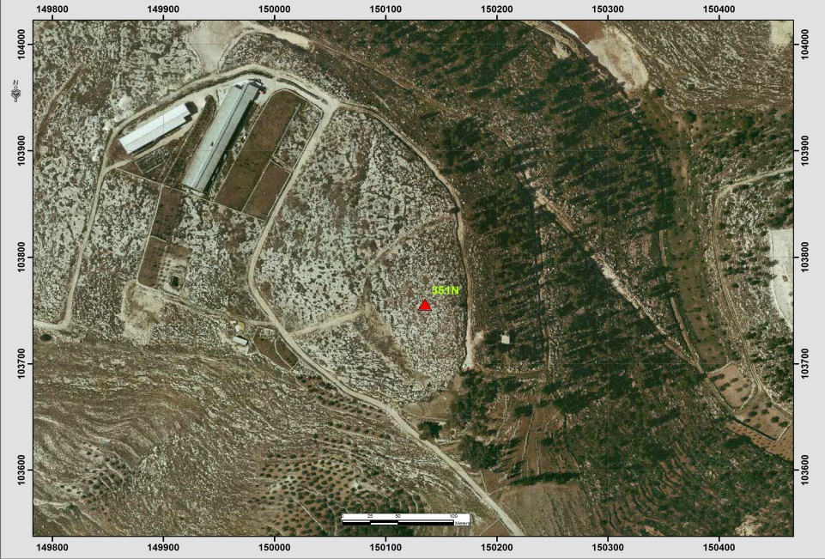
Table (5-39): Details of Trig (597B)
Date:- 10/5/2014 |  | Obs.Team:- Saleh natour, Abedalhafez almuhtaseb, Ala'a rjob, Samer Serhan
Point ID:- 597B |  | Instrument:- Leica 900
File Name:- Hebron VRS |  | Point Number:- 20
Obs. Time:- 05 : 22 : 04 |  | Accuracy:- 0.01 m
Coordinates | E | N | H
Registered | 160474.73 | 100867.46 | 902.79
Observe | 160474.94 | 100867.55 | 901.37
WGS1984 | 35° 06' 35.64447" E | 31° 29' 59.57937" N | 921.66
Description | This trig is located in the village of Hebron (Qilqis mt)  on the rock
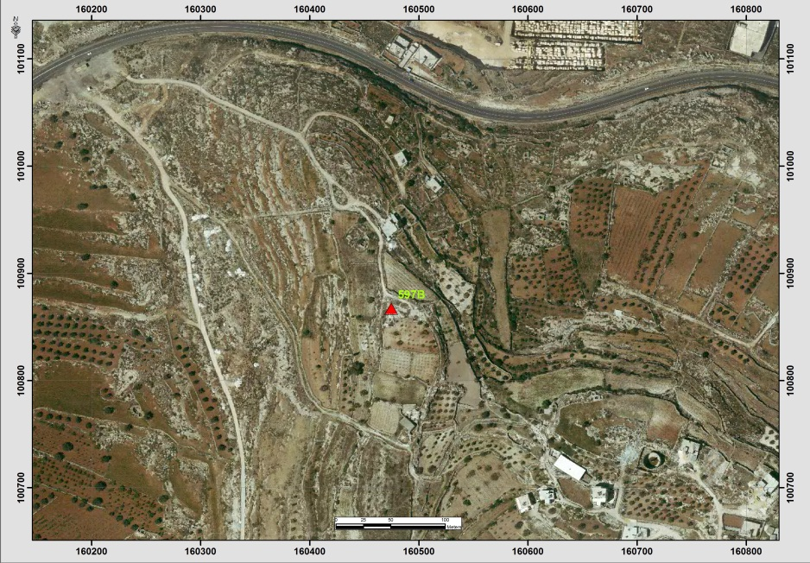

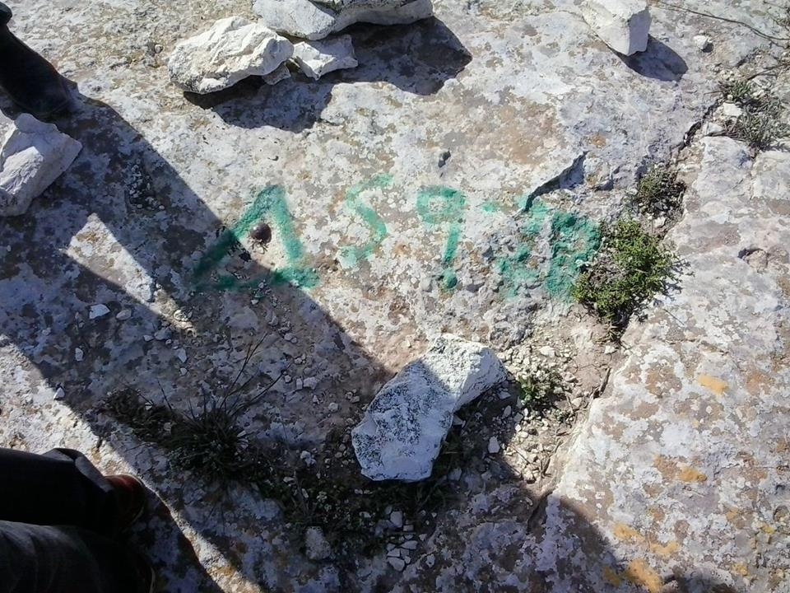

Table (5-40): Details of Trig (373N)
Date:- 10/5/2014 |  | Obs.Team:- Saleh natour, Abedalhafez almuhtaseb, Ala'a rjob, Samer Serhan
Point ID:- 373N |  | Instrument:- Leica 900
File Name:- Hebron VRS |  | Point Number:- 21
Obs. Time:- 05 : 39 : 53 |  | Accuracy:- 0.01 m
Coordinates | E | N | H
Registered | 155409.64 | 96442.86 | 739.5
Observe | 155409.90 | 96443.01 | 738.18
WGS1984 | 35° 03' 23.93917" E | 31° 27' 35.74310" N | 758.47
Description | This trig is located in the village of Yatta (beit Emra)  on the rock
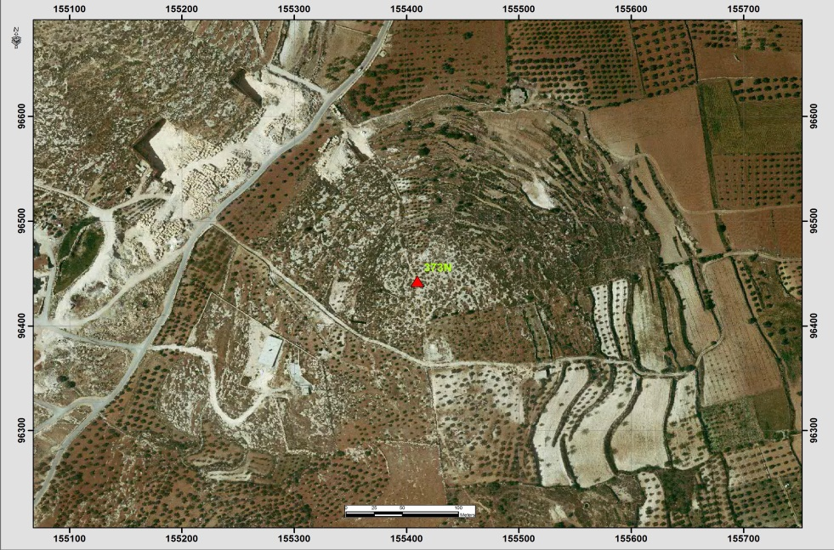
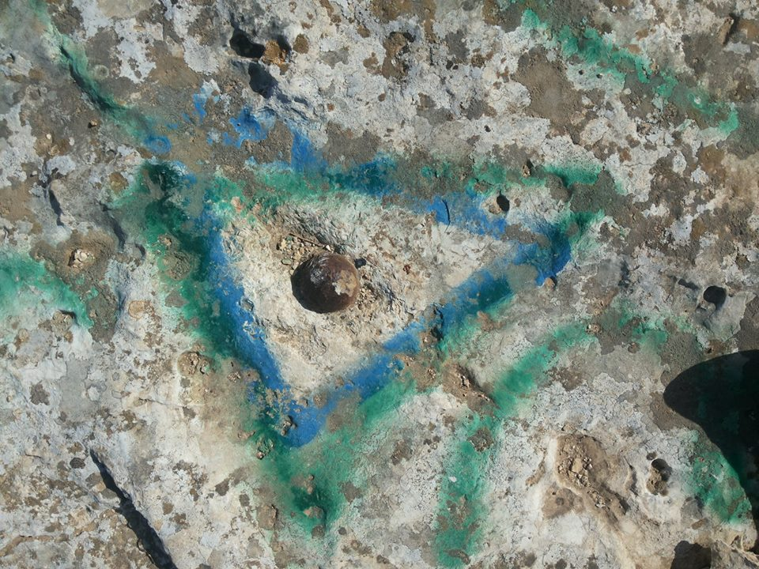
Table (5-41): Details of Trig (347N)
Date:- 10/5/2014 |  | Obs.Team:- Saleh natour, Abedalhafez almuhtaseb, Ala'a rjob, Samer Serhan
Point ID:- 347N |  | Instrument:- Leica 900
File Name:- Hebron VRS |  | Point Number:- 32
Obs. Time:- 03 : 24 : 10 |  | Accuracy:- 0.02 m
Coordinates | E | N | H
Registered | 152144.28 | 110606.8 | 567.75
Observe | 152144.45 | 110606.75 | 566.50
WGS1984 | 35° 01' 19.36062" E | 31° 35' 15.44396" N | 586.85
Description | This trig is located in the village of Bait Oula  on the rock
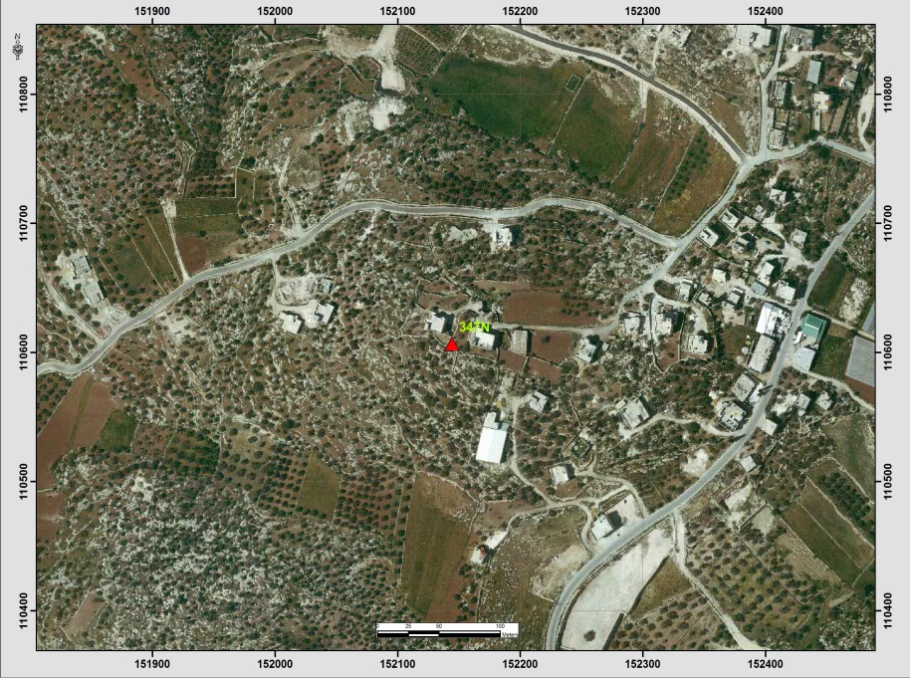

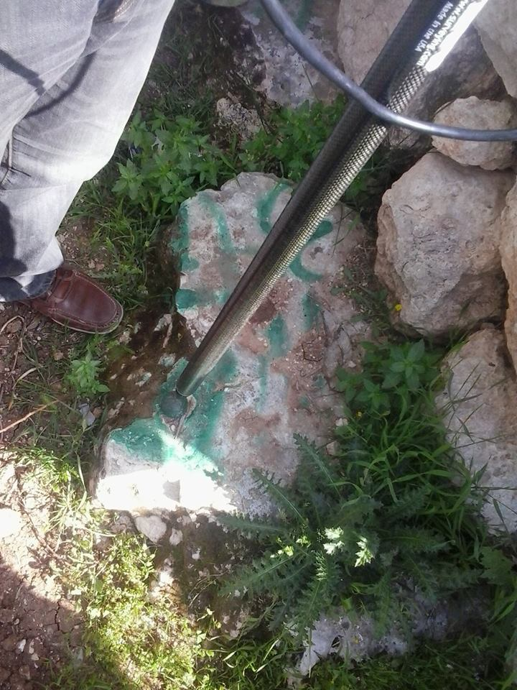
Table (5-42): Details of Trig (705P)
Date:- 10/5/2014 |  | Obs.Team:- Saleh natour, Abedalhafez almuhtaseb, Ala'a rjob, Samer Serhan
Point ID:- 705P |  | Instrument:- Leica 900
File Name:- Hebron VRS |  | Point Number:- 22
Obs. Time:- 06 : 20 : 36 |  | Accuracy:- 0.02 m
Coordinates | E | N | H
Registered | 148918.70 | 92762.38 | 669.29
Observe | 148919.15 | 92762.43 | 666.83
WGS1984 | 35° 59' 18.36202" E | 31° 25' 35.89407" N | 687.14
Description | This trig is located in the village of Aldahriyeh  on the rock
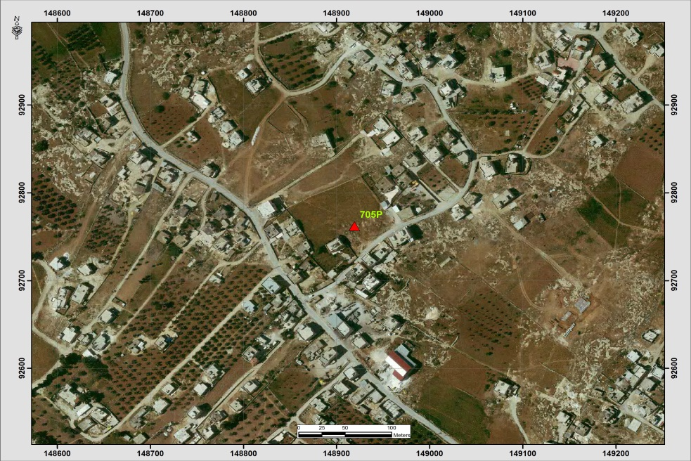

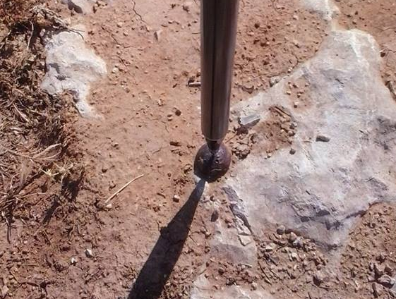
Table (5-43): Details of Trig (402N)
Date:- 10/5/2014 |  | Obs.Team:- Saleh natour, Abedalhafez almuhtaseb, Ala'a rjob, Samer Serhan
Point ID:- 402N |  | Instrument:- Leica 900
File Name:- Hebron VRS |  | Point Number:- 25
Obs. Time:- 08 : 31 : 56 |  | Accuracy:- 0.02 m
Coordinates | E | N | H
Registered | 158738.85 | 87520.78 | 796.08
Observe | 158739.76 | 87521.19 | 794.5
WGS1984 | 35° 05' 30.41067" E | 31° 22' 46.19725" N | 814.76
Description | This trig is located in the village of Alsamoua'  on the rock
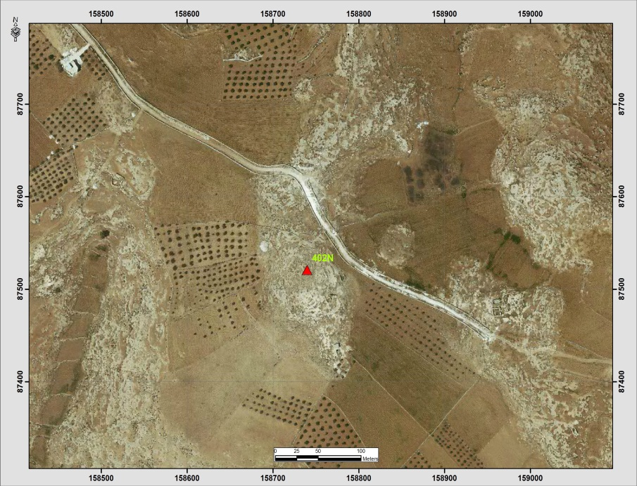

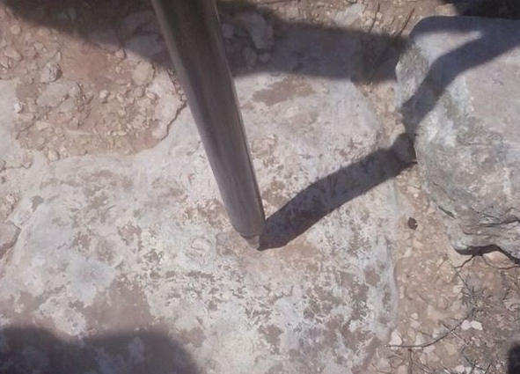

Table (5-44): Details of Trig (437N)
Date:- 10/5/2014 |  | Obs.Team:- Saleh natour, Abedalhafez almuhtaseb, Ala'a rjob, Samer Serhan
Point ID:- 437N |  | Instrument:- Leica 900
File Name:- Hebron VRS |  | Point Number:- 30
Obs. Time:- 12 : 40 : 17 |  | Accuracy:- 0.02 m
Coordinates | E | N | H
Registered | 169288.70 | 107612.62 | 824.20
Observe | 169288.57 | 107613.03 | 822.82
WGS1984 | 35° 12' 09.61841" E | 31° 33' 38.71380" N | 843.09
Description | This trig is located in the village of ALshyoukh(Wad AL-reem)  on the rock
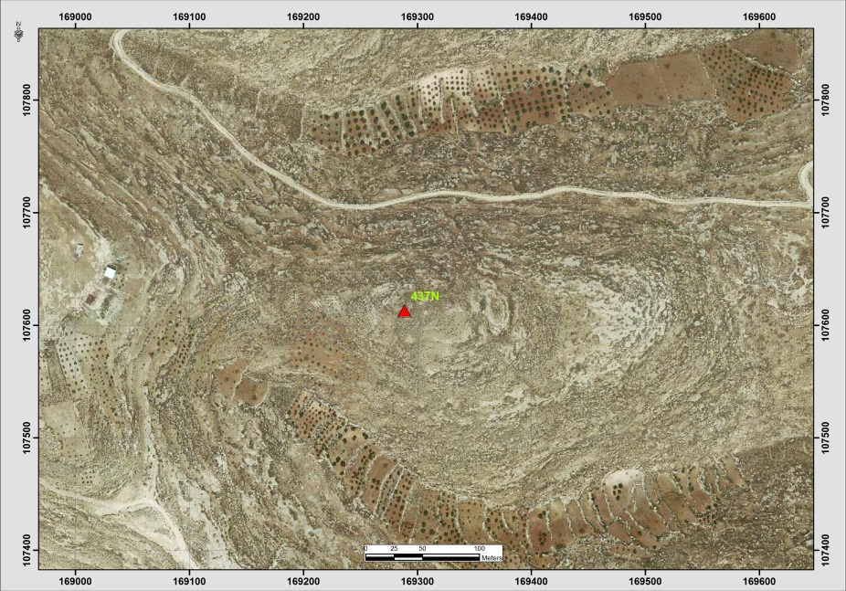

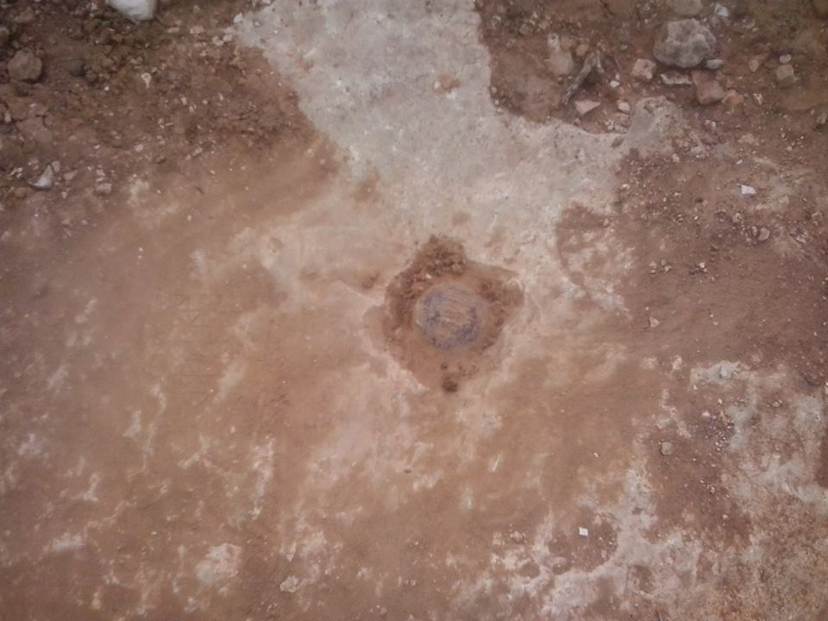
Table (5.45) also shows the information about points’ names and coordinates also it provides the location of the point according to the nearest town or city (Jenin).
Table (5-45): Selected network points (Registered)
Point(name) | Easting(m) | Northing(m) | Elevation(m) | Location
799D | 171066.13 | 216350.70 | 108.56 | Zububa
523S | 179794.28 | 210343.12 | 124.97 | Sabah Al Kheir
149T | 182397.17 | 208701.37 | 158.13 | Beit Qad
300T | 180244.82 | 207314.87 | 193.96 | Jenin
1078S | 180824.64 | 202860.76 | 371.82 | Qabatiya
1076S | 180005.87 | 203829.47 | 351.74 | Qabatiya
701E | 175936.27 | 206014.34 | 305.12 | Barqin
702E | 176065.94 | 205495.92 | 273.84 | Ash Shuhada
132T | 168551.60 | 202361.60 | 380.48 | Arraba
744E | 172917.58 | 207400.21 | 189.98 | Barqin
326V | 185353.72 | 211202.81 | 309.97 | Deir Ghazala
993R | 168522.92 | 213702.42 | 230.2 | At Tayba
579S | 174332.52 | 208442.16 | 243.89 | Kafr Dan
543W | 168772.13 | 201319.42 | 360.01 | Arraba
283P | 166284.91 | 195546.68 | 332.24 | Ar Rama

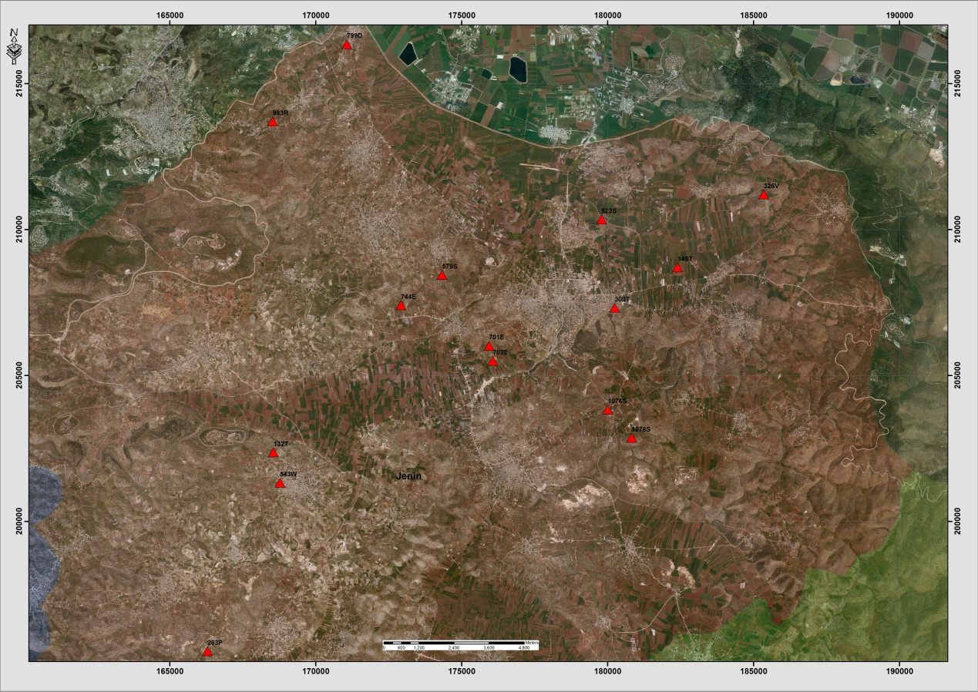 Figure (5-5): distribution of points within study area in Jenin district.

Table (5-46): Details of Trig (283P)
Date:- 18/7/2014 |  | Obs.Team:- Saleh natour, Abedalhafez almuhtaseb, Ala'a rjob, Samer Serhan
Point ID:- 283P |  | Instrument:- Leica Viva GS08
File Name:- Jenin VRS |  | Point Number:- 001
Obs. Time:- 06 : 37 : 04 |  | Accuracy:- 0.023 m
Coordinates | E | N | H
Registered | 166284.91 | 195546.68 | 332.24
Observe | 166284.839 | 195546.322 | 404.296
WGS1984 | 35° 10' 14.68571" E | 32° 21' 13.48387" N | 424.798
Description | This trig is located in the village of (Ar Rama)  on the rock
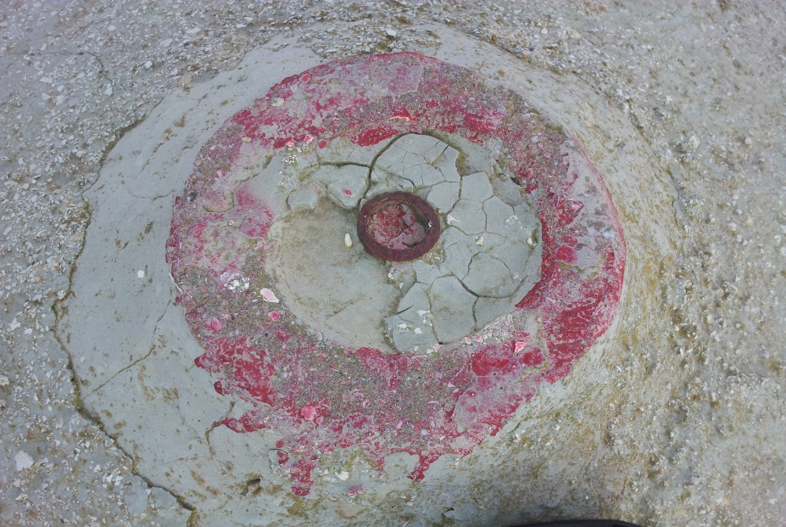

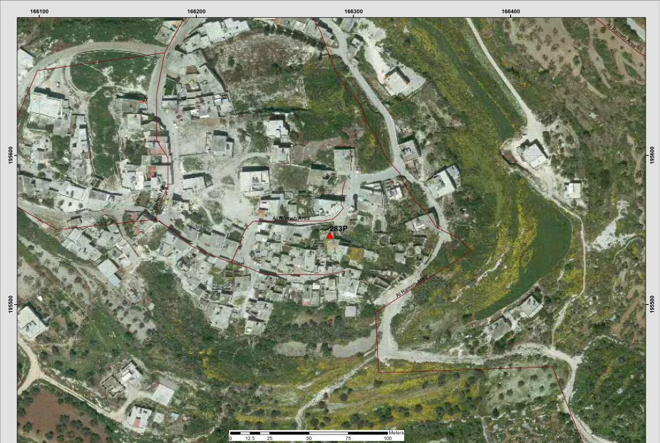
Table (5-47): Details of Trig (543W)
Date:- 18/7/2014 |  | Obs.Team:- Saleh natour, Abedalhafez almuhtaseb, Ala'a rjob, Samer Serhan
Point ID:- 543W |  | Instrument:- Leica Viva GS08
File Name:- Jenin VRS |  | Point Number:- 002
Obs. Time:- 07 : 05 : 09 |  | Accuracy:- 0.022 m
Coordinates | E | N | H
Registered | 168772.13 | 201319.42 | 360.01
Observe | 168771.987 | 201318.856 | 359.136
WGS1984 | 35° 11' 49.79176" E | 32° 24' 20.89429" N | 379.641
Description | This trig is located in the village of (Arraba)  on the rock
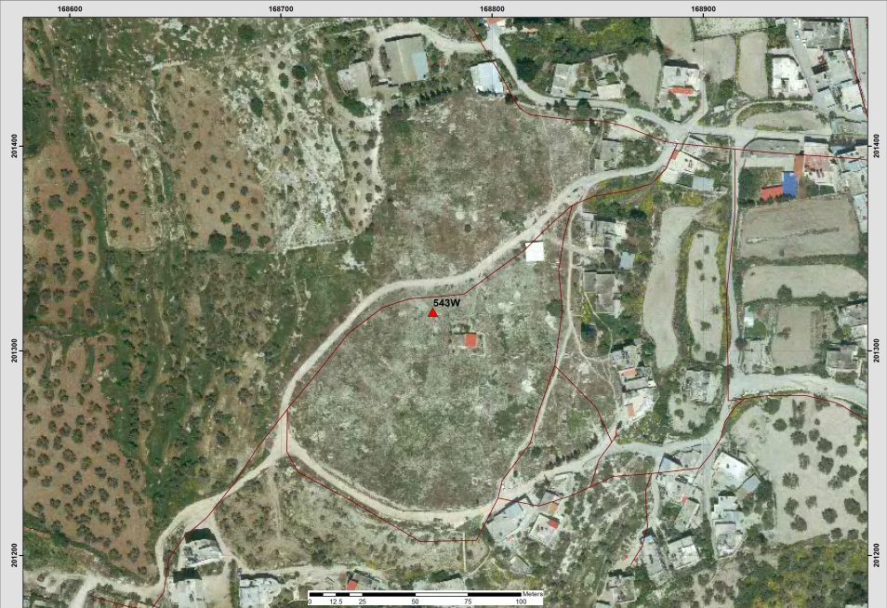
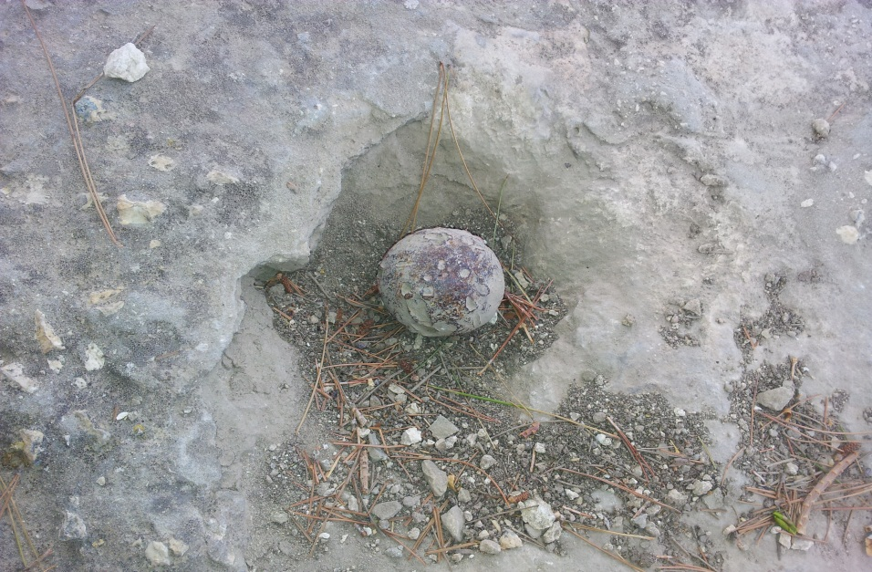
Table (5-48): Details of Trig (132T)
Date:- 18/7/2014 |  | Obs.Team:- Saleh natour, Abedalhafez almuhtaseb, Ala'a rjob, Samer Serhan
Point ID:- 132T |  | Instrument:- Leica Viva GS08
File Name:- Jenin VRS |  | Point Number:- 006
Obs. Time:- 07 : 21 : 18 |  | Accuracy:- 0.016 m
Coordinates | E | N | H
Registered | 168551.60 | 202361.60 | 380.48
Observe | 168551.439 | 202361.24 | 380.856
WGS1984 | 35° 11' 41.34843" E | 32° 24' 54.73267" N | 401.364
Description | This trig is located in the village of (Arraba)  on the rock
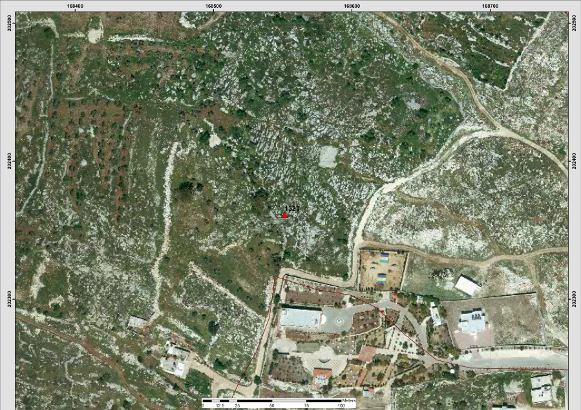

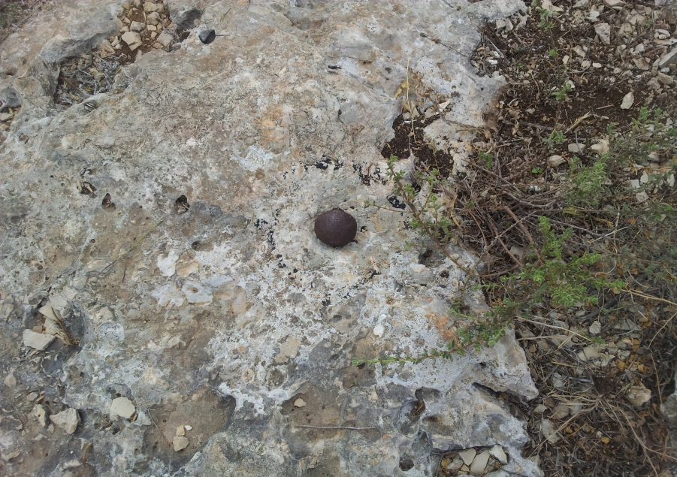
Table (5-49): Details of Trig (744E)
Date:- 18/7/2014 |  | Obs.Team:- Saleh natour, Abedalhafez almuhtaseb, Ala'a rjob, Samer Serhan
Point ID:- 744E |  | Instrument:- Leica Viva GS08
File Name:- Jenin VRS |  | Point Number:- 008
Obs. Time:- 08 : 39 : 58 |  | Accuracy:- 0.013 m
Coordinates | E | N | H
Registered | 172917.58 | 207400.21 | 189.98
Observe | 172917.434 | 207399.63 | 290.789
WGS1984 | 35° 14' 28.50572" E | 32° 27' 38.27550" N | 311.29
Description | This trig is located in the village of (Barqin)  on the rock
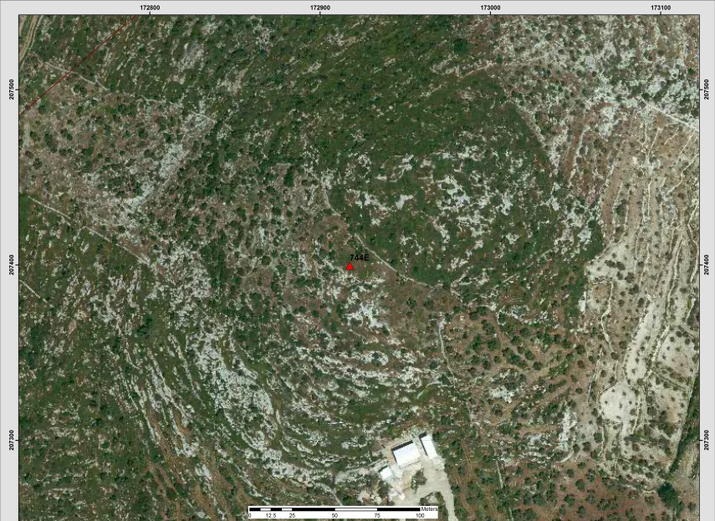
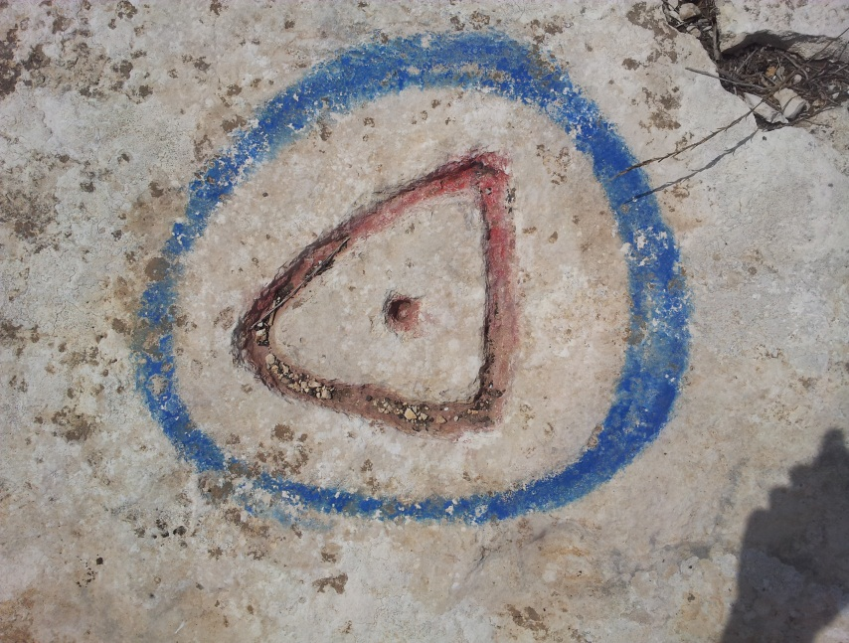
Table (5-50): Details of Trig (579S)
Date:- 18/7/2014 |  | Obs.Team:- Saleh natour, Abedalhafez almuhtaseb, Ala'a rjob, Samer Serhan
Point ID:- 579S |  | Instrument:- Leica Viva GS08
File Name:- Jenin VRS |  | Point Number:- 009
Obs. Time:- 09 : 03 : 00 |  | Accuracy:- 0.012 m
Coordinates | E | N | H
Registered | 174332.52 | 208442.16 | 243.89
Observe | 174332.338 | 208441.643 | 243.511
WGS1984 | 35° 15' 22.70202" E | 32° 28' 12.08304" N | 264.01
Description | This trig is located in the village of (Kafr Dan)  on the rock
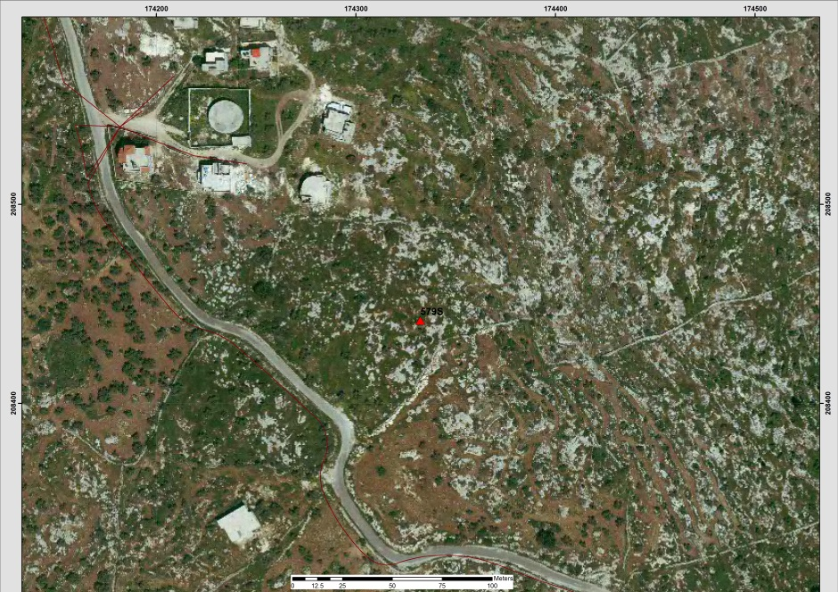

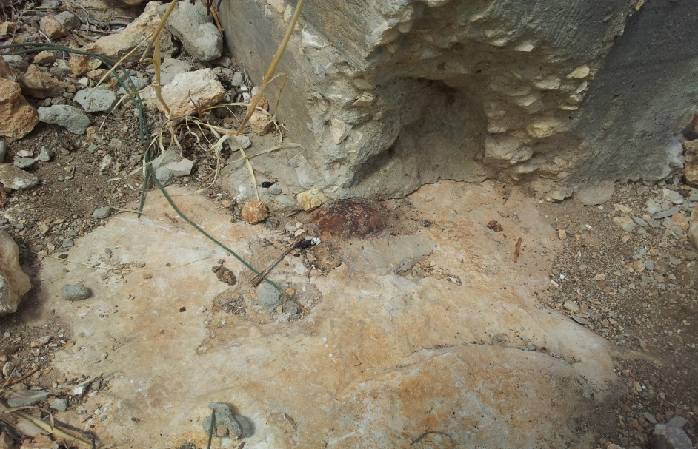
Table (5-51): Details of Trig (701E)
Date:- 18/7/2014 |  | Obs.Team:- Saleh natour, Abedalhafez almuhtaseb, Ala'a rjob, Samer Serhan
Point ID:- 701E |  | Instrument:- Leica Viva GS08
File Name:- Jenin VRS |  | Point Number:- 009
Obs. Time:- 09 : 21 : 37 |  | Accuracy:- 0.013 m
Coordinates | E | N | H
Registered | 175936.27 | 206014.34 | 305.12
Observe | 175936.246 | 206013.527 | 305.917
WGS1984 | 32° 26' 53.23028" N | 35° 16' 24.06243" E | 326.404
Description | This trig is located in the village of (Barqin)  on the rock
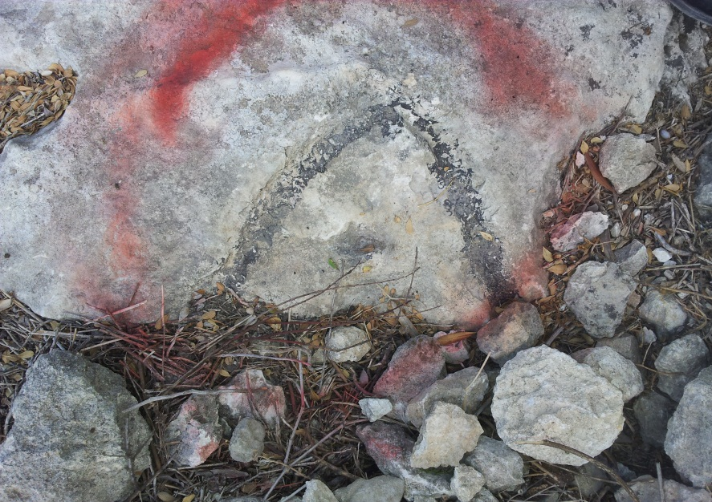

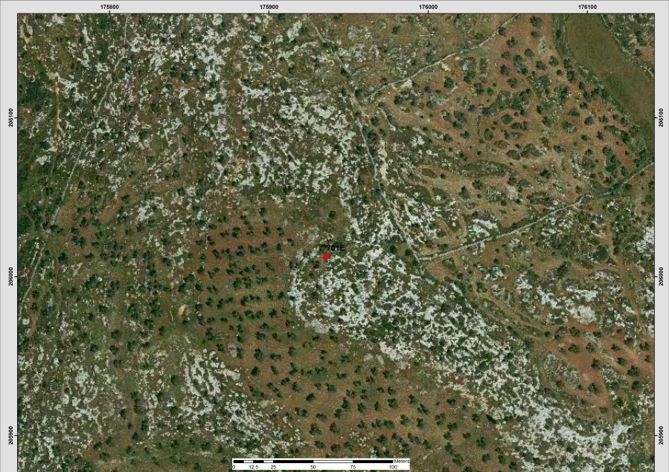
Table (5-52): Details of Trig (702E)
Date:- 18/7/2014 |  | Obs.Team:- Saleh natour, Abedalhafez almuhtaseb, Ala'a rjob, Samer Serhan
Point ID:- 702E |  | Instrument:- Leica Viva GS08
File Name:- Jenin VRS |  | Point Number:- 011
Obs. Time:- 09 : 30 : 05 |  | Accuracy:- 0.013 m
Coordinates | E | N | H
Registered | 176065.94 | 205495.92 | 273.84
Observe | 176066.018 | 205495.173 | 274.428
WGS1984 | 35° 16' 29.01769" E | 32° 26' 36.40028" N | 294.913
Description | This trig is located in the village of (Ash Shuhada)  on the rock
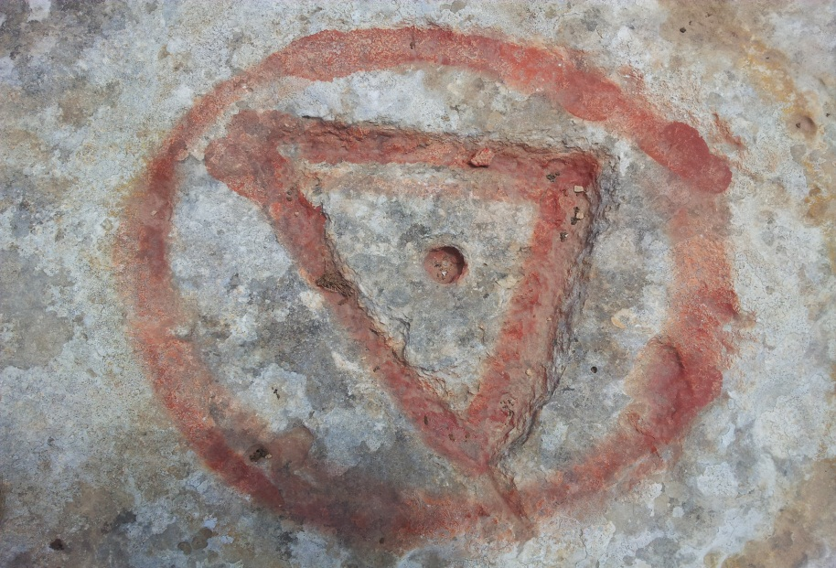

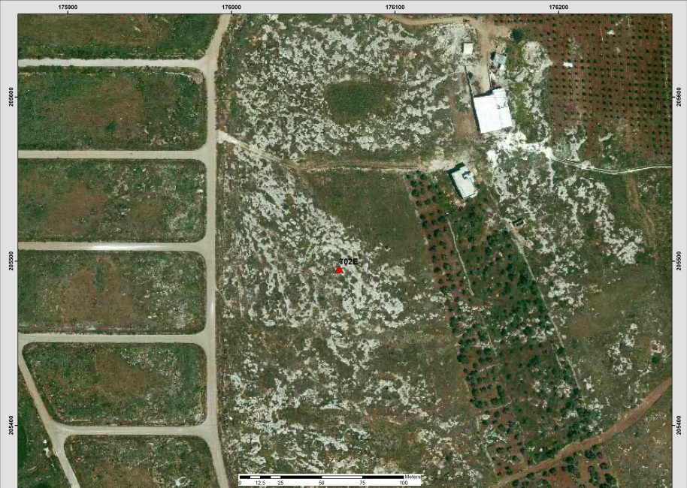
Table (5-53): Details of Trig (300T)
Date:- 18/7/2014 |  | Obs.Team:- Saleh natour, Abedalhafez almuhtaseb, Ala'a rjob, Samer Serhan
Point ID:- 300T |  | Instrument:- Leica Viva GS08
File Name:- Jenin VRS |  | Point Number:- 012
Obs. Time:- 10 : 04 : 11 |  | Accuracy:- 0.017 m
Coordinates | E | N | H
Registered | 180244.82 | 207314.87 | 193.96
Observe | 180244.72 | 207314.38 | 193.254
WGS1984 | 35° 19' 09.06541" E | 32° 27' 35.33973" N | 213.729
Description | This trig is located in the village of (Jenin)  on the rock
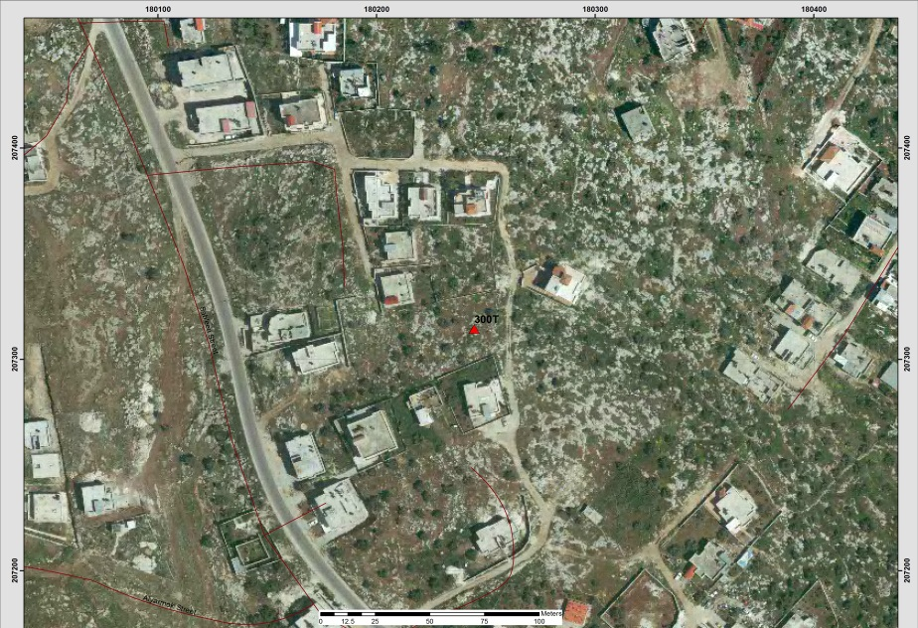
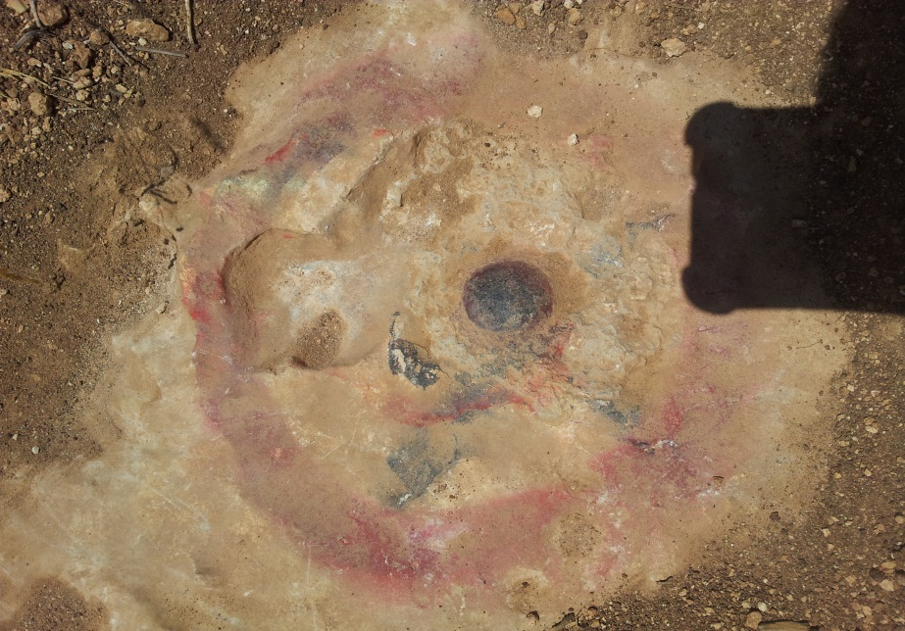
Table (5-54): Details of Trig (523S)
Date:- 18/7/2014 |  | Obs.Team:- Saleh natour, Abedalhafez almuhtaseb, Ala'a rjob, Samer Serhan
Point ID:- 523S |  | Instrument:- Leica Viva GS08
File Name:- Jenin VRS |  | Point Number:- 013
Obs. Time:- 10 : 21 : 24 |  | Accuracy:- 0.017 m
Coordinates | E | N | H
Registered | 179794.28 | 210343.12 | 124.97
Observe | 179794.43 | 210342.72 | 124.049
WGS1984 | 35° 18' 51.94351" E | 32° 29' 13.66304" N | 144.532
Description | This trig is located in the village of (Sabah Al Kheir)  on the rock
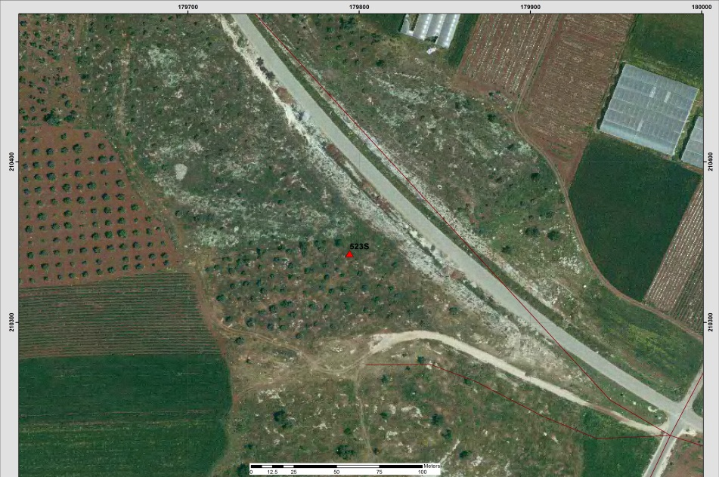

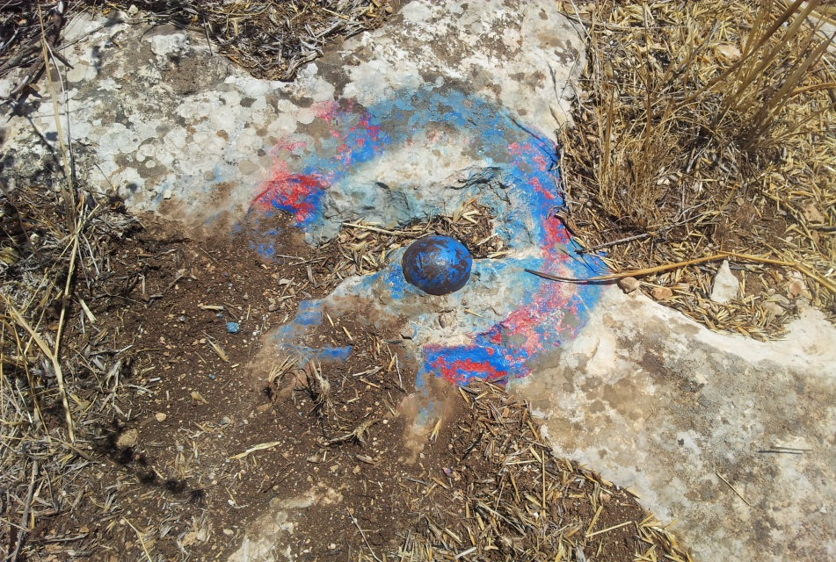
Table (5-55): Details of Trig (799D)
Date:- 18/7/2014 |  | Obs.Team:- Saleh natour, Abedalhafez almuhtaseb, Ala'a rjob, Samer Serhan
Point ID:- 799D |  | Instrument:- Leica Viva GS08
File Name:- Jenin VRS |  | Point Number:- 014
Obs. Time:- 11 : 00 : 29 |  | Accuracy:- 0.02 m
Coordinates | E | N | H
Registered | 171066.13 | 216350.70 | 108.56
Observe | 171066.45 | 216350.40 | 109.214
WGS1984 | 35° 13' 17.68601" E | 32° 32' 28.85588" N | 129.742
Description | This trig is located in the village of (Zububa)  on the rock
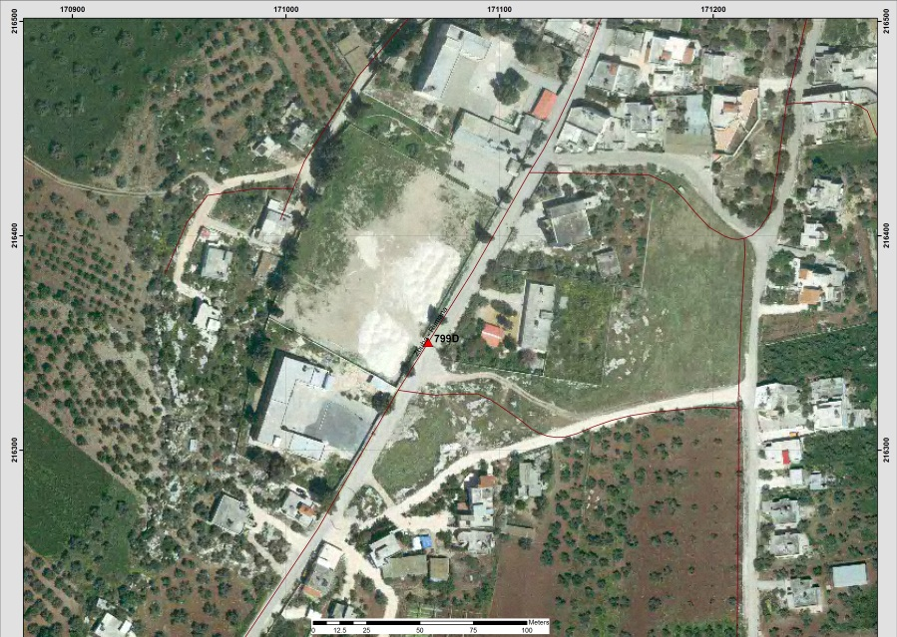

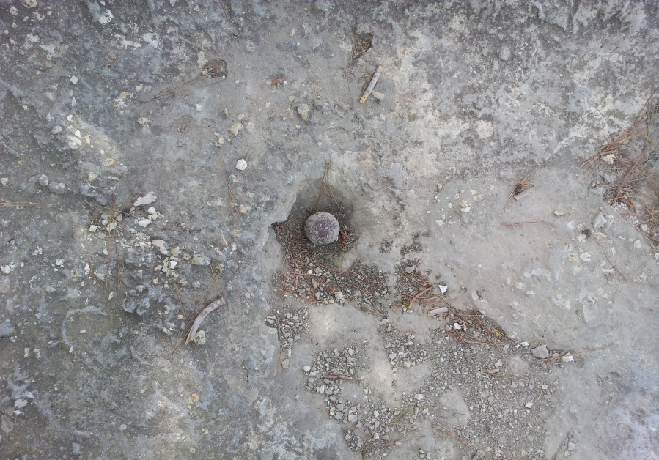
Table (5-56): Details of Trig (993R)
Date:- 18/7/2014 |  | Obs.Team:- Saleh natour, Abedalhafez almuhtaseb, Ala'a rjob, Samer Serhan
Point ID:- 993R |  | Instrument:- Leica Viva GS08
File Name:- Jenin VRS |  | Point Number:- 015
Obs. Time:- 11 : 24 : 36 |  | Accuracy:- 0.018 m
Coordinates | E | N | H
Registered | 168522.92 | 213702.42 | 230.20
Observe | 168522.77 | 213701.52 | 229.43
WGS1984 | 35° 11' 40.21056" E | 32° 31' 02.86951" N | 249.96
Description | This trig is located in the village of (At Tayba)  on the rock
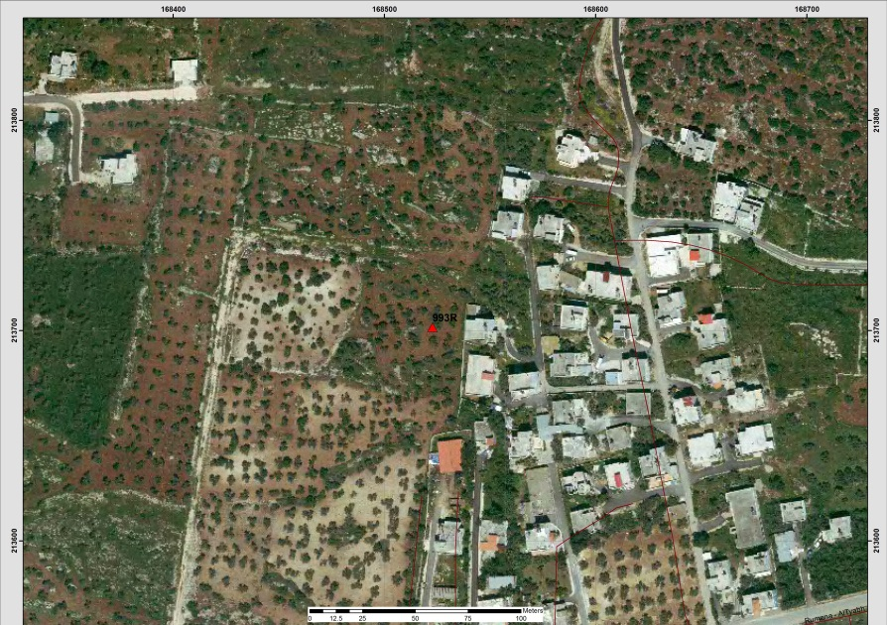
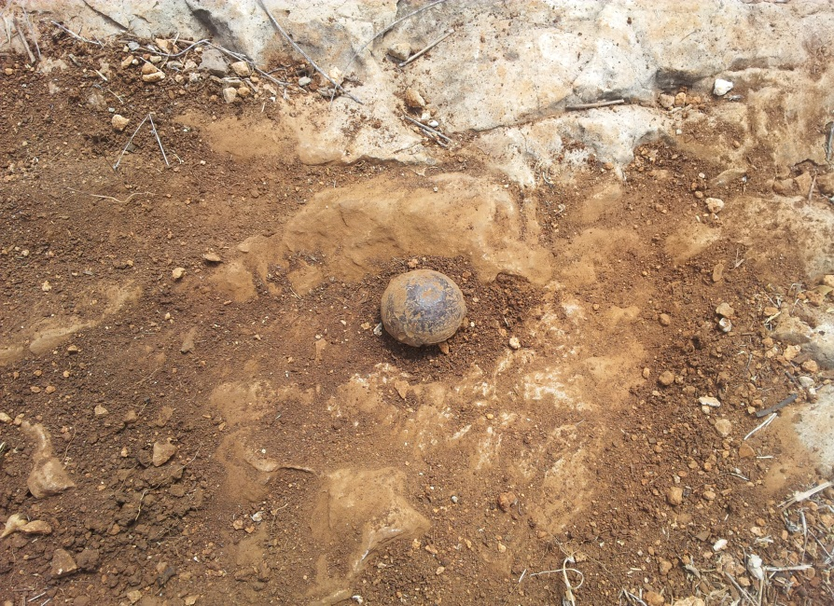
Table (5-57): Details of Trig (149T)
Date:- 18/7/2014 |  | Obs.Team:- Saleh natour, Abedalhafez almuhtaseb, Ala'a rjob, Samer Serhan
Point ID:- 149T |  | Instrument:- Leica Viva GS08
File Name:- Jenin VRS |  | Point Number:- 016
Obs. Time:- 12 : 11 : 49 |  | Accuracy:- 0.016 m
Coordinates | E | N | H
Registered | 182397.17 | 208701.37 | 158.13
Observe | 182396.81 | 208701.55 | 158.69
WGS1984 | 35° 20' 31.53713" E | 32° 28' 20.28840" N | 179.16
Description | This trig is located in the village of (Beit Qad)  on the rock
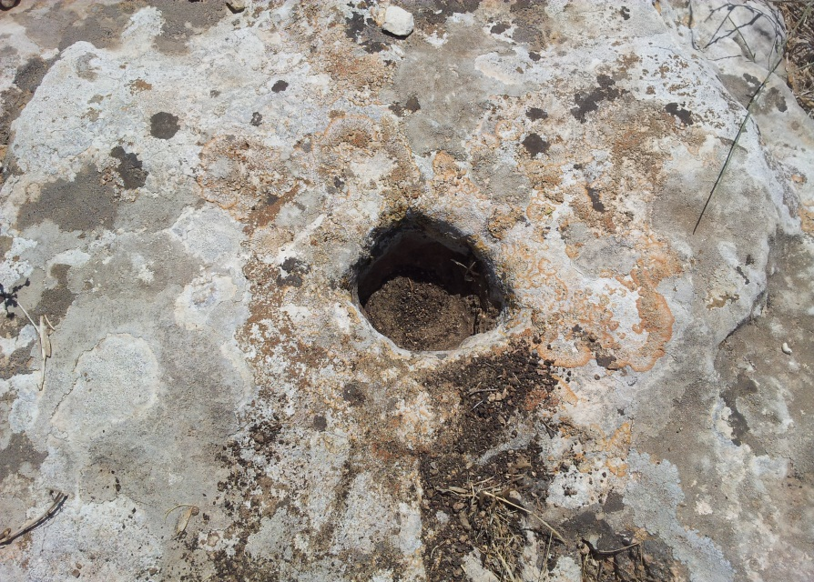
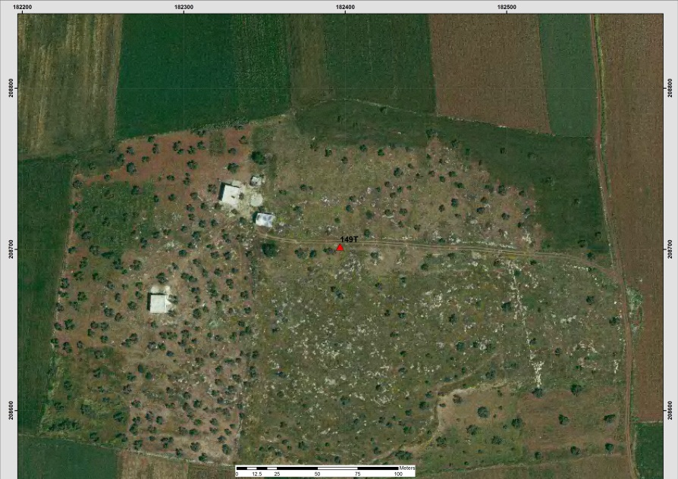
Table (5-58): Details of Trig (326V)
Date:- 18/7/2014 |  | Obs.Team:- Saleh natour, Abedalhafez almuhtaseb, Ala'a rjob, Samer Serhan
Point ID:- 326V |  | Instrument:- Leica Viva GS08
File Name:- Jenin VRS |  | Point Number:- 017
Obs. Time:- 12 : 47 : 51 |  | Accuracy:- 0.021 m
Coordinates | E | N | H
Registered | 185353.72 | 211202.81 | 309.97
Observe | 185353.416 | 211202.406 | 310.663
WGS1984 | 35° 22' 24.91227" E | 32° 29' 41.33440" N | 331.125
Description | This trig is located in the village of (Deir Ghazala)  on the rock
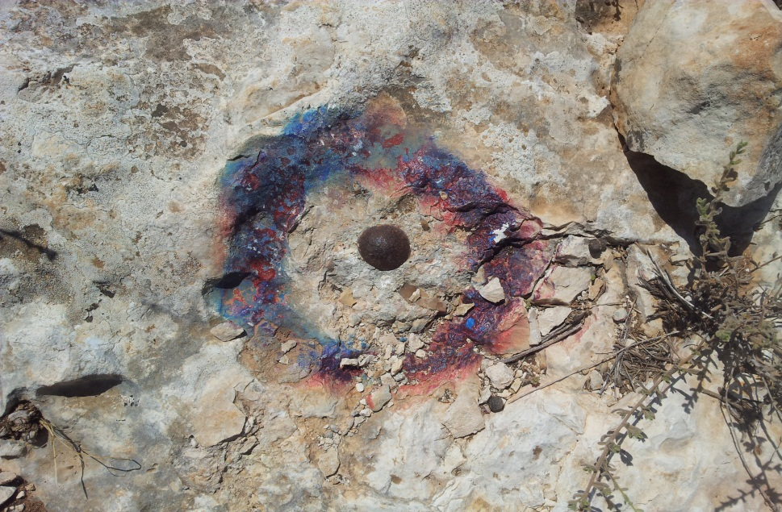
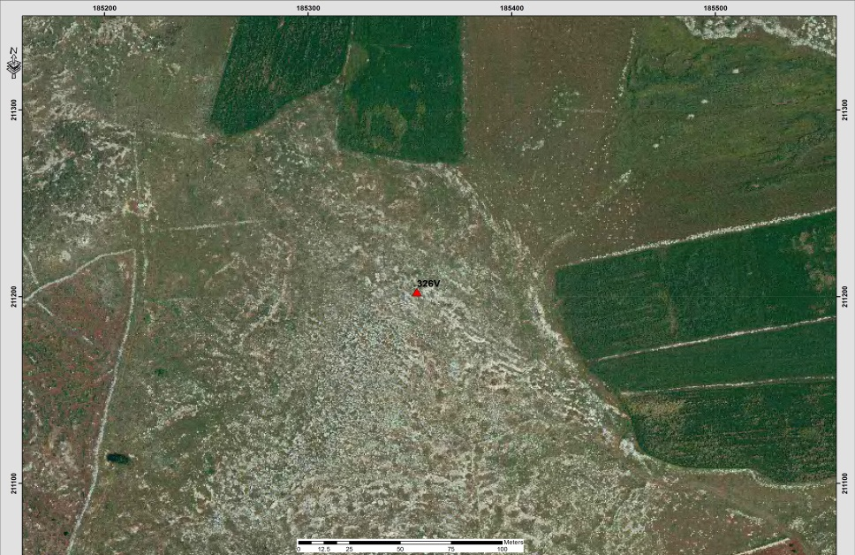

Table (5-59): Details of Trig (1076S)
Date:- 18/7/2014 |  | Obs.Team:- Saleh natour, Abedalhafez almuhtaseb, Ala'a rjob, Samer Serhan
Point ID:- 1076S |  | Instrument:- Leica Viva GS08
File Name:- Jenin VRS |  | Point Number:- 018
Obs. Time:- 02 : 02 : 01 |  | Accuracy:- 0.013 m
Coordinates | E | N | H
Registered | 180005.87 | 203829.47 | 351.74
Observe | 180005.76 | 203829.19 | 352.27
WGS1984 | 35° 18' 59.77585" E | 32° 25' 42.20879" N | 372.73
Description | This trig is located in the village of (Qabatiya)  on the rock
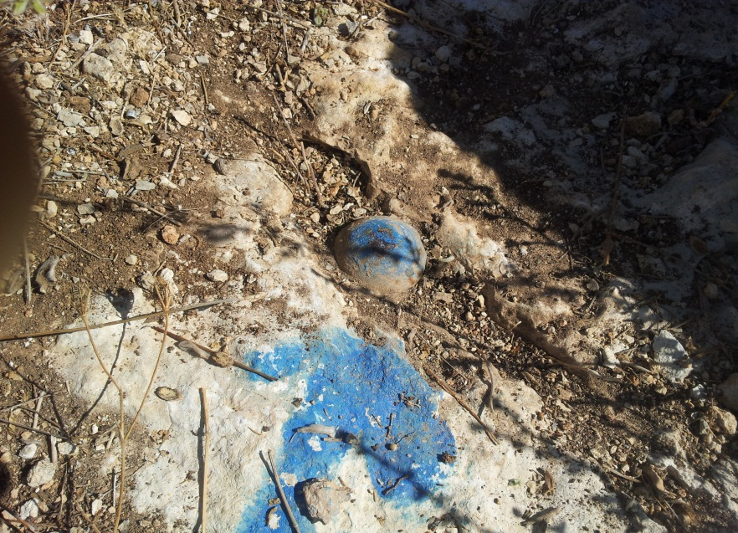
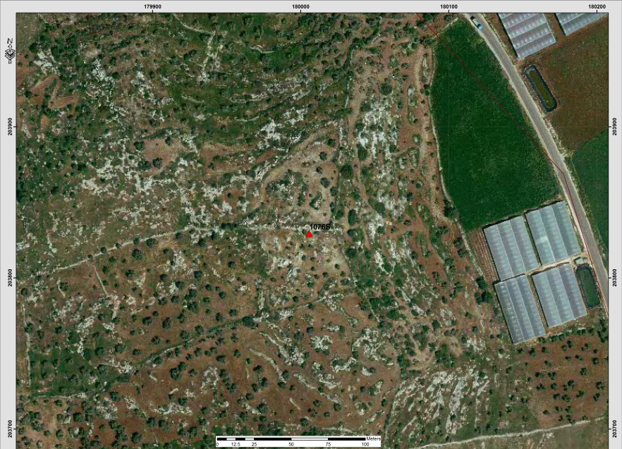

Table (5-60): Details of Trig (1078S)
Date:- 18/7/2014 |  | Obs.Team:- Saleh natour, Abedalhafez almuhtaseb, Ala'a rjob, Samer Serhan
Point ID:- 1078S |  | Instrument:- Leica Viva GS08
File Name:- Jenin VRS |  | Point Number:- 019
Obs. Time:- 02 : 15 : 18 |  | Accuracy:- 0.014 m
Coordinates | E | N | H
Registered | 180824.64 | 202860.76 | 371.82
Observe | 180824.42 | 202860.92 | 371.40
WGS1984 | 35° 19' 31.06957" E | 32° 25' 10.74688" N | 391.86
Description | This trig is located in the village of (Qabatiya)  on the rock
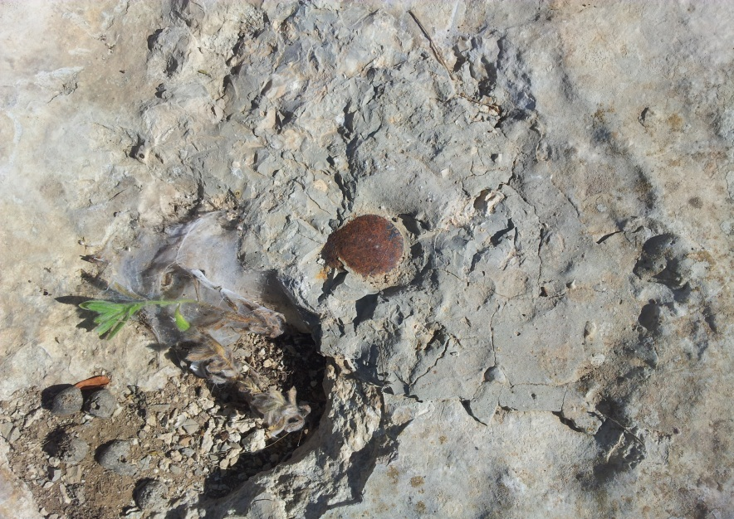
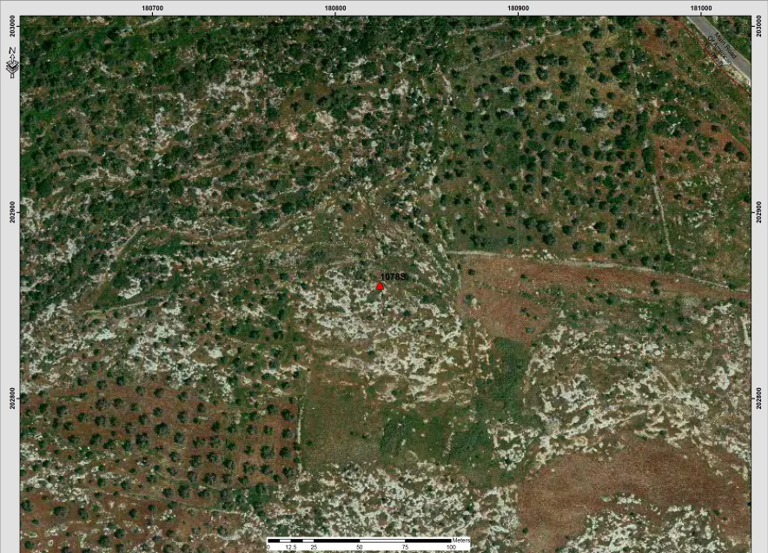

Table (5.61) also shows the information about points’ names and coordinates also it provides the location of the point according to the nearest town or city (Tubas).
Table (5-61): Selected network points (Registered)
Point(name) | Easting(m) | Northing(m) | Elevation(m) | Location
615W | 186254.24 | 191429.74 | 354.74 | Tubas
1109S | 185037.55 | 194360.38 | 506.21 | Tubas

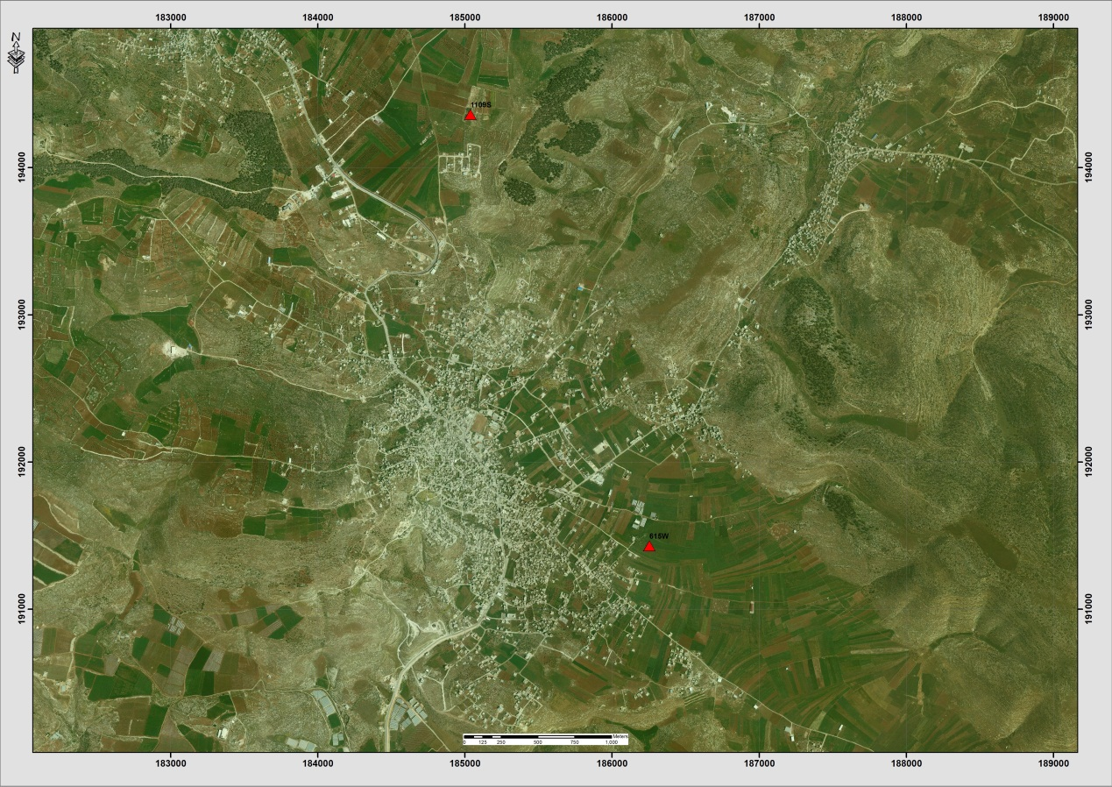
Figure (5-6): distribution of points within study area in Tubas district.

Table (5-62): Details of Trig (615W)
Date:- 18/7/2014 |  | Obs.Team:- Saleh natour, Abedalhafez almuhtaseb, Ala'a rjob, Samer Serhan
Point ID:- 615W |  | Instrument:- Leica Viva GS08
File Name:- Jenin VRS |  | Point Number:- 020
Obs. Time:- 03 : 12 : 44 |  | Accuracy:- 0.017 m
Coordinates | E | N | H
Registered | 186254.24 | 191429.74 | 354.74
Observe | 186253.91 | 191429.80 | 355.18
WGS1984 | 35° 22' 58.14264" E | 32° 18' 59.41049" N | 375.604
Description | This trig is located in the village of (Tubas)  on the rock
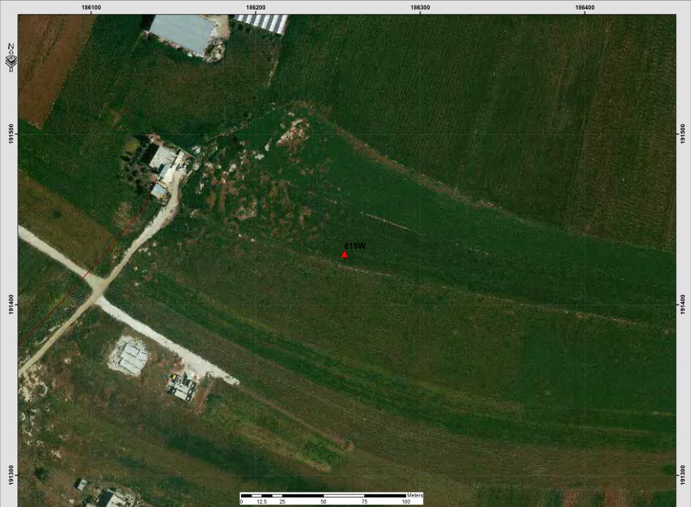

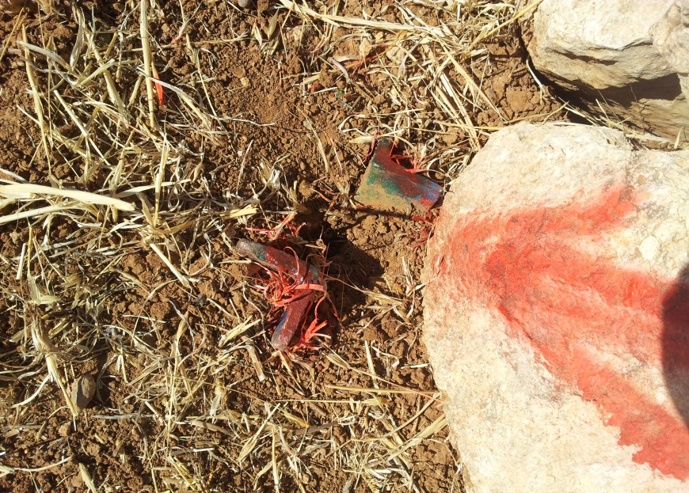
Table (5-63): Details of Trig (1109S)
Date:- 18/7/2014 |  | Obs.Team:- Saleh natour, Abedalhafez almuhtaseb, Ala'a rjob, Samer Serhan
Point ID:- 1109S |  | Instrument:- Leica Viva GS08
File Name:- Jenin VRS |  | Point Number:- 021
Obs. Time:- 03 : 35 : 44 |  | Accuracy:- 0.018 m
Coordinates | E | N | H
Registered | 185037.55 | 194360.38 | 506.21
Observe | 185037.551 | 194360.303 | 506.694
WGS1984 | 35° 22' 11.81472" E | 32° 20' 34.60753" N | 527.121
Description | This trig is located in the village of (Tubas)  on the rock
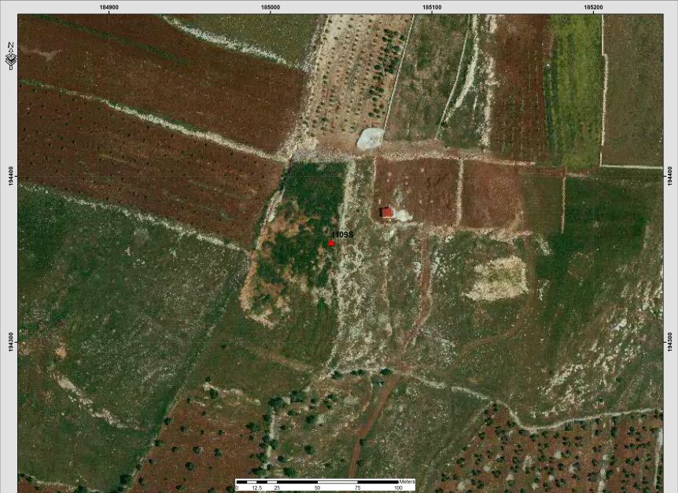
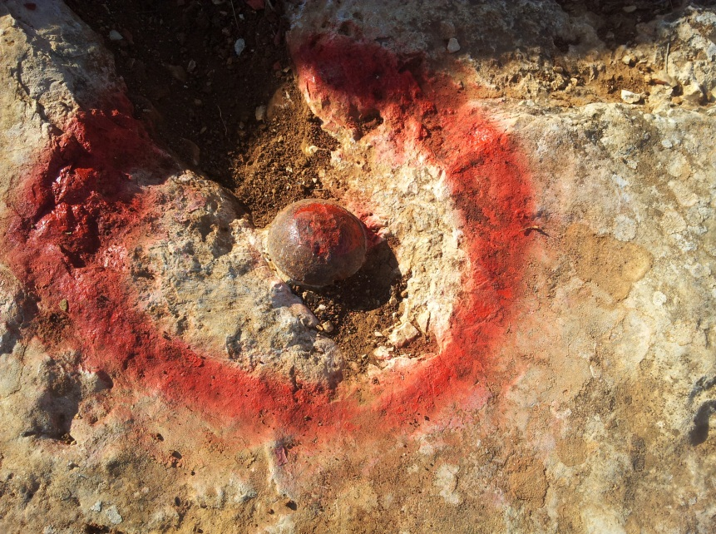
Table (5.64) also shows the information about points’ names and coordinates also it provides the location of the point according to the nearest town or city (Nablus).
Table (5-64): Selected network points (Registered)
Point(name) | Easting(m) | Northing(m) | Elevation(m) | Location
647W | 175126.00 | 185396.52 | 668.04 | Asira ash Shamaliya
333X | 173564.54 | 183636.71 | 590.25 | Asira ash Shamaliya
652W | 175284.28 | 188513.36 | 602.11 | Yasid
642X | 173777.83 | 188618.92 | 548.15 | Beit Imrin
152B | 176494.64 | 180216.24 | 600.78 | Nablus
718T | 168441.58 | 184299.89 | 370.43 | Deir Sharaf
710T | 169348.11 | 181305.79 | 568.55 | Sarra
Figure (5-7): distribution of points within study area in Nablus district.
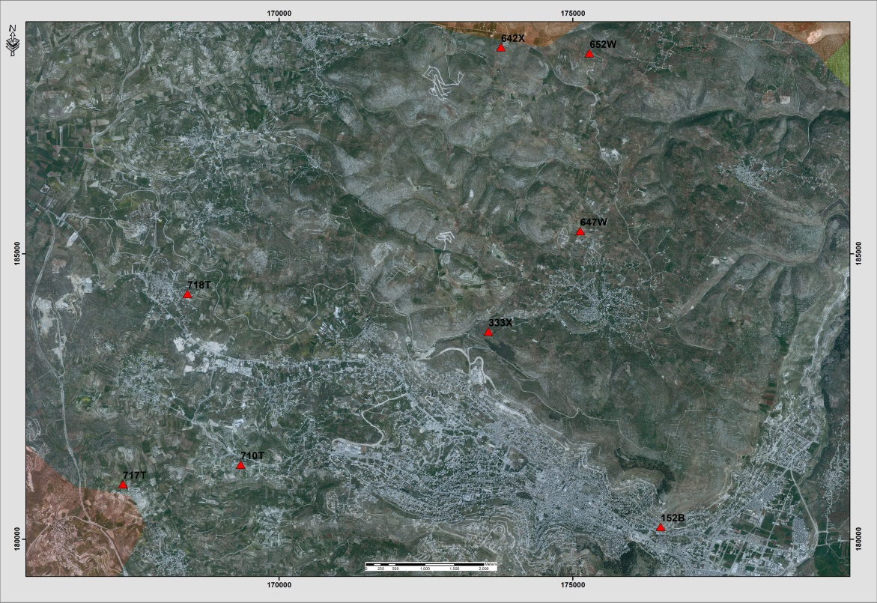
Table (5-65): Details of Trig (647W)
Date:- 21/08/2014 |  | Obs.Team:- Saleh natour, Abedalhafez almuhtaseb, Ala'a rjob, Samer Serhan
Point ID:- 647W |  | Instrument:- Leica Viva GS08
File Name:- Nablus VRS |  | Point Number:- 013
Obs. Time:- 09 : 50 : 00 |  | Accuracy:- 0.013 m
Coordinates | E | N | H
Registered | 175126.00 | 185396.52 | 668.04
Observe | 175125.74 | 185396.53 | 668.47
WGS1984 | 35° 15' 52.58937" E | 32° 15' 43.95036" N | 688.92
Description | This trig is located in the village of (Asira ash Shamaliya)  on the rock
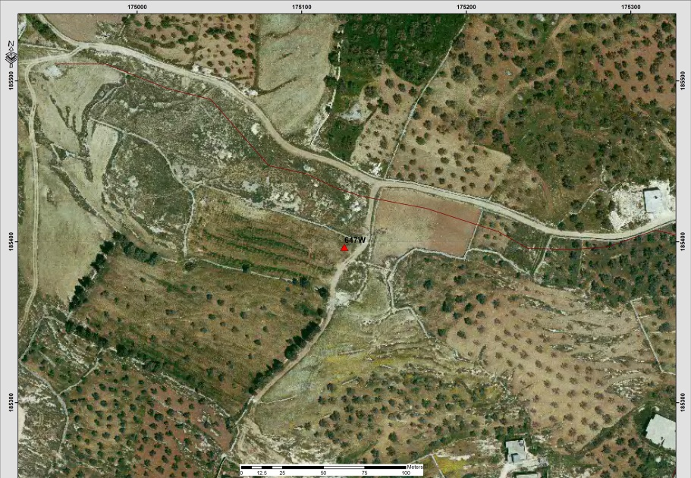

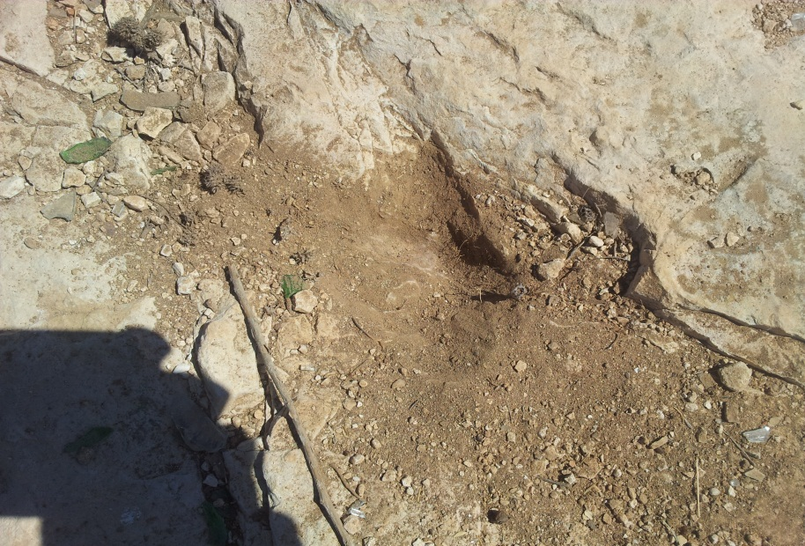
Table (5-66): Details of Trig (333X)
Date:- 21/08/2014 |  | Obs.Team:- Saleh natour, Abedalhafez almuhtaseb, Ala'a rjob, Samer Serhan
Point ID:- 333X |  | Instrument:- Leica Viva GS08
File Name:- Nablus VRS |  | Point Number:- 014
Obs. Time:- 09 : 24 : 00 |  | Accuracy:- 0.016 m
Coordinates | E | N | H
Registered | 173564.54 | 183636.71 | 590.25
Observe | 173564.25 | 183636.68 | 590.77
WGS1984 | 35° 14' 52.90296" E | 32° 14' 46.84350" N | 611.21
Description | This trig is located in the village of (Asira ash Shamaliya)  on the rock
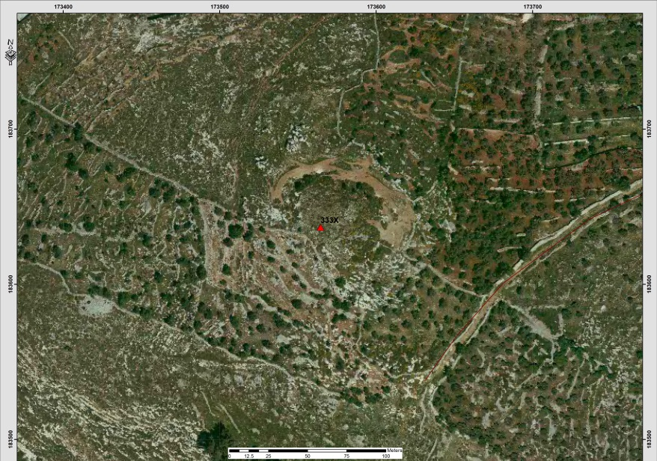

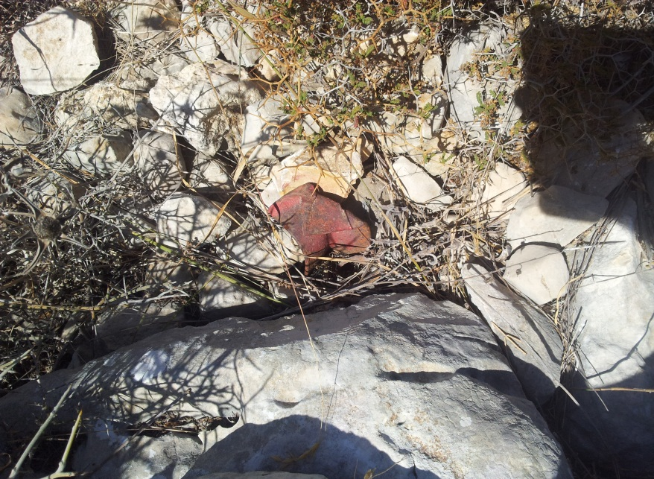
Table (5-67): Details of Trig (652W)
Date:- 21/08/2014 |  | Obs.Team:- Saleh natour, Abedalhafez almuhtaseb, Ala'a rjob, Samer Serhan
Point ID:- 652W |  | Instrument:- Leica Viva GS08
File Name:- Nablus VRS |  | Point Number:- 012
Obs. Time:- 08 : 54 : 00 |  | Accuracy:- 0.010 m
Coordinates | E | N | H
Registered | 175284.28 | 188513.36 | 602.11
Observe | 175283.90 | 188513.41 | 602.58
WGS1984 | 35° 15' 58.70084" E | 32° 17' 25.13290" N | 623.03
Description | This trig is located in the village of (Yasid)  on the rock
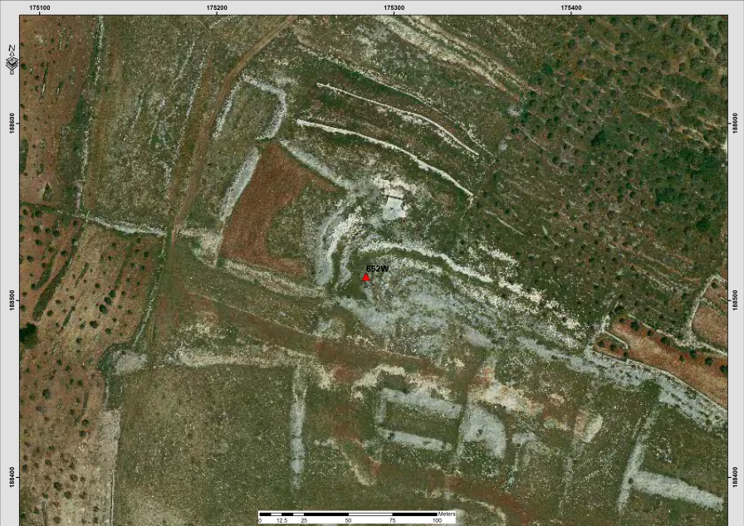
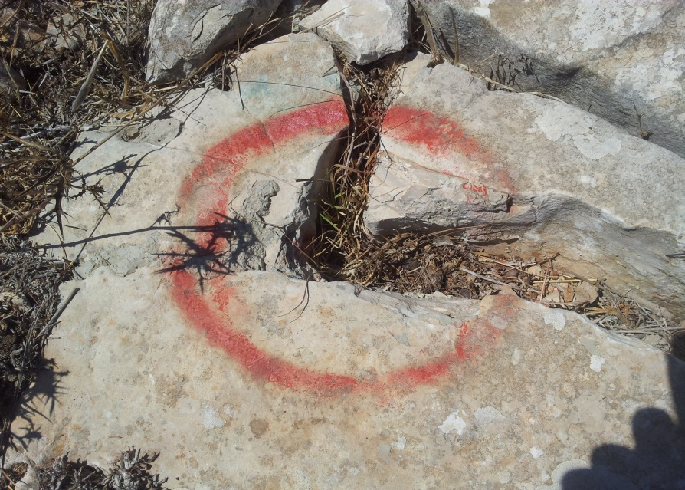
Table (5-68): Details of Trig (642X)
Date:- 21/08/2014 |  | Obs.Team:- Saleh natour, Abedalhafez almuhtaseb, Ala'a rjob, Samer Serhan
Point ID:- 642X |  | Instrument:- Leica Viva GS08
File Name:- Nablus VRS |  | Point Number:- 011
Obs. Time:- 08 : 36 : 00 |  | Accuracy:- 0.011 m
Coordinates | E | N | H
Registered | 173777.83 | 188618.92 | 548.15
Observe | 173777.63 | 188618.73 | 548.76
WGS1984 | 35° 15' 1.13533" E | 32° 17' 28.57651" N | 569.22
Description | This trig is located in the village of (Beit Imrin)  on the rock
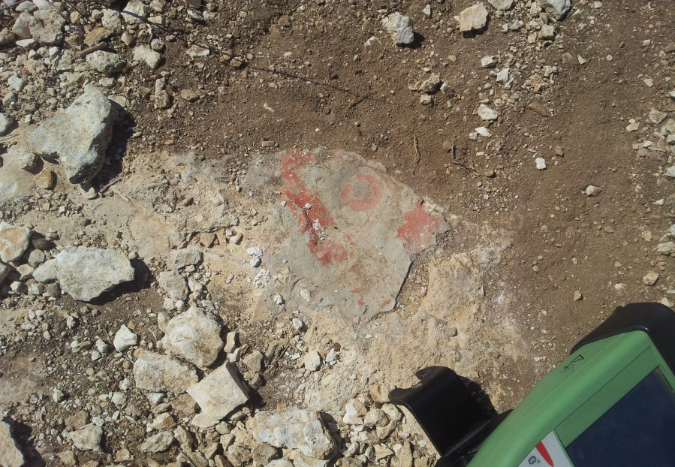
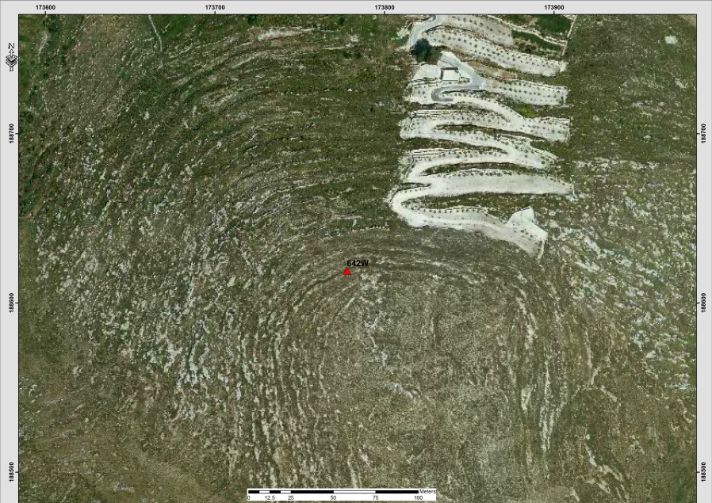

Table (5-69): Details of Trig (152B)
Date:- 21/08/2014 |  | Obs.Team:- Saleh natour, Abedalhafez almuhtaseb, Ala'a rjob, Samer Serhan
Point ID:- 152B |  | Instrument:- Leica Viva GS08
File Name:- Nablus VRS |  | Point Number:- 020
Obs. Time:- 10 : 32 : 00 |  | Accuracy:- 0.020 m
Coordinates | E | N | H
Registered | 176494.64 | 180216.24 | 600.78
Observe | 176494.86 | 180216.316 | 601.14
WGS1984 | 35° 16' 44.76134" E | 32° 12' 55.75240" N | 621.572
Description | This trig is located in the village of (Nablus)  on the rock
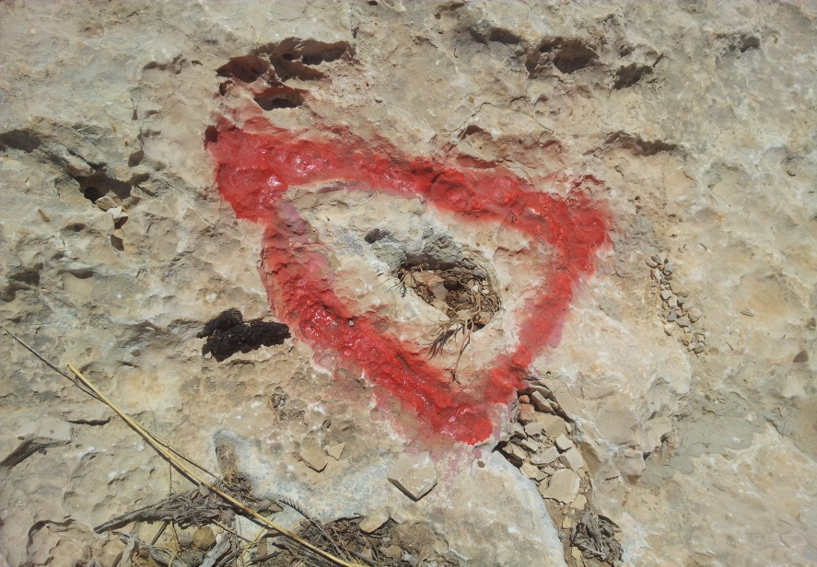

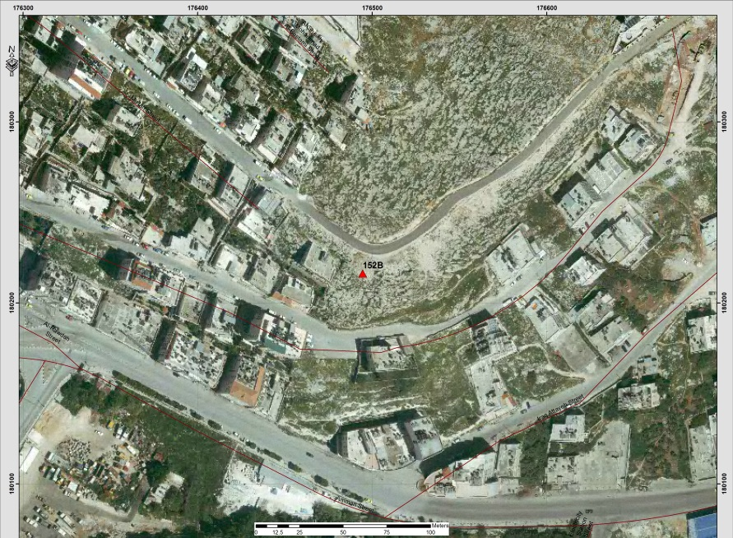
Table (5-70): Details of Trig (718T)
Date:- 21/08/2014 |  | Obs.Team:- Saleh natour, Abedalhafez almuhtaseb, Ala'a rjob, Samer Serhan
Point ID:- 718T |  | Instrument:- Leica Viva GS08
File Name:- Nablus VRS |  | Point Number:- 719
Obs. Time:- 11 : 12 : 00 |  | Accuracy:- 0.015 m
Coordinates | E | N | H
Registered | 168441.58 | 184299.89 | 370.43
Observe | 168441.386 | 184299.91 | 370.95
WGS1984 | 35° 11' 37.20657" E | 32° 15' 8.39958" N | 391.429
Description | This trig is located in the village of (Deir Sharaf)  on the rock
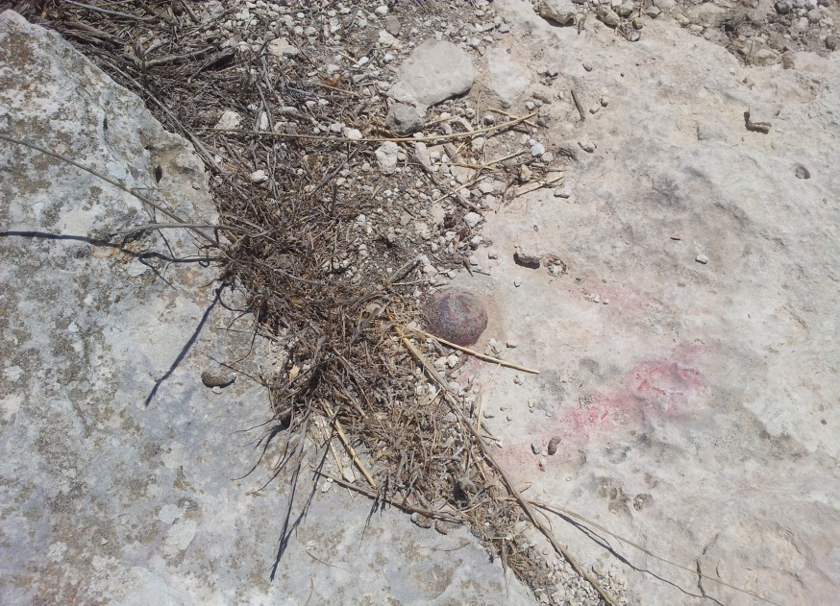
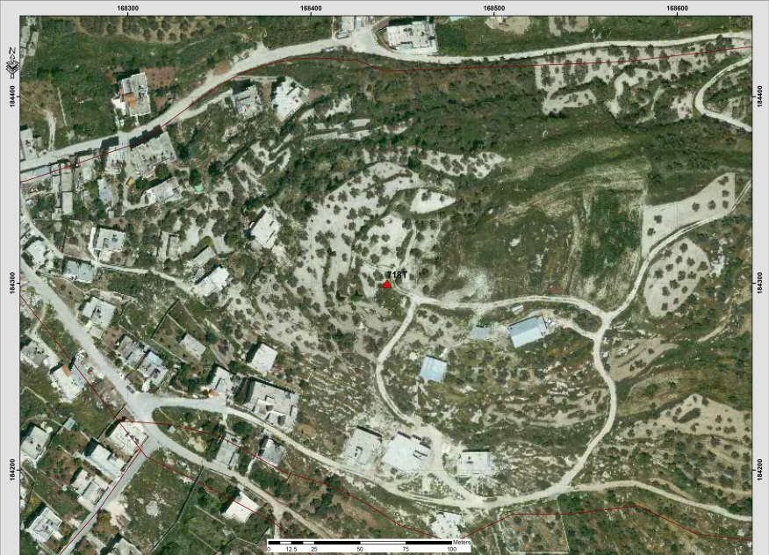

Table (5-71): Details of Trig (710T)
Date:- 2/5/2014 |  | Obs.Team:- Saleh natour, Abedalhafez almuhtaseb, Ala'a rjob, Samer Serhan
Point ID:- 710T |  | Instrument:- Leica 900
File Name:- Saleh VRS |  | Point Number:- 028
Obs.Time:- 16 : 42 : 21 |  | Accuracy:- 0.03 m
Coordinates | E | N | H
Registered | 169348.36 | 181306.00 | 568.55
Observe | 169348.11 | 181305.79 | 568.71
WGS1984 | 35° 12 11.84703" E | 32° 13' 31.20025" N | 589.16
Description | This trig is located in the village of Sara on the rock
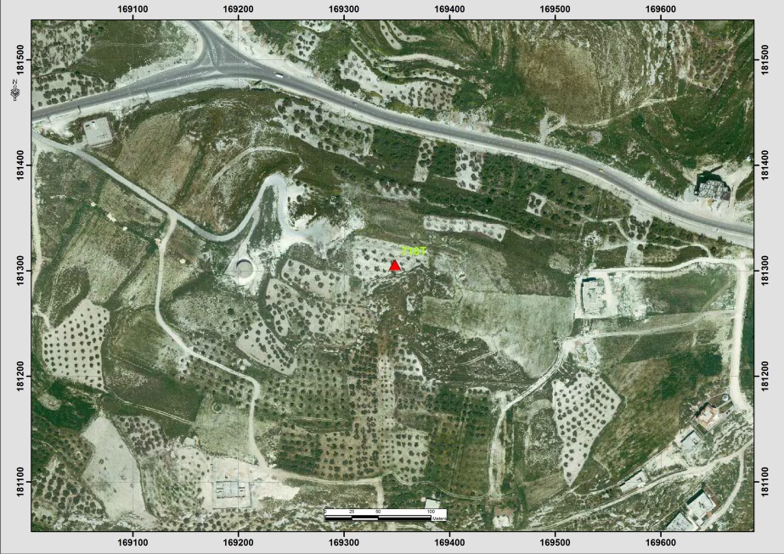

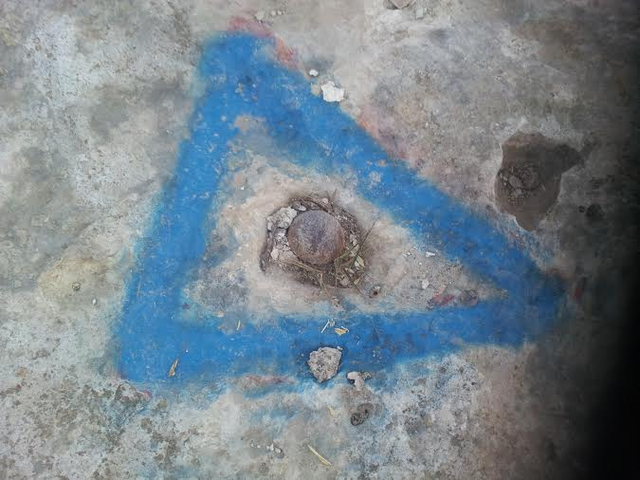
Table (5.72) also shows the information about points’ names and coordinates also it provides the location of the point according to the nearest town or city (Ramallah).
Table (5-72): Selected network points (Registered)
Point(name) | Easting(m) | Northing(m) | Elevation(m) | Location
979T | 165240.6 | 150347.93 | 751.35 | Ein Qiniya
676L | 169213.18 | 148845.37 | 845.65 | Surda
657L | 166751.52 | 147794.39 | 745.53 | Ramallah
986S | 170186.38 | 146463.99 | 871.41 | Al Bira
121Y | 171841.27 | 152650.15 | 713.1 | Ein Siniya
480T | 168216.57 | 143998.5 | 848.11 | Beituniya
2K | 169092.08 | 141297.74 | 810.02 | Qalandiya
215F | 178483.62 | 157845 | 791.77 | Abu Falah
189F | 160852.72 | 162614.21 | 477.84 | Kafr Ein
974T | 166120.91 | 154854.11 | 660.89 | Burham
220J | 157403.96 | 150943.13 | 423.78 | Bani Harith
218J | 157300.27 | 149898.38 | 397.28 | Bani Harith

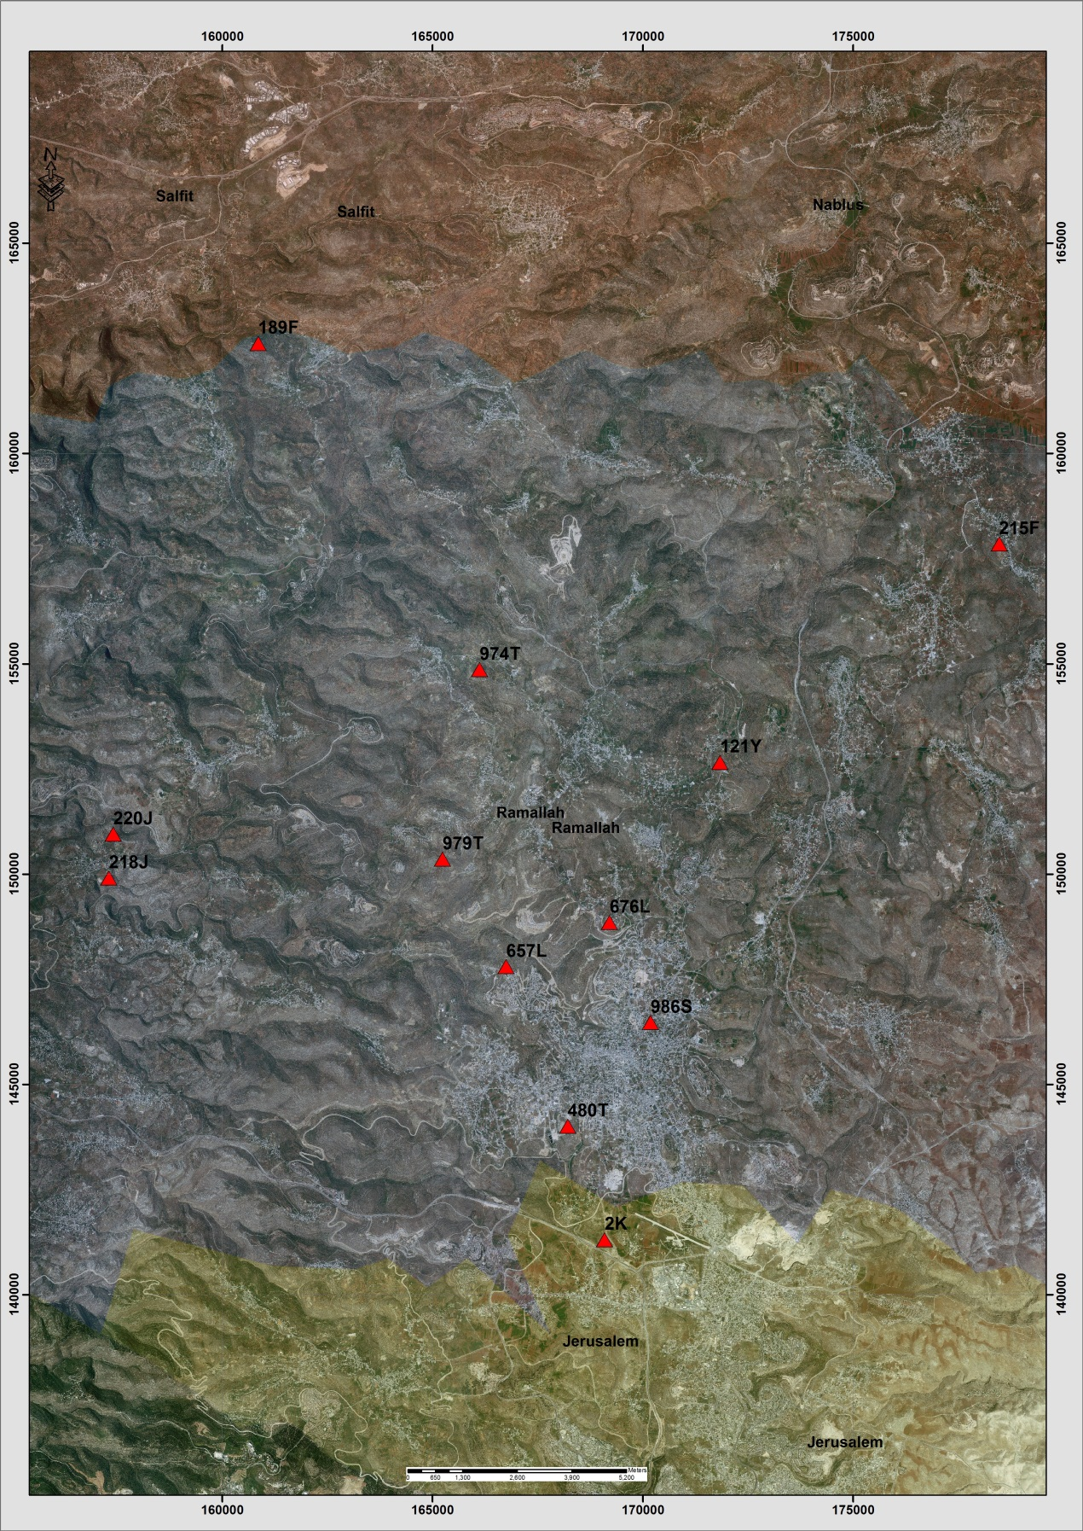
Figure (5-8): distribution of points within study area in Ramallah district.

Table (5-73): Details of Trig (979T)
Date:- 22/8/2014 |  | Obs.Team:- Saleh natour, Abedalhafez almuhtaseb, Ala'a rjob, Samer Serhan
Point ID:- 979T |  | Instrument:- Leica Viva GS08
File Name:- Ramallah VRS |  | Point Number:- 755
Obs.Time:- 09 : 01 : 00 |  | Accuracy:- 0.015 m
Coordinates | E | N | H
Registered | 165240.6 | 150347.93 | 751.35
Observe | 165240.61 | 150347.65 | 751.87
WGS1984 | 35° 9' 35.46578" E | 31° 56' 46.12556" N | 772.27
Description | This trig is located in the village of (Ein Qiniya) on the rock
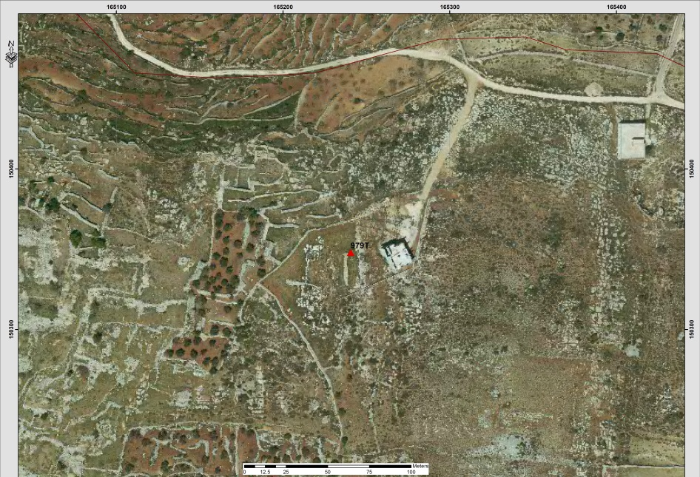

Table (5-74): Details of Trig (676L)
Date:- 22/8/2014 |  | Obs.Team:- Saleh natour, Abedalhafez almuhtaseb, Ala'a rjob, Samer Serhan
Point ID:- 676L |  | Instrument:- Leica Viva GS08
File Name:- Ramallah VRS |  | Point Number:- 759
Obs.Time:- 10 : 05 : 00 |  | Accuracy:- 0.018 m
Coordinates | E | N | H
Registered | 169213.18 | 148845.37 | 845.65
Observe | 169213.00 | 148845.467 | 846.04
WGS1984 | 35° 12' 6.71679" E | 31° 55' 57.38424" N | 866.424
Description | This trig is located in the village of (Surda) on the rock
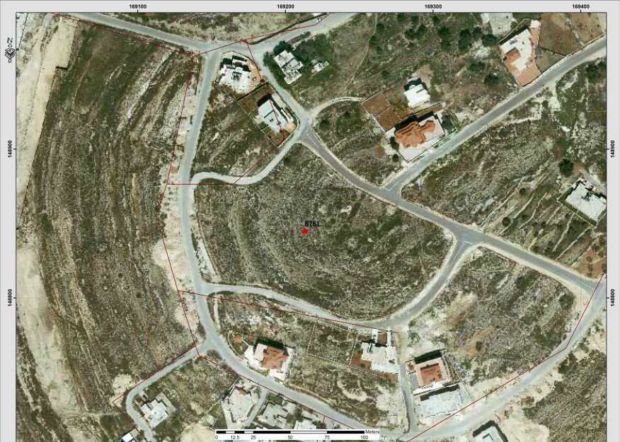

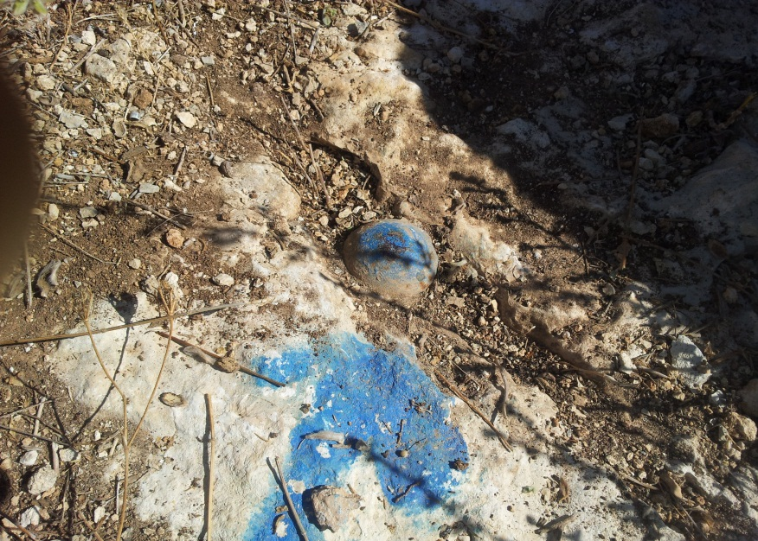
Table (5-75): Details of Trig (657L)
Date:- 22/8/2014 |  | Obs.Team:- Saleh natour, Abedalhafez almuhtaseb, Ala'a rjob, Samer Serhan
Point ID:- 657L |  | Instrument:- Leica Viva GS08
File Name:- Ramallah VRS |  | Point Number:- 761
Obs.Time:- 10 : 27 : 00 |  | Accuracy:- 0.019 m
Coordinates | E | N | H
Registered | 166751.52 | 147794.39 | 745.53
Observe | 166751.76 | 147794.26 | 746.75
WGS1984 | 35° 10' 33.02870" E | 31° 55' 23.24510" N | 767.14
Description | This trig is located in the village of (Ramallah) on the rock
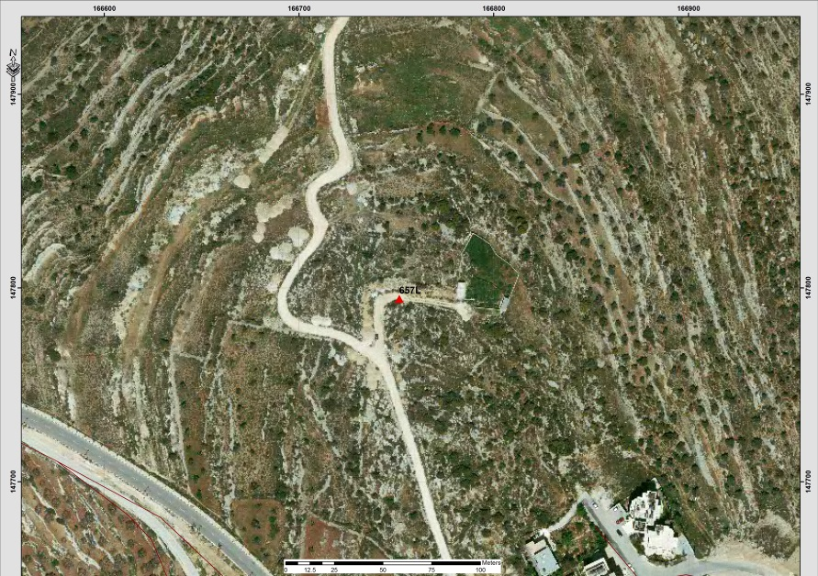

Table (5-76): Details of Trig (986S)
Date:- 22/8/2014 |  | Obs.Team:- Saleh natour, Abedalhafez almuhtaseb, Ala'a rjob, Samer Serhan
Point ID:- 986S |  | Instrument:- Leica Viva GS08
File Name:- Ramallah VRS |  | Point Number:- 763
Obs.Time:- 10 : 45 : 00 |  | Accuracy:- 0.016 m
Coordinates | E | N | H
Registered | 170186.38 | 146463.99 | 871.41
Observe | 170186.245 | 146463.937 | 871.90
WGS1984 | 35° 12' 43.76147" E | 31° 54' 40.06583" N | 892.278
Description | This trig is located in the village of (Al Bira) on the rock
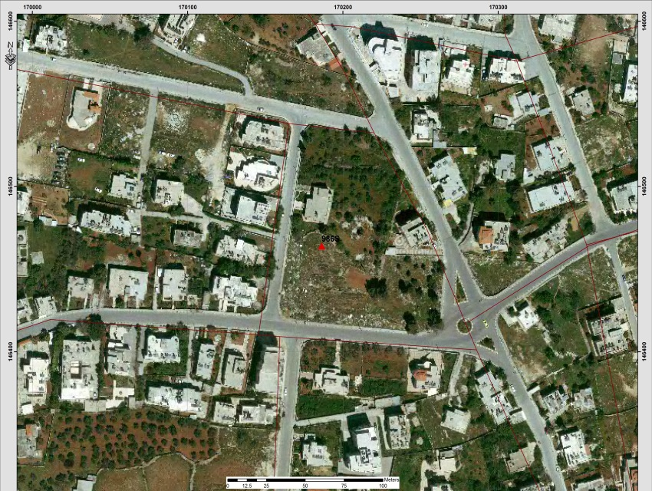
Table (5-77): Details of Trig (121Y)
Date:- 22/8/2014 |  | Obs.Team:- Saleh natour, Abedalhafez almuhtaseb, Ala'a rjob, Samer Serhan
Point ID:- 121Y |  | Instrument:- Leica Viva GS08
File Name:- Ramallah VRS |  | Point Number:- 757
Obs.Time:- 09 : 40 : 00 |  | Accuracy:- 0.019 m
Coordinates | E | N | H
Registered | 171841.27 | 152650.15 | 713.10
Observe | 171841.13 | 152650.17 | 713.61
WGS1984 | 35° 13' 46.80306" E | 31° 58' 0.89675" N | 733.99
Description | This trig is located in the village of (Ein Siniya) on the rock
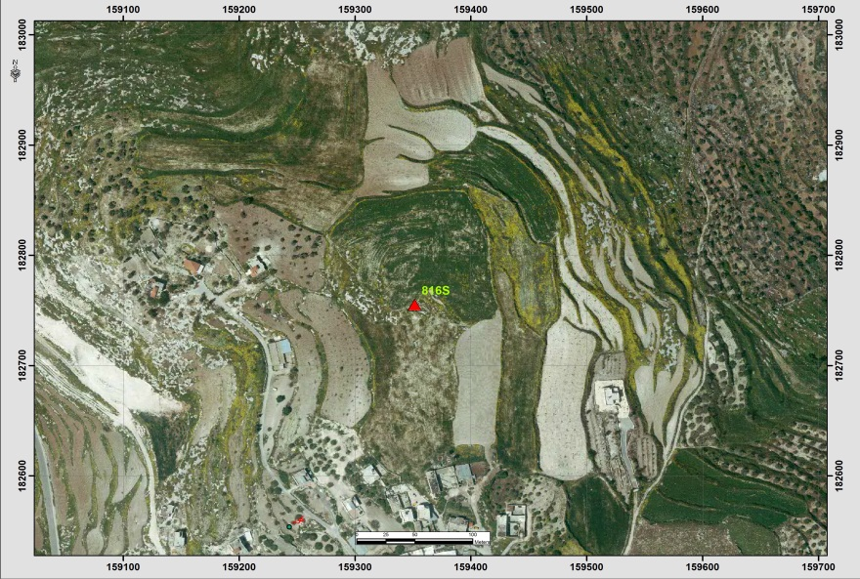
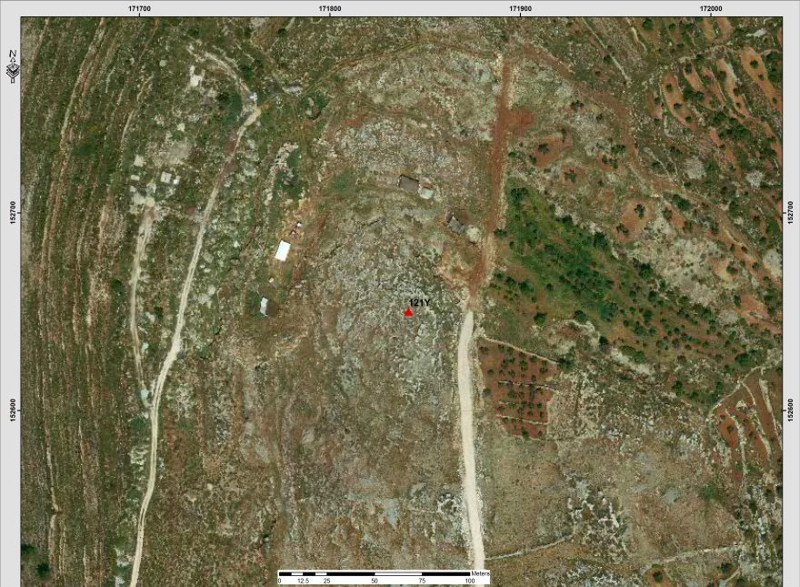
Table (5-78): Details of Trig (480T)
Date:- 22/8/2014 |  | Obs.Team:- Saleh natour, Abedalhafez almuhtaseb, Ala'a rjob, Samer Serhan
Point ID:- 480T |  | Instrument:- Leica Viva GS08
File Name:- Ramallah VRS |  | Point Number:- 765
Obs.Time:- 11 : 12 : 00 |  | Accuracy:- 0.015 m
Coordinates | E | N | H
Registered | 168216.57 | 143998.5 | 848.11
Observe | 168216.369 | 143998.476 | 848.58
WGS1984 | 35° 11' 28.79757" E | 31° 53' 20.02144" N | 868.958
Description | This trig is located in the village of (Beituniya) on the rock
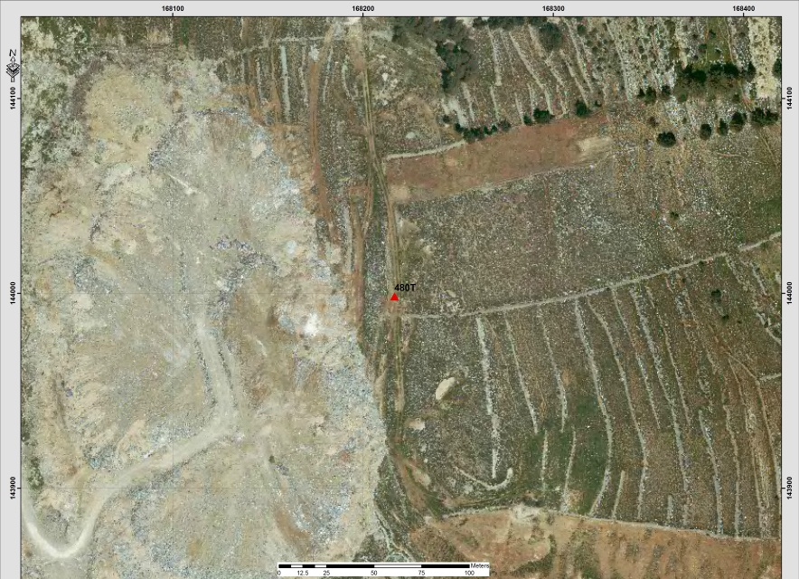

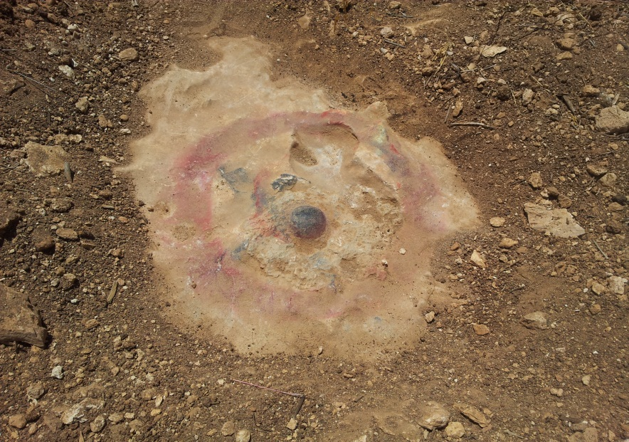
Table (5-79): Details of Trig (2K)
Date:- 22/8/2014 |  | Obs.Team:- Saleh natour, Abedalhafez almuhtaseb, Ala'a rjob, Samer Serhan
Point ID:- 2K |  | Instrument:- Leica Viva GS08
File Name:- Ramallah VRS |  | Point Number:- 772
Obs.Time:- 01 : 35 : 00 |  | Accuracy:- 0.021 m
Coordinates | E | N | H
Registered | 169092.08 | 141297.74 | 810.02
Observe | 169092.05 | 141297.88 | 810.51
WGS1984 | 35° 12' 2.12272" E | 31° 51' 52.34671" N | 830.87
Description | This trig is located in the village of (Qalandiya) on the rock
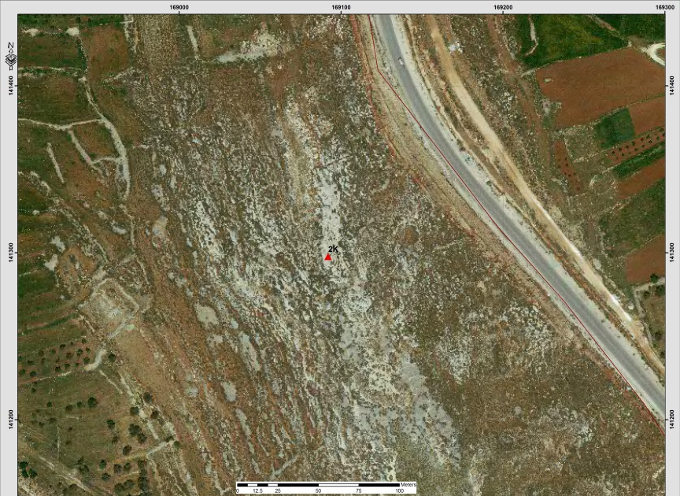
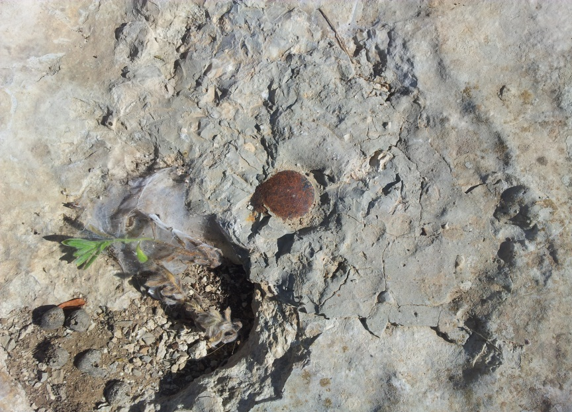
Table (5-80): Details of Trig (215F)
Date:- 22/8/2014 |  | Obs.Team:- Saleh natour, Abedalhafez almuhtaseb, Ala'a rjob, Samer Serhan
Point ID:- 215F |  | Instrument:- Leica Viva GS08
File Name:- Ramallah VRS |  | Point Number:- 775
Obs.Time:- 04 : 17 : 00 |  | Accuracy:- 0.012 m
Coordinates | E | N | H
Registered | 178483.62 | 157845.00 | 791.77
Observe | 178483.57 | 157845.13 | 792.24
WGS1984 | 35° 17' 59.94743" E | 32° 0' 49.43148" N | 812.60
Description | This trig is located in the village of (Abu Falah) on the rock
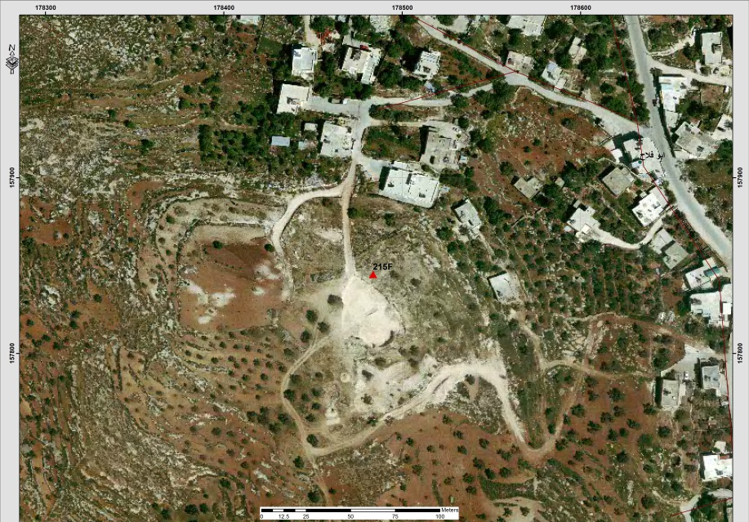
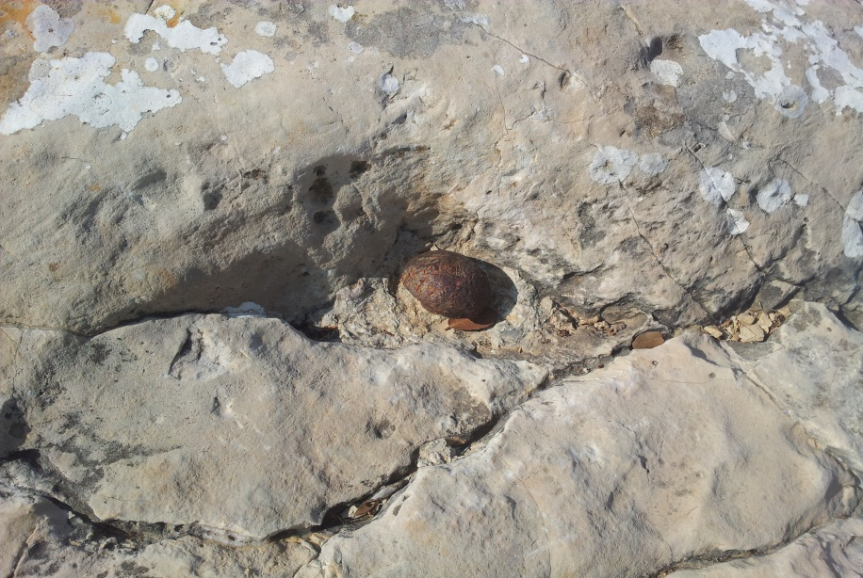
Table (5-81): Details of Trig (189F)
Date:- 22/8/2014 |  | Obs.Team:- Saleh natour, Abedalhafez almuhtaseb, Ala'a rjob, Samer Serhan
Point ID:- 189F |  | Instrument:- Leica Viva GS08
File Name:- Ramallah VRS |  | Point Number:- 751
Obs.Time:- 07:19 : 00 |  | Accuracy:- 0.018 m
Coordinates | E | N | H
Registered | 160852.72 | 162614.21 | 477.84
Observe | 160852.128 | 162613.61 | 477.98
WGS1984 | 35° 6' 47.97912" E | 32° 3' 24.25162" N | 498.43
Description | This trig is located in the village of (Kafr Ein) on the rock
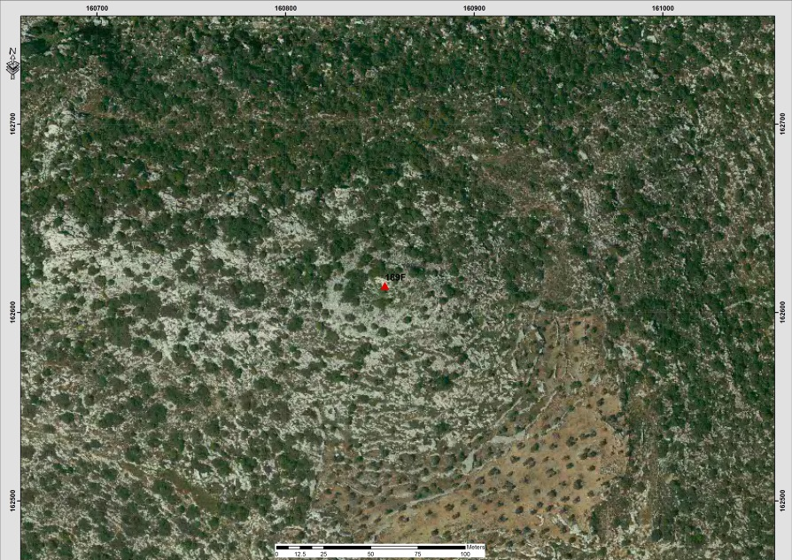
Table (5-82): Details of Trig (974T)
Date:- 22/8/2014 |  | Obs.Team:- Saleh natour, Abedalhafez almuhtaseb, Ala'a rjob, Samer Serhan
Point ID:- 974T |  | Instrument:- Leica Viva GS08
File Name:- Ramallah VRS |  | Point Number:- 753
Obs.Time:- 08 : 29 : 00 |  | Accuracy:- 0.016 m
Coordinates | E | N | H
Registered | 166120.91 | 154854.11 | 660.89
Observe | 166120.814 | 154854.02 | 661.42
WGS1984 | 35° 10' 8.92356" E | 31° 59' 12.43650" N | 681.832
Description | This trig is located in the village of (Burham) on the rock
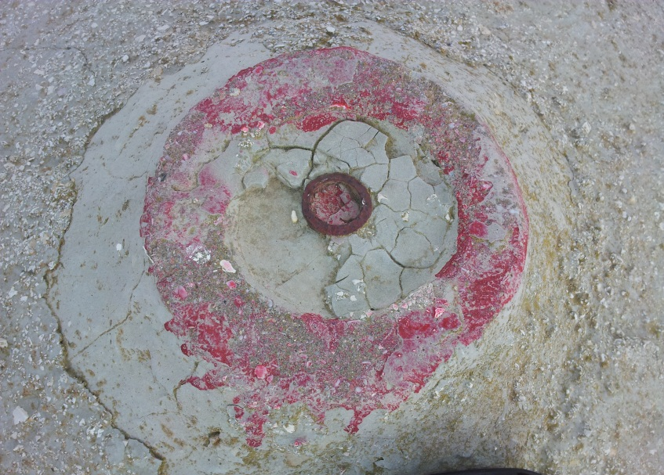
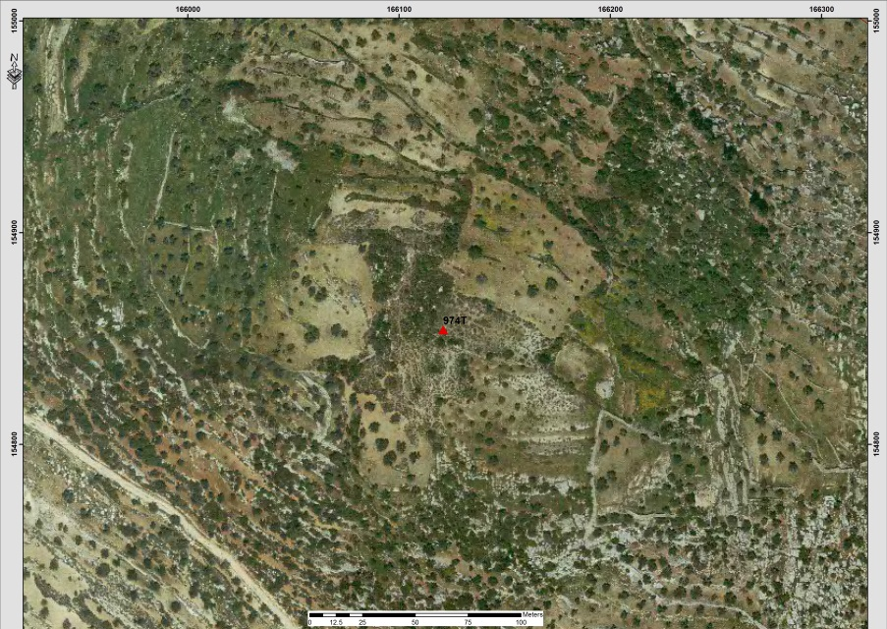

Table (5-83): Details of Trig (220J)
Date:- 22/8/2014 |  | Obs.Team:- Saleh natour, Abedalhafez almuhtaseb, Ala'a rjob, Samer Serhan
Point ID:- 220J |  | Instrument:- Leica Viva GS08
File Name:- Ramallah VRS |  | Point Number:- 769
Obs.Time:- 12 : 40 : 00 |  | Accuracy:- 0.020 m
Coordinates | E | N | H
Registered | 157403.96 | 150943.13 | 423.78
Observe | 157403.951 | 150942.834 | 424.24
WGS1984 | 35° 4' 37.05571" E | 31° 57' 5.24605" N | 444.68
Description | This trig is located in the village of (Bani Harith) on the rock
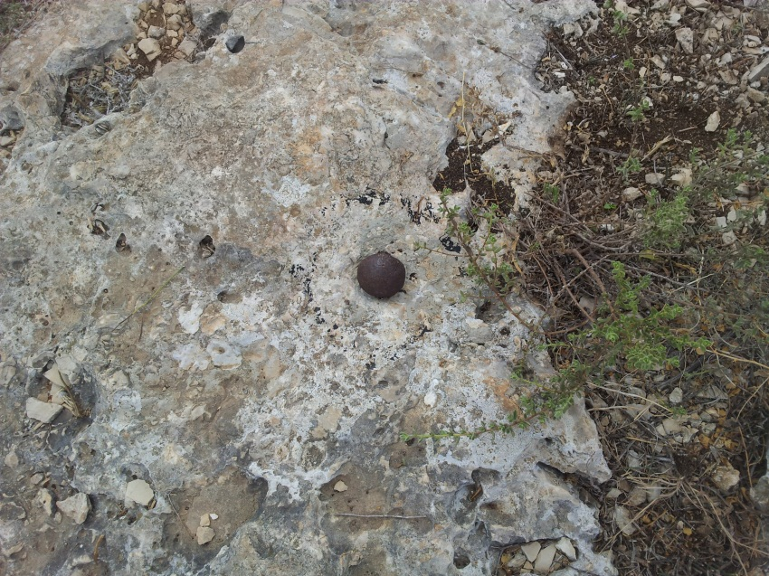

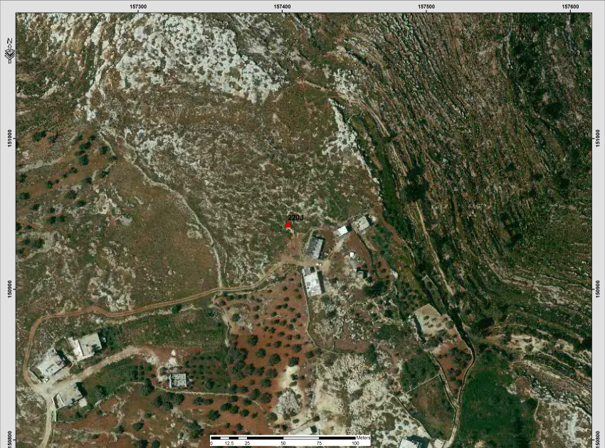
Table (5-84): Details of Trig (218J)
Date:- 22/8/2014 |  | Obs.Team:- Saleh natour, Abedalhafez almuhtaseb, Ala'a rjob, Samer Serhan
Point ID:- 218J |  | Instrument:- Leica Viva GS08
File Name:- Ramallah VRS |  | Point Number:- 768
Obs.Time:- 12 : 21 : 00 |  | Accuracy:- 0.020 m
Coordinates | E | N | H
Registered | 157300.27 | 149898.38 | 397.28
Observe | 157300.245 | 149897.999 | 397.77
WGS1984 | 35° 4' 33.15409" E | 31° 56' 31.32115" N | 418.205
Description | This trig is located in the village of (Bani Harith) on the rock
