
College of Engineering and Technology
Electrical Engineering Department
Power Engineering Program
Graduation Project

Educational Model Of Concentrating Solar Power System

Project Team
Mohammad Abu Zahra Mariam Awwad

Project Supervisor
Prof. Dr. Sameer H. Khader
Hebron-Palestine

2017

Palestine Polytechnic University
College of Engineering & Technology
Electrical Engineering Department
Hebron-Palestine
Educational Model of CSP System

Project Team
Mariam Awwad Mohammad Y. abu Zahra
According to the orientation of the supervisor on the project and the examined committee is by the arrangement of staffers all, sending in this project to the electrical engineering department are in the college of the engineering and technology by the requirement of the department for the step of the bachelors degree .

Project Supervisor signature
……………………………

Committee signature
………………….. ………………….

Department Head signature…………………
Dedication

We decide this simple work for:

To our parents

To our brothers

To our friends

To our nation

To any person working hard...

Acknowledgment

First and for most we should offer our thanks , obedience and gratitude for Allah.

Our appreciation to:

Our supervisor . Dr .Sameer Hanna Khader

Palestine polytechnic university

College of engineering & technology

Deanship of graduate studies & scientific research

Electrical engineering department

Anyone who helped us

Abstract

Energy sources such as solar power can be used to perform the work , the work obtained by use of sunlight concentrated on a fluid running in a tube, then the thermal energy resulted which can be converted to mechanical or electrical energy . theses process governed by thermodynamic cycles . the educational model of CSP system by using thermodynamic Rankin cycle .

The sunlight concentrated on a fluid running in a tube through parabolic trough , as a result of compressed and high temperature the fluid , then the fluid will evaporate and steam generate . the steam enters the turbine and rotate its blades to produce work at turbine shaft with no problems. the shaft is connected with DC generator to produce an electrical power. The exhaust steam from the turbine exhaust enters condenser which is fitting with that exhaust . the condensed steam can be reused .

ملخص

يتوفر العديد من مصادر الطاقة التي يمكن استغلالها في إنتاج أشكال أخرى من الطاقة . الطاقة الشمسية يمكن تجميعها واستغلال الطاقة الحرارية الناتجة منها لإنتاج طاقة تكون على شكل طاقة الكهربائية .

يعتمد المبدأ الأساسي للنظام على تركيز أشعة الشمس على سائل موجود داخل أنبوب , حيث يتم استغلال الطاقة الحرارية الناتجة من أشعة الشمس لتسخين السائل المجود في أنبوب من النحاس يتم ضغطه بواسطة مضخة (pump) ومن ثم يتم تسخين الماء الموجود في تنك خاص (special tank ) ويصل إلى درجة الغليان مكونا بخار الماء . ينتقل البخار داخل أنبوب نحاسي إلى التوربين , ثم يقوم البخار المضغوط بتحريك شفرات التوربين الذي يكون موصول مع عمود (shaft) يتحول الطاقة الحرارية إلى طاقة ميكانيكية على العمود التي يمكن استغلالها في إنتاج طاقة كهربائية من خلال وصل مولد مع التوربين بشكل مباشر أو من خلال بكرات . أيضا يمكن إعادة استخدام البخار الخارج من التوربين من خلال وصل مخرج بخار البخار مع المكثف (condenser) .

List Of Contents
Title …………………………………………………………………………………...1
Department head and supervisor signature…………………………2
Dedication…………………………………………………………………………..3
Acknowledgment………………………………………………………………..4
Abstract………………………………………………………………………………5
List of contents…………………………………………………………………7-9
List of figure……………………………………………………………………...10
List of tables………………………………………………………………………11
CHAPTER1 : Introduction
Introduction…………………………………………………………….14
Objectives of the project………………………………………15
Literature review………………………………………………..15
Budget estimation……………………………………………….16
Project scope………………………………………………………17
Time table…………………………………………………………..18
CHAPTER2 : Rankin cycle analysis and improvements
  - Introduction………………………………………………………20
  - The simple Rankin cycle……………………………………..21
  - Analysis of power cycle…………………………………22-24

CHAPTER3 : main components
Solar power……………………………………………………………26
Concentrating solar power type………………………26
Parabolic trough collector……..……………………26-27
Design formula……………………………………………….28

- Heat Collector Tub…………………………………………………30
Introduction…………………………………………………..30
Advantage of copper tub…………………………….30-31
Design analysis……………………………………………….31

Steam turbine………………………………………………………..32
Introduction…………………………………………………..32
Impulse steam turbine……………………………………32
Advantage of using steam turbine…………………...32

Steam condenser……………………………………………………33
Introduction……………………………………………...33-34
Surface condenser…………………………………………..34
Design analysis………………………………………….35-37

Hand Pump……………………………………………………………38
Introduction……………………………………………………38
Working principle of the hand pump………………..38
Pump component……………………………………….38-39
Design analysis………………………………………………..39

CHAPTER4: secondary component
DC generator…………………………………………………...40
Pressure gauge………………………………………………..40
RPM sensor………………………………………………………40
Temperature sensor………………………………………… 40
Voltage indicator ………………………………………………41
Ampere indicator………………………………………………41
Lamp……………………………………………………………….. 42
Special water tank …………………………………………… 42

CHAPTER5: experiment procedure and result
Purpose of the experiment………………………………… 44
Component of the system………………………………45-47
Experiment procedure……………………………………….48
Calculation result………………………….……………….49-51

CHAPTER6 : Conclusion , recommendations and problems
Conclusion …………………………………………………………52
Recommendation………………………………………………..52
Problems…………………………………………………………….52

List of figures

CHAPTER1 : Introduction
Schematic of the educational model CSP system……………14

CHAPTER2 : Rankin cycle analysis and improvement
Schematic and T-S diagram of the simple Rankin cycle….20
Schematic of Rankin cycle process ………………………………..21
Schematic of Rankin cycle efficiency ……………………………..24

CHAPTER3 :
Schematic of parabolic trough………………………………………27
the ideal of reflection from tow curved reflectors …………28
schematic of focal point………………………………………………..29

CHAPTER5 : Experiments procedure and result
project components ……………………………………………………..44
parabolic trough ………………………………………………………….45
steam turbine………………………………………………………………46
condenser……………………………………………………………………46
feed pump..………………………………………………………………….47
Relation between pressure an temperature…………………..49

List of tables

Table 1-1 budget estimation………………………………………………….15
Table 1-2 project time schedule for first semester………………….17
Table 1-3 project time schedule for first semester………………….18
Tables 5-1, 5-2 , 5-3 efficiency of the Rankin cycle…………..…49-51

CHAPTER ONE

INTRODCUTION

Introduction

Objectives of the project

Literature review

Budget estimation

Project scope

Chapter One : Introduction
Chapter Tow : Rankin cycle analysis and improvement
Chapter Three :The main component of the project
Chapter Four: The secondary components f the project

Table Time

Introduction

The energy resources available in nature such as wind , sunlight cannot be used directly of the application. these resources have to be transformed into a useful form such as heat or electricity before their use. For example , sunlight must first be use lenses or mirrors concentrate a large area of sunlight in to a small beam which reflect in a tube, then the thermal energy resulted , the conversion of heat energy (thermal) to mechanical or other forms of energy is governed by a series of thermodynamic process. Thermodynamic cycle is a series of thermodynamic process that used in power plants .

A station thermal power is a power plant in which the prime mover is steam driven . liquid is heated , turns into steam and spins a steam turbine which drives an electrical generator.

From here our project come as educational to be placed in laboratories which represent one of the ways to generate electricity using the sunlight to the problem of unclean nonrenewable energy.

As seen in the fig.1.1, the schematic of the educational model CSP system

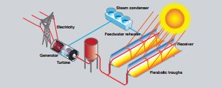fig.1.1: the schematic of the educational model CSP system

Objective of the project

The main purpose of this project is to establish and build an educational model of CSP system by using parabolic trough and Rankin cycle .

The importance for this project can be summarized in the following points :
- Educational model of CSP system .
- Concentrating solar power .
- Rankin cycle.
- Helps to understand the energy conversion .
- Review some of power plant improvement.
- Produce electricity from clear source .

1.3 Literature review

A CSP system is an assembly of a steam , where the electricity is generated by different of mechanical and electrical equipment with different process , the basic component of CSP model are parabolic trough , steam turbine, special tank, pump, DC generator, and tub.

Budget estimation

Table1-1 : Budget estimation
NO | Name of part | Cost(JD)
1. | Parabolic trough | 300
 | Heat collectors tube | 80
 | Water tank | 20
 | steam turbineTS-532 | 300
 | DC generator | 100
 | Condenser | 70
 | Other component | 280

Project scope

Chapter one : Introduction

This chapter , gives an introduction about the project, it clarifies the system as a practical idea and the table time.

Chapter two: Rankin cycle analysis and improvements

This chapter includes the analysis of the Rankin cycle that used in a steam power plants, and the possible improvements of the cycle .

Chapter Three :The main components of the project
This chapter descriptions of the concentrating solar power principle , also steam turbine, collector tub , DC generator, and pump.

Chapter four : the secondary components of the project

This chapter describes the secondary components that used between all the relevant system component , they are sensors, gauge, etc.

Time Table

Table1-2: project time schedule for first semester

Week  Process | 1 | 2 | 3 | 4 | 5 | 6 | 7 | 8 | 9 | 10 | 11 | 12 | 13 | 14 | 15 | 16
Collecting
date and literature
Analyzing of data
Calculations
Searching on the steam
Writing the documentation
Final presentation

Table1-3: project time-schedule for second semester

Week  Process | 1 | 2 | 3 | 4 | 5 | 6 | 7 | 8 | 9 | 10 | 11 | 12 | 13 | 14 | 15 | 16
Baying the steam turbine
Assembling the project
Check the project part
And perform the initial experiment
Perform final experiment
Writing the documentation
Final presentation

CHAPTER TWO
Rankin Cycle and improvements

Introduction

  - The simple Rankin Cycle

  - Analysis of the power Cycle

Introduction :
The Rankin cycle is thermodynamic cycle which converts heat into work . the heat is supplied externally to a closed loop . Rankin cycle is the one used in steam power plants. the most common fluid used in this cycle is water, but other fluid can also be used .

the simple Rankin cycle :
Rankin cycle is ideal cycle for vapor power plant , which is does not involve any internal irreversibility, the fig.2.1 shows the ideal Rankin cycle which it consist of Aathe following process :

- Process1-2 : Isentropic compression of the working fluid in the pump.
- Process2-3 : Heat addition to working fluid at constant pressure in water tank .
- Process3-4 : Isentropic expansion of in the working in turbine from water pressure on water tank to condenser pressure .
- Process 4-1: Heat Rejection from the working fluid at constant pressure in the condenser .

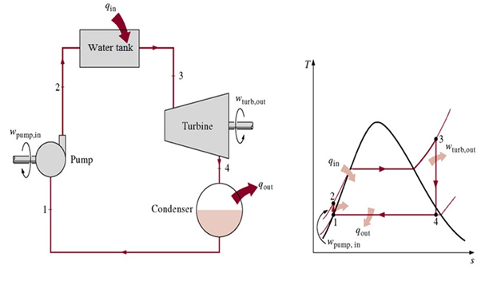

Fig.2.1: (a) the simple Rankin cycle; (b) temperature – enthalpy diagram
According to the fig.2.1 which explains the way of operating the cycle by sing the schematic and T-S diagram :
Water enters the pump at state 1 as saturated liquid and its compressed isentropicllay to the operating pressure of the water tank . the water temperature increases somewhat during this isentropic compression process due to a slight decreases in the specific volume of the water. The water enters the water tank as a compressed liquid at state 2 and will leave it as a superheated vapor at state 3, when enters as superheated it will enters turbine, where it expands isentropically and produces work by rotating the shaft connecting to electrical generator . the pressure and temperature of steam drop during this process to the values at state 4 , where steam enters the condenser . at this state , steam usually a saturated liquid –vapor mixture with a high quality [1].

Steam is condensed at constant pressure in the condenser, which is basically a large heat exchanger, by rejecting heat to a cooling medium such as river and lake , steam leaves the condenser as saturated liquid and enters the pump , completing cycle . The fig.2.2 shows the Rankin cycle process .

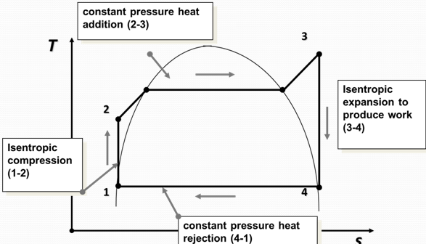
Fig.2.2 : Rankin cycle process

Analysis of the power cycle
In the Rankin cycle steam the main four components(turbine, pump, condenser, water tank) which these devices steady-flow, so the analysis of all processes can be done under stead-flow process. The potential and kinetic energy changes in the steam small so are neglected, so:

$\left(qin-qout\right)+\left(win-wout\right)=\left(hin-hout\right)$ (2.1)

When the pump and turbine assumed to be isentropic (process1-2) the conversion energy of each one as following:

$$pump work\left(q=0\right)$$
$Wp,in=h2-h1$ (2.2)

Where $h1$the enthalpy of liquid at condenser pressure$p4$, and $h2$is the enthalpy of liquid at state 2 .

Now, in the process (2-3) for constant heat , where it dose not involve work(w=0) as follows :

$qin=h3-h2$ (2.3)
For the process (3-4) isentropic expansion in turbine which (q=0) as follows:

$WT,out=h3-h4$ (2.4)
For last process(4-1) the condenser dose not involve any work condenser(w=0) as below:
$qout=h4-h1$ (2.5)
Finally the thermal efficiency of the Rankin cycle can be determined by the ratio of the area enclosed by cycle on T-S diagram as shown in fig.2.3 to the area under the heat addition process, another way shown as follow :

$Wnet=WT,out-WP,in$ (2.6)
$ᶯ=\frac{Wnet}{qin}=1-qout/qin$ (2.7)

But there is a little change in the liquid density or specific volume due to increase of pressure because pump handles water handles water which is incompressible that causes increasing pressure. For reversible adiabatic compression we using general property relation, we get

$Tds=dh-vdp$ (2.8)
$dh=vdp$ (2.9)

After integration we get the final equation as follow:
$hf1-hf4=v\left(p3-p4\right)$ (2.10)

for small quantity of ( $hf1-hf4$ ) of pump compared with turbine work $WT,out$ an at low pressure of boiler, is usually neglected. Then the equation of Rankin cycle efficiency became as below :

$ᶯ=\frac{h2-h3}{h2-hf1}$ (2.11)

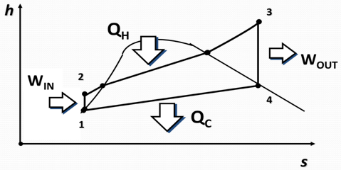
Fig.2.3 :Rankin cycle efficiency

CHAPTER THREE
Main Components

Solar power
Concentrating solar power
Highly concentrated
Parabolic trough collector
Design formula

Heat collector tub
Introduction
Advantages of copper tub
Design formulas
Design analysis

Steam turbine
Introduction
Impulse steam turbine
advantages of using steam turbine
Steam condenser
Introduction
Surface condenser
Advantages and disadvantages of condensers
Design analysis
Design formula
Introduction
Working principle of the handle pump
Pump component
Design analysis

Solar power

is the conversion of sunlight into electricity . either directly using photovoltaic (PV), or indirectly using concentrated. Concentrated solar power systems (CSP) use lenses or mirrors to concentrated a large area of sunlight into a small beam.

Concentrating solar system

Also called "concentrating solar thermal" , uses lenses or mirrors to concentrated a large area of sunlight into a small beam . contrary to photovoltaic –which converts light directly into electricity –CPS uses the heat of the suns radiation to generate electricity from conventional steam-driven turbines .

A wide range of concentrating technology exist, which can classified as:
- Central receiver .
- Linear Fresnel reflector(LFR).
- Parabolic trough.
- Parabolic dish .

A various technique are used to track the sun and concentrated light . in all of these systems are working fluid is heated by the concentrated sunlight , and then is used for power generation or energy storage . thermal storage efficiently allows up to 24- hours electricity generation.

Parabolic trough collector

Are assembled from three main functional units : the concentrator a mirror trough with a parabolic –shaped cross -section , uses a tracking device to track the curse of the sun so that the incident radiation is concentrated along the focal line on the absorber tub or receiver tub . the collectors are normally aligned in a north-south orientation so that shortly after sunrise the light from the low lying sun in the east is almost vertically incident in the parabolic opening . during the course of the day the sun (in the north hemisphere) moves south wards and its light falls at an increasingly oblique angle on the collector. The sunrays continue to concentrated through the tracking parabolic aperture onto the absorber tub but are reflected back across a longer distance .

The inclined incident sunlight causes the radiation energy captured per unit area to be correspondingly reduced relative to the cosine of the incident angle (cosine effect) . in addition the inclined reflected sunray in the north end of the collector miss the absorber tub , this is known as end loss, in order to reduce relative proportion of these end losses . the parabolic troughs are constructed to be as long as possible.
Because the solar radiation during the morning s and evenings is weakened relative to midday as a result of the longer path through the atmosphere , on a cloudless day the usable energy per collector surface is fairly evenly spread cross the day , fig.3.1 shows the parabolic trough .
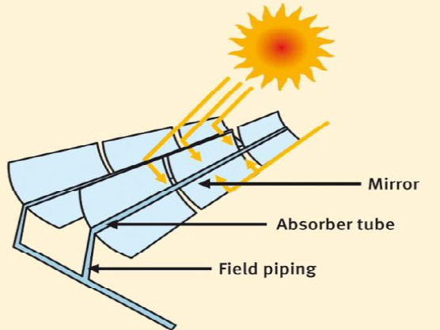
Fig.3.1 : parabolic trough collector

Highly concentrated
The most important properties for an efficient concentrating are a highly Specula reflectance for light of all wavelengths in the solar spectrum as well as precise parabolic shape. Specula reflectance means that as many rays possible are reflected according to the "angle of incident equals the angle of reflected" law and as few rays as possible are absorbed or scattered .

deviation in the parabolic shape cause the radiation to "miss" the absorber tub as shown in the fig.3.1 .

Design formula
Parabolic solar reflector and focal point : is concave mirrors and reflectors used inside telescopes and satellite dish , not any concave shape it used a parabola shaped because it has focal point unlike circular shape that dose not have focal point , fig.3.2 shows the ideal of reflection from tow curved reflectors .

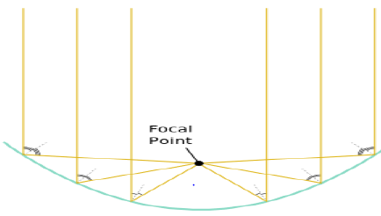

fig.3.2 :The ideal of reflection from tow curved reflectors .

To design a special parabola we need the equation of parabola and the focal length to determine the focal point location that will be used to determine the location of heating collector tub .fig.3.3 shows how it can be to determine focal point .
the parabolic general equation :
$y=ax^{2}$ (3.1)
$a$fraction used to determine the width of the parabola .
For our project we will $a=\frac{1}{40}$ for suitable parabola length . then the equation it will became as follow :

$y=\frac{1 }{40}x^{2}$ (3.2)
To determine the focal length as follow :

$focal length=\frac{1}{4}*\frac{1}{a}$ (3.3)
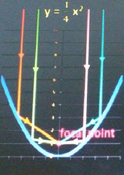
Fig .3.3: focal point

Heat collector tub

Introduction
Copper tubing is most often used for supply of hot and cold tap water, and as refrigerant line in HVAC systems. There are two basic types of copper tubing , soft copper and rigid copper. Copper tubing is joined using flare connection , compression connection, or solder. Copper offers a high level of corrosion resistance , but becoming very costly .

Advantages of copper tub
Strong, corrosion resistance , copper tub is the leading choice of modern contactors for plumbing ., heating and cooling installations in all kinds of residential and commercial buildings. There are seven primary reasons for this [2].

- Economical
The combination of easy handling, forming and joining permits savings in installation time, material and overall costs. Long term performance and reliability mean fewer callbacks, and that makes copper the ideal cost – effecting tubing material .
- Lightweight
Copper tub does not require the heavy thickness of ferrous or threaded pip of the same internal diameter. This means copper costs less to transport, handles more easily and, when installed , takes less space.

- Formable
Because copper tub can be belt and formed, it is frequently possible to eliminate elbows and joints. Smooth bends permit the tub to follow contours and corners of almost any angle .

- Easy to joint
Copper tub can be joined with capillary fittings. These fittings save material and make smooth, neat, strong and leak – proof joints. No extra thickness or weight is necessary to compensate for material removed by threading .

- Safe
Copper tube will not burn or support combustion and decompose to toxic gases. Therefore, it will not carry fire through floors, walls and ceilings .

- Resists corrosion
Excellent resistance to corrosion and scaling assures long, trouble – free service, which means satisfied customers .

System Design
- The steam flow rate through the tube can be expressed as follow:
$ṁ=ρ*v*A$ ( 3.2.1)
Where:
$ṁ:$ tank flow rate (m3/s)
$ρ$ : steam density (kg3/m3)
$v$: steam speed in tub(m/s)

- The inlet diameter of tube from the tank to the turbine is a standard value equals to $D=\frac{3}{16}$ and is a catalogue value which exist in the reference .
Steam turbine
Introduction
The steam turbine is the prime mover in which the potential energy of the steam is transformed into kinetic energy, and later in it is transformed into mechanical energy if form of rotation of the turbine shaft. The turbine shaft, directly or with other helping devices or tools, is connected with the driven mechanism .

Impulse steam turbine

For impulse steam turbines, the steam enters from nozzle to blades, which blades start moving and making work .

An impulse turbine has fixed nozzles that orient the steam flow into high speed jets. These jets contain significant kinetic energy, which is converted into shaft rotation by rotor blades, as the steam jet changes direction. A pressure drop occurs across only the stationary blades, with a net increase in steam velocity across the stage. As the steam flows through the nozzle its pressure falls from inlet pressure to the exit pressure. Due to this high ratio of expansion of steam, the steam leaves the nozzle with a very high velocity. The steam leaving the moving blades has a large portion of the maximum velocity of the steam when leaving the nozzle.

Advantages of using steam turbine
There are many advantages of using steam turbine :
- High thermal efficiency .
- The steam turbine provides a higher output power and can used in large station.
- The steam turbine does not require internal lubrication as there are no friction parts .
- In a steam turbine there is no losses due to initial condensation of system.
- Obtaining high speed range.

Steam Condenser

Introduction

In surface condensers, the exhausted steam and water don’t come into direct contact. The cooling water passes through tube and steam uniformly distributed over cooling water tube for obtaining best works. When the steam contacts are relatively cold tubes, its condenses. This condensing effect is a rapid change in the state from vapor to liquid.
The air must be prevented from leakage in the condenser for better efficiencies. The leakage of the air can causing the following effects:

1) Increased requirements of cooling water:
Leakage the air in the condenser lowers the partial pressure of steam. The saturation temperature of the steam lowered, that increases the potential heat. Increasing in the potential heat requires to increase in the amount of cooling water.

2) Decreasing the thermal efficiency:
Leakage the air in the condenser increases the back pressure on the prime mover. That increases the losses of heat drop, as heat losses increased the thermal efficiency decreases.

3) Reduced heat transfer:
Leakage the air in the condenser reduces the rate of heat transfer from the steam because the air has poor thermal conductivity, so the surface of the tubes of a surface condenser increased for a given condenser capacity.

Advantages and disadvantages of surface condenser:

Advantages:

- It gives a pure condensate which can be re circulated as
feed water to the tank.

- By regulating the flow of cooling water, the cooling of
condensate can be controlled.
- By reusing the condensate, which saves the cost of fresh water to be circulated and the cost of its chemical treatment.

Disadvantages:
- large amounts of cooling water requires.

- The construction is complicated and requires higher installation cost .

3.4.3 Design Formula :

Speed of the steam output from the nozzle mustn’t exceed the sound speed . this prevent the nozzle choke , so $Vsound =340 ,\left(\frac{m}{s}\right)$
$\dot{\dot{m}=ρ×Vsound ×An}$ (3.5.1)

Where
$\dot{m}$:Mass flow rate of steam (kg/s)
$ρ$: Steam density (kg/$m^{3}$)
An: nozzle area($m^{2})$

The required reaction from the condenser is :
$Qout=\dot{m}s ×qout$ (3.5.2)
Where
Qout: condenser heat output (Wat)
qout :the cycle work (kj/kg)

Reynolds number :
$Re=\frac{D×u}{v}$ (3.5.3)

Where
Re: Reynlod number . dimension less.
D: pipe diameter (m)
u : flow in pipe (m/s)
v : kinematic velocity ($m^{2 }$)

Nusselt number :
$Nu turbulent flow=0.023×{Re}^{0.8}×{Pr}^{n}$ (3.5.4)
$Nu=\frac{h×D}{k}$ (3.5.5)
Where
Nu: Nusselt number .
h : Heat transfer coefficient (W/$m^{2}K)$
n : 0.3 for cooling and 0.4 for heating .
k : conductivity (W/m.C°)

the overall heat transfer coefficient :
$Q=U×A×{∆T}_{m}$ (3.5.6)
$U=1/{\frac{1}{h_{i}}+\frac{A_{i}ln({r_{o}}/{ri})}{2πkL}+\frac{A_{i}}{A_{o}}\frac{1}{h_{o}}}$ (3.5.7)
${∆T}_{m}=\frac{(T_{h2}-T_{c2})-(T_{h1}-T_{c1})}{ln⁡[\frac{(T_{h2}-T_{c2})}{(T_{h1}-T_{c1})}]}$ (3.5.8)

Where
U: overall heat transfer coefficient (W/$m^{2}C°)$
$∆T$: mean temperature difference
Ai,Ao: inner and outer diameter of tube (m²).
L: tube length (m).
Th,Tc: temperatures for hot and cold fluids (C°or k)
Calculation :

$$\dot{m}=ρ×vsound×An$$

$$\dot{m}=1.13×340×4.4533×{10}^{-6}=1.7×{10}^{-3}kg/s$$

$$Qout=\dot{m}×qout$$
$$Qout=1.7×{10}^{-3}×2099.5×{10}^{3}=3570 W$$

For water , assume flow speed 1m/s and Pr=1.8 and k=0.66
Di=0.006 m and Do=0.012 m
Find ho
$$Re=\frac{Do×u}{v}$$
$$Re=\frac{0.012×1}{0.478×{10}^{-6}}=25104$$

When 2500<Re<1.25$×{10}^{5}$ the Nusslet number is

$$Nu turbulent flow=0.023×{Re}^{0.8}×{Pr}^{n}$$
$Nu turbulent flow=0.023×{25104}^{0.8}×{1.8}^{0.3}$=90.78

$$Nu=\frac{ho×D0}{k}$$

$$ho=\frac{90.78×0.66}{0.012}=4993W/{m^{2}.k}$$
find hi

$$Re=\frac{Di×u}{v}$$
$$Re=\frac{0.0061×1}{0.478×{10}^{-6}}=12761.5$$

$Nu turbulent flow=0.023×{12761.5}^{0.8}×{1.8}^{0.3}$=52.7

$$hi=\frac{52.7×0.66}{0.0061}=5704.5W/{m^{2}.k}$$

When

$T_{h1}=100C°,T_{h2}=70C°$,$T_{c1}=50C°,T_{c2}=25C° and$
$$K for copper=401 W/(m.k)$$

$${∆T}_{m}=\frac{(T_{h2}-T_{c2})-(T_{h1}-T_{c1})}{ln⁡[\frac{(T_{h2}-T_{c2})}{(T_{h1}-T_{c1})}]}$$

$${∆T}_{m}=\frac{\left(70-25\right)-\left(100-50\right)}{\ln\left[\frac{\left(70-25\right)}{\left(100-50\right)}\right]}=47.45C°$$

$$\frac{1}{h_{i}×r_{i}}=0.058$$

$$\frac{1}{h_{o}×r_{o}}=0.033$$
$$\frac{\frac{1}{K}}{ln⁡({r_{o}}/{r_{i}})}=0.0017$$
$$Q=U×A×{∆T}_{m}$$

$$3570=\frac{2π×L×47.45}{0.058+0.033+0.0017}$$

L=1.77 m the length of double pipe heat exchanger .

  - Hand pump

    - Introduction

Hand pump are manually operated pumps, they use human power and mechanical advantage to move fluids or air from one place to another. They are widely used in every country in the world for a variety of industrial, marine, irrigation and leisure activities .there are many different types of hand pump available, mainly operating on a piston, diaphragm or rotary vane principle with a check valve on the entry and exit ports to the chamber operating in opposing directions. Most hand pumps have plungers or reciprocating pistons, and are positive displacement.

    - Working principle of the hand pump

The simple hand pump works by using input and output ports, check valves, cylinder , piston , seal and handle. The working principle of the pump as the following:
- Suction: the fluid entrance in the pump by input port when the handle move clockwise (back ward), the piston in the intake stroke.
- Discharge: the fluid exits from the pump by output port when the handle move counter clock wise(in ward), the piston in the exhaust stroke .

    - Pump component:

The components of the simple hand pump, which contains :

- Body and cylinder: the body and cylinder connected with each other by wilding. The diameter of the cylinder is 1.5inch and the length of the cylinder is 12cm, the type of material for the cylinder and body is brass to prevent corrosion .
- Piton : the type of material used for the piston a aluminum, the length of the piston is 5cm and the diameter of the piston is less than 1.5inch so to maintain the clearance distance.
- Ring: the purpose of using ring is prevent leakage.
- One way valve: the purpose of using one way valve or (check valve) is to make liquid passing in on direction and prevents return of fluid. the diameter of the check valve is 0.5inch .
- Lever: the type of the material used is steel. The purpose of using lever is to moving the piston to make suction and discharge .

    - Design analysis
The mass flow rate of the hand pump can be find as the following:

$ṁpump=\frac{π}{4}d^{2}Nlµ.$ (3.5.4.1)

$µ.=µv*µm$ (3.5.4.2)

$µv=\frac{Qa}{Qth}$ (3.5.4.3)

$µm=\frac{Tth}{Ta}$ (3.5.4.4)

$$where :$$
$$N:number of moving lever(suction and discharge)$$
$$d:piston diameter(m)$$
$$L: cylinder length(m)$$
$$µ.: overall efficiency$$
$$µm: mechanical efficiency$$
$$Q th: theoretical flow rate$$
$$Qa: actual flow rate$$
$$Tth: theoritical torque$$
$$Ta: actual torque$$

CHAPTER FOURE
Secondary component

- DC generator
Generator is a device that directly convert mechanical into electrical energy by a incorporating a miniature permanent –magnetic generator. The mechanical input power could be device from intermittent movements, which might be associated with the random motion of a limb. Linear permanent –magnetic generators systems which are capable of extracting and storing energy from both reciprocating and intermittent motion.

Its specifications as follow :

- DC Generator Hand Dynamo Hydraulic Test 5v/6v/12v/24v.
- Motor Output voltage: 5V-24V.
- Turn faster, the voltage is higher. The maximum load voltage is 40
- Maximum output current exceeds: 1500mA.
- Maximum load power: 20 watts.
- Length: 130mm.
- Motor diameter: 35mm.
- Shaft length: 22mm.
- Shaft diameter: 8mm.
- Material: Plastic, iron.
- Weight: 400g.

- Pressure gauge
Pressure gauge or barometer is device used to measure the pressure of the water , steam ,etc. The pressure gauge used to measure pressure in the tank pressure range 0 to 10 bar. Also , the pressure in all relevant system is opened to the atm.

- RPM sensor
It used to measure turbine speed and display reading by digital display screen (Tachometer).Its reading value between 60-9999 rpm.

- Temperature sensor
thermocouple sensor for temperature in the tank , it consist of two consist of two dissimilar metals .joined together at one end.
When the junction of the two metals is heated or cooled a voltage is produced that can be correlated back to temperature .

Technical specification for J-type sensor:
- Temperature range 0-750 C.
- Standard limits of error above 0C : greater of 2.2C or 0.4%.

- Voltage indicator
Voltage indicator is a device that indicates the output volt from the generator by connection wires.

- Ampere indicator
Ampere indicator is a device indicates the output ampere from the generator by connection wires.

- Lamp
Lamps used to prove that the project produce electrical power.

- solar absorber tube
Specifications :
- 20 1/2" long (about 500mm)
- 1/4" outside diameter (about 58mm)
- 3/4" inside diameter (about 43mm)
- Double wall structure with vacuum between walls
- Super-absorbent inner tube coating quickly soaks up solar energy Steel, aluminum, and copper coatings for infrared reflective insulation
- Incredible thermos-like properties can keep water hot even over night

CHAPTER Five

Design Verifications & Results

Purpose of the experiment

Component of the system

Experimental procedure

Test results

5.1Purpose of the experiment
The aim of this experiment to understand the educational module of CSP system a detail of each component, to produce electricity , conduct the experiment and gather data analyze the system with obtained data.

Component of the system

Fig.5.1 illustrates the whole components of the system. Each component explained in last chapter.

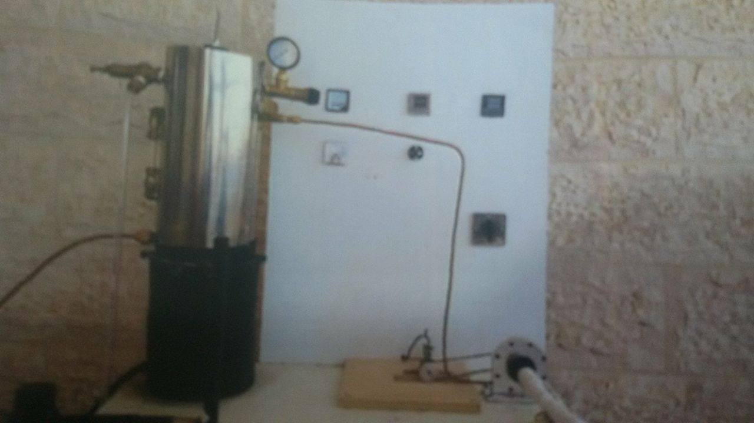

Fig 5.1 project component

- parabolic trough
as shown in the fig.5.2 the parabolic trough with its components . a mirror trough with a parabolic shaped cross section, using a track device to track the sun , and absorber tub which carry fluid , The dimension of parabolic 30cm length and 10cm width .

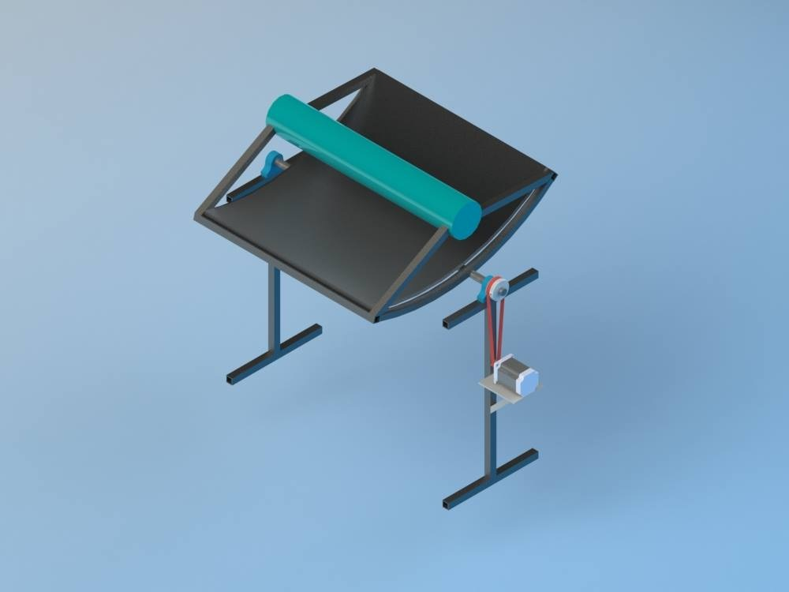
Fig 5.2 parabolic trough

- Steam Turbine
The steam turbine , shown in the Fig. 5.3 which consists the following major components :

- The housing and the base is CNC'd from Aluminum 6061-T6.
- The turbine blades and nozzle are machined from solid brass.
- The steam exhaust is 1" copper pipe.

and its typical dimension :
- Length 8 m /26 ft.
- Width 3.7 m /12.1 ft.
- Height 3.4 m /11.2 ft.
- Rotational speed up to 7,500 rpm.

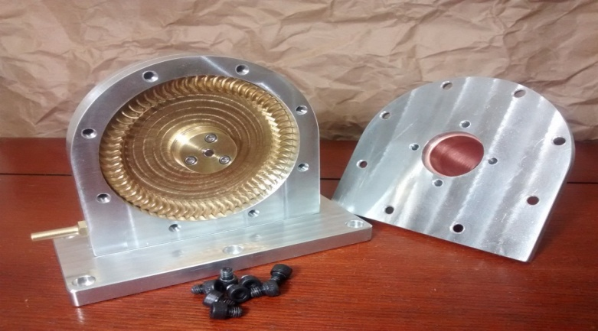

Fig : 5.3 steam turbine

- Condenser

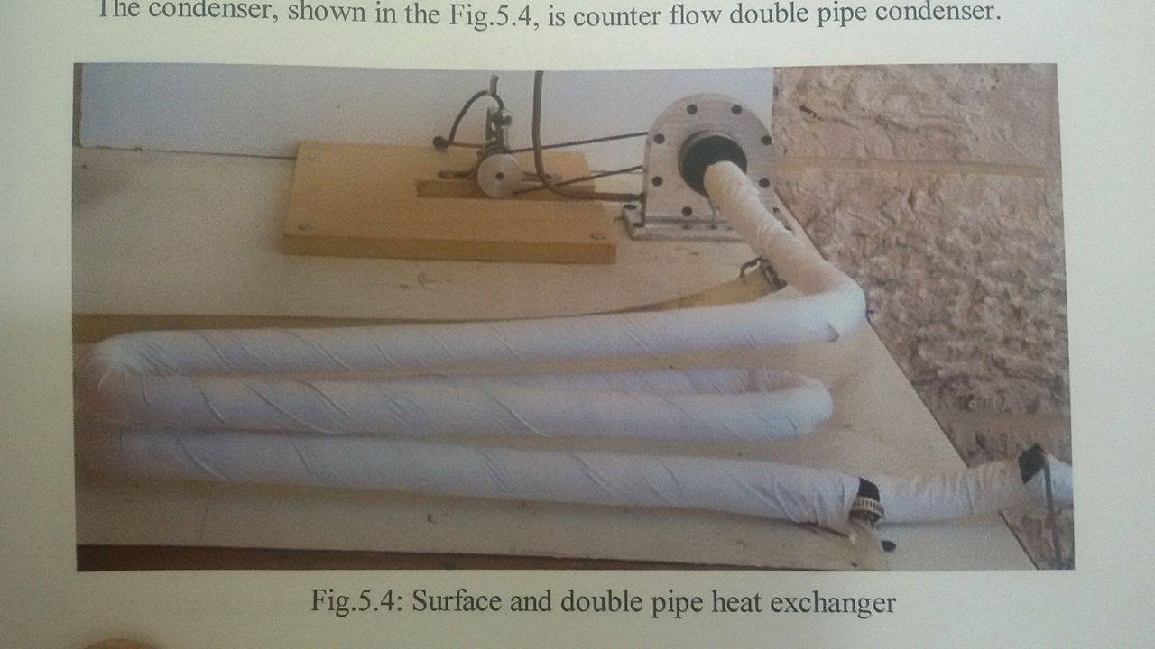
The condenser , shown in the Fig . 5.4, is flow double pipe condenser.

Fig :5.4 condenser
- Feed Pump

The feed pump , shown in the Fig. 5. 5, is simple hand pump. It can be work when the boiler pressure is 1 bar abs.
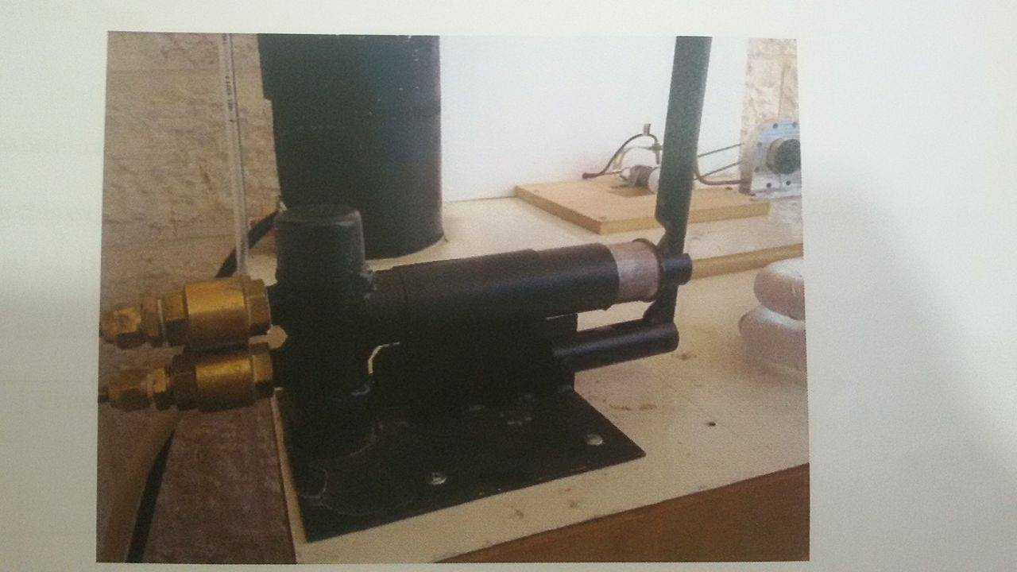

Fig5. 5 feed pump

5.3 Experiment Procedure

Follow these steps to operate Rankin cycle system:
- Fill the boiler with 3 liters of water.
- Close the steam admission valve.
- Open fuel source.
- Increase or decrease the amount of gas as required .
- Turn the digital screens on , to obtain experiment values.
- Wait until pressure in the boiler reaches 3 bar. Open the admission valve to drop pressure to 2 bar then close the valve.
- Repeat the process above.
- When pressure reaches 3 bar again , open the valve slowly without decreasing pressure too much.
- Write the temperature reading in system component , switch between readings using switch.
- Open the load switch (lamp) and write the output readings.
- Repeat the process for accurate readings.
- Finish the experiment by close the gas valve and open the steam admission valve till the turbine stops.

5.4 Results
In this experiment we calculate the efficiency of the cycle and the relationship between the voltage and RPM as illustrated as shows in Table 5.1 .
The lamp resistance is 1 ohm
T(boiler)  (C°( | Pressure (bar gauge) | T1  (C°( | T2  (C°( | T3  (C°( | T4  (C°( | Tin  (C°( | Voltage  (V) | Speed  (rpm) | Water  flow rate (L/min)
133.6 | 2 | 131.8 | 96.3 | 41.8 | 58.9 | 23.1 | 2.02 | 2384 | 1.2
133.6 | 2 | 131.8 | 96.1 | 42.1 | 60.1 | 22.9 | 1.05 | 1512 | 1.2
138.6 | 2.5 | 137.5 | 97.2 | 43.1 | 36.9 | 23 | 3.87 | 3647 | 1.2
138.6 | 2.5 | 137.6 | 97.2 | 42.9 | 62.7 | 23 | 2.1 | 2813 | 1.2
140.6 | 2.7 | 141.7 | 96.8 | 41.2 | 68.1 | 39.7 | 2.51 | 2712 | 3
143.6 | 3 | 142.8 | 98 | 43.3 | 71.2 | 42.4 | 1.45 | 1932 | 3
Table 5.1

The figure 5.1 shows the relationship between pressure and temperature such that temperature increase the pressure also increase .

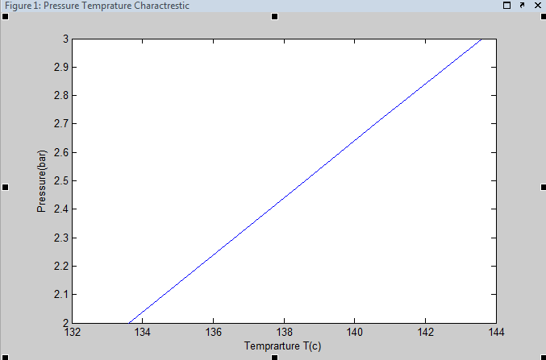
Fig 5.6

Where
$T_{1}$: steam temperature
$T_{2}$: temperature after turbine
$T_{3}$: condensed steam temperature
$T_{4}$: temperature out from condenser
$T_{in}$: temperature of water enter the condenser

According to the saturated steam table and using interpolation we obtain the following data which shows in table 5.2 and table 5.3 .
When $h_{1}=h_{f at 1 bar}=417.5(\frac{kJ}{kg})$

Pressure (bar gauge) | $$h_{1}(\frac{kj}{kg})$$ | $$h_{2}(\frac{kj}{kg})$$ | $$h_{3}(\frac{kj}{kg})$$ | $$h_{4 }(\frac{kj}{kg})$$
2 | 417. 5 | 419. 59 | 1426.9 | 1318.26
2 | 417. 5 | 419. 59 | 1426.9 | 1316.38
2. 5 | 417. 5 | 420.11 | 1442. 69 | 1326.75
2. 5 | 417. 5 | 420.11 | 1442. 69 | 1326.75
2.7 | 417. 5 | 420.32 | 1449.006 | 1322.98
3 | 417. 5 | 420. 63 | 1458.48 | 1334.30
Table 5.2

Pressure (bar gauge) | $q_{in}($w) | $w_{out}$(J) | $$q_{out}(w)$$ | $$w_{net}=w_{out}$$ | $$μ_{cycle}(\%)$$
2 | 1007.3 | 108.6 | 900 | 108.63 | 10.7
2 | 1007.3 | 110.5 | 898 | 110.52 | 10.9
2. 5 | 1022.5 | 115.59 | 909 | 115.93 | 11.3
2. 5 | 1022.5 | 115.9 | 909 | 115.93 | 11.3
2.7 | 1028.6 | 12.02 | 905 | 126.02 | 12.2
3 | 1037.8 | 124.1 | 916 | 124.17 | 11.9

Table 5.3

CHAPTER SIX
CONCLUSIONS & RECOMMENDATIONS

Contents:

Conclusions

Recommendations

Problems

6.1 Conclusion
The efficiency of the cycle is approximately 10% which low comparing with the standard limits, due to significant looses in the system components. The measured working pressure is around 2 bars which is insufficient to realize normal system operation…..

6.2 Recommendation
This project is a prototype, which simulates the basic heat operation cycles, and need to be improved by using of the following methods:
              - Reheat cycle.
              - Regenerative cycle.

6.3 Problems

The project team faced several problem during the implementation in term of high cost, hard to implement some mechanical and thermal components, and difficulty in design and implementation of the solar lenz….

References :
[1] https://www.woorank.com/en/www/concentratingsolarpowerutility.com.
[2] https://www.osti.gov/scitech/servlets/purl/8378
by E Cohen Gilbert - ‎1999 - ‎Cited by 3 - ‎Related articles
CONCENTRATING SOLAR POWER PLANTS. Gilbert E. Cohen. KJC Operating Company. 41 100 Highway 395. Boron, California 93516. David W. Kearney
[3] https://en.wikipedia.org/wiki/International_Energy_Agency
[4] https://www.copper.org/publications/pub_list/pdf/copper_tube_handbook.pdf

