CHAPTER
4
DESIGNOF STRUCTURAL MEMBERS

4.1 INTRODUCTION.

4.2 STRUCTURAL DESIGN OF THE MOUSQE.

4.3 STRUCTRAL DESIGN OF PARKING SHEDS.

4.4 STRUCTRAL DESIGN OF TWO UNDERGROUND WATER
TANKS.

4.5 STRUCTRAL DESIGN OF FESTIVAL HALL AND LECTUR
ROOMS.

4.1 Introduction:-
This chapter contains the structural analysis and design for units of the training center the Mosque, parking shed, underground water tanks, festival hall and lecture rooms. The structural design of the project is the most important thing to be done, through design we determine the amount of reinforcement in each part of the project to be realized all the conditions of construction and safety.
As we mentioned before, ACI 318m-08 and Jordanian loads code 2006, and some engineering programs were used in the design of the structures like: Atir, Safe and ETABS to find the internal forces, deflection and moments, and then hand calculation will be made to find the required reinforcement for the structures.

4.2 Structural analysis and design for the Mosque:-
In this project, we choose a new system to use in the Mosque, which is Paneled Beam system.
Paneled beam is a system use in buildings that has big areas (80 m² to 150 m²), this system consist of cross beams which make a grid action of beams. When these beams cross each other, they make small slabs between them which are simple solid slabs.

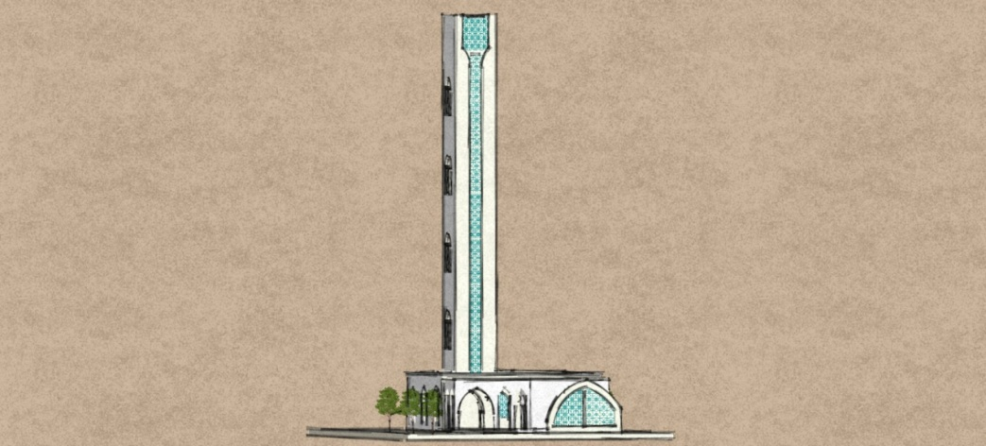
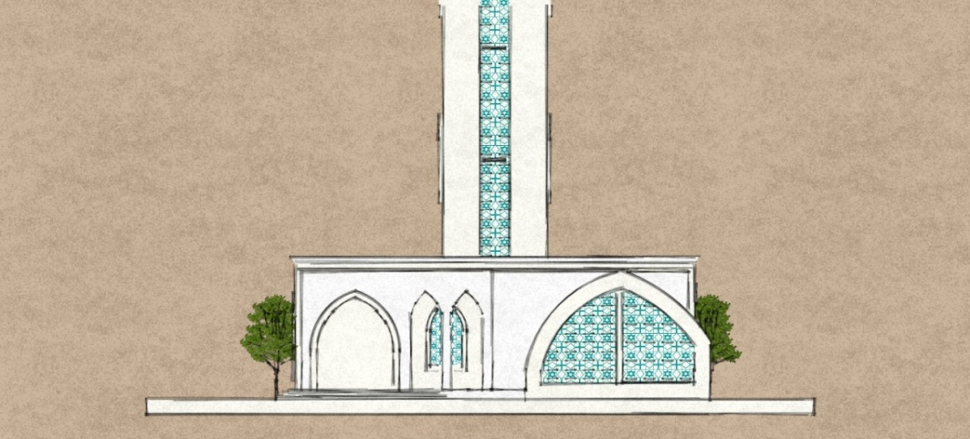

Figure (4.1): Pictures of the Mosque.

4.2.1 Load determination:-
There are three types of loads that were determined, dead load from the solid slab, live load from Jordanian code of loads for religion places, snow load according to the location of the project on Bethlehem.
- Live load :-
From previos chapter: LL = 3 KN/m²
- Snow load :-
Take h = 775 m, (Bethlehem height from sea level)
$$S=\frac{(h-400)}{320}=1.17 KN/m²$$
S = $S_{0}×μ$ = 1× 1.17 = 1.17 KN/m²

4.2.2 Design for solid slab:-
The solid slab located on the paneled beams at higher level of the mosque.
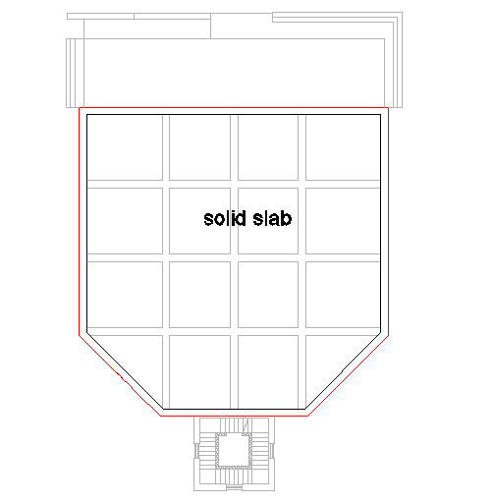

Figure (4.2): Location of solid slab in the project.

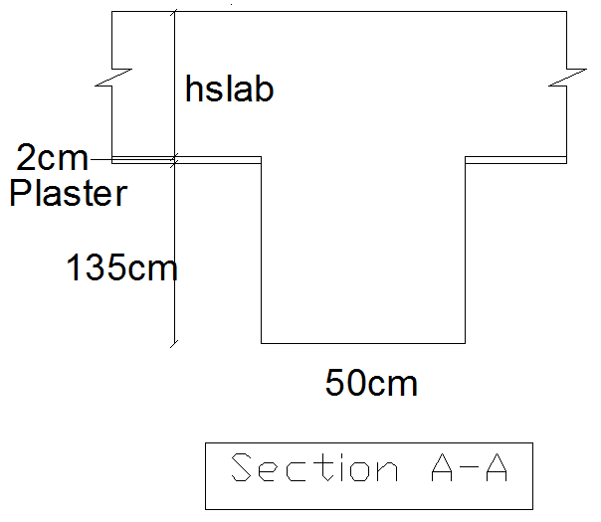
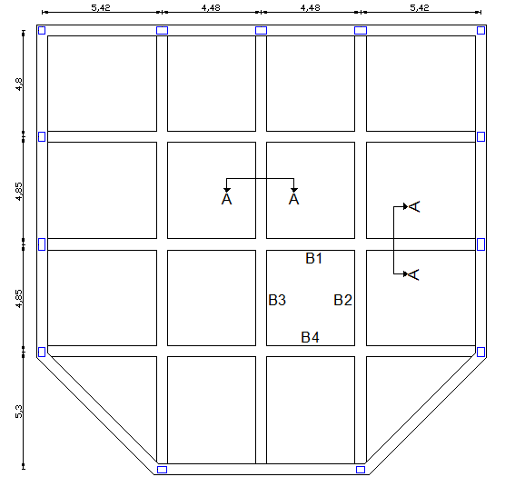

Figure (4.3): Design of solid slab.

- Limitation of deflection :-

- Approximate value h according to ACI:
$$h_{min}=\frac{clear perimeter }{180 }=\frac{4.92×3+2×4.35}{180} \\ h_{min}≥10.3 cm$$
Select h slab = 15 cm.

- Limitation of deflection h min. is based on stiffness ratio$(αi)$ between beam and slab
- Stiffness of beams:
$$B eff. ≤ 8×tf + bw$$
≤ 8×15 + 50 = 170 cm
$$B eff. ≤ 2×hb + bw$$
≤ 2 × 135 + 50 = 320 cm
Select B eff. = 170 cm.

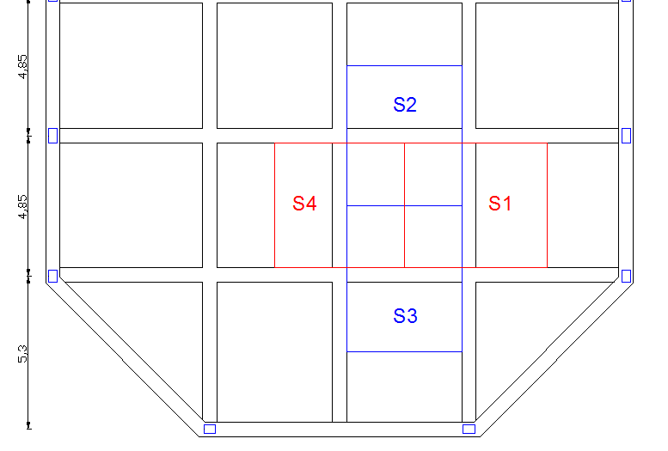
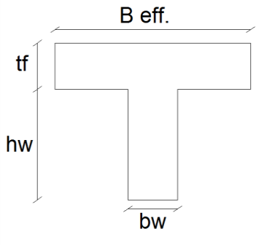

Figure (4-4): Limitation of deflection

$$Ý=\frac{\sum_{i=1}^{n}{Ai×y1}}{\sum_{i=1}^{n}{Ai}}$$
$$=\frac{170×15×7.5 + 135×50×82.5}{170×15+135×50}= 61.9 cm$$
$$I_{B1 }= I_{B2 }= I_{B3 }= I_{B4 }$$
$$I_{B}=\frac{170 ×{15}^{3}}{12}+\frac{50×{135}^{3}}{12}+170×15×{\left(61.9 – 7.5\right)}^{2}+135×50×{\left(82.5 – 61.9\right)}^{2}$$
$$I_{B}=0.207 m^{4}$$

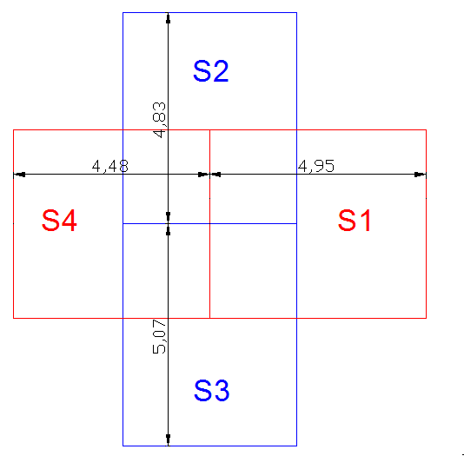
- Stiffness of slab:
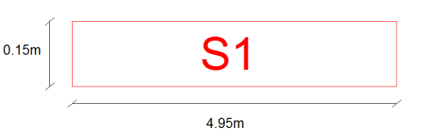
- S1 :

$$I_{s1}=\frac{4.95×0.15³}{12}= 1.392×{10}^{-3}m^{4}$$

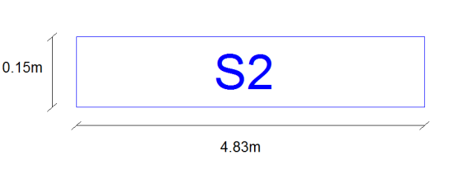
- S2 :
$$I_{s1}=\frac{4.83×0.15³}{12}= 1.358×{10}^{-3}m^{4}$$
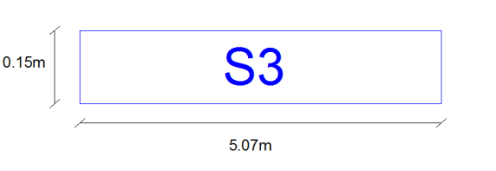
- S3 :
$$I_{s3}=\frac{5.07×{0.15}^{3}}{12}=1.43×{10}^{-3}m^{4}$$
- S4 :
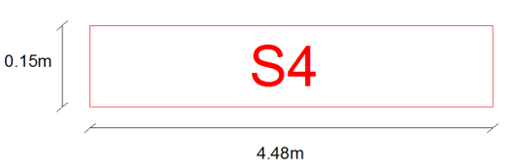
$$I_{s4}=\frac{4.48×{0.15}^{3}}{12}=1.26×{10}^{-3}m^{4}$$
$$α 1 =\frac{0.207 }{1.392×{10}^{-3}}= 148.7$$
$$α 2 =\frac{0.207 }{1.358×{10}^{-3}}= 152.4$$
$$α 3 =\frac{0.207 }{1.43×{10}^{-3}}= 144.7$$
$$α 4 = \frac{0.207 }{1.26×{10}^{-3}} = 164.3$$

$$α fm. =\frac{\sum{α}}{n}= \frac{610.1}{4}= 152.52 SO α = 2$$
$$h min. =\frac{\ln{(0.8+{fy}/{1400})}}{36+9B}$$
$$h min. = \frac{(4.81-0.5)(0.8+{420}/{1400})}{36+9×1.082} = 10.36 cm$$
Select h min. = 15 cm
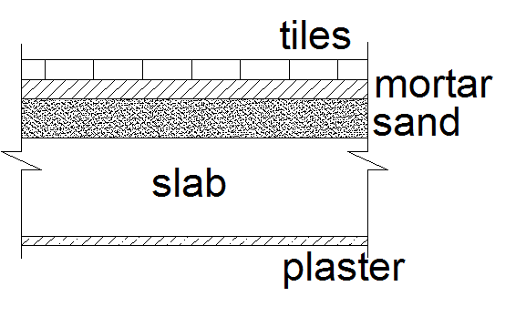
- Loads:-
- Dead load:
γ plaster = 22 KN/m³.
γ concrete = 25 KN/m³.
γ sand = 16 KN/m³.
γ tile = 23 KN/m³.
γ mortar = 22 KN/m³.
- 3 cm tiles = 0.03 × 23 = 0.69
- 2 cm mortar = 0.02 × 22 = 0.44
- 7 cm sand = 0.07 × 16 = 1.12
- 15 cm slab = 0.15 × 25 = 3.75
- 2 cm plaster = 0.02 × 22 = 0.44
$\sum{D}$= 6.44 KN/m for one strip.

- Live load = 3 KN/m
- Snow load = 1.17 KN/m

- $q_{u}= 1.2D + 1.6L + 0.5S$
= 1.2 × 6.44 + 1.6 × 3 + 0.5 × 1.17

$$q_{u} = 13.11 KN/m$$
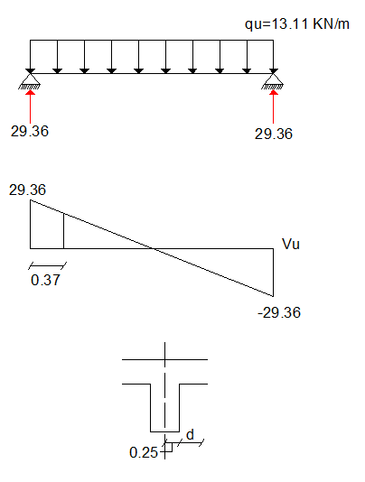
- Check shear design
- Assume one way shear
d = 150 – 20 – 10 = 120 mm
Vu = 29.36 – 13.11× 0.37
Vu = 24.5 KN
$$ØVc = 0.75 × \frac{1}{6} × \sqrt{24} × 120 ×1000$$
$$ØVc = 73.48 KN> Vu =24.5 KN$$
(No shear reinforcement is required)
- Design of bending moment:-
Using ACI table (12.3 – 12.6):
Clear span ratio = L clear short / L clear long
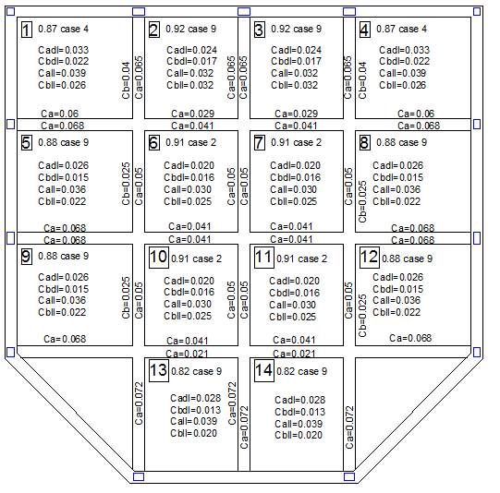

Figure (4.5): Clear span ratio and the values of ratio from table12-3 in ACI (bending moment design)
- Positive moment:
Using the values from figure (4-6) applies the following equations according to ACI:

$${Mua}^{+}=Cad × qud × La² + Cal × qul × La²$$
$${Mub}^{+}= Cbd × qud × Lb² + Cbl × qul × Lb²$$
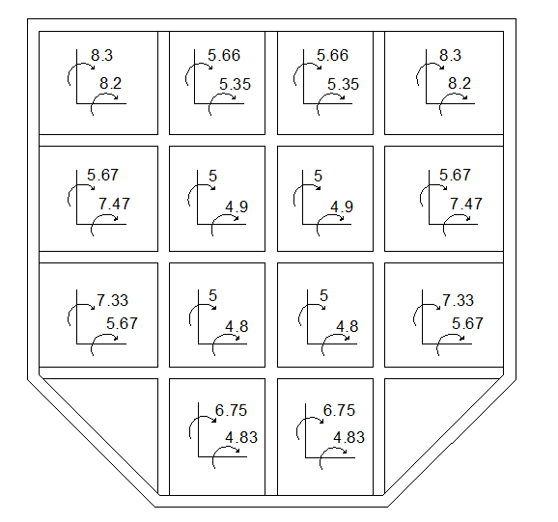

Figure (4.6): Positive moment of solid slab
- Design of bottom reinforcement:
- By taking the maximum value of the moment
Mu= 8.3 KN.m, we start design:
d= 120 mm
fy= 420 Mpa
fc´= 24 Mpa

$$kn=\frac{Mu}{b×d²}=\frac{({8.3}/{0.9)×{10}^{6}}}{1000×{120}^{2}}=0.64 Mpa$$
$$m=\frac{fy}{o.85×fc´}=\frac{420}{0.85×24}=20.58 Mpa$$
$ρ req.$= 0.00155 ⇒As req. = 185.9 mm²
→ Check for As min. = 0.0018 × h × b
= 0.0018 × 1000 × 150 = 270 mm²
As min. ˃ As req. ⇒ As = 270 mm²
$$Select ∅10-20cm, As prov. = 395 mm²$$
⇒Negative moment:
Using the values from figure (4-6) applies the following equations according to ACI:
${Mua}^{-}$= ${Ca}^{-}$× qu × La²
${Mub}^{-}$=${Cb}^{-}$ × qu × Lb²
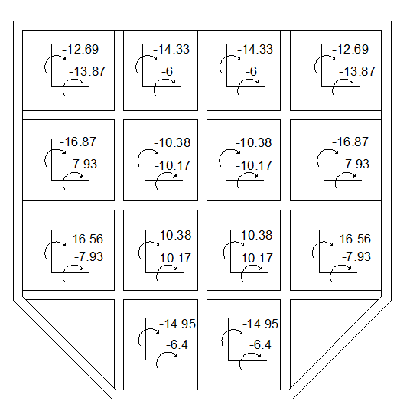

Figure (4.7): Negative moment of solid slab

- Design of top reinforcement:
- By taking the maximum value of negative moment
Mu= - 16.87 KN.m, we start design:

$$kn=\frac{Mu}{b×d²}= \frac{({16.87}/{0.9)×{10}^{6}}}{1000×{120}^{2}}=1.3 Mpa$$
$$m= \frac{fy}{o.85×fc´} = \frac{420}{0.85×24} = 20.58 Mpa$$

$$ρ req = 0.0032 As req = 384.6 mm²$$
→ Check for As min. = 0.0018 × h × b = 0.0018 × 1000 × 150 = 270 mm²
$$As req > As min As = 384.6 mm²$$
$$Select ∅10-20cm, As prov. = 395 mm²$$

4.2.3 Design for one way-rib slab:-
One way-rib slab located at the entrance of the mosque.
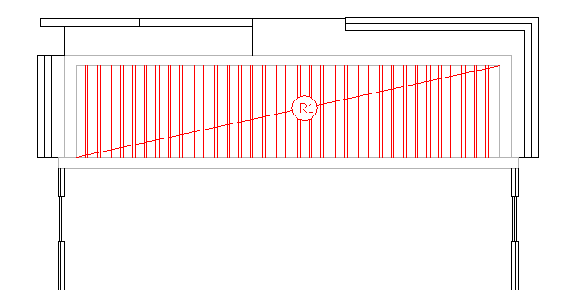

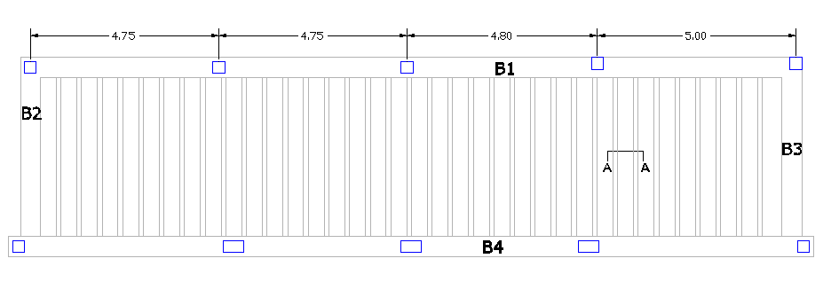

Figure (4.8): Location of rib slab at the project

- Determination for the thickness of rib slab
The value of minimum h will be determined according the following tables, if h is selected greater than the table value, the calculation is not required.

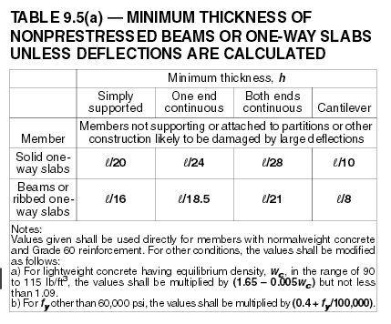

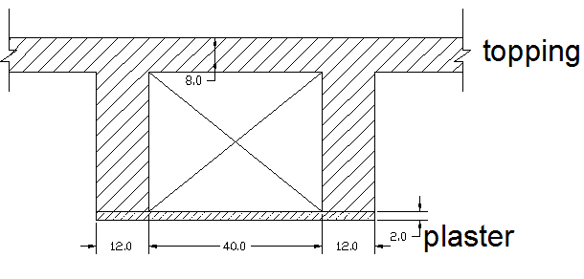
Figure (4.9): Table (9.5) from ACI318-08

Figure (4.10): Section in one way rib slab

→h min ≥ $L/{16}$ = ${4.52}/{16}$ = 28.25 cm
Select h = 32 cm (8cm Topping + 24cm Block).
- Design for Topping :-
- Determination of loads:
Cover = 0.05 × 25 = 1.25 KN/m²
Topping = 0.08 × 25 = 2 KN/m²
$\sum{D}$= 3.25 KN/m²
L= 3 KN/m²
S= 1.17 KN/m²

⇒ For 1m strip
$$qu = 1.2D + 1.6L + 0.5S$$
= 1.2 × 3.25 + 1.6 × 3 + 0.5 × 1.17
$qu$ = 9.28 KN/m²

- Design of plain concrete

$$Mu = \frac{qu ×L²}{12} = \frac{9.28 ×0.4²}{12} = 0.131 KN.m$$

$$Vu = \frac{9.28 ×0.4}{2} = 1.85 KN$$
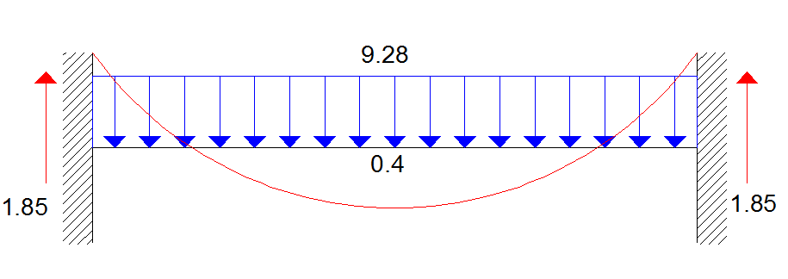

⇒Shear strength:
$$ФVc =0.75 × \frac{1}{6} × \sqrt{fc´} × b × h = 0.75 × \frac{1}{6} ×\sqrt{24} ×1000 ×80$$
$$ФVc = 49 KN> Vu=1.85 KN$$
→ No shear reinforcement is required.
⇒ Design bending moment:
$$Ф Mn = 0.55 × 0.42 × \sqrt{fc´} × b × h²/ 6$$
$$= 0.55 × 0.42 × \sqrt{24 } × 1000 × 80² / 6$$
$$Ф Mn = 1.21 KN.m> Mu=0.131 KN.m$$
→ No reinforcement is required
According to (ACI318M08-7.12.2.1), minimum reinforcement is required to prevent cracks and to minimize temperature effects:
As min. = 0.0018 × b × h = 0.0018 × 1000 × 80 = 144 mm²
$$Select mesh Ø8 / 20 cm A, withs = \frac{8²× π}{4} × \frac{100}{20} = 250 mm²$$
- Design for rib:-
⇒ Dead load:-
Cover = 0.05 × 25 × 0.52 = 0.65
Topping = 0.08 × 25 × 0.52 = 1.04
Rib = 0.12 × 25 ×0.24 = 0.72
Block = 0.4 × 12.5 × 0.24 = 1.2
Plaster = 0.02 × 22 × 0.52 = 0.23
$\sum{D}$ = 3.84 KN/m
L = 3 × 0.52 = 1.56 KN/m
S = 1.17 × 0.52 = 0.61 KN/m
$$qu = 1.2 × 3.84 + 1.6 ×1.56 + 0.5×0.61 = 7.41 KN/m$$
⇒ Analysis:
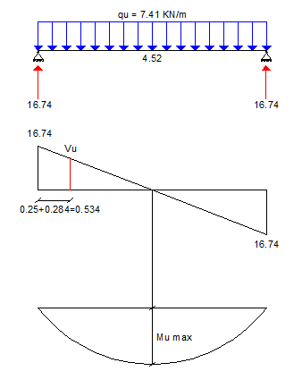
d = 320 – 20 – 10 - ${12}/2$
d = 284 mm
→ Vu = 12.78 KN
→ Mu max = 18.91 KN.m
⇒ Design of shear strength:
$$1.1 Ф Vc = 1.1 × 0.75 × \frac{1}{6} ×\sqrt{fc´} × bw × d$$
$$= 1.1 × 0.75 × \frac{1}{6} ×\sqrt{24 } × 120 ×284$$
$$1.1 Ф Vc = 22.9 KN> Vu = 12.78 KN$$
→ No shear reinforcement is required
Select Ø8 – 15 cm.
⇒ Design of bending moment:-
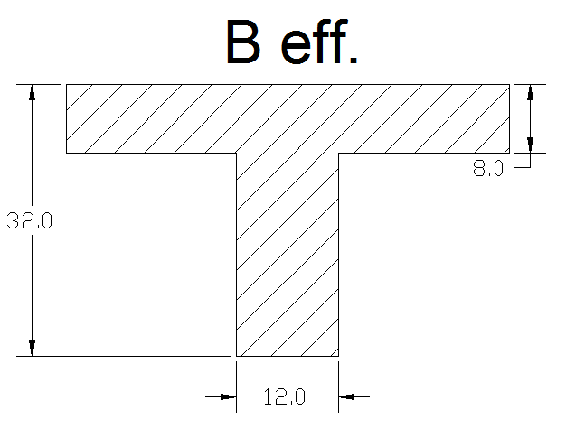
Mu max = 18.91 KN.m
$$B eff. ≤ \frac{L}{4} = \frac{452}{4} = 113 cm$$
≤ 16×tf + bw = 140 cm
≤ bw + $\frac{1}{2}$ (clear span )
= 12 + 0.5 × 40 = 52 cm
→ B eff. = 52 cm control
⇒Check a ≤ t
$$ФMn = 0.9 × 0.85 × 24 × 80 × 520 × (284 – 80/2) = 186.36 KN.m$$
$$a t Design as rectangular section$$
$$kn= \frac{Mu}{b×d²} = \frac{({18.91}/{0.9)×{10}^{6}}}{520×{284}^{2}} = 0.5 Mpa$$
$$m= \frac{fy}{o.85×fc´} = \frac{420}{0.85×24} = 20.58 Mpa$$
→$ρ req.$ = 0.001206 →As req. = 0.001206 ×520 × 284 = 178.1 mm²
According to ACI 318m08-10.5.1:
$$As min. ≥ \frac{1.4}{fy }× bw × d = \frac{1.4}{420 } × 120 × 284 = 113.6 mm²$$
$$≥ 0.25 × \frac{\sqrt{fc´}}{fy} × bw × d = 0.25 × \frac{\sqrt{24}}{420} × 120 × 284 = 99.4 mm²$$
$$As req. = 178.1 mm² > As min. = 113.6 mm²$$
$Select 2Ф12, with As prov. = 226 mm²> As req$.

    - Design for external beams:-
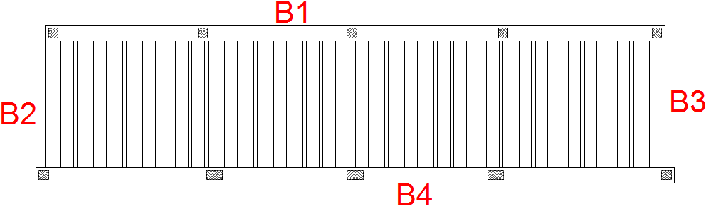

Figure (4.11): Beam 1 location
- Using "Atir" software for the following values of moment and shear:-
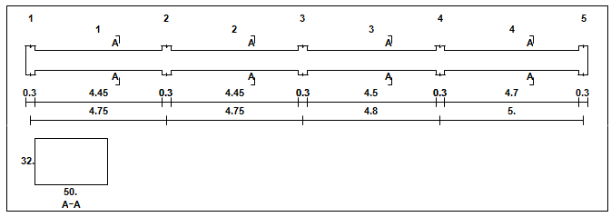

Figure (4.12): Space length of beam 1

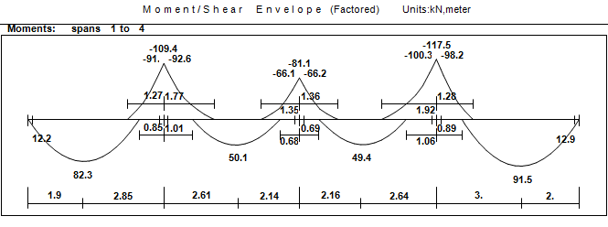

Figure (4.13): moment envelop diagram for beam 1
- Min Reinforcement of beam:
$$As = \frac{\sqrt{fc´}}{4×(fy)}×(bw)×(d) ≥ \frac{1.4}{fy} (bw) (d) ………. (ACI318m08-10.5.1)$$
d = 320 – 40 –10 – (18/2) = 261 mm
$$As min. = \frac{\sqrt{24}}{4(420)}(500)(261) ≥ \frac{1.4}{420} (500) (261)$$
$$= 380.5 mm² 435 mm², As min. = 435 mm²$$
- Positive moment reinforcement:
- Span (1):
$$Mu = 82.3 KN.m …..from Figure (4.14)$$
Check singly or doubly:
$C = (3/7)×d =(3/7)×261 = 111.86 mm$.
a = 0.85 × 111.86 = 95.1 mm
Ф = 0.65 + (250/3)×(0.004 – 0.002) =0.82
$${Mn}_{max}= 0.85 × fc´ × b × a × (d-a/2)$$
= 207.05 KN.m
$$ФMn = 207.05×0.82 = 169.78 KN.m>82.3 KN.m$$
⇒ Design the section as singly reinforcement.
kn = $\frac{Mn}{b×d²}$ = $\frac{(82.3/0.9)×{10}^{6}}{500×261²}$ = 2.68Mpa
m = $\frac{fy}{0.85×fc´}$ = 20.58Mpa
$ρ req.$= 0.0068
$$As req. = 0.0068× 50 × 26.1 = 8.87 cm²> As min.$$
As Ø 18 = 2.54 cm², use 4Ø18 with As = 10.16 cm²

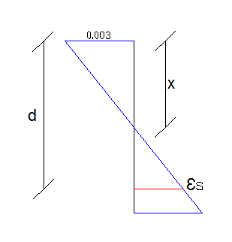
- Check for yielding:
T=C
As × Fy = 0.85 × fc´ × a × b
1016 × 420 = 0.85 × 24 × 500 × a
a = 41.83 mm
$$x = \frac{a}{B1} = \frac{41.83}{0.85} = 49.2 mm$$
0.003/49.2 = (0.003+ ∈s)/261⇒∈s= 0.0129<0.005
⇒ Ф = 0.9 is correct.

- Span (2):
Mu = 50.2KN.m …..from Figure (4.14)
Check singly or doubly:
C = (3/7)d = (3/7)×261 = 111.86 mm.
a = 0.85 × 111.86 = 95.1 mm
Ф = 0.65 + (250/3)×(0.004 – 0.002) =0.82
Mn max = 0.85 × fc´ × b × a × (d-a/2) = 207.05 KN.m

$$ФMn = 207.05×0.82 = 169.78 KN.m> 50.2KN.m$$
⇒ Design the section as singly reinforcement.
$$kn = \frac{Mn}{b×d²} = \frac{(50.2/0.9)×{10}^{6}}{500×261²} = 1.64 Mpa$$
$$m = \frac{fy}{0.85×fc´} = 20.58 Mpa$$

$ρ req.$= 0.0041
$$As req. = 0.0041× 50 × 26.1 = 5.35 cm²> As min.$$
As Ø 18 = 2.54 cm², use 4Ø18 with As = 10.16 cm²

- Check for yielding:
T=C
$$As × Fy = 0.85 × fc´ × a × b$$
$$1016 × 420 = 0.85 × 24 × 500 × a$$
$$a = 41.83 mm$$
$$x = \frac{a}{B1} = \frac{41.83}{0.85} = 49.2 mm$$
0.003/49.2 = (0.003+ ∈s)/261 ⇒∈s= 0.0129<0.005
⇒ Ф = 0.9 is correct.
- Span (3):
Mu = 49.4 KN.m …..from Figure (4.14)
Check singly or doubly:
C = (3/7)d = (3/7)×261 = 111.86 mm.
a = 0.85 × 111.86 = 95.1 mm
Ф = 0.65 + (250/3)×(0.004 – 0.002) =0.82
Mn max = 0.85 × fc´ × b × a × (d-a/2)= 207.05 KN.m
$$ФMn = 207.05×0.82 = 169.78 KN.m> Mu=49.4 KN.m$$
⇒ Design the section as singly reinforcement.
$$kn = \frac{Mn}{b×d²} = \frac{(49.4/0.9)×{10}^{6}}{500×261²} = 1.61 Mpa$$
$$m = \frac{fy}{0.85×fc´} = 20.58 Mpa$$
$ρ req.$= 0.0039
$$As req. = 0.0039× 50 × 26.1 = 5.08 cm²> As min.$$
As Ø 18 = 2.54 cm², use 4Ø18 with As = 10.16 cm²
- Check for yielding:
T=C
As × Fy = 0.85 × fc´ × a × b
1016 × 420 = 0.85 × 24 × 500 × a
a = 41.83 mm
$$x = \frac{a}{B1} = \frac{41.83}{0.85} = 49.2 mm$$
0.003/49.2 = (0.003+ ∈s)/261⇒∈s= 0.0129<0.005
⇒ Ф = 0.9 is correct.
- Span (4):
Mu = 91.5 KN.m ..from Figure (4.14)
Check singly or doubly:
C = (3/7)d = (3/7)×261 = 111.86 mm.
a = 0.85 × 111.86 = 95.1 mm
Ф = 0.65 + (250/3)×(0.004 – 0.002) =0.82
Mn max = 0.85 × fc´ × b × a × (d-a/2)= 207.05 KN.m
$$ФMn = 207.05×0.82 = 169.78 KN.m>Mu=91.5 KN.m$$
⇒ Design the section as singly reinforcement.
$$kn = \frac{Mn}{b×d²} = \frac{(91.5/0.9)×{10}^{6}}{500×261²} = 2.98 Mpa$$
$$m = \frac{fy}{0.85×fc´} = 20.58 Mpa$$
$ρ req.$= 0.0077
$$As req. = 0.0077× 50 × 26.1 = 10.05 cm² ˃ As min.$$
As Ø 18 = 2.54 cm², use 4Ø18 with As = 10.16 cm²
- Negative moment reinforcement:
- Support (1):

Mu = 92.6 KN.m…………. From figure (4.14)
$$kn = \frac{Mn}{b×d²} = \frac{(92.6/0.9)×{10}^{6}}{500×261²} = 3.02 Mpa$$
$$m = \frac{fy}{0.85×fc´} = 20.58 Mpa$$

$ρ req.$= 0.0078

$$As req. = 0.0078 × 50 ×26.1 = 10.18cm²> As min$$
As Ø 18 = 2.54 cm², use 5Ø18 with As = 12.7 cm²
- Support (2):
Mu = 66.2 KN.m…………. From figure (4.14)
$$kn = \frac{Mn}{b×d²} = \frac{(66.2/0.9)×{10}^{6}}{500×261²} = 2.16 Mpa$$
$$m = \frac{fy}{0.85×fc´} = 20.58Mpa$$

$ρ req.$= 0.0054

$$As req. = 0.0054 × 50 ×26.1 = 7.05 cm²> As min$$

As Ø 16 = 2.01 cm², use 4Ø16 with As = 8.04 cm²
- Support (3):
Mu = 100.3 KN.m …………. From figure (4.14)
$$kn = \frac{Mn}{b×d²} = \frac{(100.3/0.9)×{10}^{6}}{500×261²} = 3.27Mpa$$
$$m = \frac{fy}{0.85×fc´} = 20.58 Mpa$$

$ρ req.$= 0.0085

$$As req. = 0.0085 × 50 ×26.1 = 11.09cm²> As min$$

As Ø 18 = 2.54 cm², use 5Ø18 with As = 12.7 cm²
- Design of shear reinforcement:
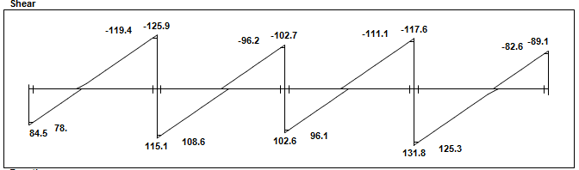

Figure (4.14): shear envelop diagram for beam 1

- Support (1):
Usually the design value of shear is taken at distance = (d) from support face.
d= 261 mm
Vu max = 119.4 KN …………. From figure (4.15)
Ф Vc = 0.75 × $\frac{1}{6}$ × $\sqrt{fc´}$ × b × d
= 0.75 × $\frac{1}{6}$ ×$\sqrt{ 24}$ ×500×261 = 79.91 KN
Ф Vc< Vu max = 119.4 KN
⇒Vs = $\frac{Vu}{Ф}$ – Vc = $\frac{119.4}{0.75}$ – $\frac{79.91}{0.75}$= 52.65 KN
- Check for section dimension:
Vs min. = $\frac{2}{3}$ ×$\sqrt{fc´}$ × b × d
$$Vs min= 426.21 KN> Vs = 52.65 KN$$
⇒ The section is large enough
- Check for the case of shear:
Case Ш:
Vsmax≥$\frac{1}{16}\sqrt{fc´}$ × bw × d = 39.95 KN
≥ $\frac{1}{3}$ × bw × d = 43.5 KN (control)
⇒ Ф Vc< Vu ≤ Ф Vc + ФVs min
ФVc + ФVs min = 79.91 + 0.75×43.5 = 112.53 KN
⇒ Case Ш for shear design:
$$\frac{Av}{S}=\frac{Vs}{Fy ×d}= \frac{52.69×10³}{420×261} = 0.48$$
Select Ø 10 ⇒ Av = 157.1 mm (2legs)
$$S =\frac{157.1}{0.48}= 32.7 cm$$S max ≤ $d/2$ = ${261}/2$ = 130.5 mm (control)
≤ 600 mm
⇒ Use 2 legs Ø10 – 15cm
- Support (2):
Usually the design value of shear is taken at distance = (d) from support face.
d= 261 mm
Vu max = 96.2 KN …………. From figure (4.15)
Ф Vc = 0.75 × $\frac{1}{6}$ × $\sqrt{fc´}$ × b × d
$$= 0.75 × \frac{1}{6} ×\sqrt{ 24} ×500×261 = 79.91 KN$$
$$Ф Vc=79.91 KN<Vu max = 96.2 KN$$
$$Vs = \frac{Vu}{Ф} – Vc = \frac{96.2}{0.75} – \frac{79.91}{0.75}= 21.72 KN$$
- Check for section dimension:
$$Vs min. = \frac{2}{3} ×\sqrt{fc´} × b × d$$
$$Vs min.= 426.21 KN> Vs = 21.72 KN$$
⇒ The section is large enough
- Check for the case of shear:
Case Ш:
$$Vsmax ≥ \frac{1}{16}\sqrt{fc´} × bw × d = 39.95 KN$$
$$≥ \frac{1}{3} × bw × d = 43.5 KN (control)$$
⇒ Ф Vc< Vu ≤ Ф Vc + ФVs min
ФVc + ФVs min = 79.91 + 0.75×43.5 = 112.53 KN
⇒ Case Ш for shear design:
$$\frac{Av}{S}= \frac{Vs}{Fy ×d}= \frac{21.72×10³}{420×261}=0.198$$Select Ø 10 ⇒ Av = 157.1 mm (2legs)
$$S = \frac{157.1}{0.198} = 79.34 cm$$
S max ≤ $d/2$ = ${261}/2$ = 130.5 mm (control)
≤ 600 mm
⇒ Use 2 legs Ø10 – 15cm
    - Design for paneled beams:-
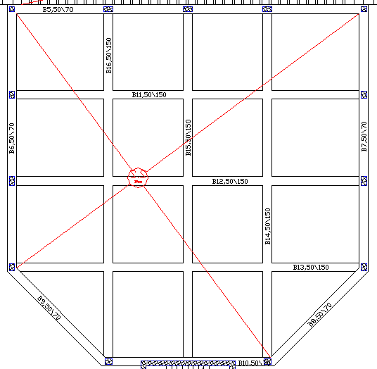

Figure (4.15): locations of paneled beams

- Using Atir" software for the following values of moment and shear:
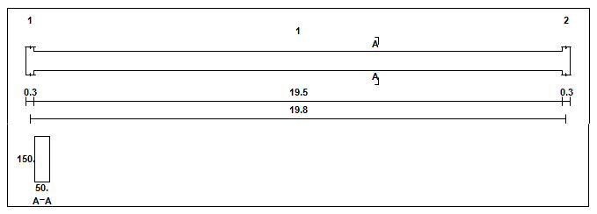

Figure (4.16): span length of beam 11

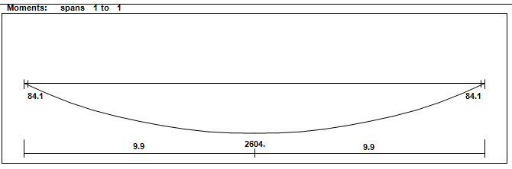

Figure (4.17): moment envelop diagram for beam 11
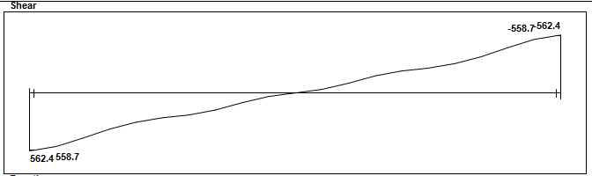

Figure (4.18): shear envelop diagram for beam 11

- Min Reinforcement of beam:
As = $\frac{\sqrt{fc´}}{4(fy)}$ (bw)(d) ≥ $\frac{1.4}{fy}$ (bw) (d) ………. (ACI318m08-10.5.1)
d = 1500 – 40 –10 – (22/2) = 1439mm
As min. = $\frac{\sqrt{24}}{4(420)}$(500)(1439) ≥ $\frac{1.4}{420}$ (500) (1439)
= 20.98 cm ²<23.98cm², As min. = 23.98 cm²
- Positive moment reinforcement:
Mu = 2604KN.m ….. from Figure (4.18)
Check singly or doubly:
C = (3/7)d = (3/7)×1439 = 616.7 mm.
a = 0.85 × 616.7 = 524.2 mm
Ф = 0.65 + (250/3)×(0.004 – 0.002) =0.82
Mn max = 0.85 × fc´ × b × a × (d-a/2)= 6292.67KN.m

$$ФMn = 6292.67×0.82 = 5160KN.m> 2604KN.m$$
⇒ Design the section as singly reinforcement.
$$kn = \frac{Mn}{b×d²} = \frac{(2604/0.9)×{10}^{6}}{500×1439²} = 2.8 Mpa$$
$$m = \frac{fy}{0.85×fc´} = 20.58 Mpa$$
$ρ req.$= 0.0072
As req. = 0.0072× 50 × 143.9 = 52 cm² ˃ As min.
As Ø 22 = 3.8 cm², use 14Ø22 with As = 53.2 cm²
- Check for yielding:
T=C
As × Fy = 0.85 × fc´ × a × b
5320 × 420 = 0.85 × 24 × 500 × a
a = 219 mm
$$x = \frac{a}{B1} = \frac{219}{0.85} = 257.72 mm$$
$$\frac{0.003}{49.2}=\frac{0.003+ ∈s}{261}∈_{s}= 0.01290.005$$
⇒ Ф = 0.9 is correct.
- Design for shear reinforcement:
Usually the design value of shear is taken at distance = (d) from support face.
d= 1439 mm
Vu max = 558.7 KN …………. From figure (4.19)
$$Ф Vc = 0.75 × \frac{1}{6} × \sqrt{fc´} × b × d$$
$$Ф Vc= 0.75 × \frac{1}{6} ×\sqrt{ 24} ×500×1439 = 440.6 KN$$
$$Ф Vc= 440.6 KN Vu max = 558.7 KN$$
$$Vs = \frac{Vu}{Ф} – Vc = \frac{558.7}{0.75} –\frac{440.6}{0.75}= 157.5 KN$$

- Check for section dimension:
$$Vs max = \frac{2}{3} ×\sqrt{fc´} × b × d$$
$$Vs max= 2350 KN> Vs = 157.5 KN$$
⇒ The section is large enough
Check for the case of shear:
Case Ш:
$$Vs min ≥\frac{1}{16}\sqrt{fc´} × bw × d = 220.3 KN$$
$$≥ \frac{1}{3} × bw × d = 239.8 KN (control)$$
⇒ Ф Vc< Vu ≤ Ф Vc + ФVs min
ФVc + ФVs min = 440.6 + 0.75×239.8 = 620.45 KN
⇒ Case Ш for shear design:
$$\frac{Av}{S}= \frac{Vs}{Fy ×d}= \frac{157.5×10³}{420×1439}=0.26$$
Select Ø 10 ⇒ Av = 157.1 mm (2legs)
$$S = \frac{157.1}{0.26} = 60.4 cm$$
S max ≤ $d/2$ = ${1439}/2$ = 719.5 mm
≤ 600 mm (control)
⇒ Use 2 legs Ø10 – 20cm
    - Design for columns :-
Select column (C3) for design:
- Design of longitudinal reinforcement :
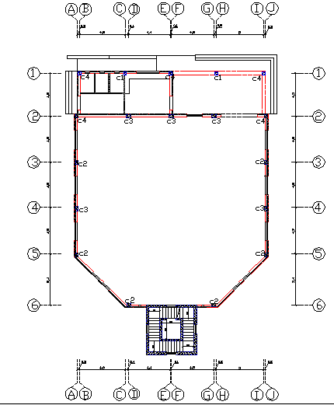

Figure (4.19): columns plan

$$P_{u} = 500 KN$$
Ag = 0.3 × 0.3 m
$$L_{u}=3.5 m$$
$\left[\frac{k.l_{u}}{r}\right]$≤ 22 ……….. ACI318.08 (10.6)
$\left[\frac{k.l_{u}}{r}\right]$= 38.8 ˃ 22, in X-direction
$\left[\frac{k.l_{u}}{r}\right]$= 38.8 ˃ 22, in Y-direction
⇒ Long column in both directions
- Bresler equation:
$$\frac{1}{P_{n}}=\frac{1}{P_{nx}}+\frac{1}{P_{ny}}-\frac{1}{P_{0}}$$
About x: $e_{y} min$ = 15 + 0.03 × h = 15 + 0.03 × 300 = 24 mm
About y: $e_{x} min$ = 15+0.03×300 =24 mm

- Magnification factor of moment:
- In $e_{y}$ and $e_{x}$ directions:

$$EI = 0.4 \frac{E_{c }I_{g}}{1+β_{dns}} ………… ACI318.08 (10-15)$$
$E_{c}$ = 4750 $\sqrt{fc´}$ = 4750 $\sqrt{24}$ = 23270.15 Mpa
$β_{dns}$ = 0.6 ….. According to ACI318.08 (R10.10.6.2)
$$I_{g}=\frac{0.3×{0.3}^{3}}{12}=0.000675m^{4}$$
$$EI = 0.4 \frac{23270.15×0.000675}{1+0.6}= 9.82 MN.m²$$
$$P_{cr}=\frac{π² ×EI}{(K×Lu)²}………….. ACI318.08 (10-13)$$
$$P_{cr} = 7.91 MN = 7910 KN$$
$$Cm = 0.6 + 0.4 \left(\frac{M1}{M2}\right) …………… ACI318.08 (10-16)$$
Cm = 1 …… According to ACI318.08 (R10.10.6.4)
$$δ_{ns}= \frac{Cm}{1-(\frac{Pu}{0.75Pc})}≥1.0………ACI318.08 (10-12)$$
$$δns = 1.09> 1$$
- Interaction diagram:
$$\frac{1}{P_{n}}=\frac{1}{P_{nx}}+\frac{1}{P_{ny}}-\frac{1}{P_{0}}$$
Axial strength $P_{nx} and{ P}_{nx} :-$
$$δns ×e= 1.09 × 24 = 26 mm$$
$$\frac{e}{h}=\frac{26}{300}=0.087$$
$$\frac{γ}{h}=\frac{300-2×40-2×10-12}{300}=0.63$$
Assume $ρ$g = 0.01 (minimum)
From interaction diagram, for $\frac{γ}{h}$ = 0.75 →$(∅Pn)/Ag = 2 ksi$
$\frac{γ}{h}$ = 0.6 →$(∅Pn)/Ag = 2 ksi$
For $\frac{γ}{h}$ = 0.63 →$(∅Pn)/Ag = 2 ksi$
$$P_{nx}=P_{ny}=\frac{2 ×(0.3×0.3)}{0.65}× \frac{1000}{145}=1.91 MN$$
$P_{0}$= 0.8 × Ag × (0.85 fc´ + $ρ$g (fy – 0.85 fc´)) ……….. ACI318.08 (10-1)
$P_{0}$= 0.8 × 300 × 300 × (0.85 × 24 × (1- 0.01) + 0.01 × 420) = 1.75 MN
$$\frac{1}{P_{n}}=\frac{1}{P_{nx}}+\frac{1}{P_{ny}}-\frac{1}{P_{0}}$$
$$\frac{1}{P_{n}}=\frac{1}{1.91}+\frac{1}{1.91}-\frac{1}{1.75}$$
$$Pn=2102.2 KN$$
$ØP_{n}$= 2102.2 × 0.65 = 1366 KN
$$ØP_{n}=1366 KN >P = 500 KN (safe)$$
Use $ρ$g = 0.01
As = 0.010 × 30 × 30 = 9 cm²
Use 8 Ø12 with As= 9.04 cm²
- Design of the tie reinforcement:-
Assume diameter of tie = 10mm
Spacing ≤ 16 × $d_{b}$ (longitudinal bar diameter) =16 × 12 = 192 mm
Spacing ≤ 48 × $d_{t}$ (tie bar diameter) = 48×10=480mm
Spacing ≤ least dimension = 30 cm
Use Ø10 / 20 cm
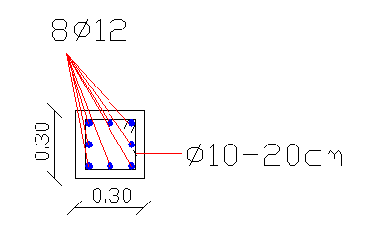

Figure (4.20): section of column 3

    - Design for Minaret:-
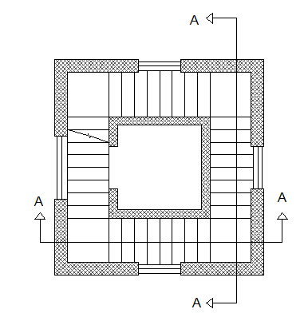
      - Design for stairs :-

Figure (4.21): plan of stairs
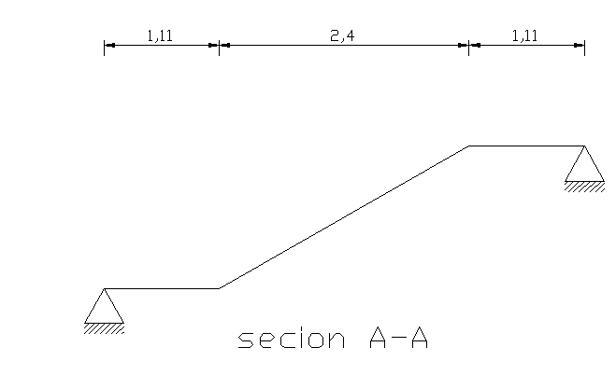

Figure (4.22): section of stairs

- Structural system of stairs which used is slab system, so the stairs was designed as one way solid slab.
- Download system of stairs the flight and landing connected with shear walls on both side.
- According to ACI table 9.5(a), minimum thickness = $l/{20}$
$$h_{min}=\frac{L}{20}=\frac{462}{20}=23cm$$Select h=25 cm

- Load determination:
$$α=\tan^{-1}\left(\frac{1.75}{30}\right)=30º$$⇒ For flight:
Concrete = (25 × 0.25) × (1/$\cos{30}$ ) = 7.2 KN/m
Plastering = (22 × 0.03) × (1/$\cos{30}$ ) = 0.76 KN/m
Stairs = (0.5×0.17×25) = 2.125KN/m
Horizontal Mortar = 0.03 ×22 × 1 = 0.66 KN/m
$$Vertical mortar = 0.03 × 22 ×\frac{0.17}{0.3}= 0.374 KN/mHorizontal tiles = 0.04 ×23×\frac{33}{30}= 1.012KN/mVertical tiles = 0.03 × 22 ×\frac{0.17}{0.3}=0.37{KN}/m$$$\sum{Dl}$ = 12.5 KN/m
$\sum{Ll}$= 3 KN/m
⇒For landing:
Concrete = (25 × 0.25) = 6.25 KN/m
Plastering = (22× 0.02) = 0.44 KN/m
Mortar = (22 × 0.02) = 0.44 KN/m
Tiles = (23 × 0.03) = 0.69 KN/m
Sand = 0.07 × 16 = 1.12 KN/m
$\sum{DL}$ = 8.94 KN/m
$\sum{LL}$= 3 KN/m
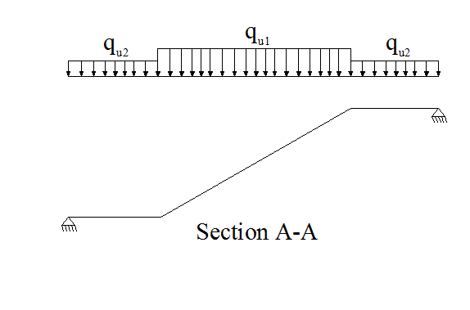
- System of stairs:-
$q_{u1}$= 1.2 × 12.5 + 1.6 ×3 = 19.8 KN
$q_{u2}$= 1.2 × 8.94 + 1.6 × 3 = 15.5 KN
$${Vu}_{max}=41.26 KN$$
$${Mu}_{max}=50.82 KN.m$$
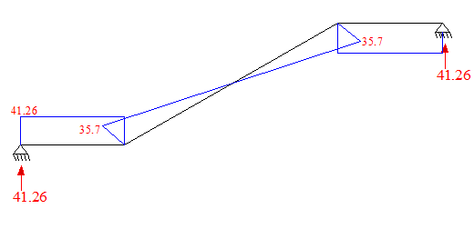
$d=250-20-12=218 mm$

- Check of shear force:-
$$∅Vc=0.75×\sqrt{fc}×\frac{1}{6}×b×d$$
$$∅Vc=0.75×\sqrt{24}×\frac{1}{6}×1000×218$$
$$∅Vc=133.5 KN>Vu=41.26 KN$$
No need to increase the slab thickness
- Design for bending moment :-
$$kn = \frac{Mn}{b×d²} = \frac{(50.82)/0.9×{10}^{6}}{1000×218²} = 1.19 Mpa$$
$$m = \frac{fy}{0.85×fc´} = 20.58 Mpa$$
$ρ req.$= 0.0029
As req. = 0.0029× 1000 × 218 = 636.8 mm²
As min = 0.0018 × 250 × 1000 = 450mm²
$$As req=636.8 mm²>As min =450 mm²$$
$$Use Ø12-17 cm, with As=\frac{{12}^{2}×π}{4}×\frac{100}{17}=664 {mm}^{2}$$
- Secondary reinforcement use $Ø10-17cm, with As=464 {mm}^{2}$
    - Design for isolated footing (F1):-
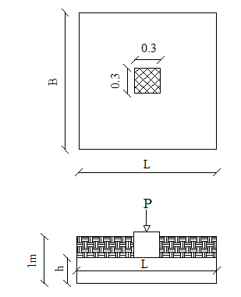

Figure (4.23): plan and section of footing (1)

- Load Calculation:
$$P_{service}=795.75 KN$$
Soil weight = 18
Column geometry = 30*30 cm
$$Allowable soil pressure = 314 KN/m²$$
$$σ_{net}=314-25×0.4-18×\left(1-0.4\right)=293.2 KN/m²$$

- Design of bearing pressure

$$σ_{net}=\frac{P_{service}}{area}⇒293.2=\frac{795.75}{area}$$
$$area = 2.72 m^{2}$$
B = L = 1.8 m
$$area= 1.8×1.8=3.24 m^{2}$$
- Design of sliding
Hu = 0 Not required
- Design of reinforcement concrete:
Factored load $P_{u}=1000 KN$
$$σ_{max}=\frac{P_{u}}{B×L}=\frac{1000}{1.8×1.8}=308.64 KN/m²<1.4×293.2=410 KN/m²$$
- Design of one way shear:
The critical section for checking one-way shear strength that is at a distance d from the face of column.
d = 400 –50 – 12 = 338 mm
$Vu$ = $0.412×308.64×1.8=228.9 KN$
$$∅Vc= 0.75×\frac{1}{6}×\sqrt{fcʹ}×bw×d$$
$$∅Vc= 0.75×\frac{1}{6}×\sqrt{24}×1800×338=372.55KN$$

- Design for two way shear:

Critical perimeter ( $b_{°}$) will be at a distance $d/2$ from the face of the column
$$b_{o}=4×(300+338)=2552 mm$$
$α_{s}$ = $40$
$$Vu= 1000-\left(308.64×{0.638}^{2}\right)= 874.4 KN$$
$$∅Vc=0.75×\left(2+\frac{4}{B_{c}}\right)×\frac{\sqrt{fcʹ}}{12}b˳×d$$
$$∅Vc= 0.75×\left(2+\frac{4}{1}\right)×\frac{\sqrt{24}}{12}×2552×338=1584.65KN$$
$$∅Vc= 0.75×\left(\frac{α×d}{b˳}+2\right)×\frac{\sqrt{fcʹ}}{12}×b_{o}×d$$
$$∅Vc=0.75×(\left(\frac{40×338}{2552}+2\right)×\frac{\sqrt{24}}{12}×2552×338)=1927.41KN$$
$$∅Vc= 0.75×4×\frac{\sqrt{fc}}{12}×b_{o}×d$$
$$∅Vc= 0.75×4×\frac{\sqrt{24}}{12}×2552×338=1056.4 KN………control$$
$$∅Vc=1056.4KN>Vu=874.4 KN$$
- $h is correct$

- Design for bending moment:-
The critical section for bending moment that is at the face of column.
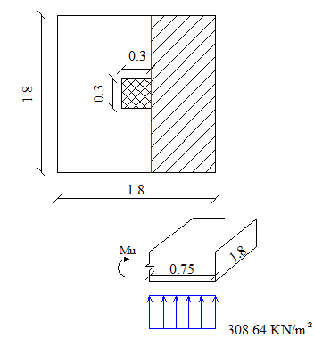

Figure (4.24): critical section for bending moment.
$$Mu=308.64×1.8×0.75×\frac{0.75}{2}$$
$$Mu=156.25 KN.m$$
$$m= \frac{Fy}{0.85×fcʹ}=\frac{420}{0.85×24}=20.6 Mpa$$
$$Mn= \frac{Mu}{∅}=\frac{156.25}{0.9}=173.61 KN$$
$$Kn= \frac{Mn}{bd²}=\frac{173.61×{10}^{6}}{1800×338²}= 0.84Mpa$$
$$ρ_{req}= \frac{1}{m}(1-\sqrt{1-\frac{2×Kn*m}{Fy}} ) \\ ρ_{req}= 0.0020$$
$${As}_{req}= ρ_{req}*b*d$$
$${As}_{req}= 0.002*180*33.8=12.43 cm²$$
$${As}_{min}= 0.0018*b*h$$
$${As}_{min}= 0.0018*180*40=12.96 cm²$$
$${As}_{req}=12.43 cm²<{As}_{min}=12.96 cm²$$
$$Select 13∅12 ,, with As=13.56 {cm}^{2}$$
Check strain:
$$T=C$$
$$As×Fy= 0.85×{fc}^{ʹ}×a×b$$
$$1296×420= 0.85×24×a×1800$$
$$a=14.82 mm$$
$$x= \frac{a}{0.85}=\frac{14.82}{0.85}=17.43 mm$$
$$\frac{0.003}{x}=\frac{0.003+ ε_{s}}{d}$$
$$ϵ_{s}= 0.055 > 0.005$$
$$∅= 0.9 is correct$$

  - Design for Parking Sheds:-
The structural system of the parking shed is frame system that carried a one way solid slab 15 cm thick. The design process includes the design of intermediate frame and the exterior and theirs footings.
For all of the elements of the shed the concrete compression strength fc' is 28 Mpa and the tensile strength of reinforcement rebar fy is 420 Mpa.
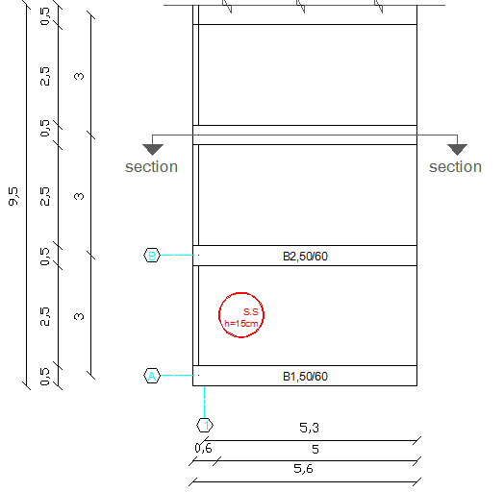
Figure (4.25): Plan of parking sheds.

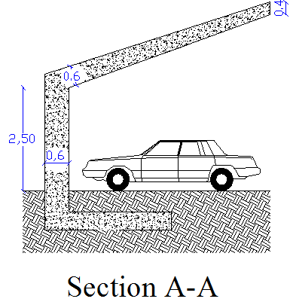

Figure (4.26): Section of parking sheds.
4.3.1 Design for slab:-
Slab will be one-way solid slab.
Thickness of slab will be calculated according to provisions in ACI-318-08 as follow:-
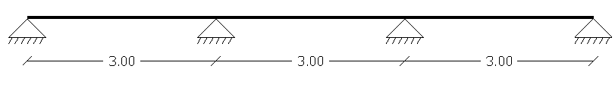

Figure (4.27): System of slab

One end Continues: (ACI-318-08, table 9.5(a))
h _{min} = L / 24
= 300 / 24 = 12.5 cm
Both end Continues: (ACI-318-08 ,table 9.5(a))
h _{min} = L / 28
= 300 / 28 = 10.7 cm
Select h = 15 cm.
- Calculation for loads:
For 1 m strip
Dead load
Slab (self-weight) = 0.15 × 25× 1 = 3.75 KN/m
Live Load
1 KN/m² will be applied to the slab
1 × 1 = 1 KN/m
Snow load
Take h = 775 m, (Bethlehem height from sea level)
$$S =\frac{(h-400)}{320}= 1.17 kN/ m²$$
$μ$ = 0.8…….. [Jordanian code page 48]
S = $S_{0}×μ$ = 0.8× 1.17 = 0.94 KN/m²
Wind load
according to Jordanian code the wind load will be calculated as follows:
Design speed:-
Ve = 33.33 m/s
Sb=1.63…..at 10m
Sb=1.17….at 3m [Jordanian code table (3-4). page 83]
For 3m …Ve =33.33×1.17/1.63= 24 m/s
Dynamic wind pressure:-
qs = 0.613 (Ve)²>550 …..[Jordanian eq. 6]
qs = 0.613 (24)² = 353 N/m²< 550
qs = 550 N/ m²
P = qs * Cb * Ca
P =550*1*0.5 = 0.27 KN/m
Wind strike the shed from the left and by analyzing the wind force on the slab a trivial value appears so we neglected.
- Load combination at the Slab:-
According to ACI, the following load combination is applied:-
1) $qu = 1.2 D + 1.6 L$
$$qu= 1.2 × 3.75 + 1.6 × 1= 6.1 KN/m$$
2$) qu = 1.2 D + 1.6 L + 0.5 S$$$qu= 1.2 × 3.75 + 1.6 × 1+ 0.5 × 0.94 = 6.57 KN/m$$
3) $qu = 1.2 D + 1.6 S + 0.5 L$
$$qu = 1.2 × 3.75 + 1.6 ×0.94 + 0.5 × 1 = 6.5KN/m$$
4) $qu = 1.2 D + 1.6 S + (Lor 0.8 W)$
$$qu = 1.2 × 3.75 + 1.6 ×0.94 + 1= 7 KN/m…Control$$

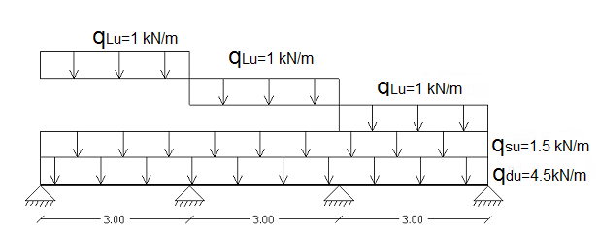
- Moment and Shear Envelop diagrams:-

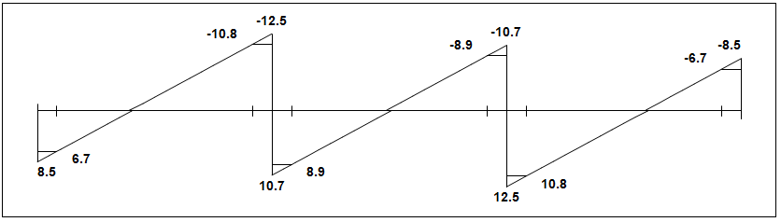
Figure (4-28): System of slab of parking shed with loads.

Figure (4-29): Slab Shear Envelop Diagram
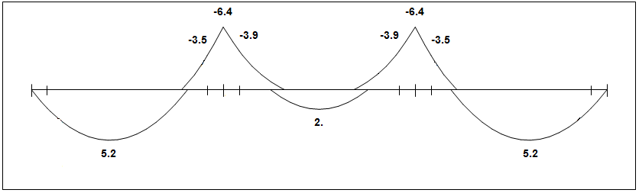

Figure (4-30): Slab Moment Envelop Diagram
- Design for Shear:-
Vu at a distance d from the face of support.
d = 150 - 20 –10/2 = 125 mm
Vu at a distance = 250 + 125 = 375 mm from center of support.
$Vumax=$10.8 KN
Check whether the thickness of the slab:-

Vc = $\frac{1}{6}\sqrt{f_{c}^{'}}b_{w }d=\frac{1}{6}\sqrt{28}×1000×125×{10}^{-3}=110.24 KN$ , ACI (11-3)
$∅$Vc = 0.75×$110.24$ = 82.68 KN
Vu max= 10.8 KN <$∅$Vc = 82.68 KN
No need to increase the slab thickness.
- Design of Bending Moment:-
Design for positive moment:-
Design of span 1and 3:-
M_{u} = 5.1 KN.m
$$Kn= \frac{\frac{M_{u}}{∅}}{bd^{2}}=\frac{5.2*\frac{{10}^{6}}{0.9}}{1000*{\left(125\right)}^{2}}=0.37 Mpa$$
$m=\frac{f_{y}}{0.85f_{c}^{'}} =\frac{420}{0.85*28}=$17.65 Map
$$ρ=\frac{1}{m}\left(1-\sqrt{1-\frac{2.K_{n}.m}{f_{y}}}\right)=\frac{1}{17.65}\left(1-\sqrt{1-\frac{2*17.65*0.37}{420}}\right)=0.00087$$
$${As}_{req}=ρ b d=0.00087 * 1000 * 125 = 108.8 {mm}^{2}$$
${As}_{min}=0.0018 b h=0.0018*1000*150=270 {mm}^{2}$ , ACI-318-08 (7.12.2.1)
$${As}_{req}=108.8.4 {mm}^{2}<{As}_{min}=270 {mm}^{2}$$

$$Select∅10-25cm$$
with As = (π × 10² / 4) × 100/25 = 316 mm²

Check: strain:-
$T=C$
$As f_{y}=0.85 f_{c}^{'} a b$
$$316*420=0.85*28*a*1000$$
$a=5.57 mm$
$$x=\frac{6.83}{0.85}=6.56 mm\frac{0.003}{x}=\frac{0.003+ϵ_{s}}{d}$$
$$\frac{0.003}{6.56}=\frac{0.003+ϵ_{s}}{125}$$
$$ϵ_{s}=0.054>0.005$$
OK $∅=0.9$

Design of span 2:-
M_{u} = 2KN.m
$$Kn= \frac{M_{u}/∅}{bd^{2}}=\frac{2*{10}^{6}/0.9}{1000*{(125)}^{2}}=0.142 Mpa$$
$$m=\frac{f_{y}}{0.85f_{c}^{'}} =\frac{420}{0.85*28}=17.65 Mpa$$
$ρ=\frac{1}{m}\left(1-\sqrt{1-\frac{2.K_{n}.m}{f_{y}}}\right)=\frac{1}{17.65}\left(1-\sqrt{1-\frac{2*17.65*0.142}{420}}\right)=0.000$34
$${As}_{req}=ρ b d=0.00034 * 1000 * 125 = 42.45 {mm}^{2}$$
$${As}_{min}=0.0018 b h=0.0018*1000*150=270 {mm}^{2}$$
$${As}_{req}=42.45 {mm}^{2}<{As}_{min}=270 {mm}^{2}$$
$${As}_{req}=270 {mm}^{2}$$
$$Select∅10/25cm$$

With As = (π × 10² / 4) × 100/25 = 316 mm²

Check: strain:-
$$T=C$$
$As f_{y}=0.85 f_{c}^{'} a b$
$$a=5.57mm$$
$x=6.56 mm$
$$\frac{0.003}{x}=\frac{0.003+ϵ_{s}}{d}$$
$$\frac{0.003}{6.56}=\frac{0.003+ϵ_{s}}{125}$$
$$ϵ_{s}=0.0.054>0.005$$
OK $∅=0.9$
Design for negative moment:
Design of support1 and 2:-
M_{u} = -3.9 KN.m
$$Kn= \frac{M_{u}/∅}{bd^{2}}=\frac{3.9*{10}^{6}/0.9}{1000*{(125)}^{2}}=0.28 Mpa$$
$$m=\frac{f_{y}}{0.85f_{c}^{'}} =\frac{420}{0.85*28}=17.65$$
$$ρ=\frac{1}{m}\left(1-\sqrt{1-\frac{2.K_{n}.m}{f_{y}}}\right)=\frac{1}{17.65}\left(1-\sqrt{1-\frac{2*17.65*0.27}{420}}\right)=0.00067$$
$${As}_{req}=ρ b d=0.00067 * 1000 * 125 = 83.83 {mm}^{2}$$
$${As}_{min}=0.0018 b h=0.0018*1000*150=270 {mm}^{2}$$
$${As}_{req}=83.83 {mm}^{2}<{As}_{min}=270 {mm}^{2}$$
$$Select∅10/25cm$$

With As = (π × 10² / 4) × 100/25 = 316 mm²

Check strain:-
$T=C$
$$As f_{y}=0.85 f_{c}^{'} a b$$
$a=5.57 mm$
$x=6.56 mm$
$$\frac{0.003}{x}=\frac{0.003+ϵ_{s}}{d}$$
$$\frac{0.003}{6.56}=\frac{0.003+ϵ_{s}}{125}$$
$$ϵ_{s}=0.054>0.005$$
So $∅=0.9$

In the secondary direction to cover the secondary moment, shrinkage and temperature is required:
$${As}_{min}=0.0018 b h=0.0018*1000*140=252 {mm}^{2}$$
$Select∅10/25cm,$With As = (π × 10² / 4) × 100/30 = 316 mm²

4.3.2 Design for Intermediate Frame:-
- Calculation of loads:-
Dead load:-
Self-weight slab= 0.15 × 25 × 3 = 11.25 KN/m
Self-weight beam= (0.4+0.6)/2× 0.5× 25 × 1 = 6.25 KN/m
Total dead load from slab = 11.25 + 6.25 = 17.5 KN/m

Live Load:-
[1KN/m²] will be applied.
1× 3 = 3 KN/m
Snow load:-
Take h = 775 m, (Bethlehem height from sea level)
$$S =\frac{(h-400)}{320}= 1.17 KN/ m²$$$μ$ = 0.8…….. [Jordanian code page 48]
S = $S_{0}×μ$ = 0.8× 1.17 = 0.94 KN/m²
S = 0.94$×$ 3 = 2.82 KN/m

Wind load:-
According to Jordanian code the wind load will be calculated as follows:
Design speed:-
Ve = 33.33 m/s
Sb=1.63…..at 10m
Sb=1.17….at 3m [Jordanian code table (3-4). page 83]
For 3m …Ve=33.33*1.17/1.63=24 m/s
Dynamic wind pressure:-
qs = 0.613 (Ve)²>550 …..[Jordanian eq. 6]
qs = 0.613 (24)² = 353 N/m²< 550
qs = 550 N/ m²
P= qs * Cb * Ca
P= 0.55×1×0.8× 3 = 1.32 KN/m at the frame column.

Wind strike the shed from the left and by analyzing the wind force on the frame beam a trivial value appears so we neglected.
Wind load on the frame beam = 0.55×0.5×1= 0.27 KN/m²
This is very small value it will be neglected.
*Weight of column = 0.6 × 0.5 × 25 × 3 = 22.5 KN (point load)
- Load combination at the intermediate frame:-
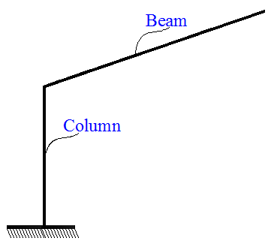
Load combination at the Intermediate frame (Beam):-
According to ACI the following load combination is applied:-
- qu= 1.2 D + 1.6 L
$$qu= 1.2 × 17.5 + 1.6 × 3 = 25.8 KN/m$$
- qu = 1.2 D + 1.6 L + 0.5 S
$qu$= 1.2 × 17.5 + 1.6 × 3 + 0.5 × 2.82 = 27.21 KN/m
- $qu= 1.2 D + 1.6 S + 0.5 L$
$$qu = 1.2 × 17.5 + 1.6 × 2.82 + 0.5 × 3 = 27 KN/m$$
- $qu = 1.2 D + 1.6 S + ( L or 0.8 W )$
$$qu= 1.2 × 17.5 + 1.6 × 2.82 + 3 = 28.5 KN/m……..Control$$
Load combination at the Intermediate frame (Column):-
According to ACI, the following load combination is applied:-
Dead = 1.2 D = 1.2 × 22.5 = 27 KN
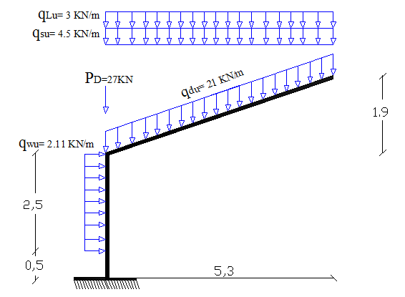
Wind = 1.6 W = 1.6 × 1.32 = 2.11 KN/m

Figure (4-31): System of Intermediate Frame.

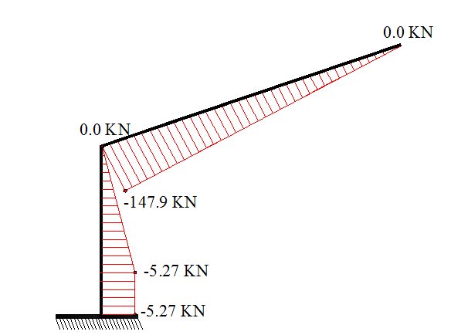
- Internal forces diagrams:-

Figure (4-32): Intermediate Frame Shear Force Diagram.
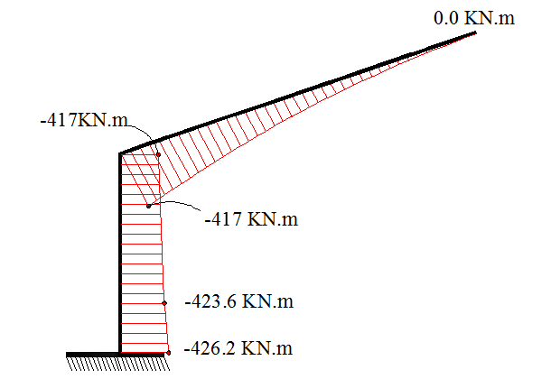

Figure (4-33): Intermediate Frame Moment Diagram.

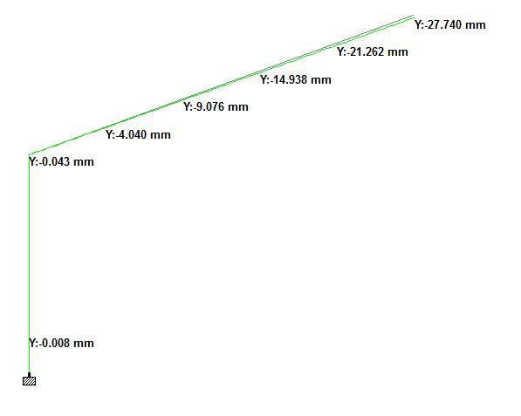

Figure (4-34): Intermediate Frame Deformation diagram.
Check Deflection:-
Allowable deflection = L / 180 = 530 / 180 = 2.92 cm
Max deflection = 2.77 cm <2.92 cm Ok

4.3.2.1 Design for Intermediate frame (Beam):-
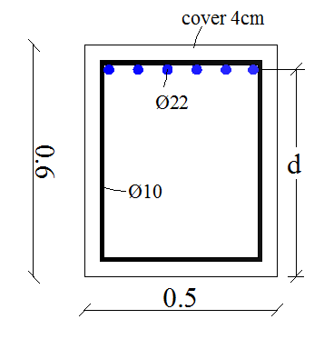
Design for Bending Moment:-

Figure (4-35): Beam section for Intermediate Frame.
M_{u} at the face = - 373 KN.m
$$d=600-40-10 –(\frac{22}{2})=539 mm$$

$$Kn= \frac{M_{u}/∅}{bd^{2}}=\frac{373*{10}^{6}/0.9}{500*{(539)}^{2}}=2.85 Mpa$$
$$m=\frac{f_{y}}{0.85f_{c}^{'}} =\frac{420}{0.85*28}=17.65 Mpa$$
$$ρ=\frac{1}{m}\left(1-\sqrt{1-\frac{2.K_{n}.m}{f_{y}}}\right)=\frac{1}{17.65}\left(1-\sqrt{1-\frac{2*17.65*2.85}{420}}\right)=0.00725$$
$${As}_{req}=ρ b d=0.00725 * 500 * 539 = 1953.75 {mm}^{2}$$
$${As}_{min}=0.25*\frac{\sqrt{f_{c}^{'}}}{f_{y}}*b*d=0.25*\frac{\sqrt{28}}{420}*500*539=849 {mm}^{2}$$
$${As}_{min}=\frac{1.4}{f_{y}}*b*d=\frac{1.4}{420}*500*539=898{mm}^{2}$$
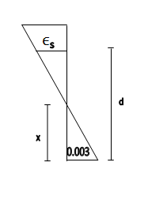
${As}_{req}=1953.75 {mm}^{2}>{As}_{min}=898 {mm}^{2}$
$$n=\frac{1953.75}{380}=5.14$$
$$Select 6∅22$$

With As = (π × 22² / 4) × 6= 2280 mm²

Check strain:-
$$T=C$$
$$As f_{y}=0.85 f_{c}^{'} a b$$
$$6*380*420=0.85*28*a*500$$
$$a=80.47 mm$$
$$x=\frac{80.47}{0.85}=94.67 mm$$
$$\frac{0.003}{x}=\frac{0.003+ϵ_{s}}{d}$$
$$\frac{0.003}{94.67}=\frac{0.003+ϵ_{s}}{539}=0.014>0.005$$
So $∅=0.9$

Design of Shear:-
Critical section at 539 from face of column
d=550 – 40 – 10 – 22/2 = 489mm
Vu = - 125.12 KN
$$V_{c}=\frac{1}{6}*\sqrt{f_{c}^{'}}*b_{w}*d \\ { V}_{c}= \frac{1}{6}*\sqrt{28}*500*489=215.6 KN$$
$${ V}_{c}=215.6 KN$$
$∅V_{c}$= 215.6*0.75 =161.72 KN
$∅V_{c}$= 171.62 KN > Vu=125.12 KN
No need shear reinforcement
Select $∅10/20 cm$
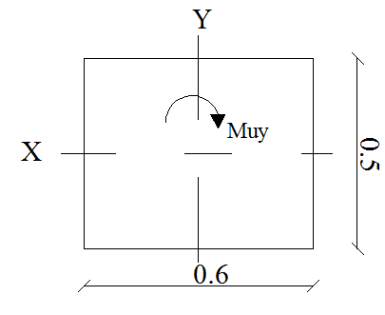
4.3.2.2 Design for Intermediate frame (column):-

Figure (4-36): Column section for Intermediate Frame.
Pu= 187.35 KN
Muy = 426.2 KN.m
Mux = 0 KN.m

Slenderness:-
Unbraced column
$$\frac{KL}{r}≤22$$
*System about y-axis
The column is short in y-direction, because we have a plain concrete wall to prevent buckling column.
*System about x-axis
$$\frac{KL}{r}≤22=\frac{2×300}{0.3×50}=40>22 →Long Column$$
Bresler equation:-
$$\frac{1}{P_{n}}=\frac{1}{P_{nx}}⟹P_{n}=P_{nx}$$

Column in long direction (x-axis):-
emin = 15+0.03*h
= 15+0.03*500 = 30mm
eprov$=\frac{mu}{p_{u}}=\frac{426.2}{187.35}=$ 2.27 mm……control
$$\frac{e}{h}=\frac{2.27}{0.5}=4.54$$
The value of (e/h) is a large, because this value is large we can't use the interaction diagram to solve column.
Check the design column as beam:-
$0.1× Ag ×f_{c}^{'}>Pu$…….. (ACI code 10.3.5)
$$0.1 ×500×600×28=840KN$$
$$Pu=187.35 KN$$
$$0.1× Ag ×f_{c}^{'}=840>Pu=187.35$$
$$⇒Designcolumnasbeam$$
M_{u} = 426.2 KN.m
$$d=600-40-10 –(\frac{22}{2})=539 mm$$
$$Kn= \frac{M_{u}/∅}{bd^{2}}=\frac{426.2*{10}^{6}/0.9}{500*{(539)}^{2}}=3.26 Mpa$$
$$m=\frac{f_{y}}{0.85f_{c}^{'}} =\frac{420}{0.85*28}=17.65 Mpa$$
$$ρ=\frac{1}{m}\left(1-\sqrt{1-\frac{2.K_{n}.m}{f_{y}}}\right)=\frac{1}{17.65}\left(1-\sqrt{1-\frac{2*17.65*3.26}{420}}\right)=0.0083$$
$${As}_{req}=ρ b d=0.0083 * 500 * 539 = 2236.9 {mm}^{2}$$
$${As}_{min}=0.25*\frac{\sqrt{f_{c}^{'}}}{f_{y}}*b*d=0.25*\frac{\sqrt{28}}{420}*500*539=849 {mm}^{2}$$
$${As}_{min}=\frac{1.4}{f_{y}}*b*d=\frac{1.4}{420}*500*539=898{mm}^{2}$$
$${As}_{req}=2236.9 {mm}^{2}>{As}_{min}=898 {mm}^{2}$$
$$n=\frac{2236.9}{380}=5.9$$
$$Select 6∅22$$

With As = (π × 22² / 4) × 6= 2280 mm²

Check strain:-
$T=C$
$As f_{y}=0.85 f_{c}^{'} a b$
$a=80.47mm$
$$x=94.7 mm$$
$\frac{0.003}{x}=\frac{0.003+ϵ_{s}}{d}$
$$\frac{0.003}{94.7}=\frac{0.003+ϵ_{s}}{539}$$
$$ϵ_{s}=0.014>0.005$$
OK $∅=0.9$
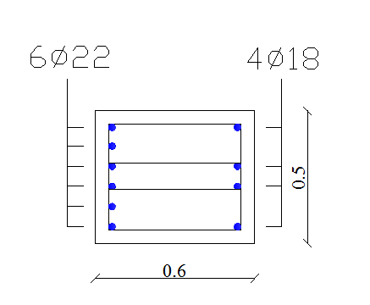
Check of reinforcement ratio for the column:-
$$ρ_{g = \frac{As}{Ag}= \frac{(6 ×380 + 4 ×254)}{500 ×600} = 0.011}$$
$$ρ_{g = 1.1\%}$$
1% < 1.1% < 8%

Check whether the nominal strength of the column is adequate for axial force:-
$$∅P_{n}=0.65×0.80×A_{g}\left(0.85×f_{c^{'}}\left(1-ρ_{g}\right)+f_{y}×ρ_{g}\right)$$
$$∅P_{n}=0.65×0.80×500×600(0.85×28(1-0.011 )+420×0.011)$$
$$∅P_{n}=4392 KN$$
$$∅P_{n}=4392 KN≫Pu=187.3 KN$$
Section its adequate enough.
Design for stirrups: -
Construction rules from ACI for tied reinforced section:
For diameter of ties:-
For $∅_{Vertical bars}=22 mm$Select $∅_{Stirrups}=10 mm$
Spacing of ties:-
$$S≤16×∅_{vertical bars}=16×22=352 mm$$
$$S≤48×∅_{stirrups}=48×10=480 mm$$
$$S≤minimum dimenstion if colummn=500 mm$$
$$S=350 mm→control.$$

4.3.3 Design for Exterior Frame:-
- Calculation of loads:-
Dead load:-
Self-weight slab= 0.15 × 25 × 1.5 = 5.62 KN/m
Self-weight beam= (0.40+0.60)/2 ×0.5 × 25 × 1 = 6.25 KN/m
Total dead load from slab = 5.62 + 6.25 = 11.87 KN/m

Live Load:-
[1KN/m²] will be applied.
1KN/m²× 1.5 = 1.5 KN/m

Snow load:-
Take h = 775 m, (Bethlehem height from sea level)
$$S=\frac{(h-400)}{320}= 1.17 kN/ m²$$$μ$ = 0.8……..[Jordanian code page 48]
S = $S_{0}×μ$ = 0.8× 1.17 = 0.94 KN/m²
S = 0.94×1.5 = 1.41 KN/m

Wind load:-
According to Jordanian code the wind load will be calculated as follows:
Design speed:-
Ve = 33.33 m/s
Sb=1.63…..at 10m
Sb=1.17….at 3m [Jordanian code table (3-4). page 83]
For 3m …Ve=33.33*1.17/1.63=24 m/s
Dynamic wind pressure:-
qs = 0.613 (Ve)²>550 …..[Jordanian eq. 6]
qs = 0.613 (24)² = 353 N/m²< 550
qs = 550 N/ m²
P = qs * Cb * Ca
P =0.55*1*0.8*1.5 = 0.66 KN/mat the frame column.

Wind strike the shed from the left and by analyzing the wind force on the frame beam a trivial value appears so we neglected.
Wind load on the frame beam = 0.55 ×0.5×1×1.5 = 0.4 KN/m²
This is very small value it will be neglected.
*Weight of column = 0.6 × 0.5 × 25 × 3 = 22.5 KN (point load)

- Load combination at the Frame:-
Load combination at the Exterior frame (Beam):-
According to ACI, the following load combination is applied:-
- $qu = 1.2 D + 1.6 L$
$$qu = 1.2 × 11.87 + 1.6 × 1.5 = 16.65 KN/m$$
- $qu = 1.2 D + 1.6 L + 0.5 S$
$$qu = 1.2 × 11.87 + 1.6 × 1.5 + 0.5 × 1.41 = 17.35 KN/m$$
- qu = 1.2 D + 1.6 S + 0.5 L
$$qu = 1.2 × 11.87 + 1.6 × 1.41 + 0.5 × 1.5 = 17.25 KN/m$$
- qu = 1.2 D + 1.6 S + ( L or 0.8 W )
$$qu = 1.2 × 11.87 + 1.6 × 1.41 + 1.5 = 18 KN/m……..Control$$
Load combination at the Exterior frame (column):-
According to ACI, the following load combination is applied:-
Dead = 1.2 D = 1.2 × 22.5 = 27 KN
Wind = 1.6 W = 1.6 × 0.66 = 1.06 KN/m

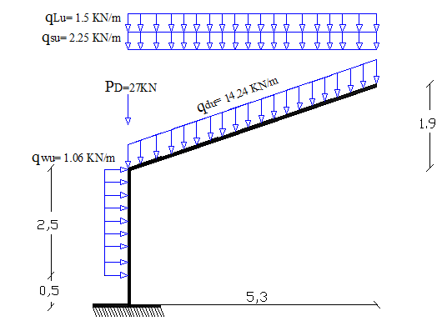

Figure (4-37): System of Exterior Frame.
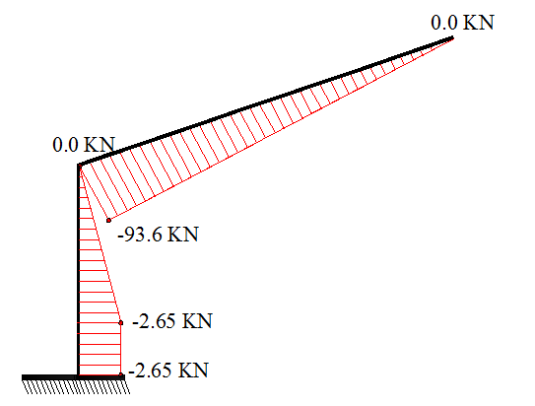
- Internal forces diagrams:-

Figure (4-38): Exterior Frame Shear Force Diagram.

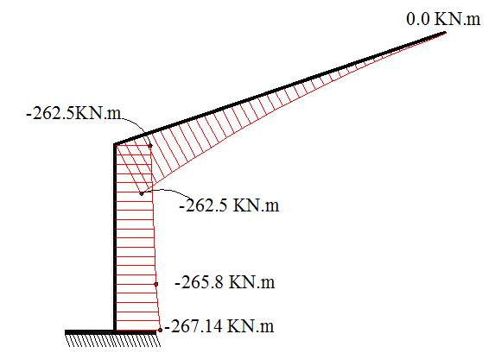

Figure (4-39): Exterior Frame Moment Diagram.

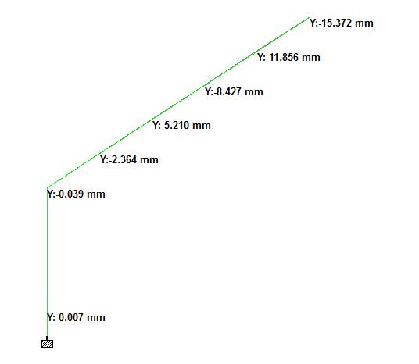

Figure (4-40): Exterior Frame Deformation diagram.
Check Deflection:-
Allowable deflection = L / 180 = 530/ 180= 2.94 cm
Max deflection = 1.53 cm <2.94 cm Ok

4.3.3.1 Design for Exterior frame beam:-
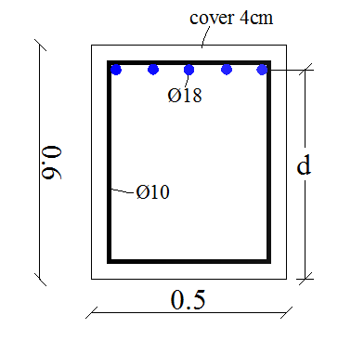
Design of Bending Moment:-
M_{u} at the face = - 236.22 KN.m
$$d=600-40-10 –(\frac{18}{2})=541 mm$$
$$Kn= \frac{M_{u}/∅}{bd^{2}}=\frac{236.22*{10}^{6}/0.9}{500*{(541)}^{2}}=1.79 Mpa$$
$$m=\frac{f_{y}}{0.85f_{c}^{'}} =\frac{420}{0.85*28}=17.65 Mpa$$
$$ρ=\frac{1}{m}\left(1-\sqrt{1-\frac{2.K_{n}.m}{f_{y}}}\right)=\frac{1}{17.65}\left(1-\sqrt{1-\frac{2*17.65*1.79}{420}}\right)=0.0044$$
$${As}_{req}=ρ b d=0.0044 * 500 * 541 =1202.3 {mm}^{2}$$
$${As}_{min}=0.25*\frac{\sqrt{f_{c}^{'}}}{f_{y}}*b*d=0.25*\frac{\sqrt{28}}{420}*500*541=852 {mm}^{2}$$
$${As}_{min}=\frac{1.4}{f_{y}}*b*d=\frac{1.4}{420}*500*541=902 {mm}^{2}$$
$${As}_{req}=1202.3 {mm}^{2}<{As}_{min}=902 {mm}^{2}$$
$$n=\frac{1202.3}{254.5}=4.72$$
$$Select 5∅18$$
With As = (π × 18² / 4) × 5= 1272.3 mm²

Check train:-
$$T=C$$
$As f_{y}=0.85 f_{c}^{'} a b$
$5*254.5*420=0.85*28*a*500$
$a=44.91 mm$
$$x=\frac{44.91}{0.85}=52.84 mm$$
$$\frac{0.003}{x}=\frac{0.003+ϵ_{s}}{d}$$
$$\frac{0.003}{52.84}=\frac{0.003+ϵ_{s}}{541}$$
$$ϵ_{s}=0.027>0.005$$
So $∅=0.9$
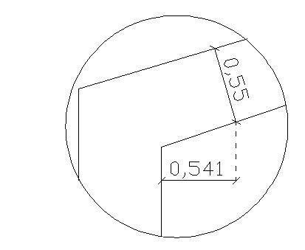
Design for Shear:-
Critical section at 541 from face of column
Vu = - 86.95 KN
$$V_{c}=\frac{1}{6}*\sqrt{f_{c}^{'}}*b_{w}*d$$
$${ V}_{c}= \frac{1}{6}*\sqrt{28}*500*541=238.6 KN$$
$∅V_{c}$ = $0.75*238.6=178.9 KN$
$V_{u}=86.95 ≤∅Vc=$178.9KN
No need shear reinforcement is required
Select $∅10-20 cm$
4.3.3.2Design for Exterior frame column:-

Figure (4-41):Column section for Exterior Frame.
Pu = 126.63KN
Muy = 267.14 KN.m
Mux = 0 KN.m

Slenderness:-
Unbraced column
$$\frac{KL}{r}≤22$$
*System about y-axis
The column is short in y-direction, because we have a plain concrete wall to prevent buckling column.
*System about x-axis
$$\frac{KL}{r}≤22=\frac{2×300}{0.3×50}=40>22 →Long Column$$
Bresler equation:-
$$\frac{1}{P_{n}}=\frac{1}{P_{nx}}⟹P_{n}=P_{nx}$$

Column in long direction (x-axis):-
emin = 15+0.03*h
= 15+0.03*500 = 30mm
$$eprov=\frac{mu}{p_{u}}=\frac{267.14}{126.63}=2.10 m……control$$
$$\frac{e}{h}=\frac{2.10}{0.5}=4.2$$
The value of (e/h) is a large, because this value is large we can't use the interaction diagram to solve column.
Check the design column as beam:-
$0.1× Ag ×f_{c}^{'}>Pu$…….. (ACI code 10.3.5)
$$0.1 ×500×600×28=840KN$$
$$Pu=126.63 KN$$
$$0.1× Ag ×f_{c}^{'}=840>Pu=126.63$$
$⇒Designcolumnasbeam$:-
M_{u} = 267.14 KN.m
$$d=600-40-10 –(\frac{18}{2})=541 mm$$
$$Kn= \frac{M_{u}/∅}{bd^{2}}=\frac{267.14*{10}^{6}/0.9}{500*{(541)}^{2}}=2.03 Mpa$$
$$m=\frac{f_{y}}{0.85f_{c}^{'}} =\frac{420}{0.85*28}=17.65 Mpa$$
$$ρ=\frac{1}{m}\left(1-\sqrt{1-\frac{2.K_{n}.m}{f_{y}}}\right)=\frac{1}{17.65}\left(1-\sqrt{1-\frac{2*17.65*2.03}{420}}\right)=0.0051$$

$${As}_{req}=ρ b d=0.0051 * 500 * 541 = 1367.31 {mm}^{2}$$
$${As}_{min}=0.25*\frac{\sqrt{f_{c}^{'}}}{f_{y}}*b*d=0.25*\frac{\sqrt{28}}{420}*500*541=852 {mm}^{2}$$
$${As}_{min}=\frac{1.4}{f_{y}}*b*d=\frac{1.4}{420}*500*541=902 {mm}^{2}$$
$${As}_{req}=1367.31 {mm}^{2}>{As}_{min}=902 {mm}^{2}$$
$$n=\frac{1367.31}{254.5}=5.4$$

$$Select 6 ∅18$$

With As = (π × 18² / 4) × 6= 1526.76 mm²

Check strain:-
$$T=C$$
$As f_{y}=0.85 f_{c}^{'} a b$
$$a=53.9 mm$$
$x=63.4 mm$
$\frac{0.003}{x}=\frac{0.003+ϵ_{s}}{d}$
$$\frac{0.003}{63.4}=\frac{0.003+ϵ_{s}}{541}$$
$$ϵ_{s}=0.022>0.005$$
OK $∅=0.9$
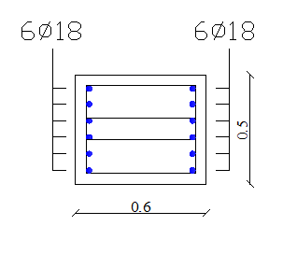
Check of reinforcement ratio for the column:-
$$ρ_{g}=\frac{As}{Ag}=\frac{(12 ×254)}{500 ×600}=0.0102$$
$$ρ_{g}=1.02\%$$
1% < 1.02% < 8%

Check whether the nominal strength of the column is adequate for axial force:-
$$∅P_{n}=0.65×0.80×A_{g}\left(0.85×f_{c^{'}}\left(1-ρ_{g}\right)+f_{y}×ρ_{g}\right)$$
$$∅P_{n}=0.65×0.80×500×600(0.85×28(1-0.0102)+420×0.0102)$$
$$∅P_{n}=4343.2 KN$$
$$∅P_{n}=4343.2 KN≫Pu=126.63 KN$$
Section it's adequate enough.

Design for stirrups:
Construction rules from ACI for tied reinforced section:
For diameter of ties:
For $∅_{Vertical bars}=18 mm$Select $∅_{Stirrups}=10 mm$
Spacing of ties:
$$S≤16×∅_{vertical bars}=16×18=288 mm$$
$$S≤48×∅_{stirrups}=48×10=480 mm$$
$$S≤minimum dimenstion if colummn=500 mm$$
$$S=250mm→control.$$

4.3.4 Design for footing:-
Subsurface condition
According to the soil report of the site, the bearing capacity at the design depth is $3.2\frac{Kg}{{cm}^{2}}≈314 \frac{KN}{m^{2}}$ and the specific weight of soil is 18$\frac{KN}{m^{3}}$
Footing design
The foundation required to support the frame is a cantilever footing with dimension $L×B$ where:
$L$: is the length of the footing that resists the moment.
$B$: is the width of the footing.
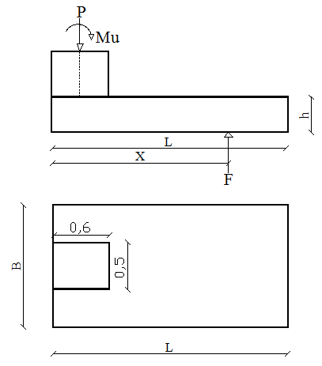
$h$: is the thickness of the footing.

Figure (4-42): Equilibrium system of footing
4.3.4.1 Design for Intermediate frame footing:-
The footing caries the frame column reaction (service load):
$$P=P_{dead}+P_{Live}{+P}_{Snow} \\ P=158.6 KN$$
Moment on the frame column:
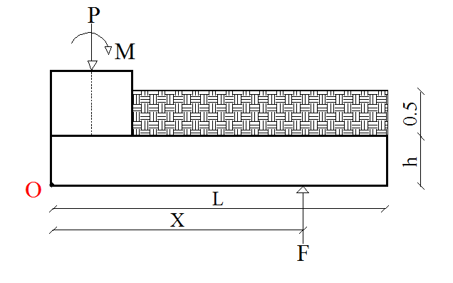
$M_{survice}=340.5 KN.m$
$$q_{net-allowable}=q_{allowable}-(q_{self-weight}+ q_{soil pressure})$$
$$q_{net-allowable}=314-(25×{0.4}_{\left(assumed\right)})+0.5×18)$$
$$q_{net-allowable}=295 \frac{KN}{m^{2}}$$
Computing the area($B×L)$
$$q_{allowable}=\frac{P}{L×B}→ L×B=\frac{P}{q_{allowable}} =\frac{158.6}{295}$$
$$L×B=0.54 m^{2}$$
Select$→$ B = 1 m,L = 2 m
With Area = 2 $×$ 1 = $2 m^{2}$

These loads will appears as a reaction somewhere on the footing base (as shown)
Summation of vertical Force = zero
F = P
By taking moment about point O:
$$P×0.3+Ms=F×X \\ 158.6×0.3+340.5=158.6×X→X=2.44 m$$

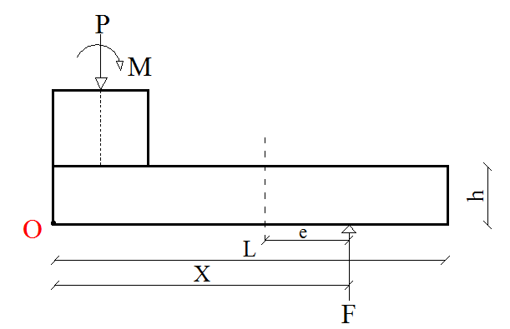
And the eccentricity:
$$e=\frac{L}{2}-X$$

Figure (4-43): Eccentricity from center of footing
Try 1:-
When a value L =2m
$$e=\frac{2.0}{2}-2.44=-1.4m$$
The negative sign of $e$ indicate that it exceeds the center of gravity of the footing base to the other side as shown in Figure (4-19).
When $e=1.4>\frac{L}{3}= \frac{2}{3}$ = 0.67 m
$⇒$(L) must be increased
Try 2:-
Let’s assume a value for $L$ =2.5 m then:
$$e=\frac{2.5}{2}-2.44=-1.19m$$
When $e=1.19>\frac{L}{3}= \frac{2.5}{3}$ = 0.83 m
$⇒$ (L) must be increased
Try 3:-
Let’s assume a value for $L$ =3 m then:
$$e=\frac{3}{2}-2.44=-0.94m$$
When $\frac{L}{6}=\frac{3}{6}=0.5 <e=0.94<\frac{L}{3}= \frac{3}{3}$ = 1 m
Contact pressure
Since $0.5m<e=0.94<1m$ then $q_{minimum}$will be negative so the following equation for computing $q_{max}$ is valid:
$$q_{max}=\frac{4×P}{3×B(L-2×e)}$$
$$q_{max}=\frac{4×158.6}{3×1×(3-2×0.94)}=188.81 KN$$
$$q_{max}=188.81<q_{net-allowable}=295 \frac{KN}{m^{2}}$$
Thus the required dimension of the footing is $3×1$m
Check against sliding failure:
The factor of safety against sliding is expressed as follows:
$${F.s}_{sliding}=\frac{Σhorizontalresistingfoces}{Σhorizontaldrivingfoces}≥1.5$$
$${F.s}_{sliding}=\frac{ΣV ×tan({\frac{2}{3 }}×∅) + p_{p}}{F_{x }+{ p}_{a}}$$
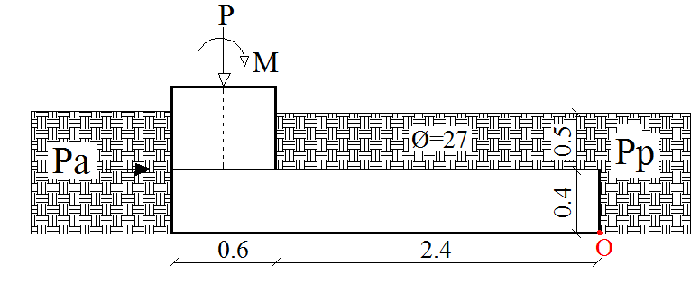

Figure (4-44): Forces for check against sliding failure.
$K_{a}=\frac{1-\sin{∅}}{1+\sin{∅}}=\frac{1-\sin{27}}{1+\sin{27}}=$0.375
$K_{p}=\frac{1+\sin{∅}}{1-\sin{∅}}=\frac{1+\sin{27}}{1-\sin{27}}=$2.66
$p_{p}=\frac{1}{2}×γ_{1}×K_{p}×H^{2}= \frac{1}{2}×18 ×2.66 ×{0.9}^{2}$ = 19.4 KN

$$p_{a}=\frac{1}{2}×γ_{1}×K_{a}×H^{2}= \frac{1}{2}×18×0.375×{0.9}^{2}=2.73 KN$$
$$ΣV=weightofsoilabovefooting+weightoffooting+P_{u}$$
$$ΣV=18×2.4×1×0.5+25×3×1×0.4+158.6=210.2 KN$$
$${F.s}_{sliding}=\frac{210.2×tan({\frac{2}{3}}×27)+19.4}{3.3+2.73}=14.5 >1.5→O.K$$

Check against overturning failure:-
The moment will be taken about point O as shown
$${F.s}_{overturning}=\frac{Resisitingmoment}{overturningmoment}>1.5$$
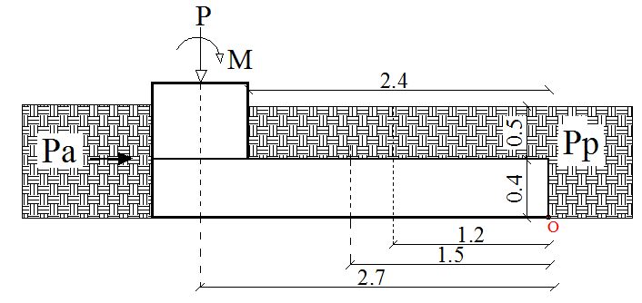

Figure (4-45): Forces for Check against overturning failure.
$$Resisitingmoment=25.9 ×1.2+ 36 ×1.5+158.6 ×2.7 +19.4 ×0.3 =519.14 KN.m$$
$$overturningmoment=340.5+2.73×0.3=341 KN.m$$
$${F.s }_{overturning}=\frac{519.14}{341}=1.53>1.5 →O.K$$
Design for footing thickness and structural reinforcement:-
Factored load:
$$Pu=184.4KN$$
$$m_{u}=426.2 KN.m$$
Then the pressure under footing is
$$q_{max}=219.5 \frac{KN}{m^{2}}$$
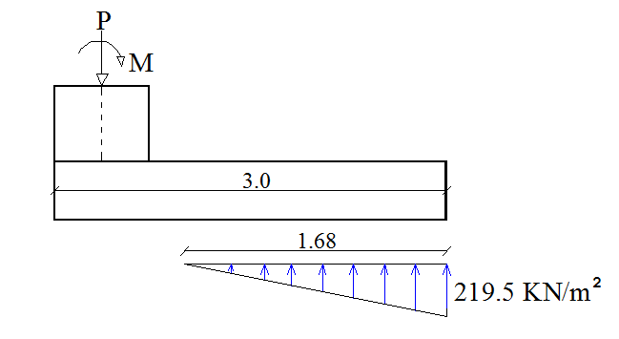

Figure (4-46): Contact Pressure diagram due to loading.
Design for footing thickness:-
The thickness of footing will be selected so that punching shear failure does not occur. Assume $∅_{max}$ main reinforcement is 22 mm and cover of 50 mm.
$$d=400-50-22=328 mm$$The footing will be design against one way shear and against punching shear.
Punching shear (Tow way shear):-
Critical perimeter ( $b_{°}$) will be at a distance $d/2$ from the face of the column
$$b_{°}=2 ×\left(600+164\right)+\left(500+328\right)=2356 mm$$
$$β=\frac{60}{50}=1.2$$
$$α_{s}=30 \left(edgecolumn\right)$$

The factored shear to be transferred across the critical perimeter is:
$$v_{u}=158.6 KN$$
The shear strength of concrete according to ACI is given by equation as follows:
$$V_{c}=\left(2+\frac{4}{β}\right)×\frac{\sqrt{f_{c^{'}}}}{12}×b_{°}×d$$
$$=\left(2+\frac{4}{1.2}\right)×\frac{\sqrt{28}}{12}×2356×328= 1817.4 KN$$

$$V_{c}=\left(\frac{α_{s}d}{b_{°}}+2\right)×\frac{\sqrt{f_{c^{'}}}}{12}×b_{°}×d$$
$$=\left(\frac{30×328}{2356}+2 \right)×\frac{\sqrt{28}}{12}×2356 ×328=2104.7 KN$$

$$V_{c}=\frac{1}{3}×\sqrt{f_{c^{'}}}×b_{°}d$$
$$=\frac{1}{3}×\sqrt{28}×2365 ×328=1363 KN$$
The minimum value of the previous equations controls.
$${∅×V}_{c}=0.75×1363=1022.3 KN>158.6 O.K$$

The footing thickness is adequate against two way shear.

One way shear:-
The critical section for checking one-way shear strength that is at a distance d from the face is shown in Fig (4-21).

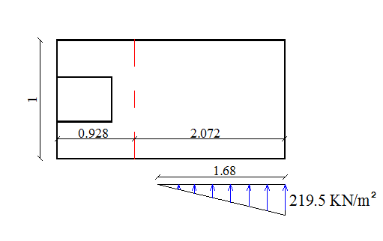

Figure (4-47): Critical section for checking one-way.

$$V_{u}=0.5 ×219.5×1.68×1=184.4 KN$$
$$∅×V_{c}=∅×\frac{1}{6}×\sqrt{f_{c'}}×b_{w}×d=0.75×\frac{1}{6}×\sqrt{28}×1000×328=216.9 KN$$

$$∅×V_{c}=216.9>V_{u}=184.4$$

Thickness of footing is adequate against one way shear.

Design for footing against bending moment:-

The critical section for bending moment that is at the face as shown in Fig (4-22)
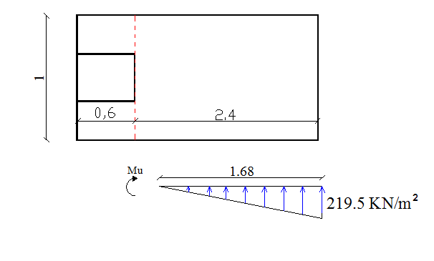

Figure (4-48): Critical section for design Moment

$$M_{u}=\frac{1}{2}×219.5×1.68×\left(\left(2.4-1.68\right)+(\frac{2}{3}×1.68)\right)=339.25 KN.m$$

$$Kn= \frac{M_{u}/∅}{bd^{2}}=\frac{339.25×{10}^{6}/0.9}{1000×{(328)}^{2}}=3.5 Mpa$$
$$m=\frac{f_{y}}{0.85f_{c}^{'}} =\frac{420}{0.85*28}=17.65 Mpa$$
$$ρ_{req}=\frac{1}{m}\left(1-\sqrt{1-\frac{2.K_{n}.m}{f_{y}}}\right)=\frac{1}{17.65}\left(1-\sqrt{1-\frac{2×17.65×3.5}{420}}\right)=0.00906$$
$$A_{sreq}=ρ_{req}×b×d=0.00906×1000×328=2974.25 {mm}^{2}/m$$
$${As}_{min}=0.0018×1000×328=590.4 mm2$$
$A_{sreq}=2974.5 {mm}^{2}$>${As}_{min}=590.4 mm2$
$Select∅22 mm$, With As =$\frac{{22}^{2}×π}{4}$ =380 mm²
$$n=\frac{2974.25}{380}=7.8$$
Select 8$∅22$
With As = (π × 22² / 4) × 8= 3040 mm²
To cover the secondary moment, shrinkage and temperature is required:
${As}_{min}=0.0018×1000×328=590.4 mm2$/m
$Select∅14 mm,$With As =$\frac{{14}^{2}×π}{4}$ =154 mm²
Use $∅14$ /25 cm
With As =$154 ×\frac{100}{25}$= 616 mm²/m

4.3.4.2 Design for Exterior frame footing:-
The footing caries the frame column reaction (service load):
$P=P_{dead}+P_{Live}{+P}_{Snow}$
$$P=104.4 KN$$
Moment on the frame column:
$$M_{survice}=221.45 KN.m$$
$$q_{net-allowable}=q_{allowable}-(q_{self-weight}+ q_{soil pressure})$$
$$q_{net-allowable}=314-(25×{0.4}_{\left(assumed\right)})+0.5×18)$$
$$q_{net-allowable}=295 \frac{KN}{m^{2}}$$
Computing the area($B×L)$
$$q_{allowable}=\frac{P}{L×B}→ L×B=\frac{P}{q_{allowable}} =\frac{104.4}{295}$$
$$L×B=0.35 m^{2}$$
Select$→$ B = 1 m, L = 2 m
With Area = 2 $×$ 1 = $2 m^{2}$
These loads will appears as a reaction somewhere on the footing base (as shown)
Summation of vertical Force = zero
F = P
By taking moment about point O:
$$P×0.3+Ms=F×X \\ 104.4×0.3+221.45=104.4×X→X=2.42 m$$

And the eccentricity:
$$e=\frac{L}{2}-X$$

Figure (4-49): Eccentricity from center of footing.
Try 1:-
When a value L =2m
$$e=\frac{2.0}{2}-2.42=-1.42 m$$
The negative sign of $e$ indicate that it exceeds the center of gravity of the footing base to the other side as shown in Figure (4-25).
When $e=1.42>\frac{L}{3}= \frac{2}{3}$ = 0.67 m
$⇒$ (L) Must be increased
Try 2:-
Let’s assume a value for $L$ =2.5 m then:
$$e=\frac{2.5}{2}-2.42=-1.17m$$
When $e=1.17>\frac{L}{3}= \frac{2.5}{3}$ = 0.83 m
$⇒$ (L) Must be increased
Try 3:-
Let’s assume a value for $L$ =3 m then:-
$$e=\frac{3}{2}-2.42=-0.92m$$
When $\frac{L}{6}=\frac{3}{6}=0.5 <e=0.92<\frac{L}{3}= \frac{3}{3}$ = 1 m
Contact pressure:-
Since $0.5m<e=0.92<1m$ then $q_{minimum}$will be negative so the following equation for computing $q_{max}$ is valid:
$$q_{max}=\frac{4×P}{3×B(L-2×e)}$$
$$q_{max}=\frac{4×104.4}{3×1×(3-2×0.92)}=120 KN$$
$$q_{max}=120<q_{net-allowable}=295 \frac{KN}{m^{2}}$$
Thus the required dimension of the footing is $3×1$m

Check against sliding failure:-
The factor of safety against sliding is expressed as follows:
$${F.s}_{sliding}=\frac{Σhorizontalresistingfoces}{Σhorizontaldrivingfoces} ≥1.5$$
$${F.s}_{sliding}=\frac{ΣV ×tan({\frac{2}{3 }}×∅) + p_{p}}{F_{x }+{ p}_{a}}$$
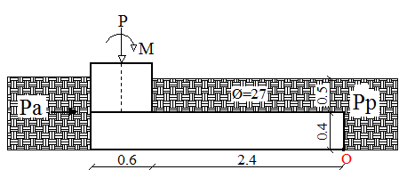

Figure (4-50): Forces for check against sliding failure.

$K_{a}=\frac{1-\sin{∅}}{1+\sin{∅}}=\frac{1-\sin{27}}{1+\sin{27}}=$0.375
$K_{p}=\frac{1+\sin{∅}}{1-\sin{∅}}=\frac{1+\sin{27}}{1-\sin{27}}=$2.66
$p_{p}=\frac{1}{2}×γ_{1}×K_{p}×H^{2}= \frac{1}{2}×18 ×2.66 ×{0.9}^{2}$ = 19.4 KN
$$p_{a}=\frac{1}{2}×γ_{1}×K_{a}×H^{2}= \frac{1}{2}×18×0.375×{0.9}^{2}=2.73 KN$$
$$ΣV=weightofsoilabovefooting+weightoffooting+P_{u}$$
$$ΣV=18×2.4×1×0.5+25×3×1×0.4+104.4=156 KN$$
$${F.s}_{sliding}=\frac{156×tan({\frac{2}{3}}×27)+19.4}{3.3+2.73}=11.62 >1.5→ O.K$$
Check against overturning failure:
The moment will be taken about point O as shown
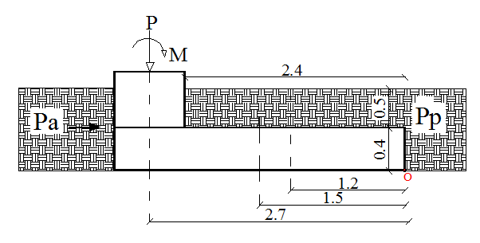
${F.s}_{overturning}=\frac{Resisitingmoment}{overturningmoment}>1.5$

Figure (4-51): Forces for Check against overturning failure.
$$Resisitingmoment=25.9 ×1.2+ 36 ×1.5+104.4×2.7 +19.4 ×0.3 =366.98 KN.m$$
$$overturningmoment=221.45+2.73×0.3=222.3 KN.m$$
$${F.s }_{overturning}=\frac{366.98}{222.3}=1.65>1.5 →O.K$$

Design for footing thickness and structural reinforcement:-
Factored load:
$$Pu=126.62 KN$$
$$m_{u}=267.14 KN.m$$
Then the pressure under footing is
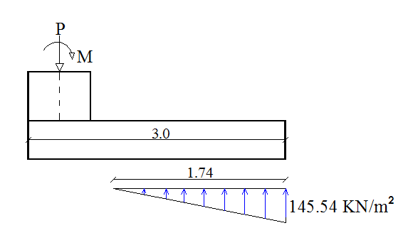
$q_{max}=145.54 \frac{KN}{m^{2}}$

Figure (4-52): Contact Pressure diagram due to loading.
Design for footing thickness:-
The thickness of footing will be selected so that punching shear failure does not occur. Assume $∅_{max}$ main reinforcement is 18mm and cover of 50 mm.
$$d=400-50-18=332 mm$$The footing will be design against one way shear and against punching shear.

Punching shear (Tow way shear):-
Critical perimeter ( $b_{°}$) will be at a distance $\frac{d}{2}$ from the face of the column
$b_{°}=2 ×\left(600+166\right)+\left(500+332\right)=236$4$mm$
$$β=\frac{60}{50}=1.2 , α_{s}=30 \left(edgecolumn\right)$$
The factored shear to be transferred across the critical perimeter is:
$$v_{u}=126.62 KN$$The shear strength of concrete according to ACI is given by equation as follows:
$$V_{c}=\left(2+\frac{4}{β}\right)×\frac{\sqrt{f_{c^{'}}}}{12}×b_{°}×d$$
$$=\left(2+\frac{4}{1.2}\right) × \frac{\sqrt{28}}{12} ×2364×332= 1845.78 KN$$

$$V_{c}=\left(\frac{α_{s}d}{b_{°}}+2\right)×\frac{\sqrt{f_{c^{'}}}}{12}×b_{°}×d$$
$$=\left(\frac{30×332}{2364}+2 \right)×\frac{\sqrt{28}}{12} ×2364 ×332=2150.3 KN$$

$$V_{c}=\frac{1}{3}×\sqrt{f_{c^{'}}}×b_{°}d$$
$$=\frac{1}{3} × \sqrt{28} ×2364 ×332=1384.34 KN$$

The minimum value of the previous equations controls.
$${∅×V}_{c}=0.75×1384.3=1038.2 KN>126.62 O.K$$
The footing thickness is adequate against two way shear.

One way shear:-
The critical section for checking one-way shear strength that is at a distance d from the face is shown in Fig (4-55).

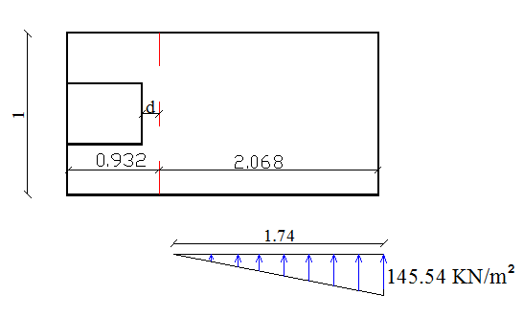

Figure (4-53): Critical section for checking one-way.

$$V_{u}=0.5 ×145.54×1.74×1=126.62 KN$$
$$∅×V_{c}=∅×\frac{1}{6}×\sqrt{f_{c'}}×b_{w}×d=0.75×\frac{1}{6}×\sqrt{28}×1000×332=219.5 KN$$
$$∅×V_{c}=219.5>V_{u}=126.62$$

Thickness of footing is adequate against one way shear.

Design for footing against bending moment:-

The critical section for bending moment that is at the face as shown in Fig (4-30)
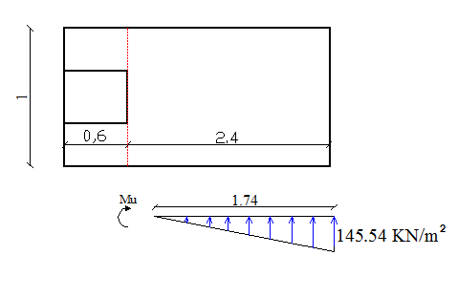

Figure (4-54): Critical section for design Moment.

$$M_{u}=\frac{1}{2} ×145.54×1.74×\left(\left(2.4-1.74\right)+(\frac{2}{3}×1.74)\right)=230.44 KN.m$$

$$Kn= \frac{M_{u}/∅}{bd^{2}}=\frac{230.44×{10}^{6}/0.9}{1000×{(332)}^{2}}=2.32 Mpa$$
$$m=\frac{f_{y}}{0.85f_{c}^{'}} =\frac{420}{0.85*28}=17.65 Mpa$$
$$ρ_{req}=\frac{1}{m}\left(1-\sqrt{1-\frac{2.K_{n}.m}{f_{y}}}\right)=\frac{1}{17.65}\left(1-\sqrt{1-\frac{2×17.65×2.32}{420}}\right)=0.0058$$
$$A_{sreq}=ρ_{req}×b×d=0.0058×1000×232=1933.25 {mm}^{2}/m$$
$${As}_{min}=0.0018×1000×332=597.6 mm2$$
$A_{sreq}=1933.25 {mm}^{2}$>${As}_{min}=597.6 mm2$
$Select∅18 mm$, With As =$\frac{{18}^{2}×π}{4}$ =254.5 mm²
$$n=\frac{1933.25}{254.5}=7.6$$
Select 8$∅18$
With As = (π × 18² / 4) × 8= 2036 mm²

To cover the secondary moment, shrinkage and temperature is required:
${As}_{min}=0.0018×1000×332=597.6 mm2$/m
$Select∅14 mm,$With As =$\frac{{14}^{2}×π}{4}$ =154 mm²
Use $∅14$ /25 cm
With As =$154 × \frac{100}{25}$= 616 mm²/m

4.3.5 Design for Tie Beam:-
The tie beam will tie the footing with the adjacent footing, and in the same time carries the plain concrete wall (H= 3m) above it.

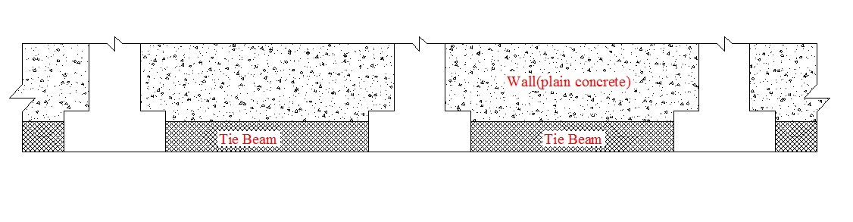

Figure (4-55): Section tie beam and footings.

- The vertical load on the tie beam it was checked and didn't need any reinforcement, so the control of the tie beam design as tension member or compression member which has the large value.

- According to IBC 2012 the tied beam will be designed as a compression member or tension member by applying the maximum reaction on footing multiplies by 10 % as axial force.
As compression member
Pu = 184.4 * 0.1 = 18.44 KN
$$P_{u}=∅×P_{n}=0.65×0.80×A_{g}\left(0.85×f_{c^{'}}\left(1-ρ_{g}\right)+f_{y}×ρ_{g}\right) \\ 18.44×{10}^{3}=0.65×0.80×300×300×(0.85×28(1-ρg )+420×ρg) \\ ρ_{g}=0.059<0.01 is$$
$${As}_{req}={As}_{min}=0.01×300×300=900 {mm}^{2}$$

As Tension member
$$A_{s req}=\frac{N}{f_{y}}=\frac{18.44x1000}{420}=43.9 {mm}^{2}$$
As = $43.9 {mm}^{2}$

- The Design as compression member is controlled:

As = 900 ${mm}^{2}$
$Select ∅12 mm$,With As =$\frac{{12}^{2}×π}{4}$ =113 cm²
$$n=\frac{900}{113}=7.96$$
Select 8$∅18$
With As = (π × 12² / 4) × 8= 904 mm²

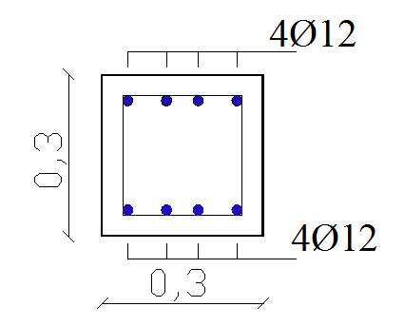

Figure (4-56): Section of Tie beam.

  - Design for two underground water tanks:-
The design process includes the design of flat slab and the walls of the tanks and their footing.
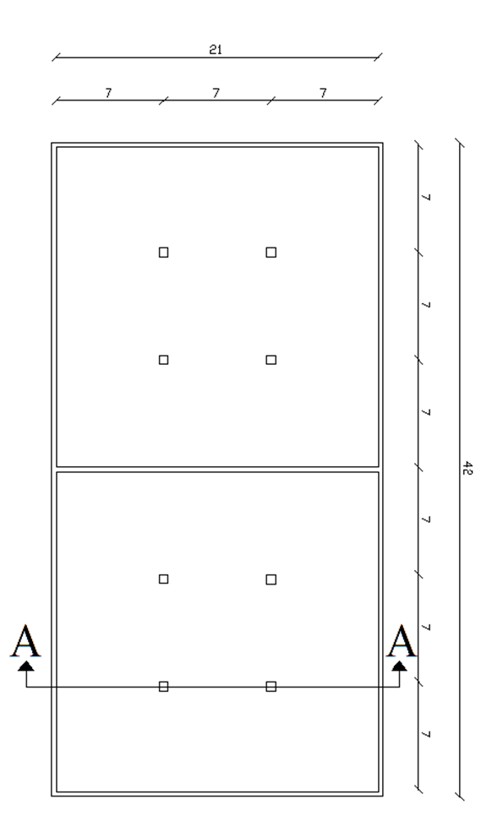
For all of the elements of the tanks the concrete compression strength fc' is 24 Mpa and the tensile strength of reinforcement rebar fy is 420 Map.

Figure (4-57): plan of water tank

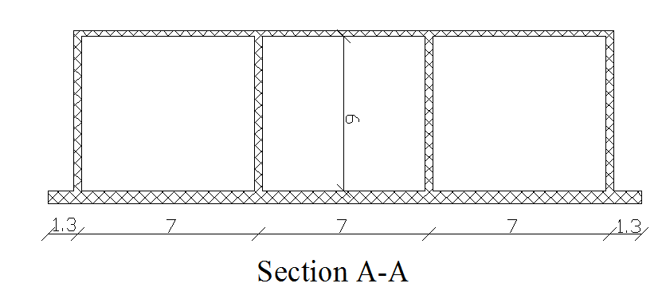

Figure (4-58): Section of water tank.

4.4.1 Design for slab:-
Slab will be Flat slab.
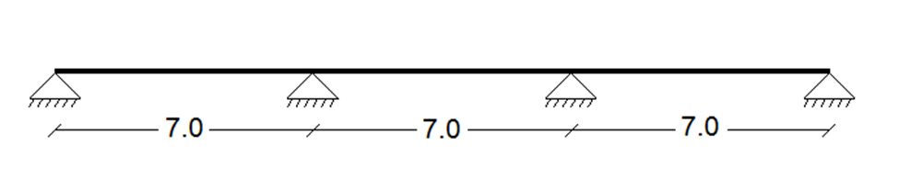
Thickness of slab will be calculated according to provisions in ACI-318-08 as follow:

Figure (4-59): System of slab
h _{min} = Ln / 33 (ACI-318-08 In table 9.5(c))
h _{min} = (7-0.3) / 33 = 20.3 cm
Select h = 21 cm
- Calculation of loads:
For 1 m strip
Dead load
Slab (self-weight) = 0.21 × 25× 1 = 5.25 KN/m

Live Load
2 KN/m² will be applied to the slab
2 × 1 = 2 KN/m
- Load combination of slab:
According to ACI, the following load combination is applied:-
- $qu = 1.2 D + 1.6 L$
$$qu = 1.2 × 5.25 + 1.6 × 2 = 9.5 KN/m$$
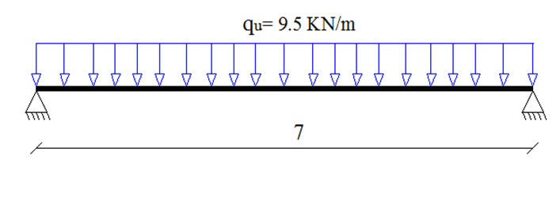
- Design against one way shear:

Figure (4-60): System of slab of one way shear with loads.
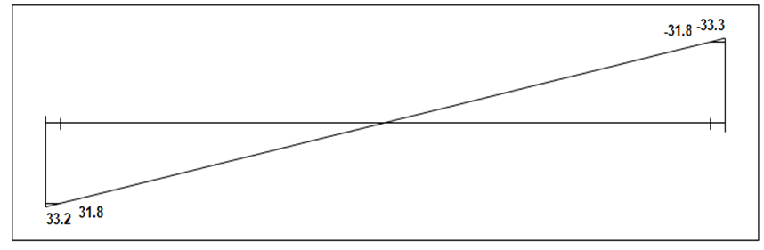

Figure (4-61): Slab Shear Envelop Diagram.
- Vu at a distance d from the face of support;
d = 210 - 20 – 10 = 180 mm
Vu at a distance = 150 + 180 = 330 mm from center of support.
Vu max = 31.8 KN
- Check whether the thickness of the slab:-
$$Vc = \frac{1}{6}\sqrt{f_{c}^{'}}b_{w }d………….. ACI318.08 (11-3)$$
$$=\frac{1}{6}\sqrt{24}×1000×180×{10}^{-3}=146.9 KN$$
∅Vc = 0.75×146.9 = 110.2 KN
$$Vu max= 31.8 KN<∅Vc = 110.2 KN$$
- No need to increase the slab thickness.
- Design against two way shear (Punching):
Support reaction of column Au = 7 × 7 × 9.5 = 465.5 KN
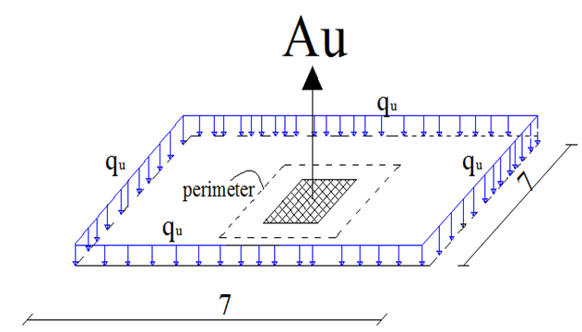
- Critical perimeter ( $b_{°}$) will be at a distance $d/2$ from the face of the column
$$b_{°}=4 ×\left(300+180\right)=1920 mm$$
$$β=\frac{30}{30}=1.0$$
$$α_{s}=40 \left(interiorcolumn\right)$$

- The factored shear to be transferred across the critical perimeter is:
Vu = Au $-q_{u}$× ${(0.3+0.18)}^{2}$
$$= 465.5 - 9.5 × {(0.3+0.18)}^{2} = 463.3 KN$$

- The shear strength of concrete according to ACI is given by equation as follows:

$$V_{c}=\left(2+\frac{4}{β}\right)×\frac{\sqrt{f_{c^{'}}}}{12}×b_{°}×d$$
$$=\left(2+\frac{4}{1.0}\right) × \frac{\sqrt{24}}{12} ×1920×180= 846.54 KN$$

$$V_{c}=\left(\frac{α_{s}d}{b_{°}}+2\right)×\frac{\sqrt{f_{c^{'}}}}{12}×b_{°}×d$$
$$=\left(\frac{40×180}{1920}+2 \right)×\frac{\sqrt{24}}{12} ×1920 ×180=811.27 KN$$
$$V_{c}=\frac{1}{3}×\sqrt{f_{c^{'}}}×b_{°}d$$
$$=\frac{1}{3} × \sqrt{24} ×1920 ×180=564.4 KN$$

- The minimum value of the previous equations controls.
$${∅×V}_{c}=0.75×564.4=423.27 KN<463.3 KN$$
Shear reinforcement is required.
Using shear studs as shear reinforcement:-
$$Vc=\frac{1}{4}×λ×\sqrt{fc}×b_{o}×d$$
$$=\frac{1}{4}×1×\sqrt{24}×1920×180=423.27KN$$
This gives
$$Vs≥\frac{Vu}{∅}-Vc=\frac{463.3}{0.75}-423.27=194.46 KN$$
The maximum value of$∅Vn$ allowed with headed-shear studs is
$$∅Vn=∅ ×\frac{2}{3} ×\sqrt{f_{c^{'}}} ×b_{o}×d$$
= 0.75$×2/3×\sqrt{24}×$1920$×$ 180 = 846.54 KN
$∅Vn$ = 846.54 KN>Vu = 463.3 KN- OK
Select 12 mm- diameter studs (Ab= 113.1 mm²) with 40 mm- diameter heads, and
$F_{yt}=350 Mpa$(Typical for shear studs).
For 8 studs Av = 8$×$113.1 =904.8 mm²
$$V_{s}= \frac{Av×Fyt×d}{S} ,ACI (11-15)$$
$$S= \frac{904.8×350×180}{194.46×{10}^{3}}$$
S = 293.13 mm < d$/$2 = 180$/2$= 90 mm
Select S= 90 mm

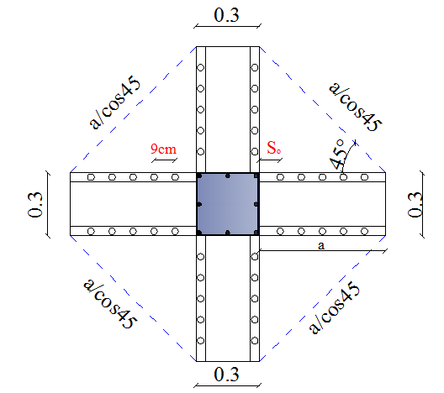

Figure (4-62): outer critical-shear section.
$${∅×V}_{c}=Vu$$
$$463.3×{10}^{3}=0.75×\frac{1}{6}×\sqrt{f_{c^{'}}}×b_{o}×d$$
$$b_{o}=4×300+\frac{4×a}{cos45}$$
$${∅×V}_{c}=0.75×\frac{1}{6}×\sqrt{24}×(1200+\frac{4a}{cos45})×180$$
$$a=519.8 mm$$
$$Select a=520 mm$$
- Use eight stud rails with the first stud located at $s_{o}$=90mm from column face. Subsequent studs are at a spacing of$s$= 90 mm with $6∅12$ head shear studs per rail.

- Design for bending moment:-
The manual analysis of forces and displacement in a flat slab is complex, due to its highly indeterminate nature; so we analyzed flat slab by using safe program.
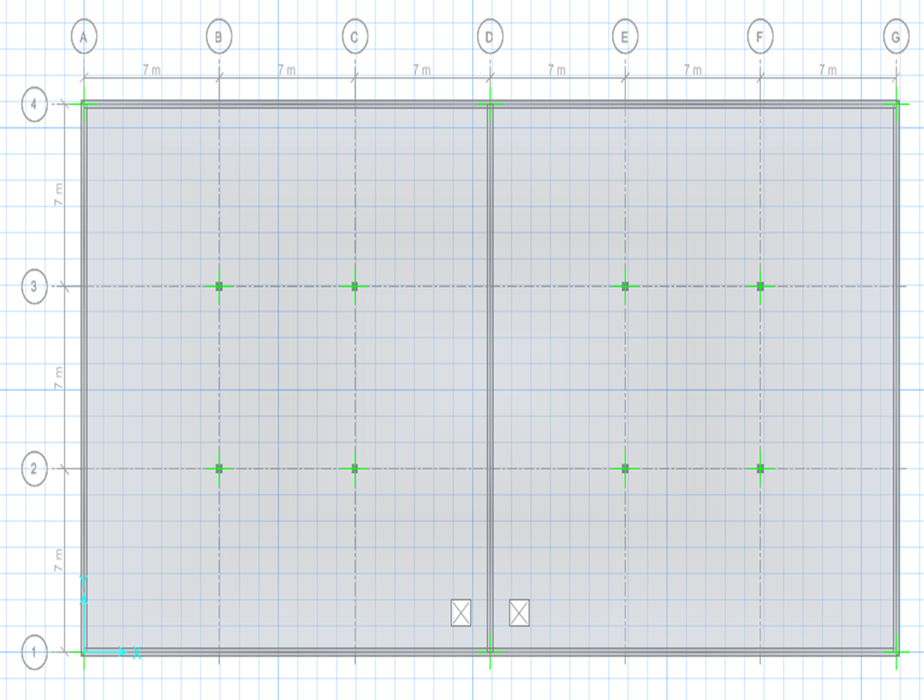

Figure (4-63): Flat slab on SAFE program.

Bottom reinforcement:-
We used the basic mesh$∅14-18cm$ in the bottom reinforcement in both directions (x, y) to cover moments on flat slab.
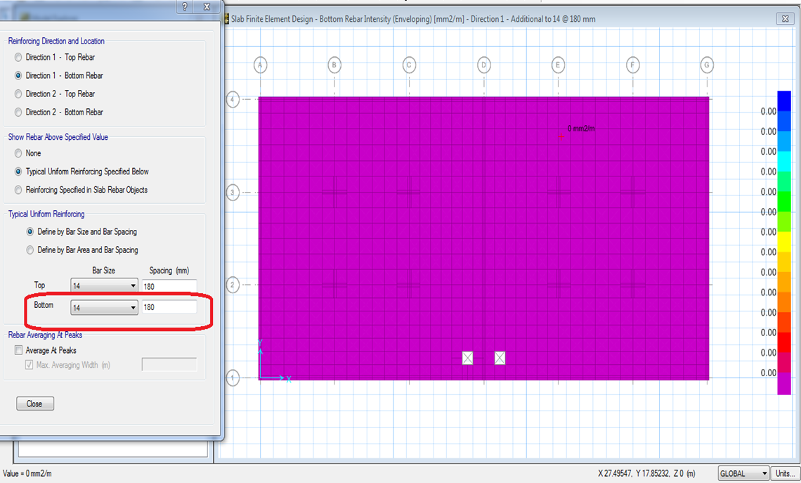

Figure (4-64): Bottom reinforcement of flat slab.

$${As}_{Prov}=\frac{{14}^{2}×π}{4} ×\frac{100}{18}=855.2{mm}^{2}/m$$
$${As}_{min}=0.0018×b×h$$
= 0.0018 $×1000×210=378{mm}^{2}/m$
$${As}_{Prov}=855.2{mm}^{2}/m >{As}_{min}=378{mm}^{2}/m$$

Top reinforcement:-
We used the basic mesh $∅14-18cm$ in the top reinforcement in both directions (x, y) to cover moments on flat slab, and we need $8{cm}^{2}$ additional reinforcement around of columns.
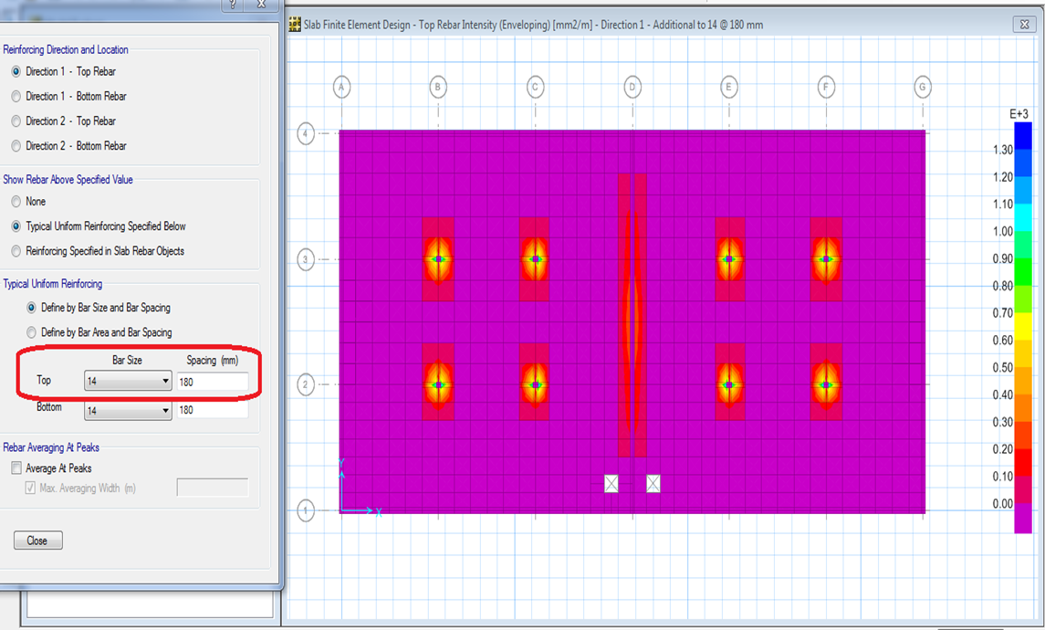

Figure (4-65): Top reinforcement of flat slab.

Additional reinforcement
$$Select ∅14-18cm$$
$$With{As}_{Prov}=\frac{{14}^{2}×π}{4} ×\frac{100}{18}=855.2{mm}^{2}/m$$

4.4.2 Design for column:-
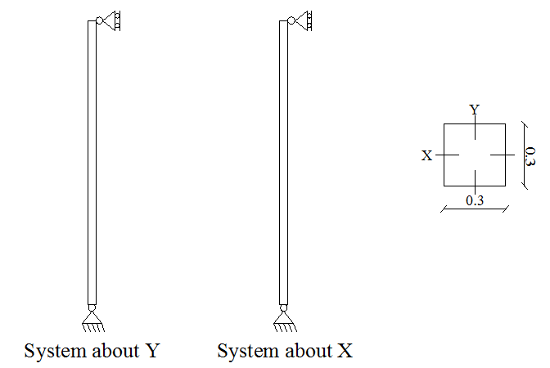

Figure (4-66): system of column.
PD = 257.25 KN
PD = 98 KN
Factored loads:-
According to ACI, the following load combination is applied:-
$qu = 1.2 D + 1.6 L$
$$qu = 1.2 × 257.25 + 1.6 × 98 = 465.5 KN$$
Slenderness:-
⇒ Braced column (nonsway)
$$\frac{KL}{r}≤34-12×\frac{M_{1}}{M_{2}}……… ACI318.08$$
K = 1.0
$$rx=ry=0.3×30=9 cm$$

$\left[\frac{K×L}{r_{x}}\right]=\frac{1×300}{9}$= 66 ˃ 22, in X-direction
$\left[\frac{K×L}{r_{y}}\right]=\frac{1×300}{9}$= 66 ˃ 22, in Y-direction
⇒ Long column in both directions
Bresler equation:-
$\frac{1}{P_{n}}$= $\frac{1}{P_{nx}}$ + $\frac{1}{P_{ny}} -\frac{1}{P_{0}}$
About x: $e_{y}min$ = 15 + 0.03 × h = 15 + 0.03 × 300 = 24 mm
About y: $e_{x}min$ = 15 + 0.03 × 300 = 24 mm
Magnification factor of moment:

- In both(Xand Y) direction:

EI = 0.4 $\frac{E_{c }I_{g}}{1+β_{dns}}$ ………… ACI318.08 (10-15)
$E_{c}$ = 4750 $\sqrt{fc´}$ = 4750 $\sqrt{24}$ = 23270.15 Mpa
$$β_{dns}= \frac{{Pu}_{D}}{Pu}=\frac{1.2×257.25}{465.5}=0.66$$
$$I_{g}= \frac{b ×h^{3}}{12}=\frac{0.3×{0.3}^{3}}{12}=0.00067 m^{4}$$
$$EI= 0.4×\frac{23270.15×0.00067}{1+0.66}=3.92 MN.m^{2}$$
$$P_{cr}= \frac{π^{2}×EI}{{(K×L)}^{2}}=\frac{π^{2}×3.92}{3^{2}}=4.3 MN$$
Cm = 0.6 + 0.4 $\left(\frac{M1}{M2}\right)$ …………… ACI318.08 (10-16)
Cm = 1
$$δ_{ns}= \frac{cm}{1-(\frac{Pu}{0.75P_{cr}})}≥1.0…….. ACI318.08 (10-12)$$
$$δns = 1.17> 1$$
$e_{x}=e_{y}=24×1.17=28$mm
By using the Interaction Diagram:-
$$P_{nx}=P_{ny}$$
Axial strength in ex-direction … $P_{nx}$
$$\frac{e}{h}= \frac{28}{300}=0.093$$
$$\frac{γ}{h}=\frac{300-2×40-2×10-12}{300}=0.63$$
Assume $ρ$g = 0.01 (minimum)
$$From interaction diagram, for\frac{γ}{h}=0.75 ⟶\frac{∅P_{n}}{Ag}=2.0 ksi$$
$$for\frac{γ}{h}=0.6 ⟶\frac{∅P_{n}}{Ag}=2.0 ksi$$
$$By interpolation,for\frac{γ}{h}=0.63 ⟶\frac{∅P_{n}}{Ag}=2.0 ksi$$
$$P_{nx}=P_{ny}=\frac{2×0.3×0.3}{0.65}×\frac{1000}{145}=1.91 MN$$
$P_{0}$= 0.8 × Ag × (0.85 fc´ $×(1-ρ$g) + fy$×ρ$g) ……….. ACI318.08 (10-1)
$P_{0}$= 0.8 × 300 × 300 × (0.85 × 24 × (1- 0.01) + 0.01 × 420) = 1.75 MN
$\frac{1}{P_{n}}$= $\frac{1}{P_{nx}}$ + $\frac{1}{P_{ny}} -\frac{1}{P_{0}}$
⇒$P_{n}$=2102.2 KN
$ØP_{n}$= 2102.2 × 0.65 = 1366.43 KN ˃ Pu = 465.5 KN (safe)
Use $ρ$g = 0.01
As = 0.01 × 300 × 300 = 900mm²

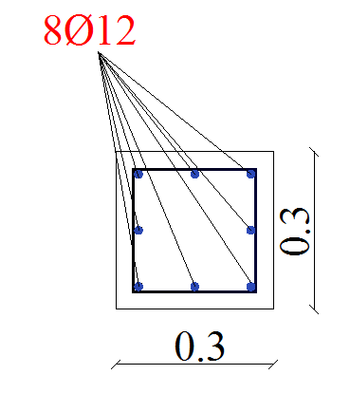
$Select∅12 mm$, With As =$\frac{{12}^{2}×π}{4}$ =113 mm²
$$n=\frac{900}{113}=7.96$$
$$Select 8∅12$$

With As = 113× 8= 904 mm²

Design of stirrups:-
Construction rules from ACI for tied reinforced section:
For diameter of ties:-
For $∅_{Vertical bars}=12 mm$Select $∅_{Stirrups}=10 mm$
Spacing of ties:-
$$S≤16×∅_{vertical bars}=16×12=192 mm$$
$$S≤48×∅_{stirrups}=48×10=480 mm$$
$$S≤minimum dimenstion if colummn=300mm$$
$$S=190 mm →control.$$
4.4.3 Design for tank walls:-
The water tanks must be designed to withstand the loads it will be subjected to during of use, but it is important to consider the loading cases during of construction. These cases are:-
Case1: the water tanks are full of water during leakage test period and before backfill.
Case 2: backfill the water tanks and no water are in the tanks.
The design of water tanks will include the full effect of the soil loads and water pressure without taking loads acting in directions that reduce the effects of each other.

4.4.3.1 Calculation of loads:-
- Case1: the water tanks are full of water during leakage test period and before backfill
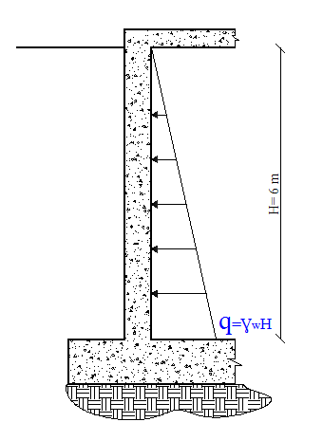
The hydrostatic pressure on the walls equals to the density of water$(9.81\frac{KN}{m^{3}}$) multiplied by the height of water (H)

Figure (4-67): Loads on wall due to water pressure.

- Case 2: backfill the water tanks and no water are in the tanks
The load on the walls come from soil action equal to earth pressure at rest ($K_{o}$) multiplied by the height and the density of soil$q=k_{o}γH$ for the pressure.
The earth pressure at rest is calculated as: $K_{o}=1-sinø$
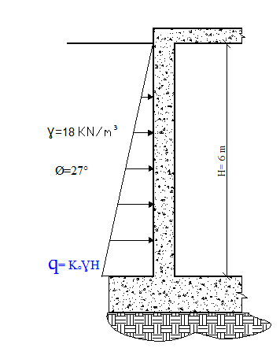

Figure (4-68): Loads on wall due to soil pressure.
4.4.3.2 Structural Analysis of the walls:-
Because the analysis of water tanks very complicated, will be analysis of the walls of the water tanks by using computer software, since there are many cases and loading conditions to be considered and the accuracy that the program gives.
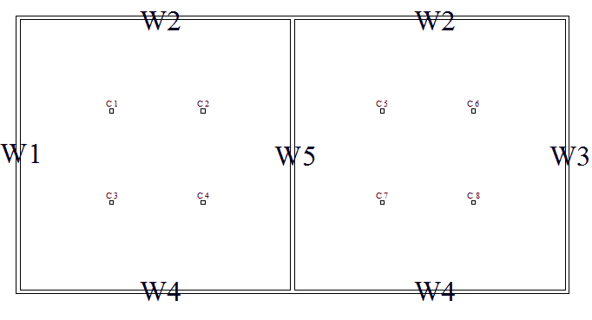

Figure (4-69): walls names.

Analysis and Result:
We used the staad Pro software for the analysis and design of water tank. The programs use the finite element method in finding the internal forces for the walls.
- Wall 3 is shown in detail and design as an example.
4.4.3.3 Design for shear force:-
${Vu}_{max}=$125.6 KN/m
For 1 meter strip:-

Thickness t =300 mm
d=300-20-16 =264 mm
$$∅×Vc=1/6×0.75×\sqrt{f_{c^{'}}} ×b_{w}×d$$

$∅×Vc=1/6×0.75×\sqrt{24} ×1000×264$ = 161.66 KN/m >125.6 KN/m

$∅×Vc=161.66 KN/m>$ Vu = 125.6KN/m
Thikness is safe & no shear rainforcement is required
4.4.3.4 Design for bending moment:-
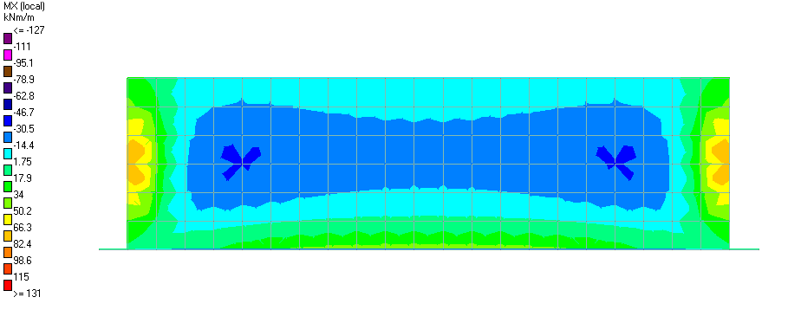
Design for Horizontal Bending Moment (horizontal steel):

Figure (4-70): Bending moment MXX due to case 1

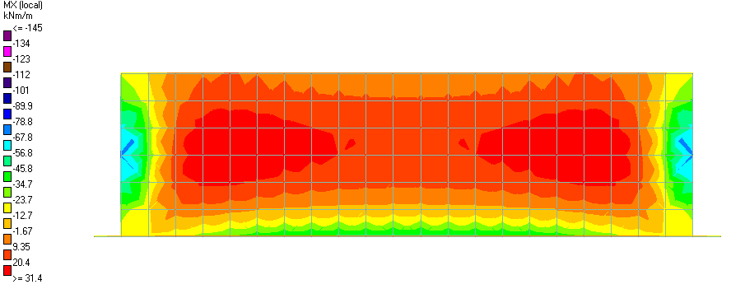

Figure (4-71): Bending moment MXX due to case2

- Maximum moment from case1 & case2 are approximately the same, so we will take the larger value and the reinforcement will be the same inside and outside.

Maximum moment in the middle of the wall:-
Mxx= - 30.14KN.m/m
d = 300 - 20 - 16 = 264 mm
$$Kn=\frac{Mn}{{b×d}^{2}}=\frac{(30.14/0.9)×{10}^{6}}{1000×{264}^{2}} =0.5 Mpa$$
$$m=\frac{fy}{0.85×f_{c^{'}}}=\frac{420}{0.85×24}=20.6 Mpa$$
$$ρ_{req}=\frac{1}{20.6}\left(1-\sqrt{1-\frac{2×0.5×20.6}{420}}\right)=0.0012$$
$$A_{s req}=ρ_{req}×b×d=0.0012×100×26.4=3.18 {cm}^{2}/m$$
$$A_{s min}=0.0012×100×30=3.6{cm}^{2}/m$$
$Select ∅10 mm$, with As =0.79 cm²

$$A_{s }=\frac{0.79}{0.2}=3.95 {cm}^{2}/m>A_{s min}$$
$$∴use ∅10@20cm outside$$
Maximum moment in the corner of the wall:-
Mxx= 69.75KN.m/m
$$Kn=\frac{Mn}{{b×d}^{2}}=\frac{(69.75/0.9)×{10}^{6}}{1000×{264}^{2}} =1.11 Mpa$$
$$m=\frac{fy}{0.85×f_{c^{'}}}=\frac{420}{0.85×24}=20.6 Mpa$$
$$ρ_{req}=\frac{1}{20.6}\left(1-\sqrt{1-\frac{2×1.11×20.6}{420}}\right)=0.00272اكتبالمعادلةهنا.$$
$$A_{s req}=ρ_{req}×b×d=0.00272×100×26.4=7.18 {cm}^{2}/m$$
$$A_{s min}=0.0012×100×30=3.6 {cm}^{2}/m$$
$Select ∅14 mm$, with As =1.54 cm²

$$A_{s }=\frac{1.54}{0.2}=7.7 {cm}^{2}/m >A_{s required}$$
$$∴use ∅14@20cm inside$$

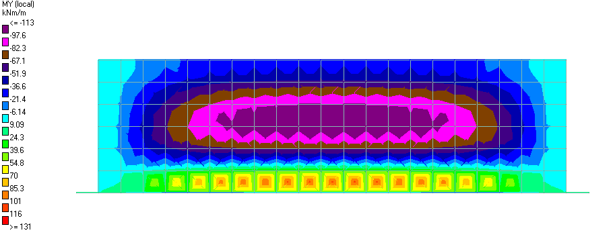
Design for Vertical Bending Moment (Vertical Steel):-

Figure (4-72): Bending moment MYY due to case 1.
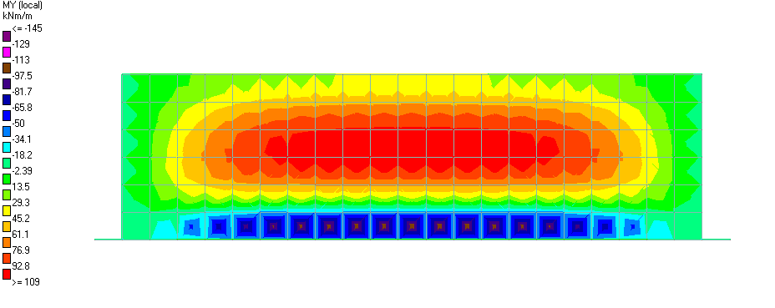

Figure (4-73): Bending moment MYY due to case2

- Maximum moment from case1 & case2are approximately the same, so we will take the larger value and the reinforcement will be the same inside and outside.
Maximum moment in the middle of the wall:-
Myy= 111KN.m/m
$$Kn=\frac{Mn}{{b×d}^{2}}=\frac{(111/0.9)×{10}^{6}}{1000×{264}^{2}} =1.77 Mpa$$
$$m=\frac{fy}{0.85×f_{c^{'}}}=\frac{420}{0.85×24}=20.6 Mpa$$
$$ρ_{req}=\frac{1}{20.6}\left(1-\sqrt{1-\frac{2×1.77×20.6}{420}}\right)=0.00442$$
$$A_{s req}=ρ_{req}×b×d=0.00442×100×26.4=11.67 {cm}^{2}/m A_{s min}=0.0012×100×30=3.6 {cm}^{2}/m$$
$Select ∅16 mm$, with As =2.01 cm²

$$A_{s }=\frac{2.01}{0.17}=11.82{ cm}^{2}/m>A_{s req}$$
$$∴use ∅16@17cm bothside$$
Maximum moment in the corner of the wall:-
Mxx= - 24.69KN.m/m
$$Kn=\frac{Mn}{{b×d}^{2}}=\frac{(24.69/0.9)×{10}^{6}}{1000×{264}^{2}} =0.44 Mpa$$
$$m=\frac{fy}{0.85×f_{c^{'}}}=\frac{420}{0.85×24}=20.6 Mpa$$
$$ρ_{required}=\frac{1}{20.6}\left(1-\sqrt{1-\frac{2×0.4×20.6}{420}}\right)=0.00096$$
$$A_{s req}=ρ_{req}×b×d=0.00096×100×26.4=2.53 {cm}^{2}/m$$
$$A_{s min}=0.0012×100×30=3.6 {cm}^{2}/m$$
$Select ∅10 mm$, with As =0. 79 cm²

$$A_{s }=\frac{0.79}{0.2}=3.6{cm}^{2}/m>A_{s min}$$
$$∴use ∅10@20cm bothside$$

4.4.4 Design for mat foundation:-
The design of raft foundations may be carried out by one of two methods:
- The conventional rigid method.
- The finite element method utilizing computer programs.
The conventional method is easy to apply and the computations can be carried out using hand calculations. However, the application of the conventional method is limited to rafts with relatively regular arrangement of columns.
In contrast, the finite element method can be used for the analysis of raft regardless of the column arrangements, loading conditions, and existence of cores and shear walls. Commercially available computer programs can be used. The user should, however, have sufficient background and experience.

4.4.4.1 Rigidity for foundation:-
The rigidity of mat foundation calculated as the following:
Rigidity of raft foundation (B= 23 m * L= 44 m)
$$Ix=\frac{bh^{3}}{12}=\frac{44×{23}^{3}}{12}=44612.33 m^{4}$$
$$Iy=\frac{bh^{3}}{12}=\frac{23×{44}^{3}}{12}=163269.3 m^{4}– Control$$
$$K_{r}=\frac{I_{b}×E'}{Es×B^{3}} "eq 6.17 principle of foundation(Braja M. Das)"$$

$I_{b}$: Moment inertia of raft foundation material
$E'$: Modules elasticity of concrete =4700$×\sqrt{fc'}$
B: width of mat foundation
Es: modules elasticity of soil

$E'$=4700$×\sqrt{24 }$=23025.20 MN/m2
Es (soft rock) =1000 MN/m2
$$K_{r}=\frac{163269.33×23025.2 }{1000×{23}^{3}}= 308.9 >> 0.5 Rigid$$
The value of $K_{r}>$0.5 it should be design as rigid mat foundation.

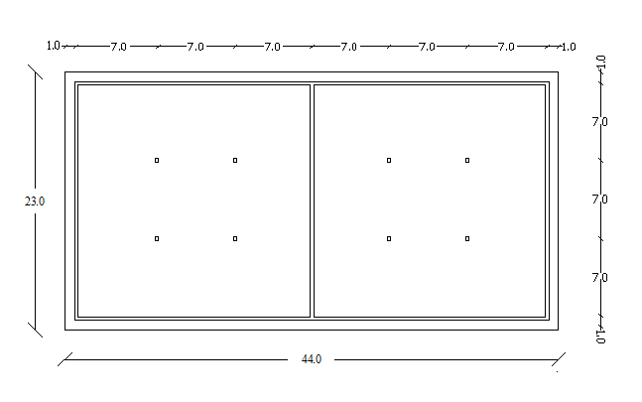
4.4.4.2 Conventional Rigid Method:-

Figure (4-74): rigid mat foundation

4.4.4.2.1 Determine the pressure on the soil below the mat foundation:-

$$q=\frac{Q}{A}±\frac{My.X}{Iy}±\frac{Mx.Y}{Ix}eq 6.24 principle of foundation(Braja M. Das)$$

$$My=Q×e_{x}$$

$$Mx=Q×e_{y}$$

Q (total service load) = 77292.4 KN

$$X^{'}=\frac{Q_{1}×{x^{'}}_{1}+Q_{2}×{x^{'}}_{2}+…}{Q_{total}}$$

$$X'=((352×-7×2)+(352×-14×2)+(352×7×2)+(352×14×2)+1065×-21+1065×21)/77292.4=0.0$$

$$Y^{'}=\frac{Q_{1}×{y^{'}}_{1}+Q_{2}×{y^{'}}_{2}+…}{Q_{total}}$$

$$Y^{'}=\frac{\left(352×-7×4\right)+\left(352×7×4\right)+2097.4×-7+2097.4×7}{77292.4}=0.0$$

- The load eccentricities ex and ey equal zero ($e_{x}=e_{y}=0.0$).

$$My=Mx=0.0×77292.4=0.0$$

$$q=\frac{Q}{A}=\frac{77292.4}{23×44}=76.37 {KN}/{m^{2}}$$

$$q=76.37 {KN}/{m^{2}}<q_{allow}=314{KN}/{m^{2}}$$

- The mat foundation will be divided into several strips in both directions; the stress distribution will be defined for each strip.
Each strip will be treated as continuous footing with flexure along the strip only.

4.4.4.2.2 Design strip for mat foundation:-

Design strip column as an example.
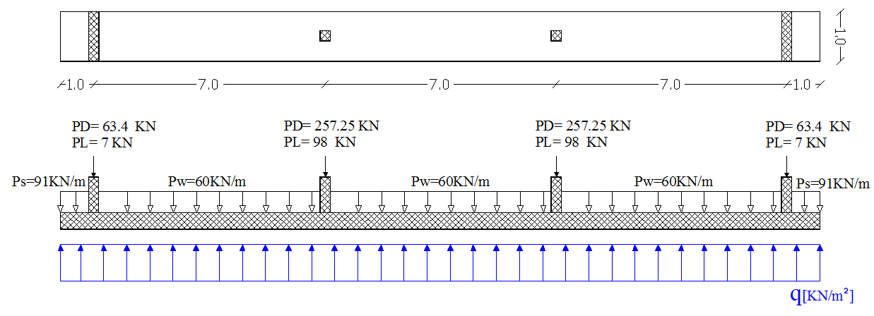

Figure (4-75): strip of mat foundation

$$∑QL=1764KN$$
$$∑QD=75528 KN$$
$$Q_{u}=1.2×PD+1.6×PL$$
$$Q_{u}=1.2×75528+1.6×1764=93456 KN$$

$$q=\frac{Q_{u}}{A}=\frac{93456}{23×44}$$

- $q=92.4 KN/m^{2}$

- Design against of punching shear:-
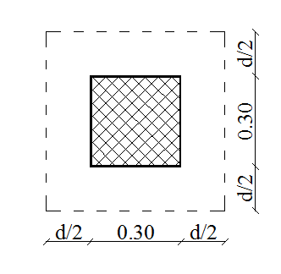
Critical perimeter ( $b_{°}$) will be at a distance $d/2$ from the face of the column
assume h= 40cm
$$d= 400 - 50 - 14= 336mm$$
$$b_{°}=4 ×\left(300+336\right)=2544 mm$$
$$β=\frac{30}{30}=1.0$$
$$α_{s}=40 \left(interiorcolumn\right)$$

The factored shear to be transferred across the critical perimeter:-
Vu= 450.8 KN
The shear strength of concrete according to ACI is given by equation as follows:-
$$V_{c}=\left(2+\frac{4}{β}\right)×\frac{\sqrt{f_{c^{'}}}}{12}×b_{°}×d$$
$$=\left(2+\frac{4}{1.0}\right) × \frac{\sqrt{24}}{12} ×2544×336= 2093.8 KN$$

$$V_{c}=\left(\frac{α_{s}d}{b_{°}}+2\right)×\frac{\sqrt{f_{c^{'}}}}{12}×b_{°}×d$$
$$=\left(\frac{40×336}{2544}+2 \right)×\frac{\sqrt{24}}{12} ×2544 ×336=2541.5 KN$$

$$V_{c}=\frac{1}{3}×\sqrt{f_{c^{'}}}×b_{°}d$$
$$=\frac{1}{3} × \sqrt{24} ×2544 ×336=1395.85KN$$
The minimum value of the previous equations controls.
$${∅×V}_{c}=0.75×1395.85=1046.9 KN>450.8 KN$$

- Thikness is safe(h=40cm)

- Design against for one way shear:-
$${Vu}_{max} = 127.11 KN/m$$
For 1 meter strip:-

Thickness h =400 cm
$$d=400-50-14 =336mm$$
$$∅×Vc=0.75×\frac{1}{6}×\sqrt{f_{c^{'}}} ×b_{w}×d$$

$∅×Vc=0.75×1/6×\sqrt{24} ×1000×336$ = 205.75 KN/m

$∅×Vc=205.75 KN$> Vu=127.11 KN
- Thikness is safe (h = 40cm)

- Design of bending moment:-
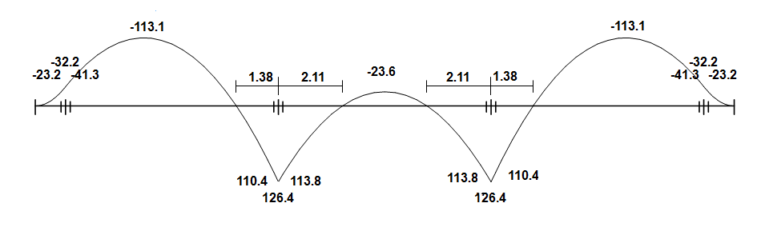

Figure (4-76): Moment Envelop Diagram

Design for bottom reinforcement:-
${Mu}_{max}$=113.8 KN.m
$$Kn= \frac{\frac{M_{u}}{∅}}{bd^{2}}=\frac{113.8×\frac{{10}^{6}}{0.9}}{1000×{\left(336\right)}^{2}}=1.12 Mpa$$
$$m=\frac{f_{y}}{0.85f_{c}^{'}} =\frac{420}{0.85×24}=20.6$$

$$ρ_{req}=\frac{1}{m}\left(1-\sqrt{1-\frac{2.K_{n}.m}{f_{y}}}\right)$$
$$ρ_{req}=\frac{1}{20.6}\left(1-\sqrt{1-\frac{2*1.12*20.6}{420}}\right)=0.0027$$
As_{req} = $ρ_{req}×$ b$× d$
As_{req} = $0.0027×$1000$×$336 = 922.1 mm²/m
As_{min} = $ρ_{min}×$ b$× h$
As_{min} = 0.0018$×$1000$×$336 = 604.8 mm²/m< As_{req}
Select $∅14@16cm with As=962.5$mm²/m
check maximum spacing:-
$$S=380\left(\frac{280}{f_{s}}\right)-2.5c_{c}=s=380\left(\frac{280}{280}\right)-2.5×50=25.5$$
$$S=25.5 cm>16 cm ok$$

Design for top reinforcement:-
${Mu}_{max}$= -113.1 KN.m
$$Kn= \frac{\frac{M_{u}}{∅}}{bd^{2}}=\frac{113.1×\frac{{10}^{6}}{0.9}}{1000×{\left(336\right)}^{2}}=1.12 Mpa \\ m=\frac{f_{y}}{0.85f_{c}^{'}} =\frac{420}{0.85×24}=20.6$$
As_{req} = $ρ_{req}×$ b$× d$
$$ρ_{req}=\frac{1}{m}\left(1-\sqrt{1-\frac{2.K_{n}.m}{f_{y}}}\right) \\ ρ_{req}=\frac{1}{20.6}\left(1-\sqrt{1-\frac{2*1.12*20.6}{420}}\right)=0.0027$$
As_{req} = 0.0027*1000*336 =922.1 mm²/m
As_{min} = $ρ_{min}×$ b$× h$
$$Asmin = 0.0018×1000×336=604.8 mm2/m< Asreq$$
Select $∅14@16cm with As=962.5$mm²/m
check maximum spacing :
$$S=380×\left(\frac{280}{f_{s}}\right)-2.5c_{c}$$
$$S=380×\left(\frac{280}{280}\right)-2.5×50=25.5>16 cm ok$$

4.5Design for festival hall and lecture rooms:-
The design process for festival hall includes the design for shells and the columns under shells.
The structural system of the lecture rooms is frame system that carried a one way solid slab. The design process includes the design for solid slab and the frame and their footings.
For all of the elements of the festival hall and lecture rooms the concrete compression strength${ f}_{c}^{'}$ is 24 Mpa and the tensile strength of reinforcement rebar $f_{y}$ is 420Map.
4.5.1Design for festival hall's Shell:-
Shells as a Structural Form:-
Thin shells are an example of strength through forms as opposed to strength through mass. The effort in design is to make the shell as thin as practical requirement will permit so that the dead weight is reduced and the structure function as a membrane free from large bending stress .by this means, a minimum of material is used to the maximum structural advantage.
A shell structure is a thin curved membrane or slab usually of reinforced concrete that functions Both as structure and covering .The term “shell” is used to describe the structures which possess strength and rigidity due to its thin, Natural and curved form such as shell of egg, a nut, human skull, and shell of tortoise.
The Shell Shape:-
The shell used to cover the festival hall building.
Our shell can be classified under surface of translation spherical shells.

4.5.1.1Code provisions:-
The following provisions are taken from "Concrete Shell Structures Practice and Commentary" ACI 334.1R-92 (Reapproved 2002) in combination with ACI 318-08(chapter 19 -SHELLS AND FOLDED PLATE MEMBERS)
1- Shell Analysis:-
•The shell could be analyzed using various methods such as classical shell theory, simplified mathematical or analytical models, or numerical solutions using finite element, finite differences, or numerical integration techniques. In our case, due to the uni-symmetry and complexity it is not possible to derive a mathematical equation to find the internal forces .Instead, we will use the General Method.
• Elastic behavior is the commonly accepted basis for determining stresses, displacements, and stability of thin shells.
2- Shell thickness:-
• Shell thickness is not always dictated by strength requirements but often by deformation of edge members, stability, and cover over reinforcing steel.
• Stress concentrations due to abrupt changes in section shall be considered and, where necessary, the thin shell shall be gradually thickened.
3- Shell Reinforcement:-
• Shell reinforcement shall be provided to resist tensile stresses from internal membrane forces, to resist tension from bending and twisting moments, to limit shrinkage and temperature crack width and spacing, and as reinforcement at shell boundaries, load attachments, and shell openings.
• Reinforcement for shear and bending moments about axes in the plane of the shell slab
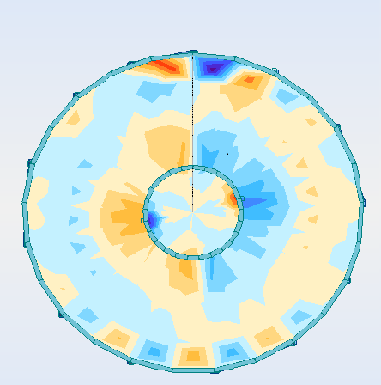
Shall be calculated in accordance with Chapters 10, 11, and 13 in ACI 318M-08.

Figure (4-77): Support System of the shell.
The support system consists of concrete curved beam directly under the shell supported be concrete columns.

4.5.1.2Structural Analysis for the shell:-
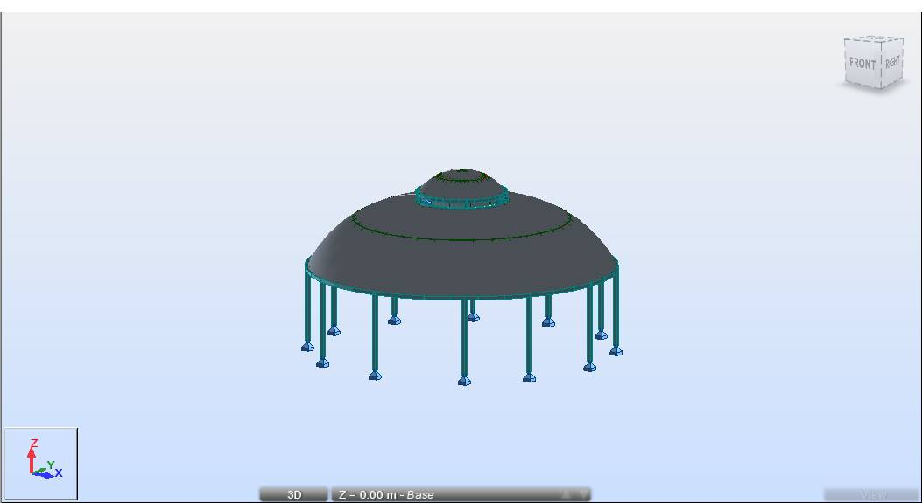
Figure (4-78): Analytical model of shell.
Membrane force in X-direction $N_{xx}$ (negative sign indicate the compression force while the positive sign indicate the tension force)
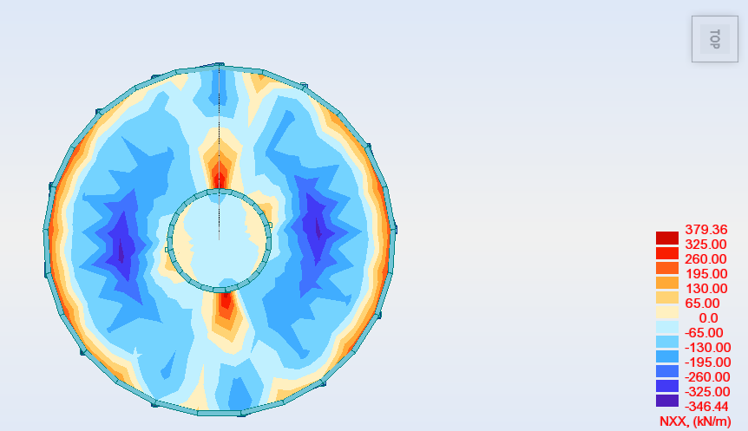
Figure (4-79): Membrane force in X-directionNxx.
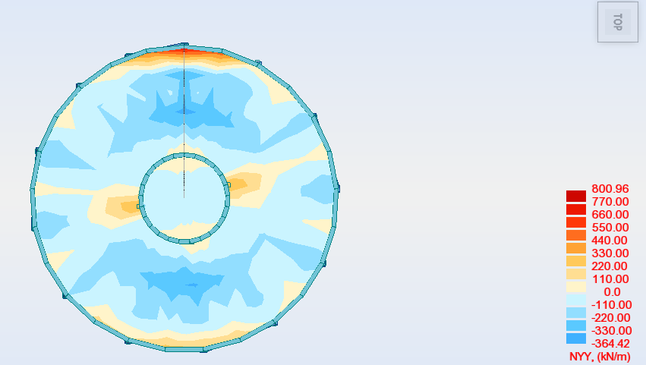

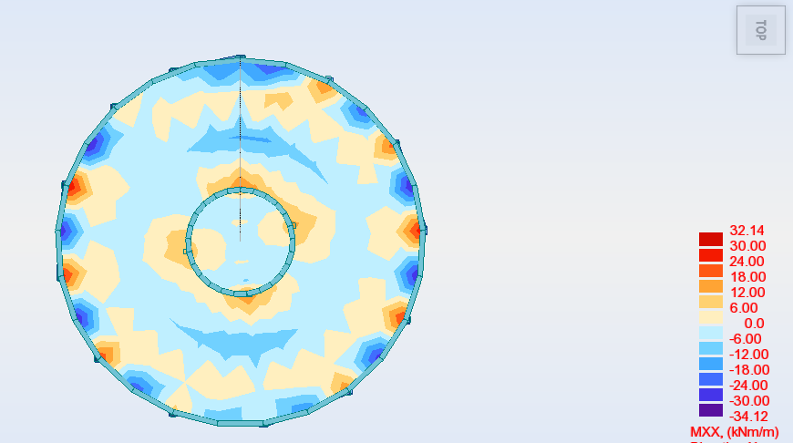
Figure (4-80): Membrane force in X-directionNyy.

Figure (4-81): Bending moment in x-directionMxx.

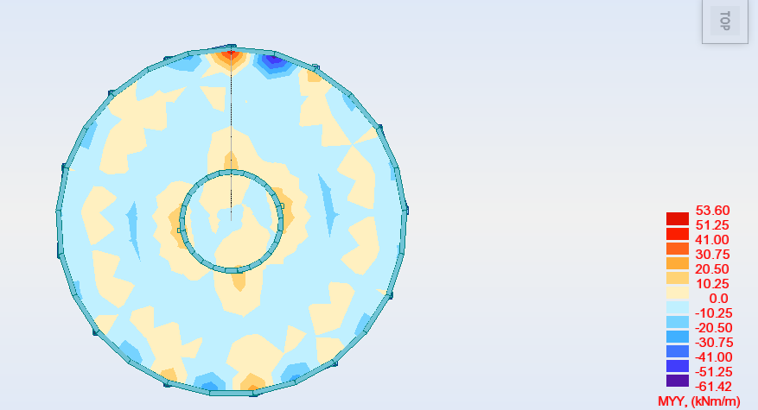

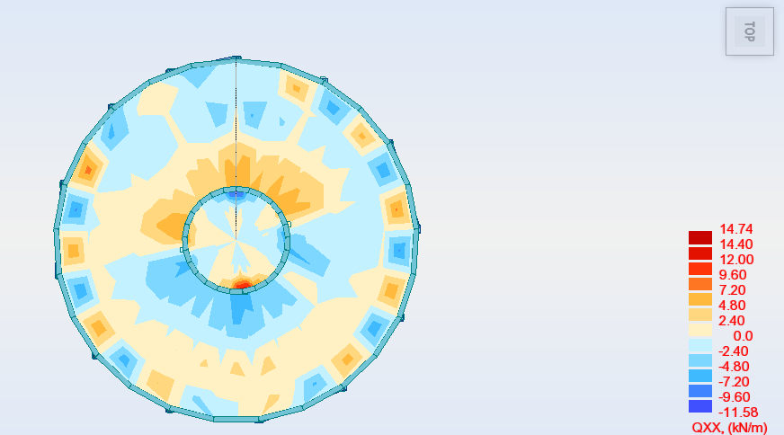
Figure (4-82): Bending moment in y-direction Myy.

Figure (4-83): Shear Force in x-direction Qxx.

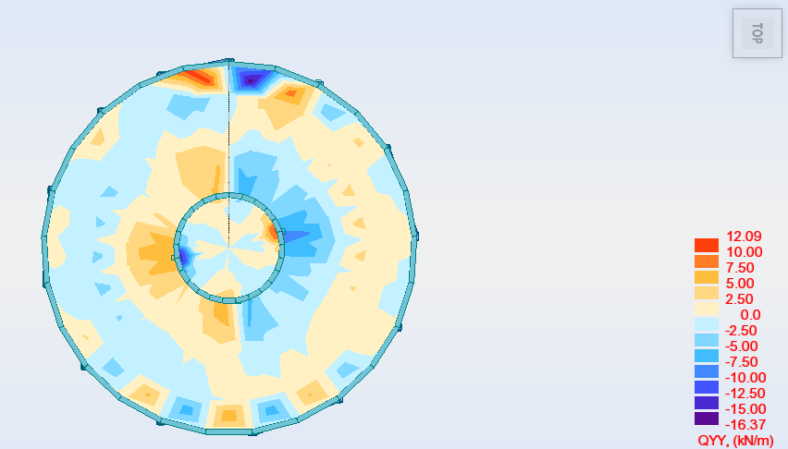
Figure (4-84): Shear Force in y-direction Qyy.
It is noted from the above results that the Bending moment and shear forces values are so small so that it can be neglected except above the supports.
4.5.1.3Structural Design for the shell:-
We will show the design of the Lower Shell as an example.
Design for Compression Forces:-
The maximum compression force is $N$=356.62 KN/m, the section will be designed as a compression rectangular section with height of 15 cm and 1 m width:
$$P_{u}=∅×P_{n}=0.65×0.80×A_{g}(0.85×f_{c^{'}}\left(1-ρ_{g}\right)+f_{y}×ρ_{g}) \\ 494.44=0.65×0.80×150000(0.85×24\left(1-ρ_{g}\right)+420×ρ_{g}) \\ ρ_{g}=-0.0384<0.0018 is less than the minimum reinforcement ratio$$
$$A_{s minimum}=0.0018×100×15=2.7 {cm}^{2}/m$$

Design for Tension Forces:-
The maximum tensile force in the shell (not above the support) is$N$=364.96 KN/m, the whole force will be carried be the reinforcement steel only:
$$A_{s required}=\frac{N}{f_{y}}=\frac{364.96x1000}{420}=8.68 {cm}^{2}/m$$
$$A_{s req}=8.68\frac{{cm}^{2}}{m}….control$$
$$Select ∅12 mm with As =\frac{π×{1.2}^{2}}{4}=1.13 cm2$$
$$n=\frac{8.68}{1.13}=7.68≈8∅12 bars for 1 meter width4 bars in top and 4 in bottom$$
$∴use ∅12@25cm,$For both Directions top and bottom.
Design the shell above the supports:-
Design for shear forces:-
The maximum shear force in the shell above the support is$Q$=16.08 KN/m, the force is designed so that no shear reinforcement is required:
$$d=300-20-14=266 mm \\ ∅×V_{c}=∅×\frac{1}{6}×\sqrt{f_{c'}} ×b_{w}×d=0.75×\frac{1}{6} ×\sqrt{24} ×1000×266=162.5 KN$$
$$∅×V_{c}=162.5 KN> Q=16.08 KN$$
Design for Bending Moment:-
The bending moment direction that appears above the supporting beams is perpendicular to them.
The maximum Bending moment is$M$=53.07 KN/m:
$$Kn= \frac{\frac{M_{u}}{∅}}{bd^{2}}=\frac{53.07×\frac{{10}^{6}}{0.9}}{1000×{\left(266\right)}^{2}}=0.83 Mpa$$

$$m=\frac{f_{y}}{0.85f_{c}^{'}} =\frac{420}{0.85×24}=20.6$$

$$ρ_{req}=\frac{1}{m}\left(1-\sqrt{1-\frac{2.K_{n}.m}{f_{y}}}\right)=\frac{1}{20.6}\left(1-\sqrt{1-\frac{2×0.83×20.6}{420}}\right)=0.002$$
$$A_{s req}=ρ_{req}×b×d=0.002×100×22.6=5.32 {cm}^{2}/m$$

$${As}_{min}=0.0035×100×15=5.25{cm}^{2}/m$$

$$Select ∅14 mm With As =\frac{{1.4}^{2}×π}{4}=1.54\frac{cm2}{m}$$

$$∴ bove support use ∅14@11 cm, to cover bending moment and normal forces.$$

Reinforcement Detailing:-
The reinforcement steel that resists the tension and compression stresses above the support of the shell is placed in the bottom and top layers of the shell. However, the steel that resist the bending moment is place in the top layer perpendicular to the steel resisting the tensile force that acts along the beams.

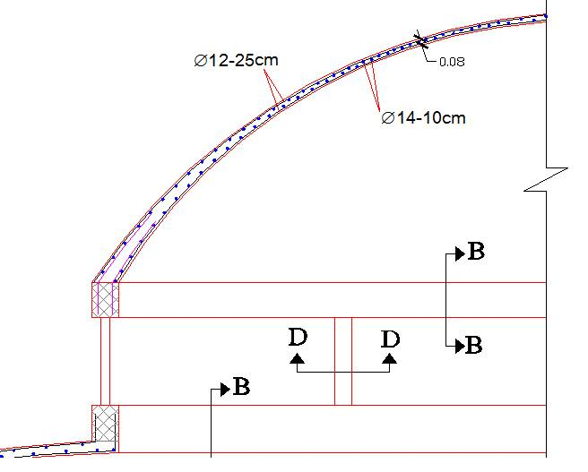
Figure (4-85): The reinforcement detailing for the top shell.
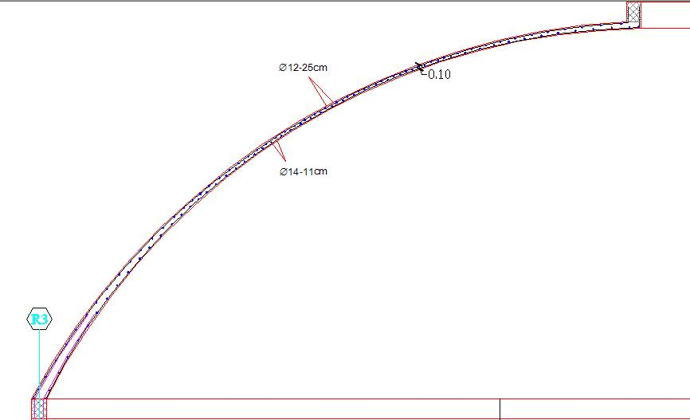
Figure (4-86): The reinforcement detailing for the bottom shell.
4.5.1.4Design for ring beam supporting the shell:-

The ring beam supporting the shell are subjected to bending moment and torsion

1-Shear force:

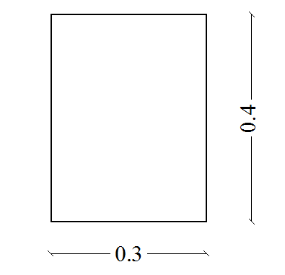
Max Vu = 90.35 KN

2- Bending moment:

Mu = +60.4KN.m

Mu = -58.68KN.m

3- Torsion

Tu = 40.3KN.m
- Design bending moment:-

- Positive moment

Mu = +60.4KN.m

$$d=400-40-10-\frac{14}{2}=343 mm$$

$$Kn= \frac{\frac{M_{u}}{∅}}{bd^{2}}=\frac{60.4×\frac{{10}^{6}}{0.9}}{300×{\left(343\right)}^{2}}=1.9 Mpa \\ m=\frac{f_{y}}{0.85f_{c}^{'}} =\frac{420}{0.85×24}=20.6$$
$$ρ_{req}=\frac{1}{m}\left(1-\sqrt{1-\frac{2.K_{n}.m}{f_{y}}}\right)=\frac{1}{20.6}\left(1-\sqrt{1-\frac{2×1.9×20.6}{420}}\right)=0.00477$$
$$A_{s req}=ρ_{req}×b×d=0.00477×300×343=490.8 {mm}^{2}$$
$${As}_{min}≥0.25×\frac{\sqrt{f_{c}^{'}}}{f_{y}}×b×d=0.25*\frac{\sqrt{24}}{420}*300*343=300 {mm}^{2}$$
$${As}_{min}≥\frac{1.4}{f_{y}}*b*d=\frac{1.4}{420}*300*343=343 {mm}^{2}$$
$${As}_{req}=490.8{mm}^{2}>{As}_{min}=343 {mm}^{2}$$
$$n=\frac{490.8}{154}=3.18$$
$$Select 4∅14 in the bottom$$
- Negative moment:-

Mu = 58.68 KN.m

$$d=400-40-10-\frac{14}{2}=343 mm$$

$$Kn= \frac{\frac{M_{u}}{∅}}{bd^{2}}=\frac{58.68×\frac{{10}^{6}}{0.9}}{300×{\left(343\right)}^{2}}=1.84 Mpa \\ m=\frac{f_{y}}{0.85f_{c}^{'}} =\frac{420}{0.85×24}=20.6$$
$$ρ_{req}=\frac{1}{m}\left(1-\sqrt{1-\frac{2.K_{n}.m}{f_{y}}}\right)=\frac{1}{20.6}\left(1-\sqrt{1-\frac{2×1.84×20.6}{420}}\right)=0.0046$$
$$A_{s req}=ρ_{req}×b×d=0.0046×300×343=473.21 {mm}^{2}$$
$${As}_{min}≥0.25×\frac{\sqrt{f_{c}^{'}}}{f_{y}}×b×d=0.25*\frac{\sqrt{24}}{420}*300*343=300 {mm}^{2}$$
$${As}_{min}≥\frac{1.4}{f_{y}}*b*d=\frac{1.4}{420}*300*343=343 {mm}^{2}$$
$${As}_{req}=43.21{mm}^{2}>{As}_{min}=343 {mm}^{2}$$
$$n=\frac{473.1}{154}=3.1$$
$$Select 4∅14 in the top$$
- Design for Torsion and shear force:-

$$Tu=40.3 KN.m$$

$Vu=90.35 KN$

- Check if torsion may be neglected:-
Torsion may be neglected if Tu is smaller than
$$Tu≤0.33×∅×λ×\sqrt{fc}×\left(\frac{{Acp}^{2}}{Ppc}\right)=∅×\frac{1}{4}×T_{cr}$$
$$Acp=300×400=120000 {mm}^{2}$$
$$Ppc=300×2+400×2=1400 mm$$
$$∅×\frac{1}{4}×T_{cr}=0.75×0.33×1×\sqrt{24}×\left(\frac{{120000}^{2}}{1400}\right)=12.47 KN.m <40.3KN.m$$
$∴$ The torsion reinforcement must be considered.
- Check for probability of brittle failure of concrete:-
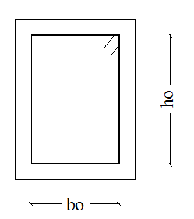
The dimensions of the cross section are adequate to prevent a brittle mode of failure if the following equation is satisfied.
$$\sqrt{{(\frac{Vu}{bw×d})}^{2}+{(\frac{Tu×Ph}{1.7×{A_{oh}}^{2}})}^{2 }}≤∅×(\frac{Vc}{bw×d}+2×\sqrt{fc})$$
$$A_{oh}=b_{o}×h_{o} =310×210=65100 {mm}^{2}$$
$$Ph=310×2+210×2=1040 mm$$
$$\sqrt{{(\frac{90.35×{10}^{3}}{300×343})}^{2}+{(\frac{40.3×{10}^{3}×1040}{1.7×{65100}^{2}})}^{2}}=2.99<0.75×\left(\frac{90.35×{10}^{3}}{300×343}+2×\sqrt{24}\right)=10$$
$∴$Cross sectional dimensions are adequate for resisting brittle failure
- Determine the required area of stirrup reinforcement for shear:-

$$V_{c}=\frac{1}{6}×\sqrt{f_{c^{'}}} ×b_{w}×d=0.75×\frac{1}{6} ×\sqrt{24} ×300×343=84 KN$$
$$∅×V_{c}=0.75×84=63 KN<Vu=90.35 KN$$
$$V_{s}=\frac{Vu}{∅}-Vc=\frac{90.35}{0.75}-84=36.47 KN$$
$$\frac{A_{v}}{S}=\frac{Vs}{bw×d}=\frac{36.47×{10}^{3}}{300×343}=0.35$$
$$S_{max}=\frac{d}{2}=\frac{343}{2}=171.5 mm$$
$∴$Maximum stirrup spacing (S) should not exceed of $S_{max}=171.5 mm$
- Determine the required area of stirrup reinforcement for torsion:-
$$\frac{A_{t}}{S}=\frac{Tu}{2×∅{×f}_{yt}{×A}_{o}{×\cot\left(θ\right)}^{2}}$$
$$A_{o}=0.85×A_{oh}=0.85×65100=55335 {mm}^{2}$$
$$\frac{A_{t}}{S}=\frac{40.3×{10}^{6}}{2×0.75×420×55335{×\cot\left(45\right)}^{2}}=1.156$$
$$S_{max}≤\frac{Ph}{8}=\frac{1040}{8}=130mm≤300mm$$
$∴$Maximum stirrup spacing (S) should not exceed of $S_{max}=130 mm$
- Determine the combined area of stirrup reinforcement for shear and torsion:-
$${\left(\frac{A_{v}}{S}\right)}_{Total}=\frac{A_{v}}{S}+2\left(\frac{A_{t}}{S}\right)>\frac{3.5×bw}{f_{yt}}$$
$${\left(\frac{A_{v}}{S}\right)}_{Total}=0.35+2×1.156=2.66>\frac{3.5×300}{420}=2.5$$
Try $∅$10 mm closed stirrups
$$\frac{2×79}{S}=1.56⟹S=10.12 cm$$
Therefore, maximum stirrup spacing based on shear and torsion combined is 13 cm
which is larger than 10 cm. Use two-legs, $∅$10 closed stirrups spaced at 10cm.

- Calculate the longitudinal reinforcement required for torsion:-
$$Al=(\frac{At}{S})×Ph×(\frac{f_{yt}}{f_{y}})×{cot⁡(θ)}^{2}$$
$f_{yt}=f_{y}=420 Mpa$ ,$θ=45°$
$$Al=1.156×1040=12 {cm}^{2}$$
$${Al}_{min}=\frac{0.42×\sqrt{fc}×A_{cp}}{fy}-(\frac{At}{S})×Ph×(\frac{f_{yt}}{f_{y}})$$
$$Where\left(\frac{At}{S}\right)≥\frac{0.175×bw}{f_{yt}}⟹ \left(\frac{At}{S}\right)=1.156>\frac{0.175×300}{420}=0.125$$
$${Al}_{min}=\frac{0.42×\sqrt{24}×65100}{420}-1622=8.83 {cm}^{2}<12 {cm}^{2}$$
$$Al=12 {cm}^{2}$$

ACI Code 11.5.6.2 requires that longitudinal torsion reinforcement be distributed around the perimeter of closed stirrups with a maximum spacing of 30 cm. One bar must be positioned in each corner of the stirrups to provide anchorage for the legs of the stirrups. The least longitudinal bar diameter to be used is the larger of 0.042 times the stirrup spacing, or 10 mm.

$$\frac{Al}{4}=\frac{12}{4}=3 {cm}^{2}$$

$$Total area of top reinforcement = 4.73 + 3 = 7.73 cm2, use 4 ∅ 16$$
$$Total area of bottom reinforcement = 4.91+3=7.91 cm2, use 4 ∅ 16$$
$$Area of middle reinforcement = 3+3=6 cm2, use 4 ∅14$$

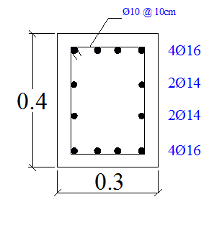

Figure (4-87): Designed cross section of ring beam.
4.5.2Design for lecture rooms:-
In this hall, we choose a frame system to use in the lecture halls.
The frame is a system use in buildings that has big areas.
4.5.2.1 Design for solid slab:-
Slab will be one-way solid slab.
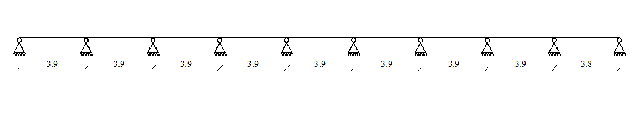
Thickness of slab will be calculated according to provisions in ACI-318-08 as follow:-

Figure (4-88): System of slab.
Minimum thickness (Deflection Requirements)
$$For first and last span \left(one end continuous\right)h min=\frac{L}{24}=\frac{390}{24}=16.25 cm$$
$$For interior span\left(both end continuous\right)h min=\frac{L}{28}==\frac{390}{28}=13.9 cm$$
Take slab thickness h= 17 cm

Calculation for loads:-
For 1 m strip
Dead load:-

Slab (self-weight) = 0.17 × 25× 1 = 4.25 KN/m

Live Load:-

3 KN/m² will be applied to the slab
1 × 3 = 1 KN/m

Snow load:-
Take h = 775 m, (Bethlehem height from sea level)
$$S_{0}=\frac{(h-400)}{320}=\frac{775-400}{320}= 1.17 kN/ m²$$$μ$ = 1.0…….. [Jordanian code page 48]
S = $S_{0}×μ$ = 1.0 $×$ 1.17 = 1.17 KN/m²

Load combination at the Slab:-
According to ACI, the following load combination is applied:-
1) $q_{u}$ = 1.2 D $+$ 1.6 L
$q_{u}$ = 1.2 $×$4.25$+$ 1.6 $×$3 = 9.9 KN/m
2) $q_{u}$ = 1.2 D $+$ 1.6 L $+$ 0.5 S
$q_{u}$= 1.2 $×$4.25$+$ 1.6 $×$3$+$ 0.5 $×$1.17 = 10.5 KN/m…….Control
3) $q_{u}$= 1.2 D $+$ 1.6 S $+$ 0.5 L
$q_{u}$= 1.2 $×$4.25$+$ 1.6 $×$1.17$+$ 0.5 $×$3 = 8.472KN/m
4) $q_{u}$= 1.2 D $+$ 1.6 S $+$ (L or 0.8 W)
${ q}_{u}$= 1.2 $×$4.25$+$ 1.6 $×$1.17$+$3 = 9.972 KN/m
Moment and Shear Envelop diagrams:-
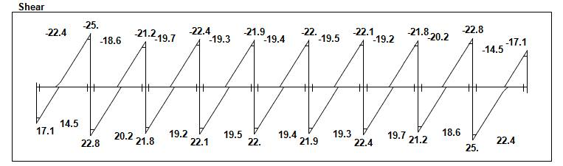

Figure (4-89): Slab Shear Envelop Diagram.
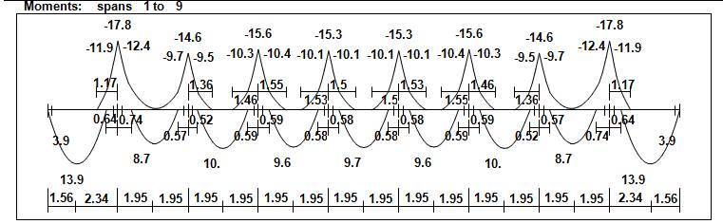

Figure (4-90): Slab Moment Envelop Diagram.
Design for Shear force:-
Vu at a distance d from the face of support
d = 170 - 20 – 10/2 = 145 mm
Vu at a distance = 250 + 125 = 395 mm from center of support.
Vu_{max} = 22.4 KN
Check whether the thickness of the slab:-
$$Vc = \frac{1}{6}\sqrt{f_{c}^{'}}b_{w }d=\frac{1}{6}\sqrt{24}×1000×145×{10}^{-3}=118.4 KN , ACI (11-3)$$
$$∅ Vc = 0.75×118.4 = 88.8 KN$$
$$Vu max= 22.4 KN <∅ Vc = 88.8 KN$$

No need to increase the slab thickness.
Design for Bending Moment:-
Design for positive moment:-
${Mu}_{max}$= 13.9KN.m
$$Kn= \frac{\frac{M_{u}}{∅}}{bd^{2}}=\frac{13.9*\frac{{10}^{6}}{0.9}}{1000*{\left(145\right)}^{2}}=0.73 Mpa$$
$$m=\frac{fy}{0.85×f_{c}^{'}}=\frac{420}{0.85×24}=20.6 Mpa$$
$$ρ=\frac{1}{m}\left(1-\sqrt{1-\frac{2.K_{n}.m}{f_{y}}}\right)=\frac{1}{20.6}\left(1-\sqrt{1-\frac{2*20.6*0.73}{420}}\right)=0.00179$$
$${As}_{req}=ρ b d=0.00179 * 1000 * 145= 257.76 {mm}^{2}$$
${As}_{min}=0.0018 b h=0.0018*1000*170=306 {mm}^{2}$ , ACI-318-08 (7.12.2.1)
$${As}_{req}=257.76 {mm}^{2}<{As}_{min}=306 {mm}^{2}$$
$$Select∅10-25cm$$

With As = (π × 10² / 4) × 100/25 = 314 mm²$>{As}_{req}=306{ mm}^{2}$

- the required reinforcement for maximum positive moment is smaller
than minimum reinforcement, so the bottom reinforcement for all span is$∅10-25cm.$

Check: strain:-

$T=C$
$As f_{y}=0.85 f_{c}^{'} a b$
$$314*420=0.85*24*a*1000$$
$a=6.46 mm$
$$x=\frac{6.46}{0.85}=7.6 mm\frac{0.003}{x}=\frac{0.003+ϵ_{s}}{d}$$
$$\frac{0.003}{7.6}=\frac{0.003+ϵ_{s}}{145}$$
$$ϵ_{s}=0.054>0.005$$
OK $∅=0.9$

Design for negative moment:-
M_{u} = -12.4KN.m
$$Kn= \frac{M_{u}/∅}{bd^{2}}=\frac{12.4*{10}^{6}/0.9}{1000*{(145)}^{2}}=0.65 Mpa$$
$$m=\frac{f_{y}}{0.85f_{c}^{'}} =\frac{420}{0.85*28}=20.6 Mpa$$
$$ρ=\frac{1}{m}\left(1-\sqrt{1-\frac{2.K_{n}.m}{f_{y}}}\right)=\frac{1}{20.6}\left(1-\sqrt{1-\frac{2*20.6*0.65}{420}}\right)=0.00158$$
$${As}_{req}=ρ b d=0.00159 * 1000 * 145 = 230 {mm}^{2}$$
$${As}_{min}=0.0018 b h=0.0018*1000*170=306 {mm}^{2}$$
$${As}_{req}=230 {mm}^{2}<{As}_{min}=306 {mm}^{2}$$
$$Select∅10-25cm$$

With As = (π × 10² / 4) × 100/25 = 314 mm²

- the required reinforcement for maximum negative moment is smaller
than minimum reinforcement, so the top reinforcement for all support is$∅10-25m$

Check: strain:-
$$T=C$$
$As f_{y}=0.85 f_{c}^{'} a b$
$a=6.46 mm$
$x=7.6 mm$
$\frac{0.003}{x}=\frac{0.003+ϵ_{s}}{d}$
$\frac{0.003}{7.6}=\frac{0.003+ϵ_{s}}{145}$
$$ϵ_{s}=0.054>0.005$$
So $∅=0.9$
- In the secondary direction to cover the secondary moment, shrinkage and temperature is required:
$${As}_{min}=0.0018 b h=0.0018*1000*170=306 {mm}^{2}$$
$$Select ∅10-25 cm$$
With As = (π × 10² / 4) × 100/25 = 314 mm²

4.5.2.2 Design for exterior beam:-
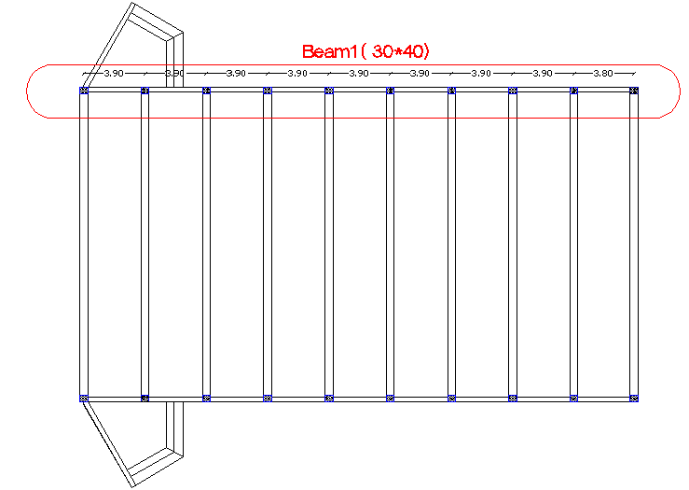

Figure (4-91): location of beam 1.
Using "Atir" software for the following values of moment and shear:-
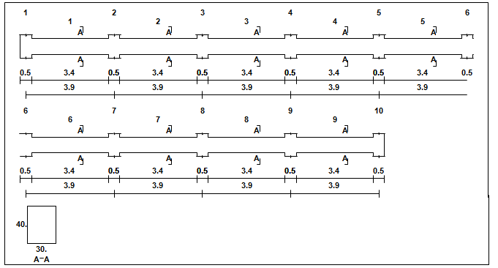

Figure (4-92): geometry of beam 1.

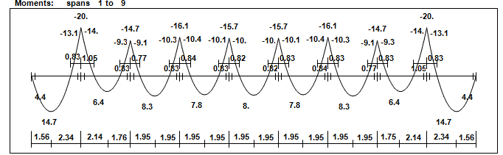

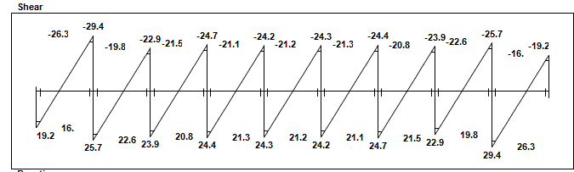
Figure (4-93): Beam Moment Envelop Diagram.

Figure (4-94): Beam shear Envelop Diagram.
Design for Bending Moment:-
Design for positive moment:-
$${Mu}_{max}= 14.7KN.m$$
d = 400 – 40 –10 – (12/2) = 344 mm
$$Kn= \frac{\frac{M_{u}}{∅}}{bd^{2}}=\frac{14.7*\frac{{10}^{6}}{0.9}}{300*{\left(344\right)}^{2}}=0.46 Mpa$$
$$m=\frac{f_{y}}{0.85f_{c}^{'}} =\frac{420}{0.85*24}=20.6 Mpa$$

$$ρ=\frac{1}{m}\left(1-\sqrt{1-\frac{2.K_{n}.m}{f_{y}}}\right)=\frac{1}{20.6}\left(1-\sqrt{1-\frac{2*20.6*0.46}{420}}\right)=0.0011$$
$${As}_{req}=ρ b d=0.0011 * 300* 344= 111 {mm}^{2}$$

Min Reinforcement of beam:-
As = $\frac{\sqrt{fc´}}{4(fy)}$(bw) (d) ≥ $\frac{1.4}{fy}$ (bw) (d)
As min. = $\frac{\sqrt{24}}{4(420)}$(300) (344) ≥ $\frac{1.4}{420}$ (300) (344)
= 301<344 mm², As min. = 344 mm²
$$As min. = 344 {mm}^{2}>{As}_{req}=111{mm}^{2}⇒ As=344{mm}^{2}$$
Select $4∅12 with A_{s}=452 mm²$
Check: strain:-

$$T=C$$
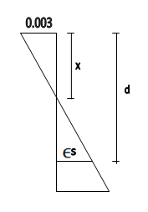
$452*420=0.85*24*a*300$
$$a=31 mm$$
$$x=\frac{31}{0.85}=36.5 mm\frac{0.003}{x}=\frac{0.003+ϵ_{s}}{d}$$
$$\frac{0.003}{36.5}=\frac{0.003+ϵ_{s}}{344}$$
$$ϵ_{s}=0.025>0.005$$
OK $∅=0.9$

- the required reinforcement for maximum negative moment is smaller than minimum reinforcement, so the bottom reinforcement for all span is$4∅12$.

Design for negative moment:-
${Mu}_{max}$= -14KN.m
$$Kn= \frac{\frac{M_{u}}{∅}}{bd^{2}}=\frac{14*\frac{{10}^{6}}{0.9}}{300*{\left(344\right)}^{2}}=0.44Mpa$$
$$m=\frac{f_{y}}{0.85f_{c}^{'}} =\frac{420}{0.85*24}=20.6 Map ρ=\frac{1}{m}\left(1-\sqrt{1-\frac{2.K_{n}.m}{f_{y}}}\right)=\frac{1}{20.6}\left(1-\sqrt{1-\frac{2*20.6*0.44}{420}}\right)=0.0010$$
$${As}_{req}=ρ b d=0.0010 * 300* 344= 109 {mm}^{2}$$
Min Reinforcement of beam:-
$$As min. = 344 {mm}^{2}>{As}_{req}=109{mm}^{2}⇒ As=344{mm}^{2}$$
Select $4∅12, with A_{s}=452 mm²$
Check: strain:-
$$T=C$$
$As f_{y}=0.85 f_{c}^{'} a b$
$a=31 mm$
$x=36.5 mm$
$\frac{0.003}{x}=\frac{0.003+ϵ_{s}}{d}$
$\frac{0.003}{36.5}=\frac{0.003+ϵ_{s}}{344}$
$$ϵ_{s}=0.025>0.005$$
So $∅=0.9$
- the required reinforcement for maximum negative moment is smaller than minimum reinforcement, so the top reinforcement for all support is$4∅12$.

Design for Shear force:-
Usually the design value of shear is taken at distance (d) from support face.
$$d = 344 mm$$
Vu max = 26.3 KN
$$Ф Vc = 0.75 × \frac{1}{6} × \sqrt{fc´} × b × d$$
$$Ф Vc= 0.75 × \frac{1}{6} ×\sqrt{ 24} ×300×344 = 63.19 KN$$
$$Ф Vc=63.19 KN>Vu=26.3 KN$$
⇒ No need shear reinforcement
⇒Use 2 legs Ø10 – 20cm
4.5.2.3 Design for Frame:-
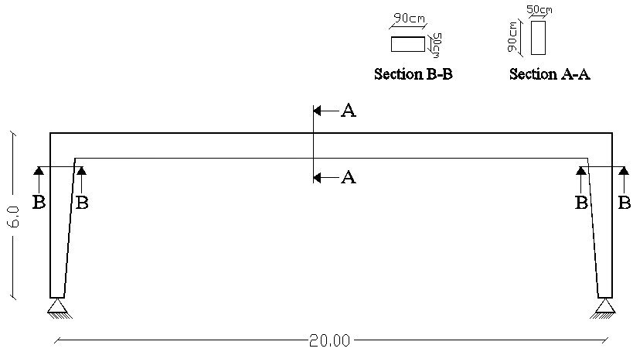

Figure (4-95): System of frame.

4.5.2.3.1Structural Analysis for the frame:-
Autodesk Robot Structural Analysis Professional is the software used to analyze the frame.
- Internal forces diagrams:-
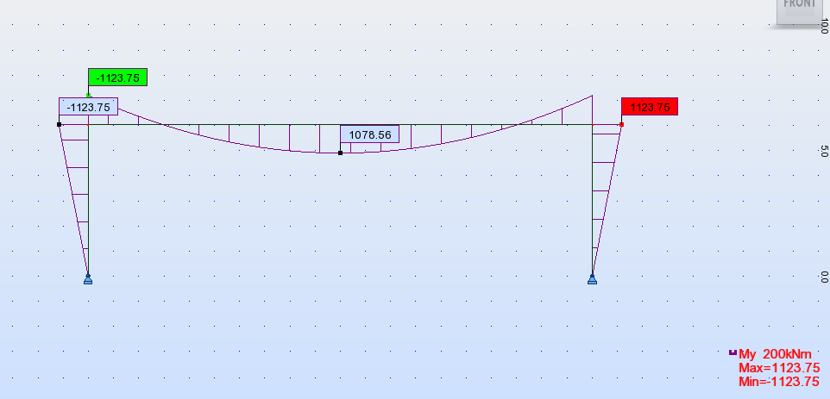

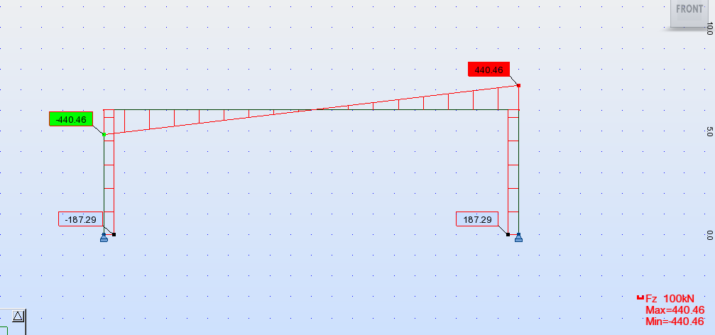
Figure (4-96): Frame Moment Diagram.

Figure (4-97): Frame Shear Force Diagram.

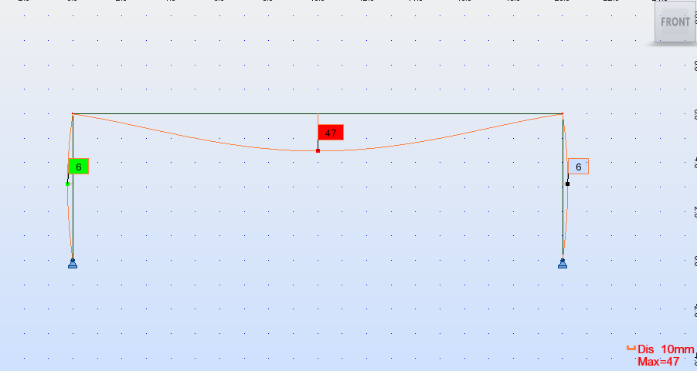

Figure (4-98): Frame Deformation diagram.
Check Deflection:-
Allowable deflection = L / 360 = 2000 / 360 = 5.55 cm
$$Max deflection =4.7 cm<5.55 cm Ok$$
4.5.2.3.2 Design for frame beam:-
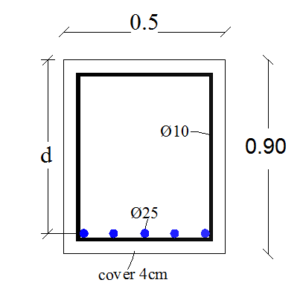
- Design of Bending Moment:-

Figure (4-99): Beam section (A-A) for Frame.
Positive moment:-
$${Mu}_{max} = 1078.56 KN.m$$
$$d=900-40-10 –(\frac{25}{2})=837.5 mm$$
$$Kn= \frac{M_{u}/∅}{bd^{2}}=\frac{1078.56*{10}^{6}/0.9}{500*{(837.5)}^{2}}=3.42Mpa$$
$$m=\frac{f_{y}}{0.85f_{c}^{'}} =\frac{420}{0.85*24}=20.6$$
$$ρ=\frac{1}{m}\left(1-\sqrt{1-\frac{2.K_{n}.m}{f_{y}}}\right)=\frac{1}{20.6}\left(1-\sqrt{1-\frac{2*20.6*3.42}{420}}\right)=0.0091$$
$${As}_{req}=ρ b d=0.0091 * 500 * 837.5= 3810.6 {mm}^{2}$$
$${As}_{min}≥0.25*\frac{\sqrt{f_{c}^{'}}}{f_{y}}*b*d=0.25*\frac{\sqrt{24}}{420}*500*837.5=1221.1 {mm}^{2}$$
$${As}_{min}≥\frac{1.4}{f_{y}}*b*d=\frac{1.4}{420}*500*837.5=1395.83 {mm}^{2}$$
$${As}_{req}=3810.6 {mm}^{2}>{As}_{min}=1395.83 {mm}^{2}$$
$$n=\frac{3810.6}{491}=7.76$$
$$Select 8∅25-with{ A}_{s}=3928 {mm}^{2}$$

Check: strain:-

$T=C$
$As f_{y}=0.85 f_{c}^{'} a b$
$$3928*420=0.85*24*a*500$$
$a=161.74 mm$
$x=\frac{161.74}{0.85}=$190.3 mm
$\frac{0.003}{x}=\frac{0.003+ϵ_{s}}{d}$
$$\frac{0.003}{190.3}=\frac{0.003+ϵ_{s}}{837.5}$$

$$ϵ_{s}=0.0102>0.005→∅=0.9$$
Negative moment:-
The critical section for design at the face of column
$${Mu}_{max} =-994.18 KN.m$$
$$Kn= \frac{M_{u}/∅}{bd^{2}}=\frac{994.18*{10}^{6}/0.9}{500*{(837.5)}^{2}}=3.15 Mpa$$
$$m=\frac{f_{y}}{0.85f_{c}^{'}} =\frac{420}{0.85*24}=20.6$$
$$ρ=\frac{1}{m}\left(1-\sqrt{1-\frac{2.K_{n}.m}{f_{y}}}\right)=\frac{1}{20.6}\left(1-\sqrt{1-\frac{2*20.6*3.15}{420}}\right)=0.00819$$
$${As}_{req}=ρ b d=0.00819 * 500 * 837.5 = 3429.76 {mm}^{2}$$
$${As}_{min}≥0.25*\frac{\sqrt{f_{c}^{'}}}{f_{y}}*b*d=0.25*\frac{\sqrt{24}}{420}*500*837.5=1221.1 {mm}^{2}$$
$${As}_{min}≥\frac{1.4}{f_{y}}*b*d=\frac{1.4}{420}*500*837.5=1395.83 {mm}^{2}$$
$${As}_{req}=3429.76 {mm}^{2}<{As}_{min}=1395.83 {mm}^{2}$$
$$n=\frac{3429.76}{491}=6.9$$

$$Select 7∅25-with{ A}_{s}=3437 {mm}^{2}$$

Check strain:-
$$T=C$$
$As f_{y}=0.85 f_{c}^{'} a b$
$a=141.52 mm$
$x=166.5 mm$
$\frac{0.003}{x}=\frac{0.003+ϵ_{s}}{d}$
$\frac{0.003}{166.5}=\frac{0.003+ϵ_{s}}{837.5}$
$ϵ_{s}=0.012>0.005$So $∅=0.9$

- Design of Shear force:-
Critical section at 837.5mm from face of column
$${Vu}_{max} = 365.06 KN$$
$$Ф Vc = 0.75 × \frac{1}{6} × \sqrt{fc´} × b × d$$
$$Ф Vc= 0.75 × \frac{1}{6} ×\sqrt{ 24} ×500×837.5 =265.43 KN$$
$$Ф Vc=265.43 KN<Vu=365.06 KN$$
The shear reinforcement is required
Region 3:-
$$V_{u}≤ø V_{c}+ø V_{s min}$$
$$∅V_{s min}≥0.75 \frac{1}{16}\sqrt{f_{c}^{'}}{ b}_{w }d=0.75*\frac{1}{16}*\sqrt{24}*500*837.5=96.16 KN$$
$∅V_{s min}≥0.75 \frac{1}{3}{ b}_{w }d=0.75*\frac{1}{3}*500*1137.5=105 KN$Controls
$∅V_{c}$ = $265.43KN$
$$V_{u}=365.06 KN<265.42+105=370.4 KN$$
Minimum shear reinforcement is required.
Use two legs with Av = 2 × (π × 10² / 4) = 157 mm²
$$S=\frac{Av×f_{y}×d}{V_{s min}}= \frac{157×420×837.5}{{105}/{0.75} ×{10}^{3}}=394 mm$$
$$S≤d/2$$
$$S=\frac{837.5}{2}=418.75 mm$$
$$S≤600 mm$$
Select $∅10/20 cm$

4.5.2.3.3 Design for frame column:-
Use structural analysis and design programs (such as Prokon, CSI Column, etc.) for constructing interaction diagrams for the column section.
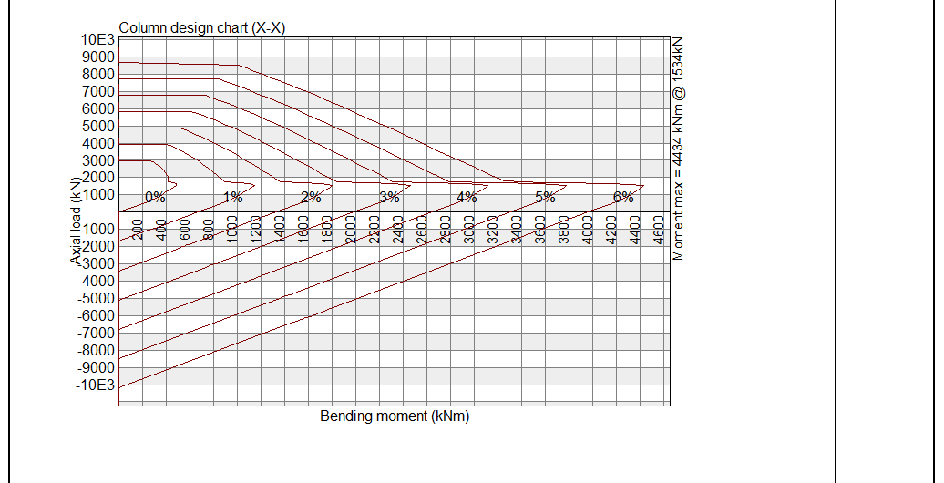
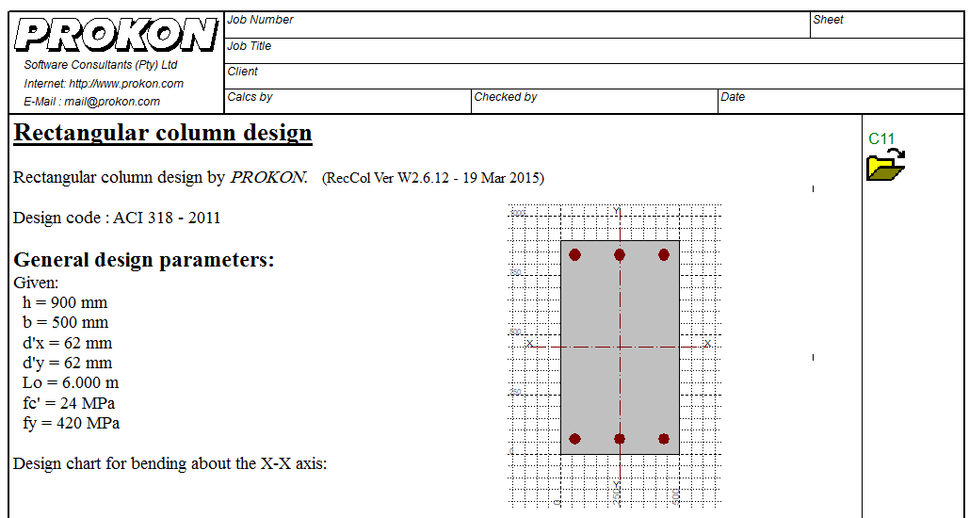

Figure (4-100): interaction diagram for the column

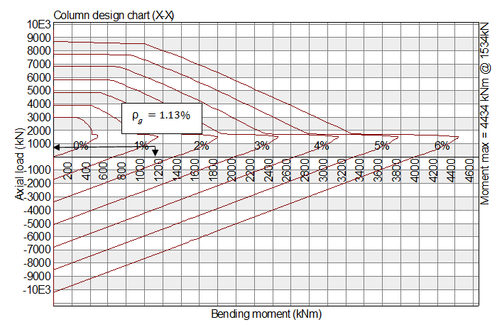
From the interaction diagram constructed in Prokon Program:

$$ρ_{g}=1.13\%⟶ Pu=1000 KN$$
$$⟶Mu=1100 KN.m$$
$$ρ_{g}=\frac{A_{s}}{A_{c}}⇒A_{s}=ρ_{g}×A_{c}=0.0113×50×90=50.85 {cm}^{2}$$
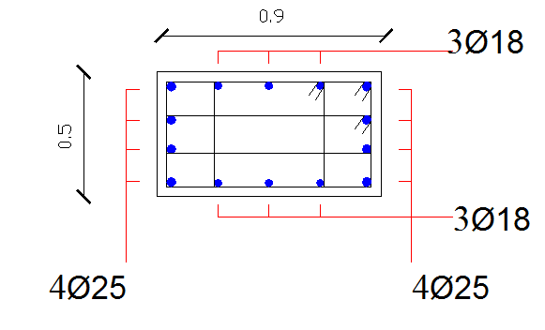

$${As}_{prov}=8×4.91+6×2.54=54.5 {cm}^{2}$$

4.5.2.3.4 Design for footing:-
Subsurface condition:-
According to the soil report of the site the bearing capacity for soil at the design depth is $3.2\frac{Kg}{{cm}^{2}}≈314 \frac{KN}{m^{2}}$ and the specific weight of soil is 18$\frac{KN}{m^{3}}$
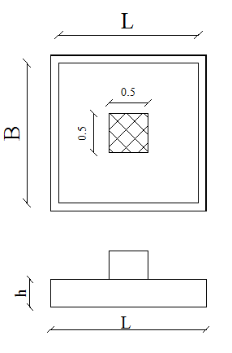

Figure (4-101): plan and section for footing.
The footing caries the frame column reaction (service load):-
$$Q=760.8 KN$$
$$H = 60.81 KN$$
$$q_{net-allowable}=q_{allowable}-(q_{self-weight}+ q_{soil pressure})$$
$$q_{net-allowable}=314-(25×{0.4}_{\left(assumed\right)})+((1-0.4)×18)$$
$$q_{net-allowable}=293.5 \frac{KN}{m^{2}}$$

Computing the area (B$×L$):-
$$q_{allow}=\frac{Q}{L×B}→B×L=\frac{Q}{q_{allow}} =\frac{760.8}{293.5}=2.6 m^{2}$$
$$select B=L=1.7 m$$
$$e=\frac{M}{Q}=\frac{24.56}{740.8}=0.033 m$$
Contact pressure:-
$$When e=0.033<\frac{L}{6} =\frac{1.7}{6}=0.28 m$$Then$q_{max}$is given by the Following equation
$$q_{max}=\frac{Q}{B×L}\left(1+\frac{6e}{L}\right)= \frac{760.8}{1.7×1.7}\left(1+\frac{6×0.033}{1.7}\right)=293.9{KN}/{m^{2}} \\ q_{max}=293.9{KN}/{m^{2}}<1.3×q_{allow}=1.3×293.5=382{KN}/{m^{2}}$$
Footing stability:-
Check against sliding failure:-
The factor of safety against sliding is expressed as follows:
$${F.s}_{sliding}=\frac{sumation of horizontal resistingfoces}{sumation of horizontal driving foces}$$
$${F.s}_{sliding}=\frac{εV ×tan⁡({\frac{2}{3}}∅) }{F_{H}}$$
$$εV=weight of soi labove footing+weight of footing+Q$$
$$εV=18×1.2×1.2×0.6+25×1.7×1.7×0.4+760.8=805.25KN$$
$${F.s}_{sliding}=\frac{805.25×tan({\frac{2}{3}}×27)}{60.81}=4.3>1.5→ O.K$$

Design for footing thickness and structural reinforcement:-
Factored load:-
$$Q_{u}=1017.1KN$$
$$H_{u}=82.12KN$$
$$e=\frac{Mu}{Qu}=\frac{34.19}{1017.1}=0.033 m$$
Then the pressure under footing is:-
$$q_{max}= \frac{1017.1}{1.7×1.7}\left(1+\frac{6×0.033}{1.7}\right)=392.8\frac{KN}{m^{2}}<410.9\frac{KN}{m^{2}}$$
$$q_{min}= \frac{1017.1}{1.7×1.7}\left(1-\frac{6×0.033}{1.7}\right)=310.94 \frac{KN}{m^{2}}$$
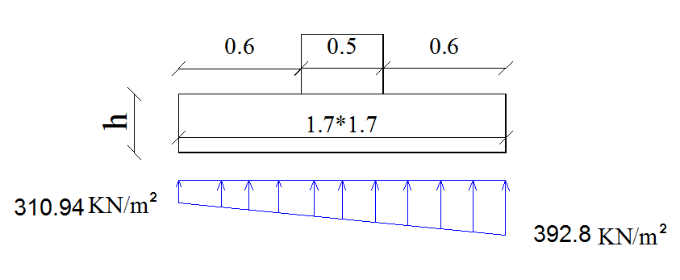

Figure (4-102): Contact Pressure diagram due to loading (factored).
Design for footing thickness: the thickness of footing will be selected so that punching shear failure does not occur. Assume $∅_{max}$ main reinforcement is 16 mm and cover of 50 mm.
$$d=400-50-16=334mm$$The footing will be design against one way shear and against punching shear.

One way shear:-
The critical section for checking one-way shear strength that is at a distance d from the face of column the pressure at d from the face is 380 $\frac{KN}{m^{2}}$ and at the very far end of the footing is 392.8$\frac{KN}{m^{2}}$ so that$V_{u}$ :

$$V_{u}=\left(\frac{392.8+380}{2}\right)×0.266×1.7=174.73 KN$$

$$∅×V_{c}=∅×\frac{1}{6}×\sqrt{f_{c'}}×b_{w}×d=0.75×\frac{1}{6}×\sqrt{24}×1700×334=347KN$$

$$∅×V_{c}=347>V_{u}=174.73 →No shear reinforcement$$

Thickness of footing is adequate against one way shear.

Punching shear (Tow way shear):
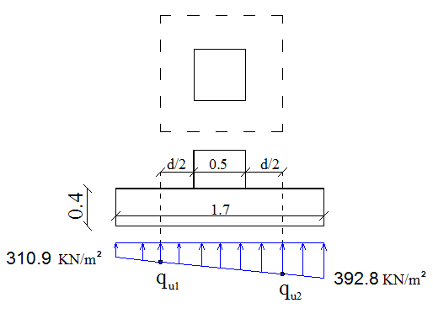
Critical perimeter ( $b_{°}$) will be at a distance $d/2$ from the face of the column
$$b_{°}=(500+334)×4=3336mm$$

Figure (4-103): critical section for checking two way shear

$$q_{u1}=371.9{KN}/{m^{2}}$$

$$q_{u2}=331.8 {KN}/{m^{2}}$$
Factored shear to be transferred across the critical perimeter is:-
$$v_{u(net)}=1017.1-0.5×\left(331.8+371.9\right)×0.834×0.834=772.4 KN$$
The shear strength of concrete according to ACI is given by equation as follows:
$$V_{c}=\left(2+\frac{4}{β}\right)×\frac{\sqrt{f_{c^{'}}}}{12}{×b}_{°}×d$$
$$V_{c}=\left(\frac{α_{s}d}{b_{°}}+2\right)×\frac{\sqrt{f_{c^{'}}}}{12}{×b}_{°}×d$$
$$V_{c}=\frac{1}{3}×\sqrt{f_{c^{'}}}×b_{°}×d$$
The minimum value of the previous equations controls.
$$β=\frac{50}{50}=1.0$$
$$α_{s}=40\left(interiorcolumn\right)$$

The third equation controls:
$$V_{c}=\frac{1}{3}×\sqrt{24}×3336×334 =1819KN$$
$${∅×V}_{c}=0.75×1819=1364.6 KN>772.4 KN$$
The footing thickness is adequate against two way shear.

Design for footing against bending moment:-

The critical section for bending moment that is at the face of column, the pressure at the face is363.9${KN}/{m^{2}}so that Mu$:

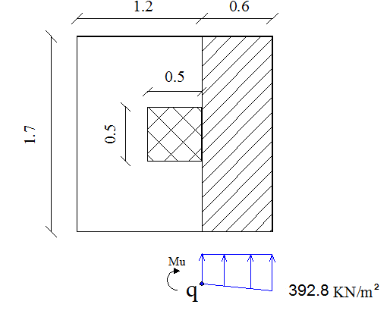

Figure (4-104): critical section for design Moment.
$$M_{u}=\left(363.9×0.6×1.7×\frac{0.6}{2}\right)+\left(28.9×0.6×1.7×\frac{1}{2}×\frac{0.6×2}{3}\right)=117 KN.m$$

$$Kn= \frac{M_{u}/∅}{bd^{2}}=\frac{117×{10}^{6}/0.9}{1700×{(334)}^{2}}=0.68 Mpa$$
$$m=\frac{f_{y}}{0.85f_{c}^{'}} =\frac{420}{0.85*24}=20.6 Mpa$$
$$ρ_{req}=\frac{1}{m}\left(1-\sqrt{1-\frac{2.K_{n}.m}{f_{y}}}\right)=\frac{1}{20.6}\left(1-\sqrt{1-\frac{2×20.6×0.68}{420}}\right)=0.0016$$
$$A_{sreq}=ρ_{req}×b×d=0.0016×1700×334=942.8 {mm}^{2}$$
$${As}_{min}=0.0018×1700×400=1224{mm}^{2}$$
$$A_{sreq}=942.8 {mm}^{2}<{As}_{min}=1224{ mm}^{2}$$
$$A_{S}=1224 {mm}^{2}$$
$Select∅16mm$, With As =$\frac{{16}^{2}×π}{4}$ = 201 mm²
$$n=\frac{1224}{201}=6.1$$
- $select 7∅16 bars in both directons$.

